Four Seasons Hotel New York Downtown Celebrates International Women’s Day

Four Seasons Hotel New York Downtown launches new Resident Healers Program in celebration of International Women’s Day
March 8, 2018, New York, U.S.A.

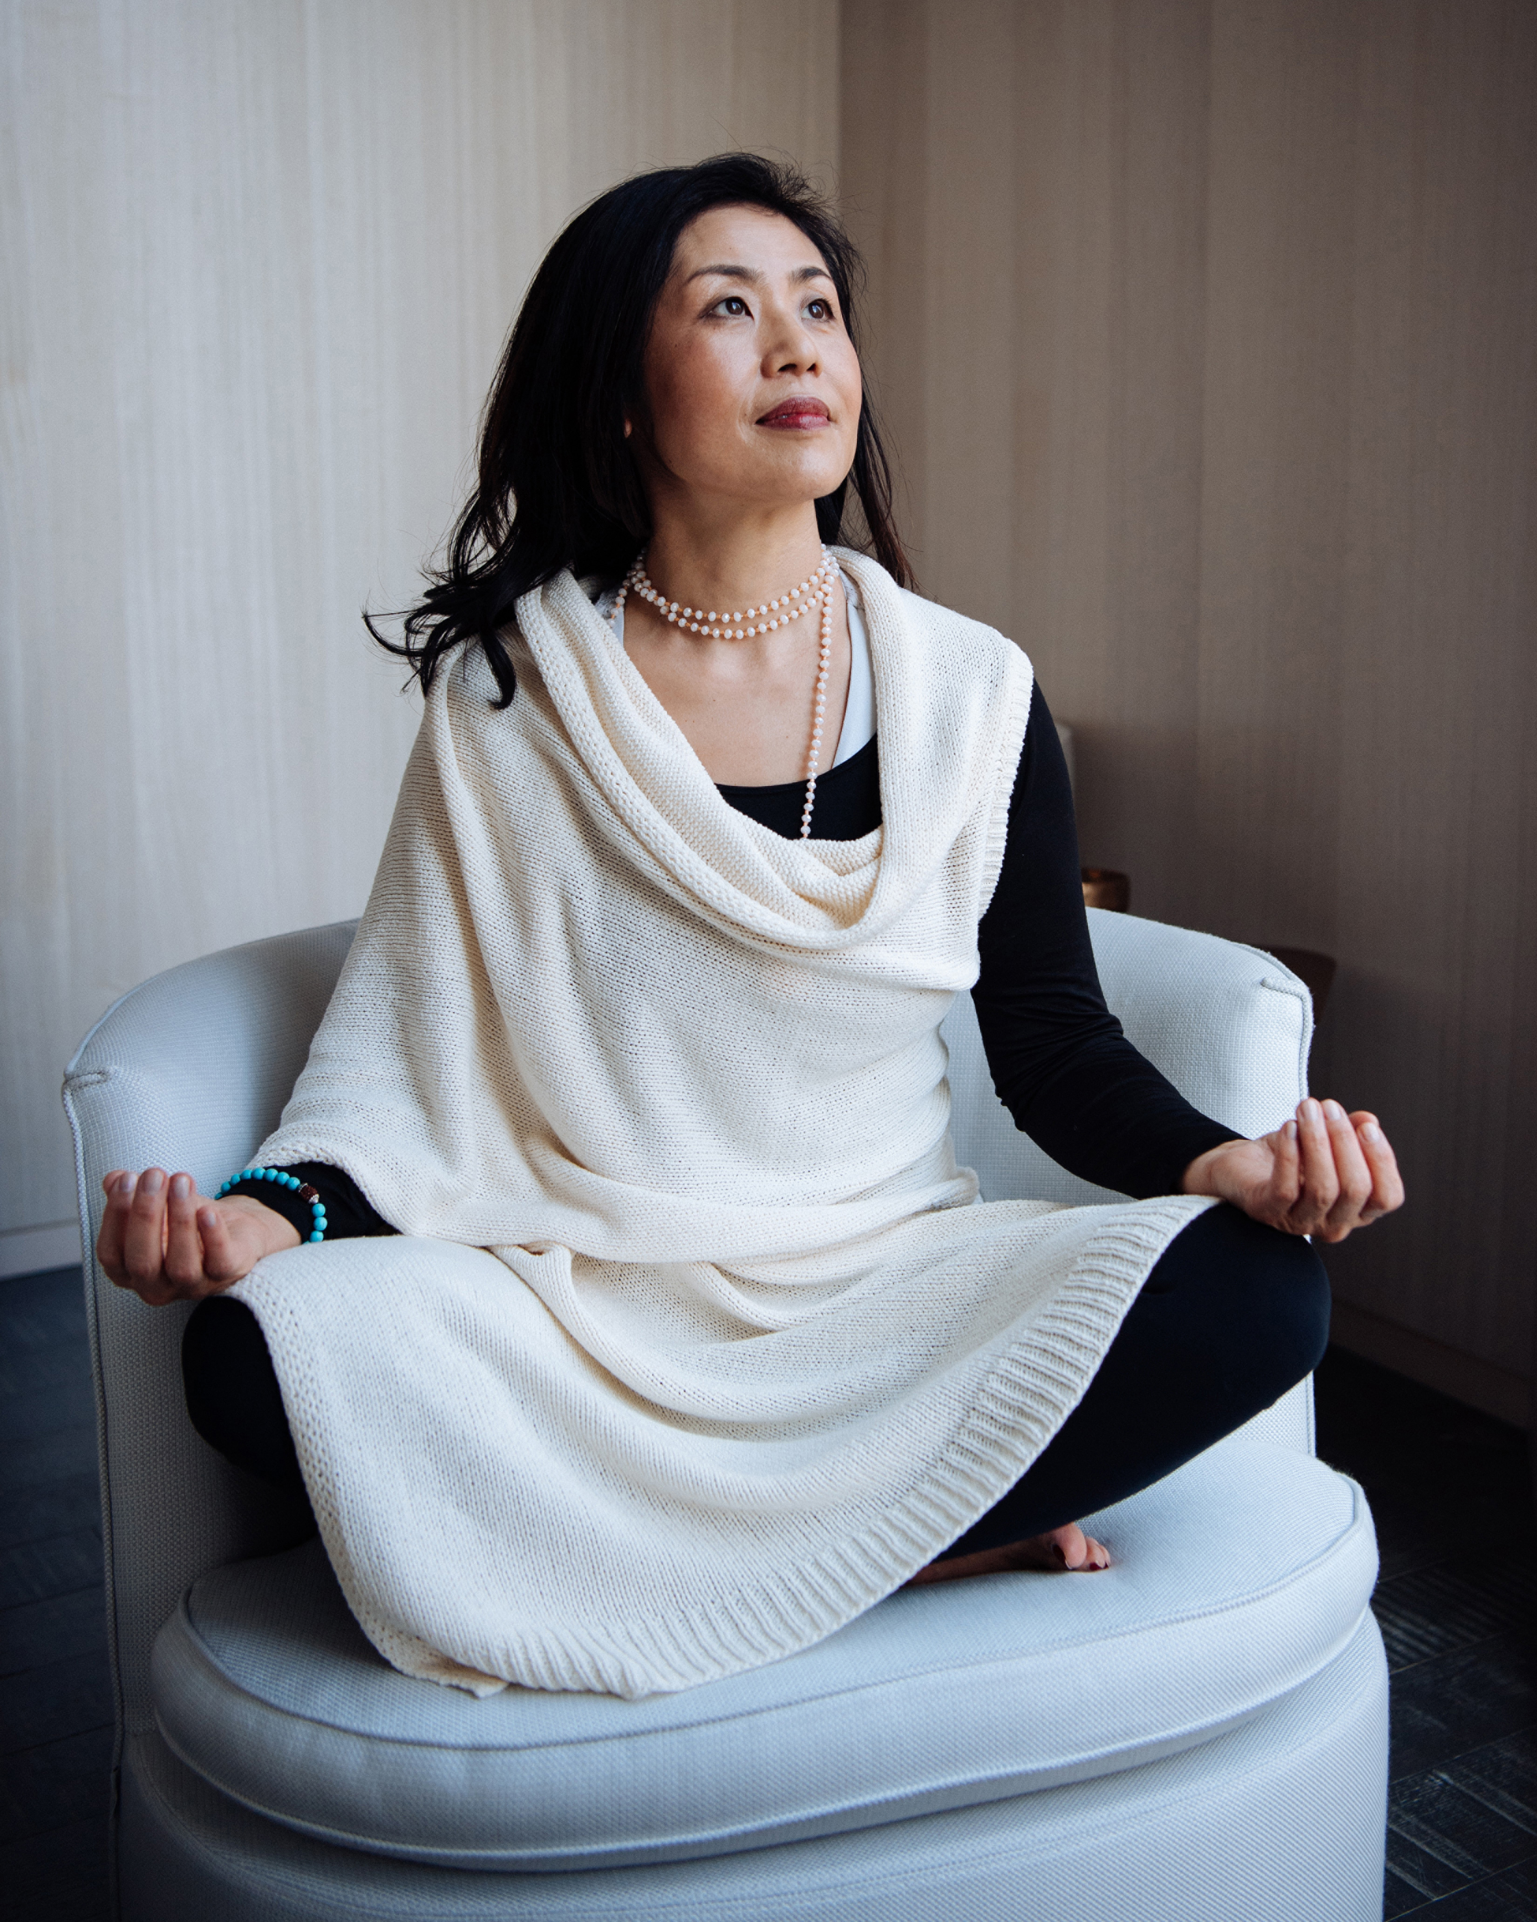
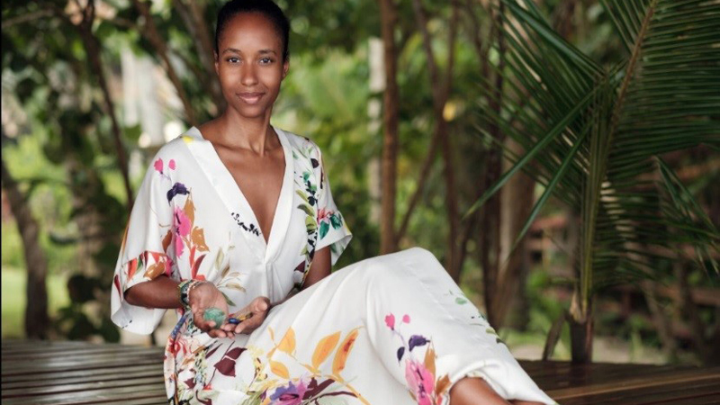 | 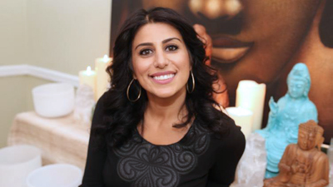 | 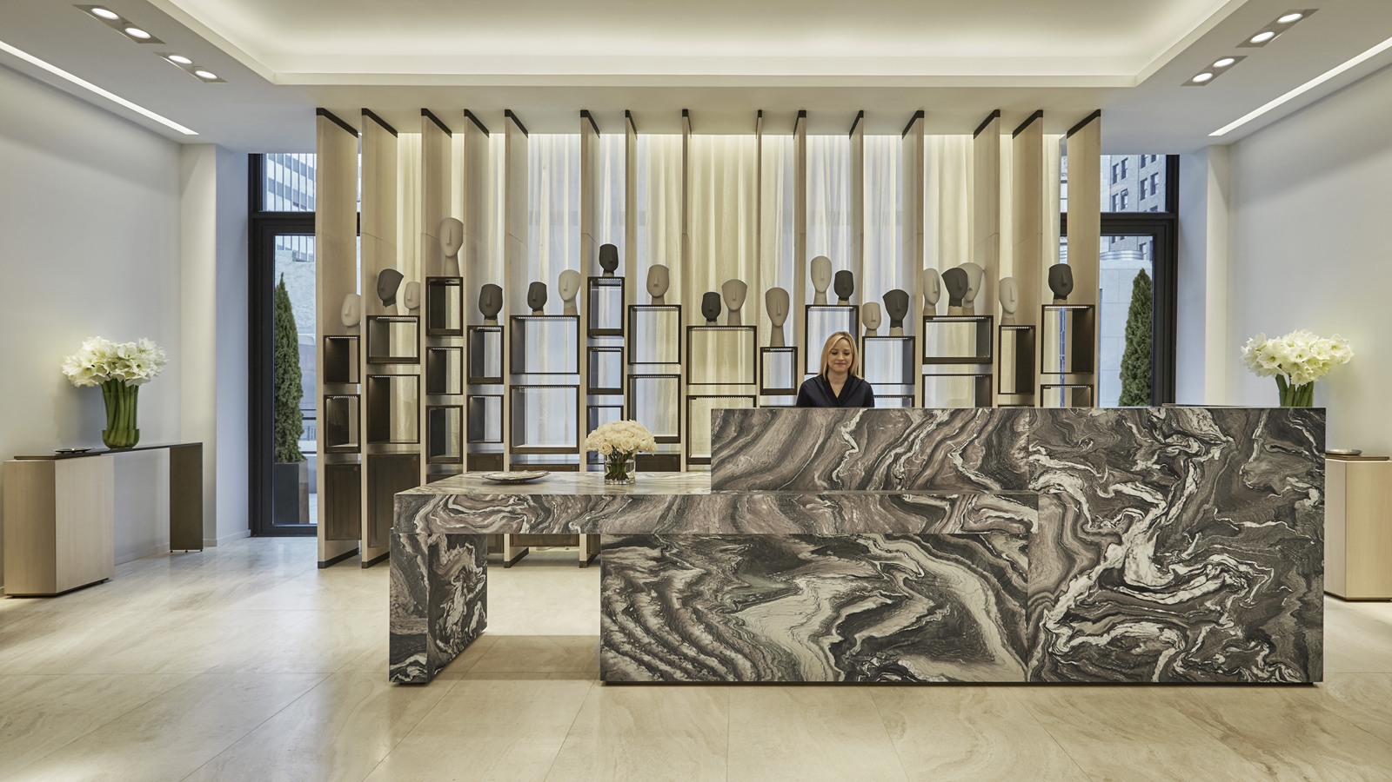
Four Seasons Hotel New York Downtown celebrates International Women’s Day with the launch of a new Resident Healers Program, showcasing three leading women in the health and wellness industry in New York City.
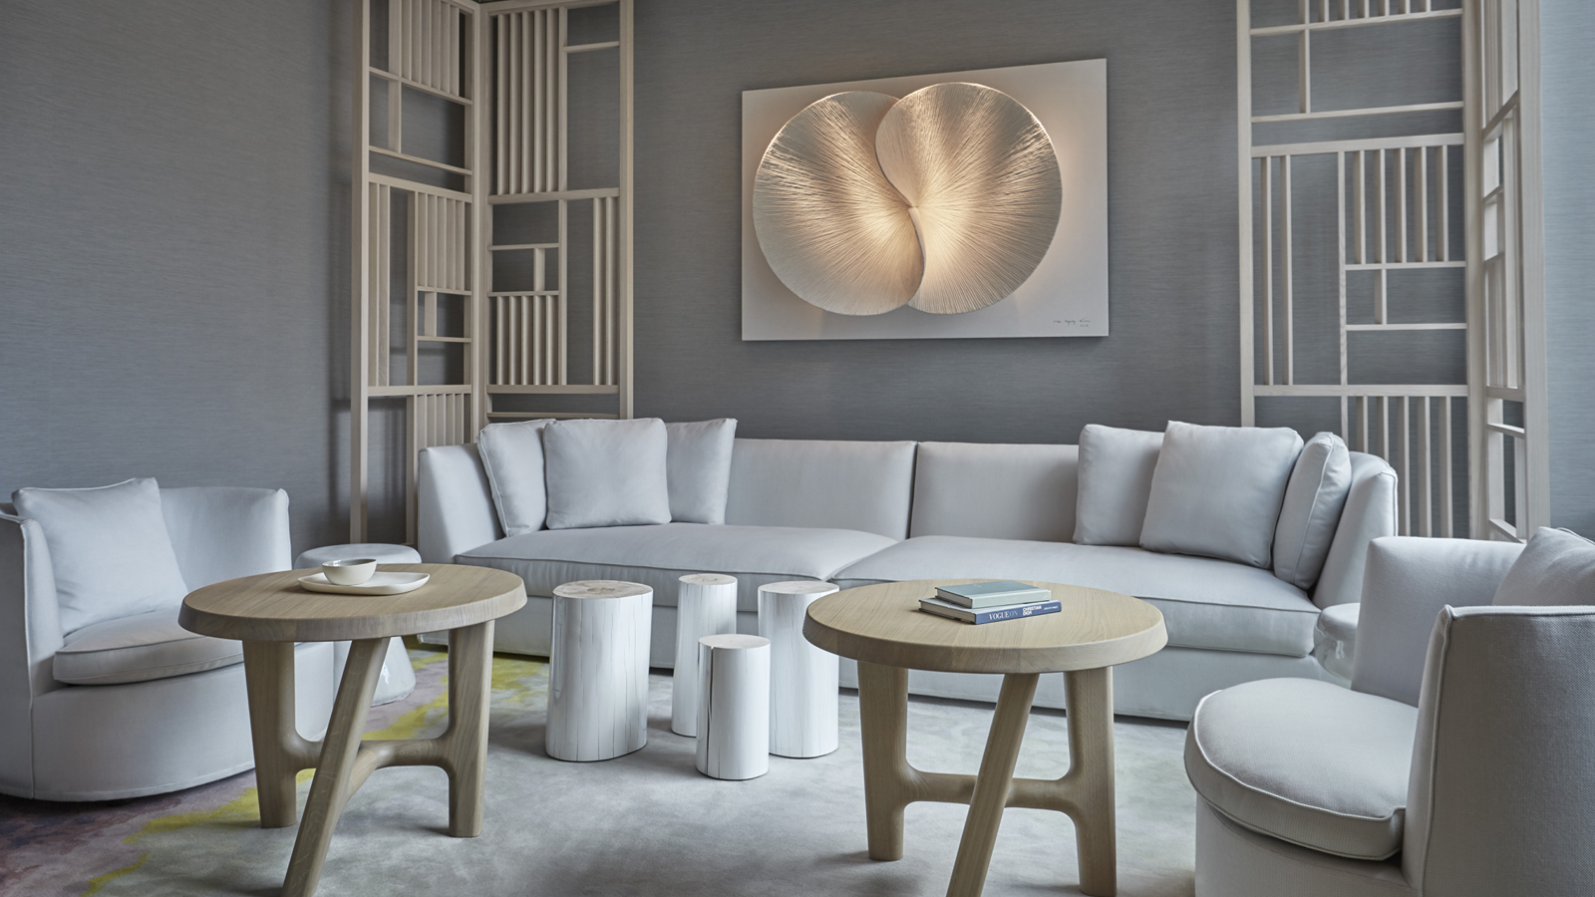 |  | 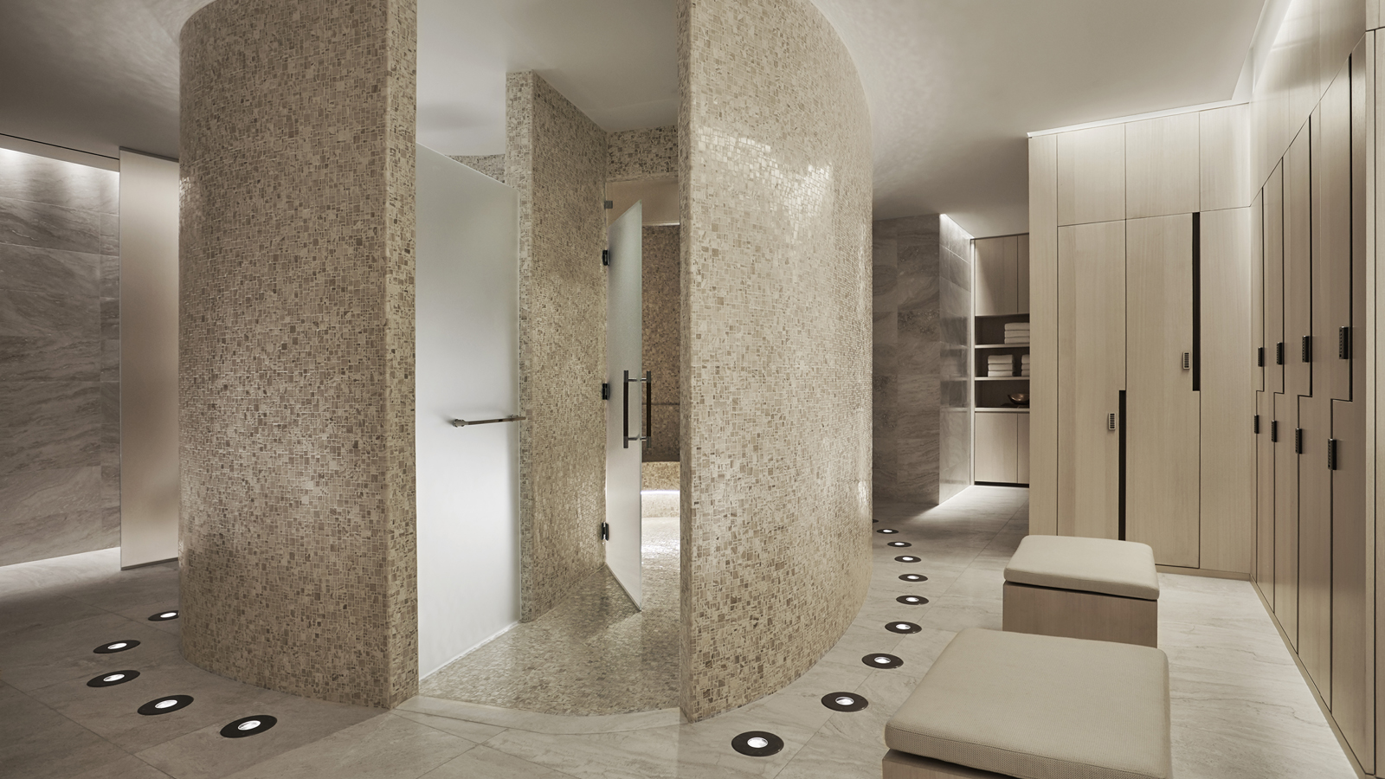
Included in the Resident Healers Program offered at The Spa at Four Seasons Hotel New York Downtown are the following women, all completely unique in their field:
- Deganit Nuur, creator of The Nuurvana Method
- Rashia Bell, creator of The Cristalline
- Snow Shimazu, creator of AIR BEAUTIFUL
Each of the three Resident Healers provide unique, mindful experiences for each guest during one-one-one private appointments at The Spa. Deganit Nuur is an acupuncturist, herbalist and clairvoyant; Rashia Bell is a crystal healer and mediation master; Snow Shimazu is a travel wellness expert, advanced body work educator and all around wellness guru. Each of these leading women offer guests seeking something greater than the traditional spa service.
International Women's Day is a day that celebrates the social, economic, cultural and political achievements of women across the world, with the objective being to pay homage to and show gratitude towards women’s selfless contributions to people’s lives and society overall. Each of the Resident Healers featured at The Spa is committed to teaching individual guests how to acknowledge their own unique gifts and potential, with the view that with encouragement and enlightenment, each client can reach their own pinnacle of personal success.
To book an individual consultation with any of the Resident Healers, contact The Spa at Four Seasons Hotel New York Downtown on 646 880 1990.
About Dr Deganit Nuur, The Nuurvana Method
Dr. Deganit Nuur is a world renowned spiritual teacher, intuitive, acupuncturist, writer, and lecturer. Nuur was named “Top 15 Intuitives Globally” by Gwyneth Paltrow’s publication Goop. Nuur created and teaches the revolutionary Nuurvana Method, which is based upon traditional eastern philosophy that seeks to integrate mind, body, and spirit. The Nuurvana Method goes beyond what meets the eye to heal the spiritual plane, resulting in profound shifts in mind and body and thereby reintegrating spirit into alignment with one’s true purpose and passion. Sessions always include a clairvoyant reading, crystal sound bath, aromatherapy, chakra clearing, and a completely customised mantra, with 90 minute sessions including acupuncture, cupping, supplement and lifestyle prescriptions when applicable.
About Rashia Bell, The Cristalline
Energetic interior designer and crystal healer Rashia Bell, is the co-founder of The Cristalline, a multi-faceted lifestyle company that works to help create balance within all areas of life. After more than ten years working on the business side of fashion, beauty, jewelry and luxury industries for companies such as Mikimoto, Vivre and Monique Péan, Rashia found her creative outlet and expressive voice through interior design. A graduate of both the Fashion Institute of Technology and the New York School of Interior Design, she has also completed two Crystal Healing Certifications by the Crystal Academy of Advanced Healing Arts, and is a Level 2 Usui Shiki Ryoho Reiki Healer.
Rashia decided to take a uniquely holistic approach to the spaces she transforms for The Cristalline, by incorporating the energetic and healing powers of crystals and stones into her interiors. The foundation for this design process is specialising in personal healing work, where Rashia has lead workshops, private events and retreats around the world and works to show her clients how to find balance both within themselves and the spaces they live and work in.
About Snow Shimazu, AIR BEAUTIFUL
Snow treats the physical, mental and energetic damage caused by travelling. Through premium one-on-one sessions before, during and after travel, Snow encourages balance and clarity within each client’s lifestyle. Each customised program specifically targets concerns in conjunction with the travel itinerary, as well as before and after travel. Regular and steady lifestyle sessions help bring the optimisation of presence, vitality and resilience within each client and collectively within life.
Snow was born in Japan though experienced advanced training from around the world. Her years of diverse and multi-disciplinary experiences in art, travelling, manual therapy, yoga, meditation and spiritually blend beliefs help Snow understand the essential nature of how to prevent and recover from the damage caused by travelling. Snow received a Masters of Arts Management from American University in Washington, DC and did her graduate internship at the Smithsonian Institution.
Additional Collaborations
In support of International Women’s Day, The Spa team at Four Seasons Hotel New York Downtown is also proud to showcase the following diverse collaborations with female-led businesses:
Dr Burgener Switzerland: Dr Burgener supports schools in India through the sales of her products, of which a percentage is donated to the Women for Women project. Dr Burgener strives to empower women to achieve professional and financial independence through education and training. The brand supports women’s cooperatives with products hand made by women in challenged countries.
Ash + Ames: Project: Get Gorgeous. Get Global. Give Back. All jewelry pieces reflect the strength, confidence and diversity of the women who both design and share them. Every piece tells a unique story, from female artisans all around the world. Each season a portion of Ash + Ames pieces are created by women in developing countries, of which 100 percent of the proceeds are returned to their communities.
Sefte: Led by twin sisters Jenn and Sarah Pearsall, Sefte Living offers casually elegant home decor and accessories. Inspired by nature and created by hand using centuries old techniques, Sefte’s artisans from Peru create softness and luxury that can not only be seen, but felt. Each piece is one-of-a-kind and designed to instill a sense of sanctuary within each home.

RELATED

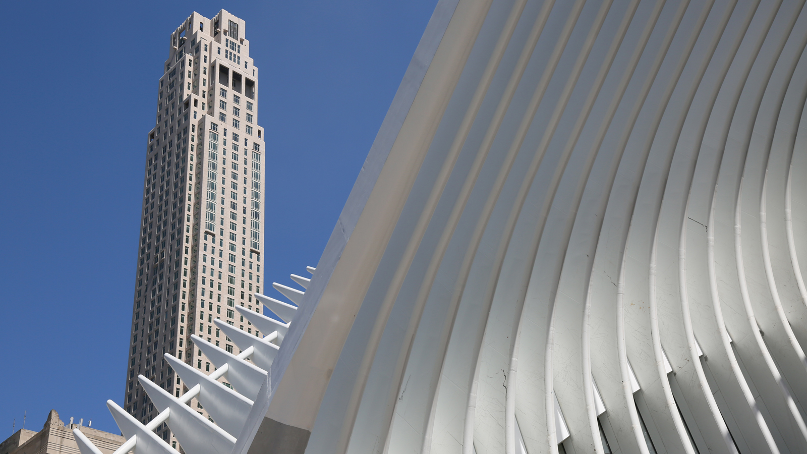 | October 22, 2019, New York, U.S.A.  Four Seasons Hotel New York Downtown Launches Martinis & Mistletoe  https://publish.url/newyorkdowntown/hotel-news/2019/martinis-and-mistletoe-festive-package-and-contest.html
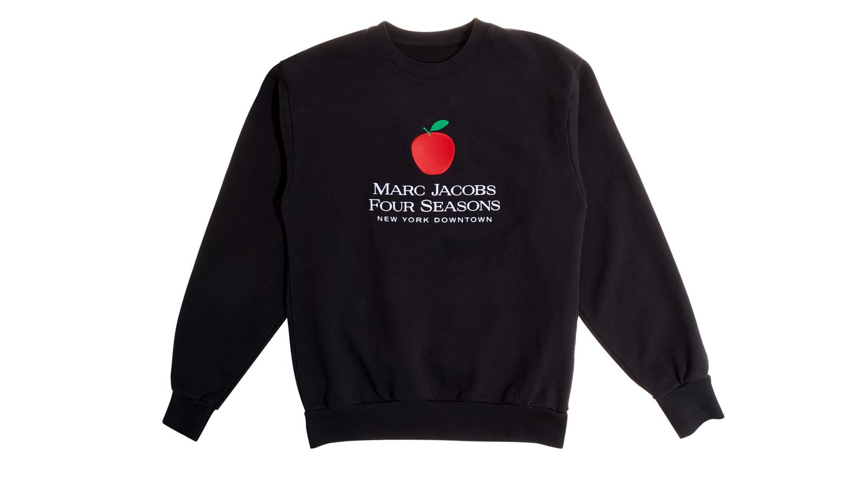 | September 9, 2019, New York, U.S.A.  Four Seasons Hotel New York Downtown Launches Limited-Edition Marc Jacobs Sweatshirt in Celebration of New York Fashion Week 2019  https://publish.url/newyorkdowntown/hotel-news/2019/fashion-week-marc-jacobs-sweater.html

PRESS CONTACTS

Kristi Blake
Director of Public Relations and Communications
27 Barclay Street
New York
U.S.A.
kristi.blake@fourseasons.com

+1 (646) 880-1917

