Four Seasons Hotel Tokyo at Otemachi Welcomes Keith Motsi as Head Bartender & Beverage Operations

August 2, 2022, Tokyo, Japan

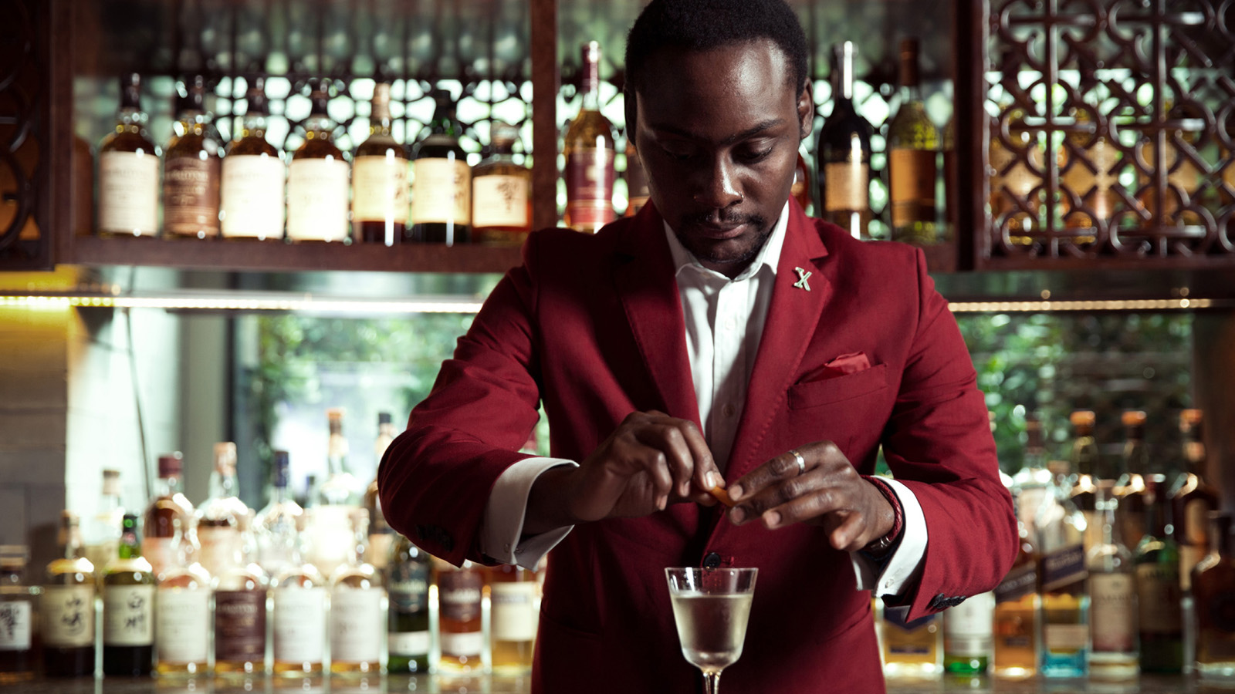
Fresh from a season of accolades and awards, Keith Motsi has been appointed Head Bartender & Beverage Operations at Four Seasons Hotel Tokyo at Otemachi. The role puts him in charge of the Hotel’s entire beverage operations, including VIRTÙ, the Paris-meets-Tokyo bar.
Bringing an intriguing blend of charisma and diligence, Keith is set to elevate the beverage scene in Tokyo with extraordinary drinking experiences. Here is a Head Bartender who does it all, from keeping a close eye on whether each guest is having a memorable time to putting on his dancing shoes on during lively nights – “regulars will soon know all my signature moves,” he laughs.
Every detail is important: Is it too cold? Are the lights just right? Is the music too loud? “Guests want a place that feels like home,” he explains. “Cocktails are key, of course, but people really come for the experience. If they order a glass of water, we’ll serve them the best water they’ve ever had.”
Also in the pipeline are drinks tailored to the Japanese palate, with Keith seeking to learn more about local tastes and preferences. The upcoming selection will add to VIRTÙ’s already-impressive attributes – from regularly updated micro-seasonal cocktails, to a world-leading collection of vintage French spirits and Japanese whiskies. Keith is also excited to host takeover nights with top mixologists from around Japan, as part of the ongoing Bar Masters series.
Storied and intricately crafted though they may be, the drinking experiences at Four Seasons Hotel Otemachi are ultimately fun. “People anticipate something serious at a luxury five-star hotel, but we bring in an element of entertainment,” says Keith. “At the end of the day, we are on stage. And every moment is showtime.”
Born in Zimbabwe and raised in England, Keith’s bartending journey has taken him around the world. Most recently, he served as Head Bartender at Charles H., the signature speakeasy at Four Seasons Hotel Seoul. During his tenure, both bar and bartender garnered several accolades, including the Altos Bartenders’ Bartender Award 2022 by Asia’s 50 Best Bars.
Prior to this, he led the opening of EQUIS, the signature bar at Four Seasons Hotel Beijing – within a year of operations, it was named Best Hotel Bar in China 2018 by Drink Magazine Asia. The early years of his career were spent in the UK, including at Soho House & Co, a prestigious members’ club in London, and SKIPPY’S Cocktail Bar, part of a renowned bar company in the north of England.
Growing up in a family that loved to cook and host large gatherings at home, young Keith gained an early insight into the art of creating a welcoming, joyful atmosphere. He first began working in a bar before he was old enough to serve alcohol – a part-time job at Jakes Bar & Grill in Leeds. It was love at first night. As he recalls, “People were celebrating, crying, falling in love, being nostalgic - the atmosphere was incredible. And the bartenders were the rock stars!”
Now in Tokyo, Keith has plenty keeping him busy when he is not behind the bar. To start with, he is on a Michelin marathon: “Japan has 203 Michelin starred restaurants, and I’m slowly working my way through the list.” As a rugby player, he is keen to dive into local rugby culture, both as a player and a spectator. He also plans to explore the country’s whiskey landscape and track down rare bottles to add to his collection back home in the UK.

RELATED

August 2, 2022, Tokyo, Japan
ヘッドバーテンダー兼飲料オペレーションにキース・モッツィが着任
https://publish.url/jp/otemachi/hotel-news/2022/new-head-bartender-keith-motsi-2.html

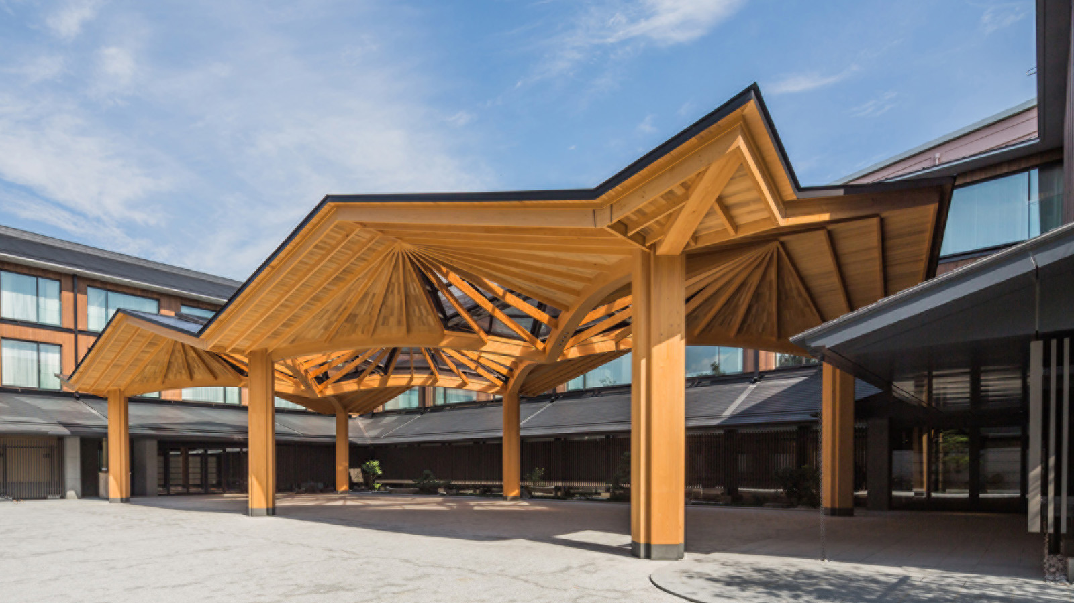 | July 26, 2022, Kyoto, Japan  坐禅やファミリーストレッチなど宿泊ゲスト向けの「ウェルネスアクティビティ」を開始  https://publish.url/jp/kyoto/hotel-news/2022/summer-wellness.html

PRESS CONTACTS

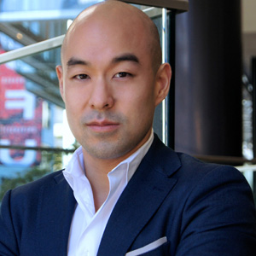 | Shingo Kido  Director of Public Relations and Communications  1-2-1 Otemachi  Chiyoda-ku, Tokyo  Japan  shingo.kido@fourseasons.com

