Say "I Do" on Bali's Longest Overwater Wedding Aisle at Four Seasons Resort Bali at Jimbaran Bay

Choose from new beachfront, oceanfront and treetop venues for the Ultimate Water Wedding at Four Seasons Resorts Bali, featuring a 57 metre (187 foot) overwater wedding aisle
March 15, 2018, Bali, Indonesia

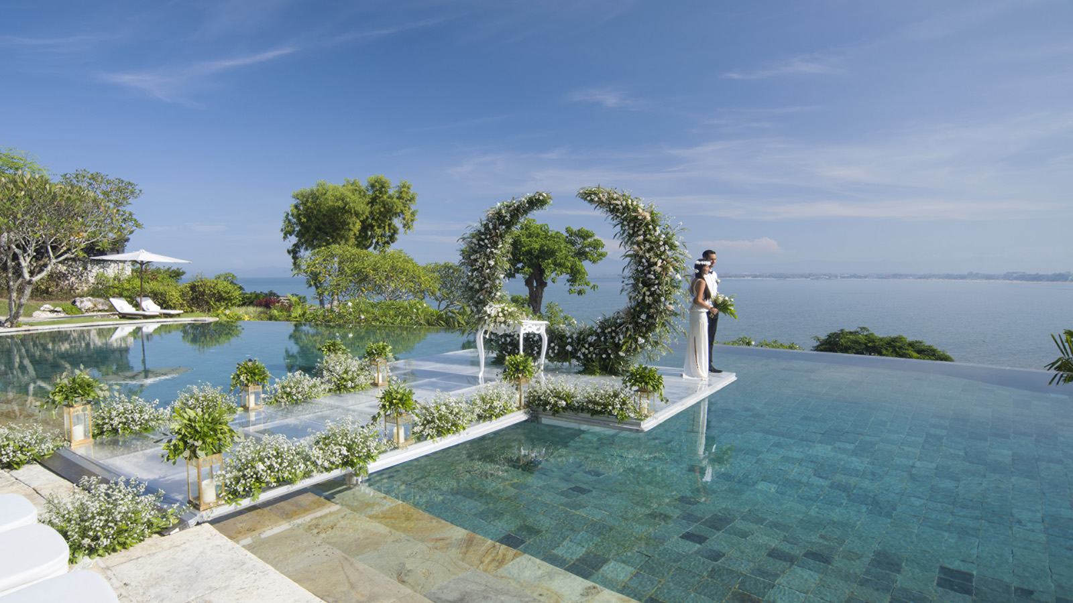
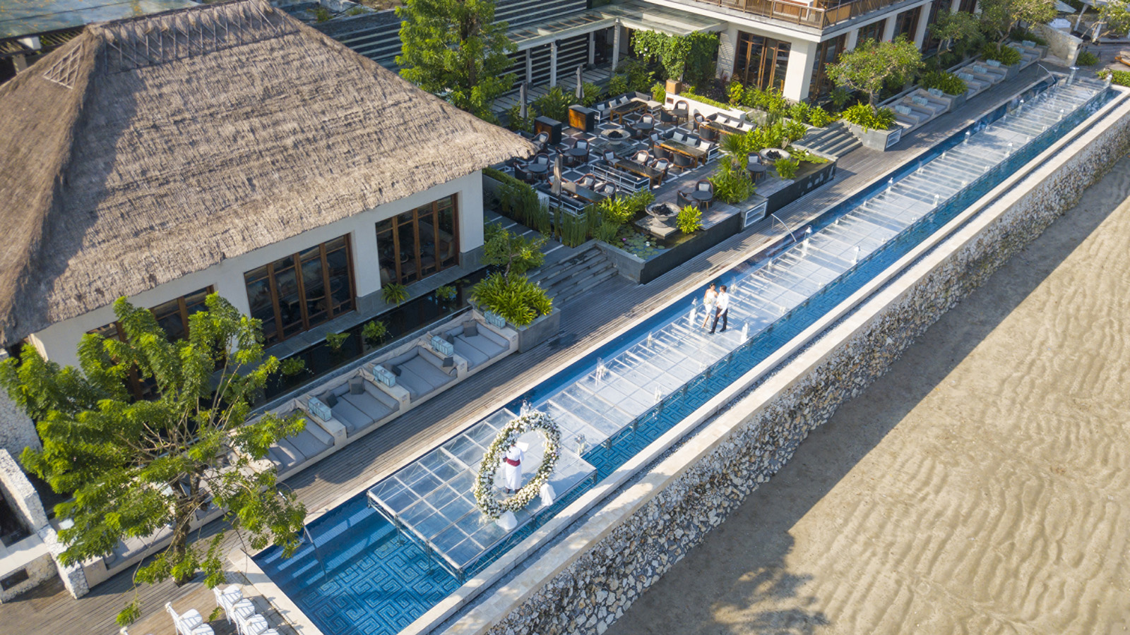 | 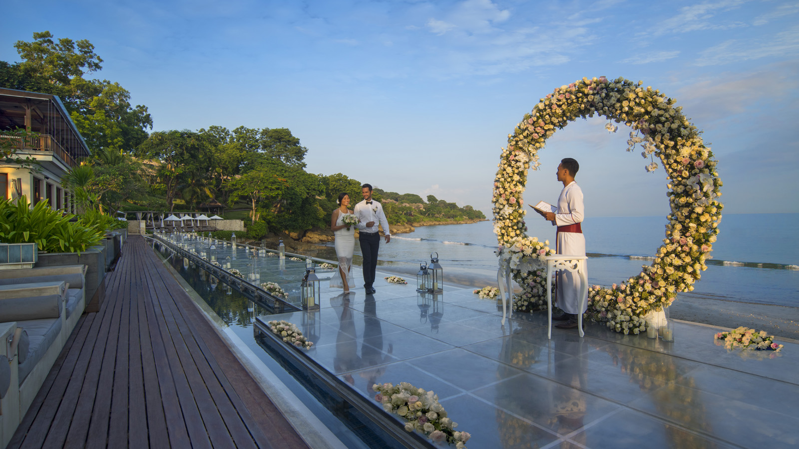 | 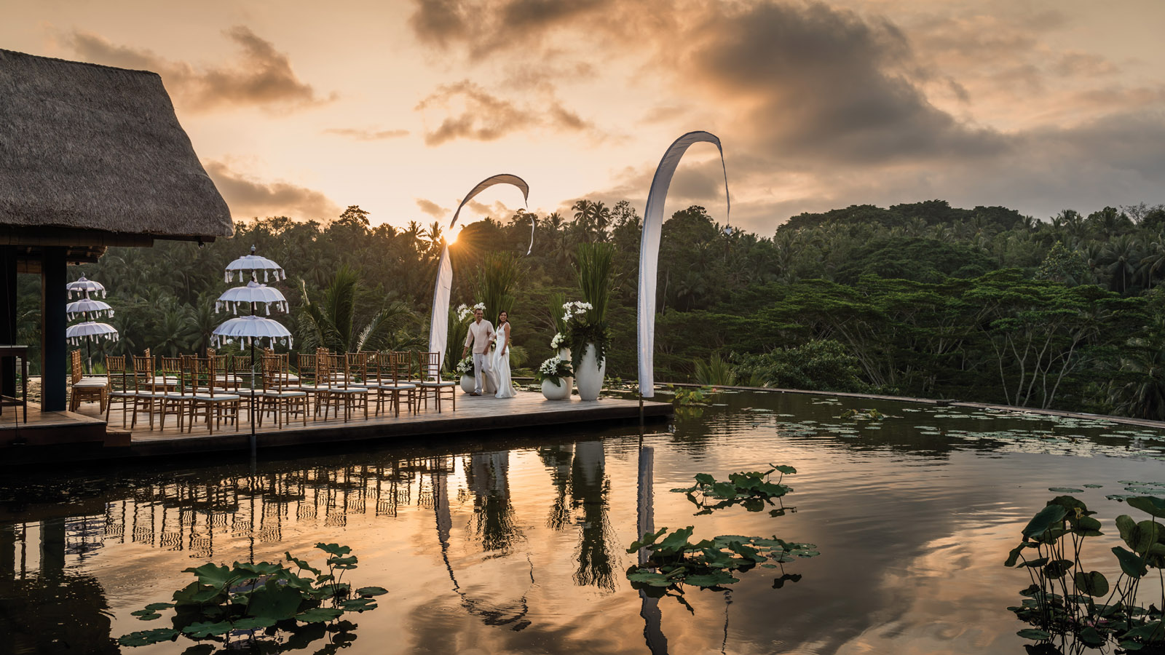
Why walk down the aisle when you can float? In its latest upgrade following completion of a two-year renovation,
Four Seasons
Resort Bali at Jimbaran Bay has launched new ocean-view water weddings including Bali’s longest overwater aisle, measuring 57 metres, or 187 feet.
The floating venues – launched as part of a new Ultimate Water Wedding Experience – maximise the Resort’s unrivalled views and exotic ambience. Located in a quiet corner of Jimbaran Bay, the all-villa beach retreat blends traditional Balinese architecture with chic sophistication and 14 hectares (35 acres) of tropical gardens cascading down to the turquoise ocean.
Couples can opt for elevated 180-degree sunset views as they exchange vows perched atop an infinity pool 35 metres (115 feet) above the sea; or a beachfront wedding at Sundara, the glamorous beach club featuring a 57-metre (187 foot) pool that can be transformed into the island’s longest floating aisle directly over Jimbaran’s golden sands.
Water weddings are the latest innovation following the complete renovation of 147 pool villas, redesigned and expanded to offer guests a fresh and modern take on authentic Balinese style. The most exclusive sanctuary is the 1,296 square metre (13,950 square foot) three-bedroom Imperial Villa, double its previous size to become the ultimate location for a wedding, reception and honeymoon in one idyllic venue.
The azure oceanfront settings at
Four Seasons
Jimbaran Bay are complemented by emerald green vistas at sister resort
Four Seasons
Sayan, nestled among ricefields and lush forest in Ubud’s highlands. Couples cross a beautiful suspension bridge between two rivers to exchange vows on an elliptical lotus pond, high above the trees with 360-degree valley views.
“Bali is a dream wedding destination offering both coastal and mountain backdrops, as well as convenient access from around the globe. Our new water weddings embrace Bali’s natural beauty to offer a dramatically different alternative to typical chapel or garden weddings,” says Uday Rao, General Manager of
Four Seasons
Resorts Bali. “At the same time, we have launched the Ultimate Water Wedding Experience for couples looking for absolute privacy, flexibility and creativity with a resort buy-out.”
The Ultimate Water Wedding includes a full five-night buyout of either
Four Seasons
Jimbaran Bay or
Four Seasons
Sayan, providing couples and their guests with exclusive benefits. The experience begins as soon as the couple lands in Bali with VIP airport arrival and transfer, ultra-luxe accommodations for all guests and dedicated service from the entire staff: 40 world-class chefs, 150 butlers and room attendants, and 30 spa therapists, recreation and wellness experts. The wedding day itself will be unforgettable with the ceremony held at one of the new water wedding venues, accompanied by a traditional blessing and vibrant Balinese dance performance. A unique gift of jewellery designed by John Hardy especially for the wedding couple makes the perfect memento of the Ultimate Water Wedding in Bali.
Whether they decide on a beach or mountain wedding, couples have one wedding specialist assigned as their dedicated point of contact from initial enquiry through to their big day, delivering seamless service with Four Seasons personalisation, efficiency and genuine care. The Resort’s wedding specialist also manages the process for couples to legally marry in Bali.

RELATED

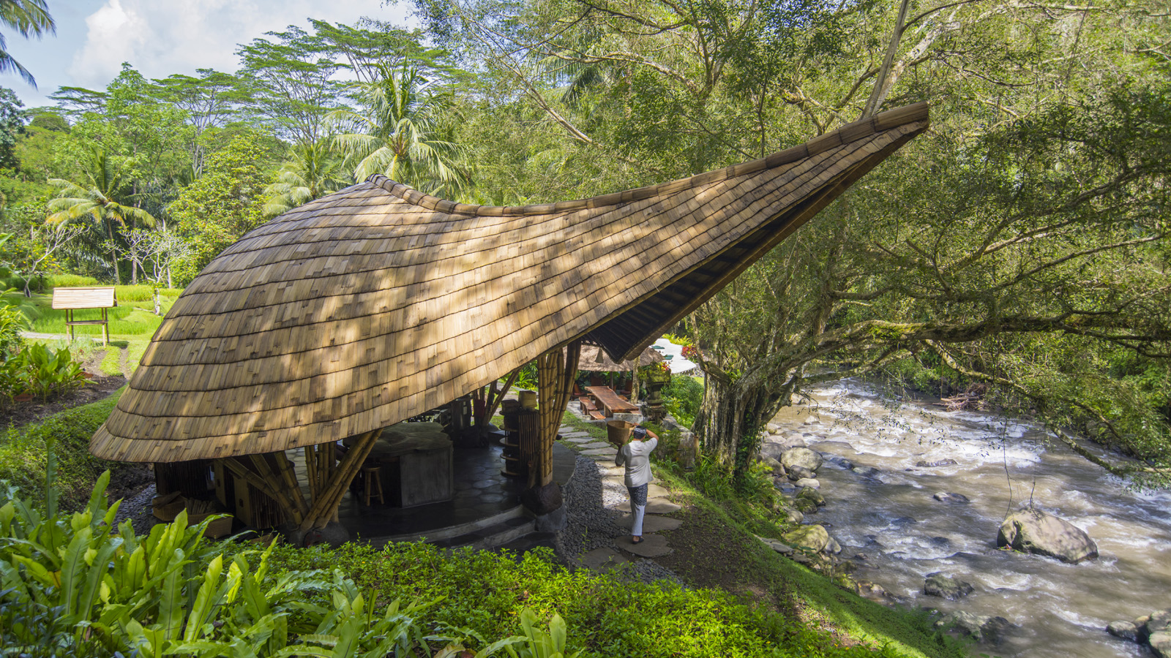 | February 20, 2018, Bali at Sayan, Indonesia  巴厘岛首个定制设计的河畔烹饪学校于山妍四季启幕  https://publish.url/zh/sayan/hotel-news/2018/new-sokasi-cooking-school-2.html
February 20, 2018, Bali at Sayan, Indonesia
Bali's First Custom-Designed Riverside Cooking School Opens at Four Seasons Resort Bali at Jimbaran Bay
https://publish.url/sayan/hotel-news/2018/new-sokasi-cooking-school.html

PRESS CONTACTS

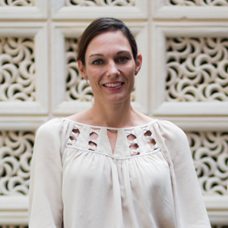 | Marian Carroll  Director of Public Relations  Jimbaran  Indonesia  marian.carroll@fourseasons.com  +62 (361) 701010

