Visually Inspired with Four Seasons Hotel DIFC

Four Seasons Hotel Dubai International Financial Centre will revive your artistic side with a list of five best art galleries in DIFC
April 26, 2021, Dubai, U.A.E.

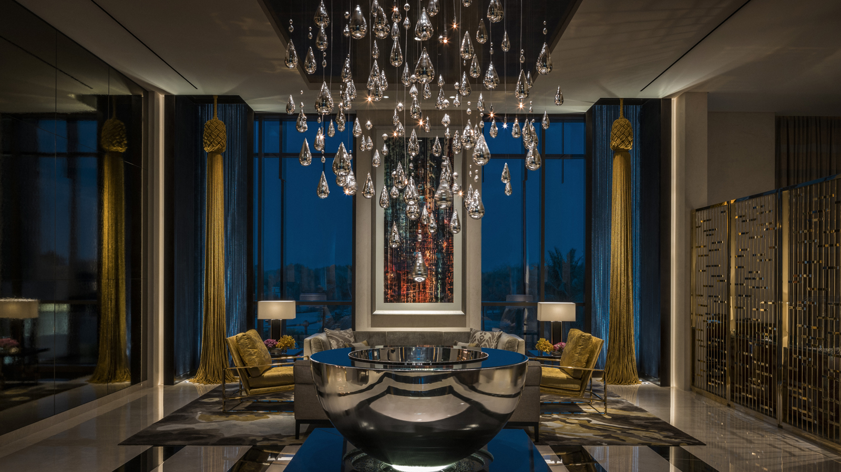
The best thing about being located in the middle of Dubai’s Art Hub? Having the best art galleries and exhibitions right at your doorstep. Whether you’re an art fanatic, an amateur, or just looking for something to do, at Four Seasons Hotel Dubai International Financial Centre we have prepared a list of the five best galleries for you to visit. It’s time: put your phone down, grab your Monet and let’s Gogh!
1. Opera Gallery
If you know your art galleries, you’ve definitely heard of Opera Gallery. Located all around the world in prime locations such as New York, London, Monaco, and Miami, Opera Gallery is one of the leading dealers and representatives of modern and contemporary art, and can be seen in our very own neighbourhood in DIFC.
Alongside its permanent exhibitions of well-known contemporary artworks such as those of Blek Le Rat and The London Police through collaborations with museums and other art centres in the world, the gallery puts on specific shows throughout the year. Some of these have included Warhol and Basquiat in Geneva and Picasso in Singapore, to name a few. Keep a close lookout and who knows, maybe the next one will be in Dubai?
Discover Opera’s pieces at Gate Village 03, between meals, as an afternoon activity, or if you’re just in need of a quick source of inspiration. The opening hours are the following:
- Sunday – Wednesday: 10:00 am – 10:00 pm
- Thursday: 10:00 am – 12:00 midnight
- Friday: 2:00–9:00 pm
- Saturday: 11:00 am – 9:00 pm
Contact Opera Gallery by calling: +971 4 323 0909.
2. The Farjam Foundation
Up next: a whole lot of installations and abstract work. If these are things you enjoy, The Farjam Foundation is a must for your visit in DIFC. Not only is it a modern and contemporary exhibition space with fun, eccentric works for you to admire, it is also a foundation that hosts tours and specialised programs with local universities and institutions to teach their audience about cultural differences in the Middle East.
Being a non-profit and non-governmental organisation, The Farjam Foundation’s aim is to create a diverse exhibition filled with colours, materials and nationalities of the artists they showcase. Some of these include Farhad Moshiri and Ahmed Moustafa, or if more European abstract work is what you strive to see, you can also find Henri Matisse and Gerhard Richter.
- Wander around the gallery and discover art mediums and artists you’ve never seen before at Gate Village, Building 10 on Sundays to Thursdays from 10:00 am to 8:00 pm.
Contact The Farjam Foundation by calling: +971 4 425 0400.
3. Christie's Gallery
In a world where significant events have shaped the course of history, such as the iconic moon landing and the game-changing invention of the internet, it's fascinating to know that this gallery's journey started long before, in 1766. Since then, Christie's evolved into a global hub with branches across Hong Kong, London, Shanghai, and more, including the one right at your doorstep in DIFC.
If you’re interested in learning more, some exhibitions present masterpieces from award-winning artists, such as Ibrahim El-Salahi, Inji Efflatoun, Hassan Sharif, and Mohamed Ahmed Ibrahim alongside other renowned art experts who enrich art diversity in the region.
- Christie's Dubai is open from 10:00 am to 7:00 pm on weekdays and it is located in Gate Village, Building 03, DIFC, Dubai. We invite you to visit their gallery's walls, where creativity and luxury converge to inspire you!
Contact Christie's Dubai by calling +971 4 425 5647.
4. Tabari Gallery
In the mood to learn more about the local culture? Tabari Gallery displays only Middle Eastern art, in the aims of sharing cultures, values and emotions of this part of the world to a more global audience. The gallery was established in 2003 and the name “Tabari” is a term coined to highlight the notions of borders, places and identities for greater cultural understanding.
Some of the artists exhibited include Middle Eastern artists such as Mohamed Abla, Hussein Madi, Samah Shihadi and works from Naqsh Collective. Our personal favourite? Michael Halak’s orange piece named Collision, hidden behind the gallery’s stairwell.
- Discover Tabari Artspace, located at Gate Village 03, Level 2 and open from Sunday to Thursday from 10:00 am to 6:00 pm. Join us and immerse yourself in a spectrum of cultures.
Contact Tabari Gallery by calling: +971 4 323 0820.
5. Sconci Gallery
Last but not least, is Sconci Gallery, known for offering its audience a wide range of art mediums from the seventeenth century and onwards. Founded in 1977 in Rome, the Sconci Family have taken on UAE as their second home, with already two galleries in Dubai, one in DIFC and the other in Dubai Design District.
The mix of modern and contemporary art it presents includes some of the works of Picasso, Andy Warhol, GUMM, Mr. Brainwash and many, many more. Some of the artworks can be purchased and for each piece that is sold, it is additionally accompanied by a certificate of authenticity for its lucky new owners to keep record of.
- The gallery is a mix of vibrant colours, culture and textures located right in the middle of DIFC at Gate Village 03. Sconci Gallery is open from 10:00 am to 11:30 pm on weekdays and from 11:00 am to 11:30 pm on weekends. Visit and be visually inspired. We’re sure you’ll Louvre it!
Contact Sconci Gallery by calling: +971 4 589 6513.

RELATED

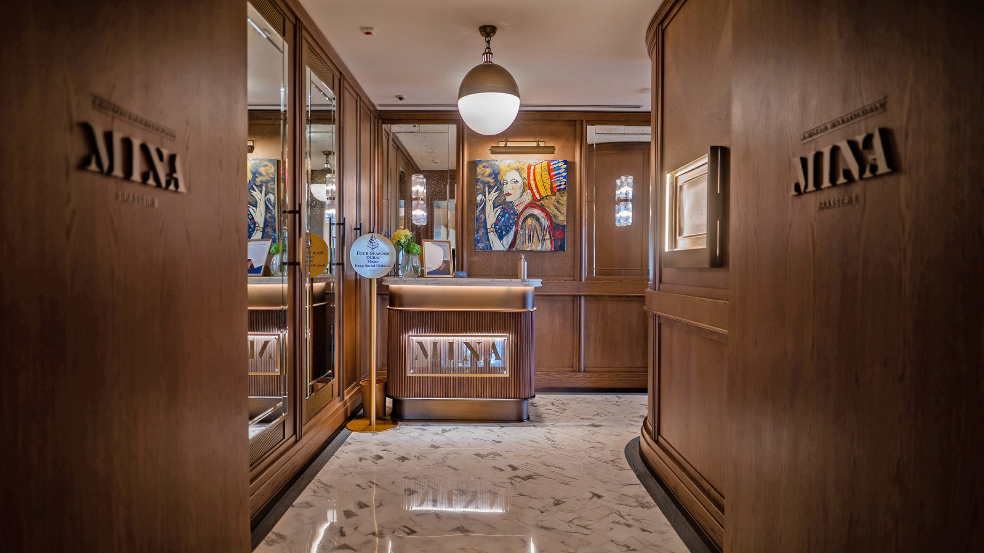 | September 5, 2023, Dubai, U.A.E.  Mina Brasserie at Four Seasons Hotel DIFC Introduces Urban Chic Brunch  https://publish.url/dubaidifc/hotel-news/2023/mina-brasserie-saturday-brunch.html
May 30, 2023, Dubai and Abu Dhabi, UAE
Embracing Harmony and Kindness to Oneself on Global Wellness Day 2023 with Four Seasons UAE Collection
https://publish.url/dubai/hotel-news/2023/global-wellness-day-dubai-abu-dhabi.html

PRESS CONTACTS

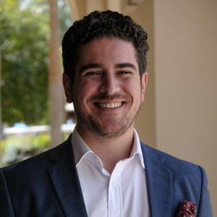 | Ghaith Adnan  Assistant Director of PR and Communications  Jumeirah Road  Dubai  United Arab Emirates  ghaith.adnan@fourseasons.com  + 971 4 270 7884

