Four Seasons Hotel Prague Unveils Christmas and New Year Program

Four Seasons Hotel Prague is preparing a magical program of seasonal feasts, traditional Bohemian decoration-making workshops, spa treatments and festive afternoon tea, culminating in a dazzling New Year Party
October 3, 2018, Prague, Czech Republic

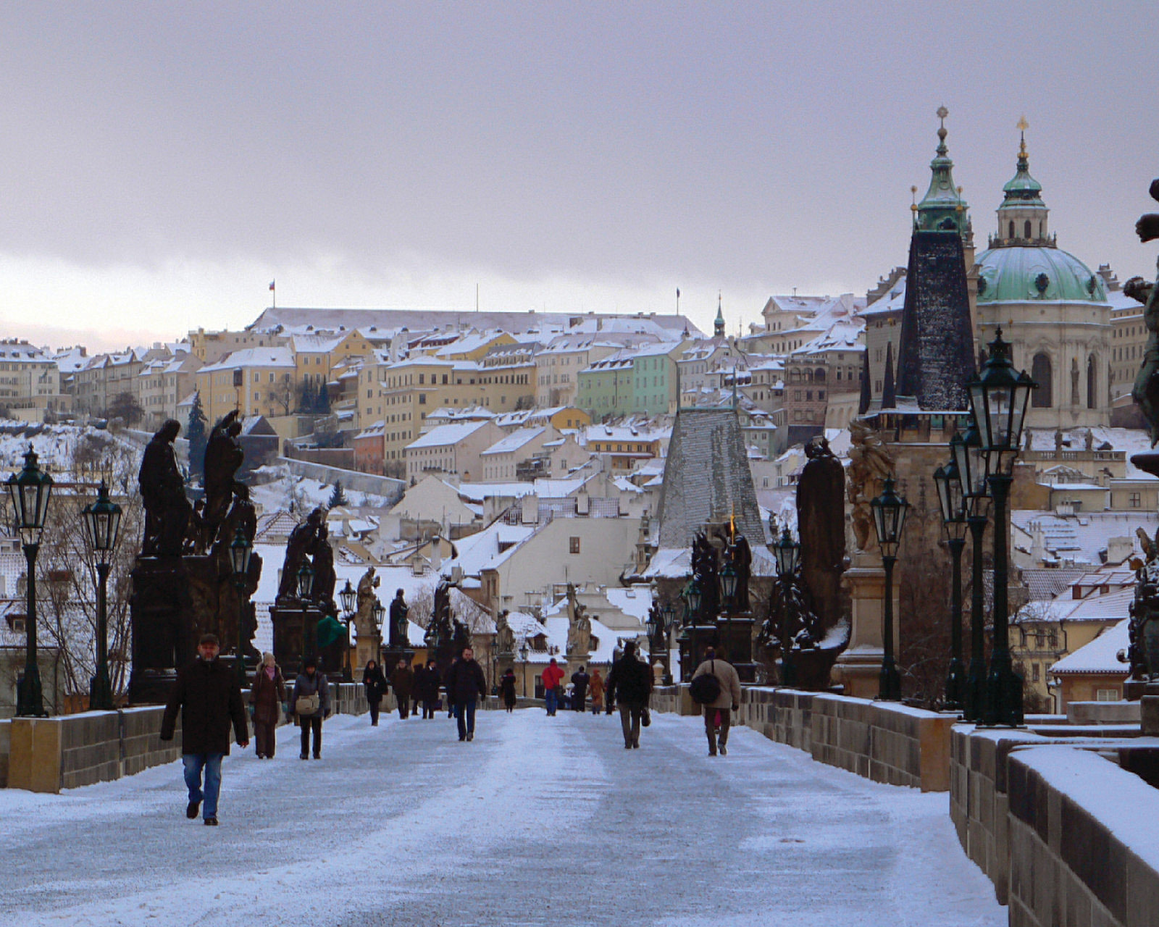
 | 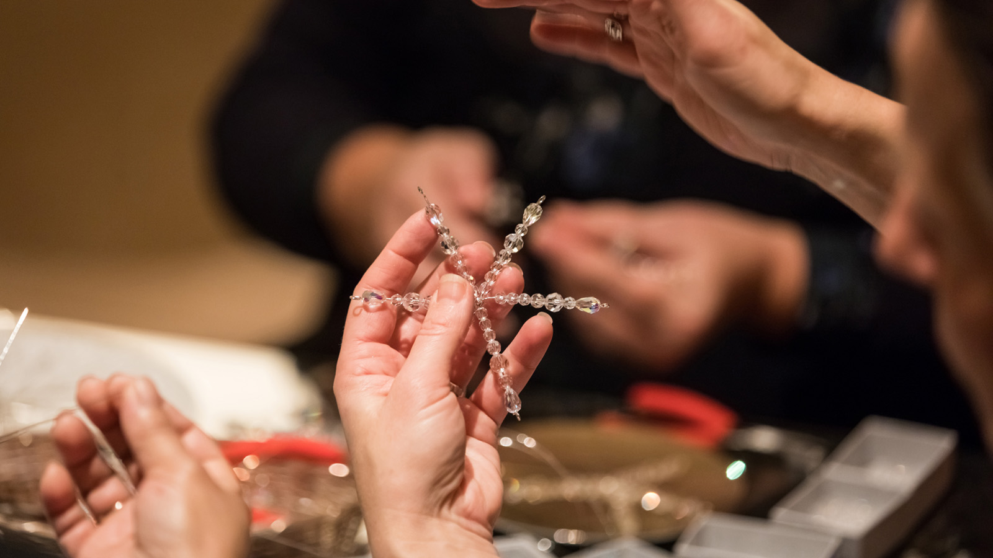 | 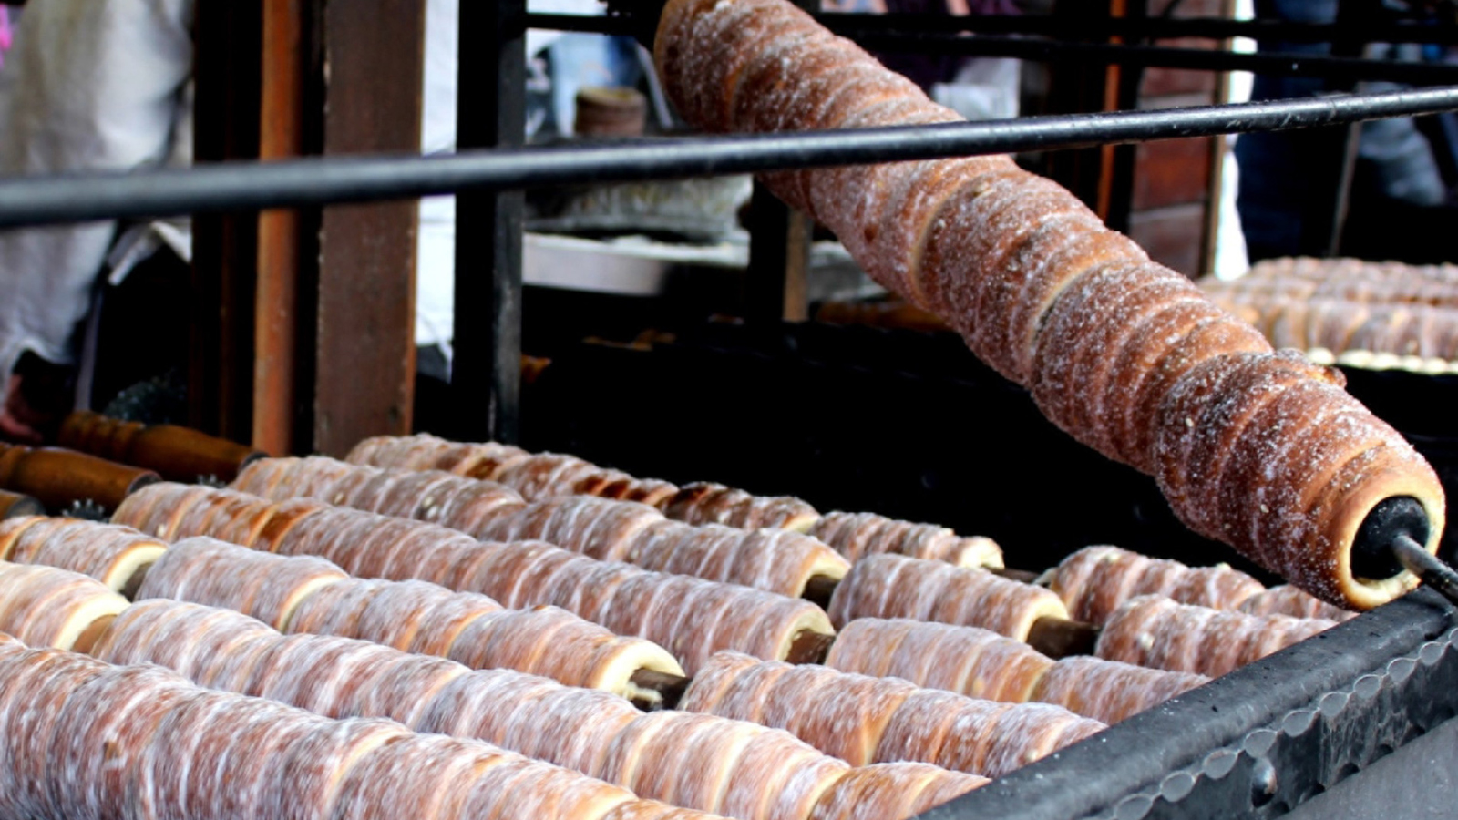
Four Seasons Hotel Prague unveils its festive program for Christmas and New Year, from shopping the famous Christmas Markets to special holiday menus, spa treatments and more.
Winter Prague: Markets and Mulled Wine
Prague is the perfect winter escape. The cobbled streets, mulled wine, roasted chestnuts, atmospheric concerts and exhibitions are the perfect Christmas dream. Perhaps the biggest highlight are the infamous Christmas Markets – all centred on the historically beautiful Old Town with its fairy-tale spires and picturesque buildings. The Markets are the essence of seasonal wonder in the city and Four Seasons Hotel Prague has created its own special Prague Christmas Markets package. After being collected from the Hotel by a horse-drawn carriage guests will be whisked away to the Old Town Market for an unforgettable shopping trip. Guests can soak up the atmosphere over a glass of mulled wine and roasted chestnuts or pick up a traditional gift for their loved ones. This offer requires a two-night minimum stay and is available from November 30 until December 29, 2018.
Live Piano and Tea for Two
Four Seasons Hotel Prague guests and visitors are invited to curl up and get cosy by the fireplace in The Gallery Lounge. Every day, exquisite Czech Festive Tea will be served with traditional Christmas cookies, mulled wine and hot chocolate. On Thursdays, Fridays and Saturdays from 2:00 to 5:00 pm (except December 24, 2018) guests will be treated to live piano performances.
Preciosa Glass Christmas Decorations
Four Seasons Hotel Prague guests are invited to join craftsmen from the renowned Czech glass maker Preciosa each Friday afternoon from 4:00 to 6:00 pm in the beautiful lobby, where they will demonstrate how to create the company’s signature snowflake decoration. Guests are invited to participate in the workshop and produce their own decorations by Preciosa to take home as a keepsake.
Sumptuous Feasts
Christmas Eve, December 24, is when CottoCrudo starts its seasonal offerings for guests. From 4:00 pm, Christmas carols sung by a children’s choir will ring through the lobby while guests sit back and listen while being treated to roasted chestnuts and Gianduja hot chocolate. Afterwards guests can experience a succulent four-course menu in the exquisite CottoCrudo restaurant.
On Christmas Cay, December 25, CottoCrudo will serve a special Christmas Lunch and Dinner menu.
Advent at AVA Spa
A serene Advent atmosphere awaits guests at the Hotel's AVA Spa, which features five treatments rooms, including a couple’s suite or spa bath with a stunning view of Prague. Surrounded by comfortable loungers and a fireplace, the vitality pool area forms the centrepiece of the AVA Spa. In addition to one-time visits, guests can buy an annual membership or gift certificates for all facial and body treatments.
During the festive season, Four Seasons Hotel Prague is offering an exclusive seasonal treatment, the Crystalus Body Massage. The sensory massage is a delight for the mind, body and spirit. Using healing Australian tiger iron stones to deliver Sodashi’s signature massage technique, it also draws on the energetic qualities of prehnite, rhyolite, chrysoprase, mookaite, jasper and amethyst to balance the chakras. Combined with Sodashi’s unique blend of Australian plant essences, the massage and crystal vibrations work to restore complete relaxation and harmony. The healing tiger iron stone is made up of layers of tiger eye, jasper and hematite. Found in Western Australia, tiger iron is one of the most energetically grounding stones and it emanates a strong, calming flow of life force energy. It boosts the circulation of blood, lymphatics and chi, and also increases vitality and mental clarity. The Crystalus Body Massage lasts 90 minutes and is priced at CZK 6,800 per person.
Bringing in the New Year
Guests are invited to bring in the New Year at Four Seasons Hotel Prague in style. From 7:00 pm Champagne will be flowing in the lobby. The elegant evening features a Gala dinner with a delicious dinner menu and a fantastic live jazz music program at CottoCrudo Restaurant that will entertain guests till the early hours of the morning. It will surely be a night to remember.

RELATED

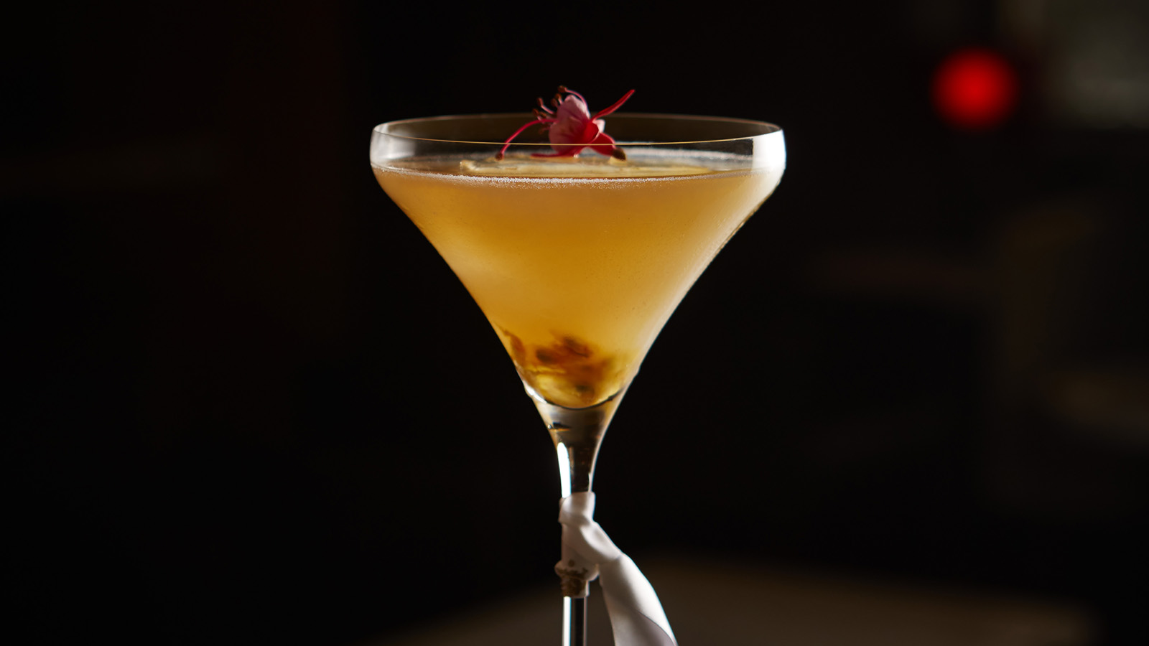 | July 31, 2018, Prague, Czech Republic  Four Seasons Hotel Prague představuje nové letní koktejly  https://publish.url/cs/prague/hotel-news/2018/summer-cocktail-collection-2.html
July 31, 2018, Prague, Czech Republic
Four Seasons Hotel Prague Introduces New Summer Cocktail Collection
https://publish.url/prague/hotel-news/2018/summer-cocktail-collection.html

PRESS CONTACTS

Martina Vavrova
Director of Public Relations
Veleslavínova 2A/1098
Prague
Czech Republic
martina.vavrova@fourseasons.com

420 221 426 615

