Introducing the Taste of Anguilla Culinary Experience by Four Seasons Anguilla Executive Chef Emmanuel Calderon

Delight in culinary exploration with the Resort’s Taste of Anguilla experience guided by Executive Chef Emmanuel Calderon - offering an inside look into the island’s natural splendour and most abundant natural resource, salt
May 23, 2023, Anguilla, West Indies

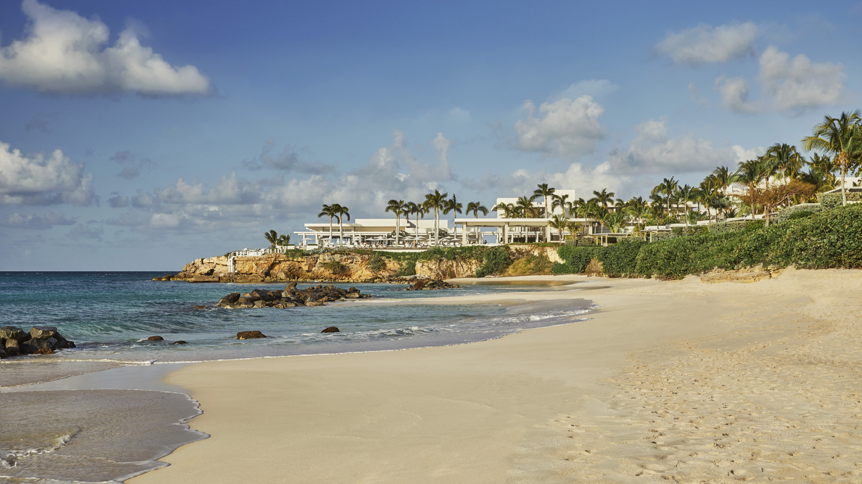
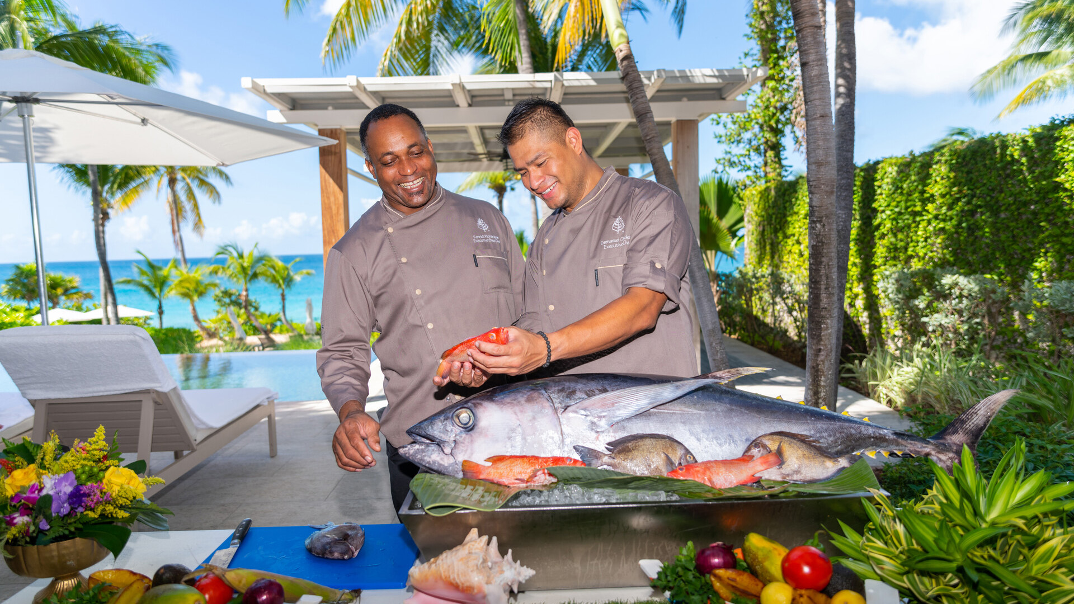
Four Seasons Resort and Residences Anguilla introduces Taste of Anguilla, the Resort’s exciting new culinary experience curated by Executive Chef Emmanuel Calderon. The new offering is exclusively available to Resort guests and provides an inside look at how the island’s most abundant natural resource, salt, is harvested, where the salt is harvested from, and the many ways salt is used in traditional Caribbean cuisine.
Revered as the gastronomic capital of the Caribbean, Anguilla is beloved for its untouched beaches and peaceful island culture, but most notably, for its exceptional culinary scene. Through the Taste of Anguilla experience, the Resort hopes to educate guests on Anguilla’s natural bounty, highlight the flavours and dishes of the Caribbean, and offer a new and engaging way to get acquainted with the soul of the island through food.
Executive Chef Emmanuel Calderon’s culinary philosophy is to “keep dishes simple and let the ingredients do the talking.” This authentic epicurean experience honours Chef’s practice and showcases the wonder of salt, the key ingredient in most culinary endeavours, savoury or sweet.
Highlights of the Taste of Anguilla experience include:
- A visit to one of Anguilla’s seventeen magnificent salt ponds accompanied by Executive Chef Emmanuel Calderon where participants will be shown how to harvest salt.
- A visit to Vinty’s Garden, a local produce vendor that supplies fruits and vegetables to the Resort’s main food and beverage establishment, SALT, whereby guests will select fresh produce to enjoy with breakfast on location and with dinner in the evening.
- The experience will culminate with cocktails at SALT where Executive Chef Emmanuel Calderon will demonstrate how to fillet the local catch of the day and make his signature ceviche seasoned with salt and garnished with the vegetables harvested at Vinty’s Garden.
Escape to the stunning Caribbean island of Anguilla and discover a world of tranquillity, luxury, and curated experiences. With its pristine beaches and world-class dining options, this hidden gem is the perfect destination for a summer getaway. By way of American Airlines' twice-daily direct flights from Miami, getting to Anguilla has never been easier. Plus, with the Resort's Discover Anguilla offer, guests can enjoy a complimentary fifth night including daily breakfast. Book now through December 15, 2023, and experience the ultimate Caribbean vacation.

RELATED

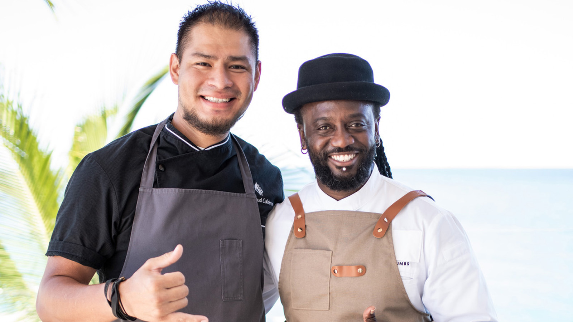 | May 5, 2023, Anguilla, West Indies  Four Seasons Anguilla Announces Esteemed Lineup of Culinary, Mixology and Sports Programs for Summer Season  https://publish.url/anguilla/hotel-news/2023/summer-programming.html
April 4, 2023, Anguilla, West Indies
Four Seasons Anguilla Adds to Extraordinary Roster of Spring Offerings
https://publish.url/anguilla/hotel-news/2023/april-programming.html

PRESS CONTACTS

Cara Chapman
US Director of PR, Bacchus Agency
121 West 27th Street, Suite 304
New York
USA
cara@bacchus.agency

+1 646 992 3567

