From Our Four Seasons Family to Yours: Four Seasons Hotel Washington, DC Shares Love of Hospitality with Tips to Recreate the Experience at Home

March 27, 2020, Washington, DC, U.S.A.

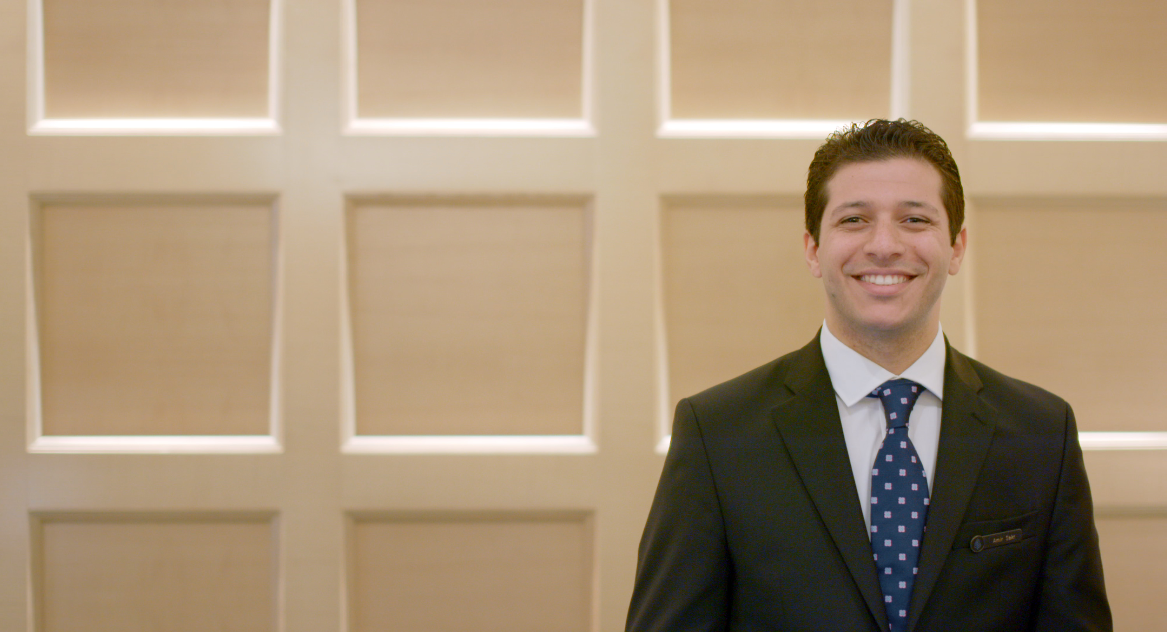
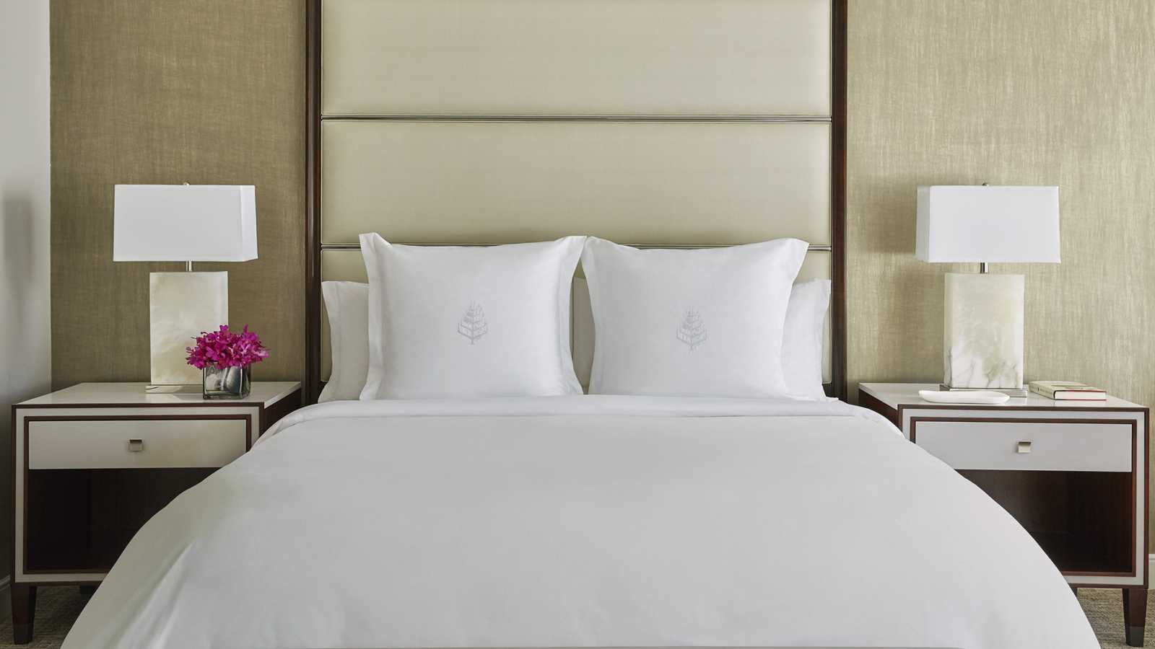 | 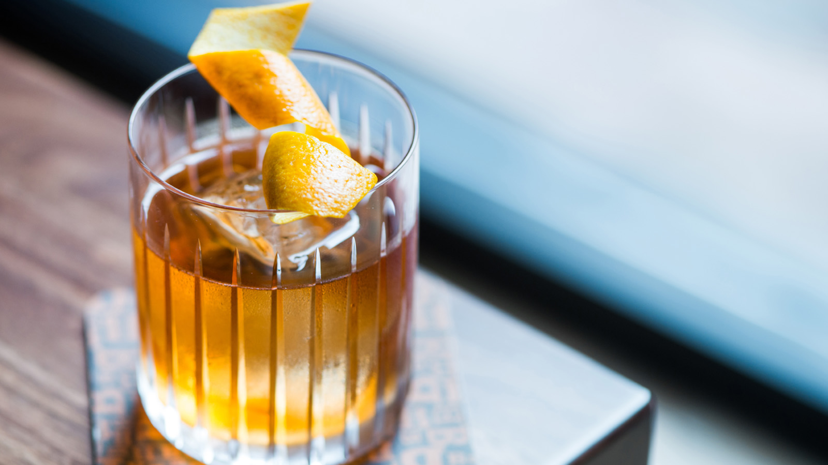 | 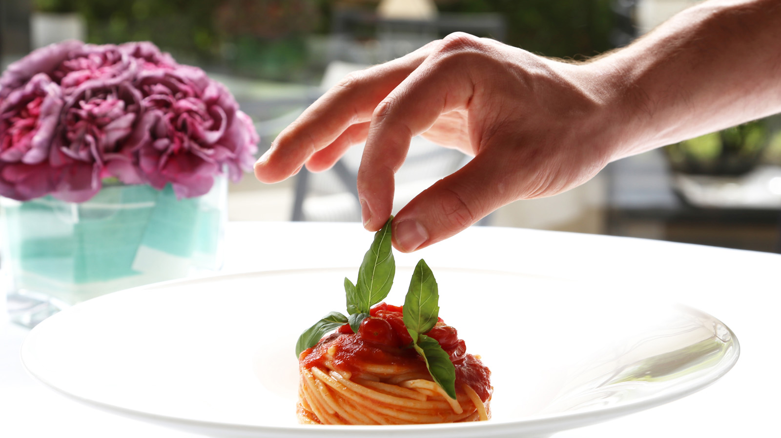
The family at Four Seasons Hotel Washington, DC is honoured to share a collection of professional hospitality tips entitled “From Our Four Seasons Family to Yours” to help recreate a little of the Four Seasons magic at home.
Regional Vice President and General Manager David Bernand says, "It is in times of adversity that we are reminded of who we are. We are hoteliers. We have always been and we will continue to be. In these incomprehensible, unprecedented times, I am so grateful for the strength and community spirit of our team, our Four Seasons family. Collectively, we will get through this. At a time when many of our guests are not able to experience first-hand what makes a stay at Four Seasons Hotel Washington, DC so exceptional, we hope to share a little of our craft with you."
Over the coming weeks the team of Four Seasons Hotel Washington, DC will be sharing their tips of the trade in a social media series entitled "From Our Four Seasons Family to Yours" to allow their community to create the Four Seasons Hotel Washington, DC experience at home.
The team has spent thousands of hours perfecting the process of making a bed, adding thoughtful touches to the everyday, cooking comforting foods and baking delightful desserts - in this series they will be sharing their secrets.
Over the next few weeks follow along on @fswashington to learn:
- Regional Vice President and General Manager David Bernand's recipe for chouquettes - a pastry favourite served at the Hotel originating from his grandfather’s bakery in rural France
- Famed Chef Michael Mina’s recipe for BOURBON STEAK’s famous truffle mac & cheese
- Executive Chef Sebastien Giannini's tomato pasta sauce recipe - a room service favourite - the recipe was passed down to him from his grandmother who lives in the south of France
- Housekeeping Director Brad Harrell's tips for making a bed, Four Seasons style
- Food and Beverage Director Christian Storck's favourite cocktail recipe
- Spa Director Nabil Gomes' tips for making an at-home facial
- Learning Manager Sylvie Balenger's tips for creating the nightly turn down service for your family
- Pastry Cook Dana Bloom’s recipe for Seasons banana chocolate muffins
Four Seasons Hotel Washington, DC is Washington’s first and only Forbes Five-Star, AAA Five-Diamond hotel. The 222-room Hotel is situated in historic Georgetown and within walking distance to some of the city’s most iconic monuments and sites. The Hotel remains open, with limited services and in respect of the latest government guidelines, to accommodate guests that need to come to DC. For more information, visit the Hotel's website or call +1 202 342 0444.

RELATED

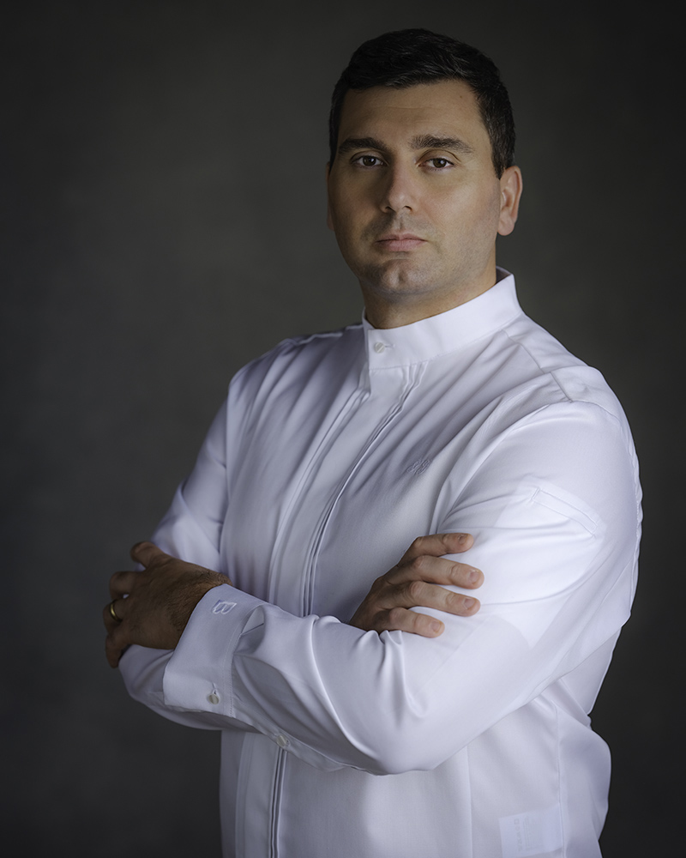 | February 7, 2020, Washington, DC, U.S.A.  Four Seasons Hotel Washington, DC Appoints Sebastien Giannini as Executive Chef  https://publish.url/washington/hotel-news/2020/new-executive-chef-sebastien-giannini.html
February 3, 2020, Washington, DC, U.S.A.
Four Seasons Hotel Washington, DC Invites Couples to Luxuriate in Love This February with Tailor Made, Romantic Offerings Ranging from Lovely to Luxe
https://publish.url/washington/hotel-news/2020/valentines-day.html

PRESS CONTACTS

Anina Belle Giannini
Director of Public Relations
2800 Pennsylvania Avenue N.W.
Washington
U.S.A.
aninabelle.giannini@fourseasons.com

+1 202 944 2074

