Wedding in the Woodlands

October 13, 2015, Orlando at Walt Disney World Resort, U.S.A.

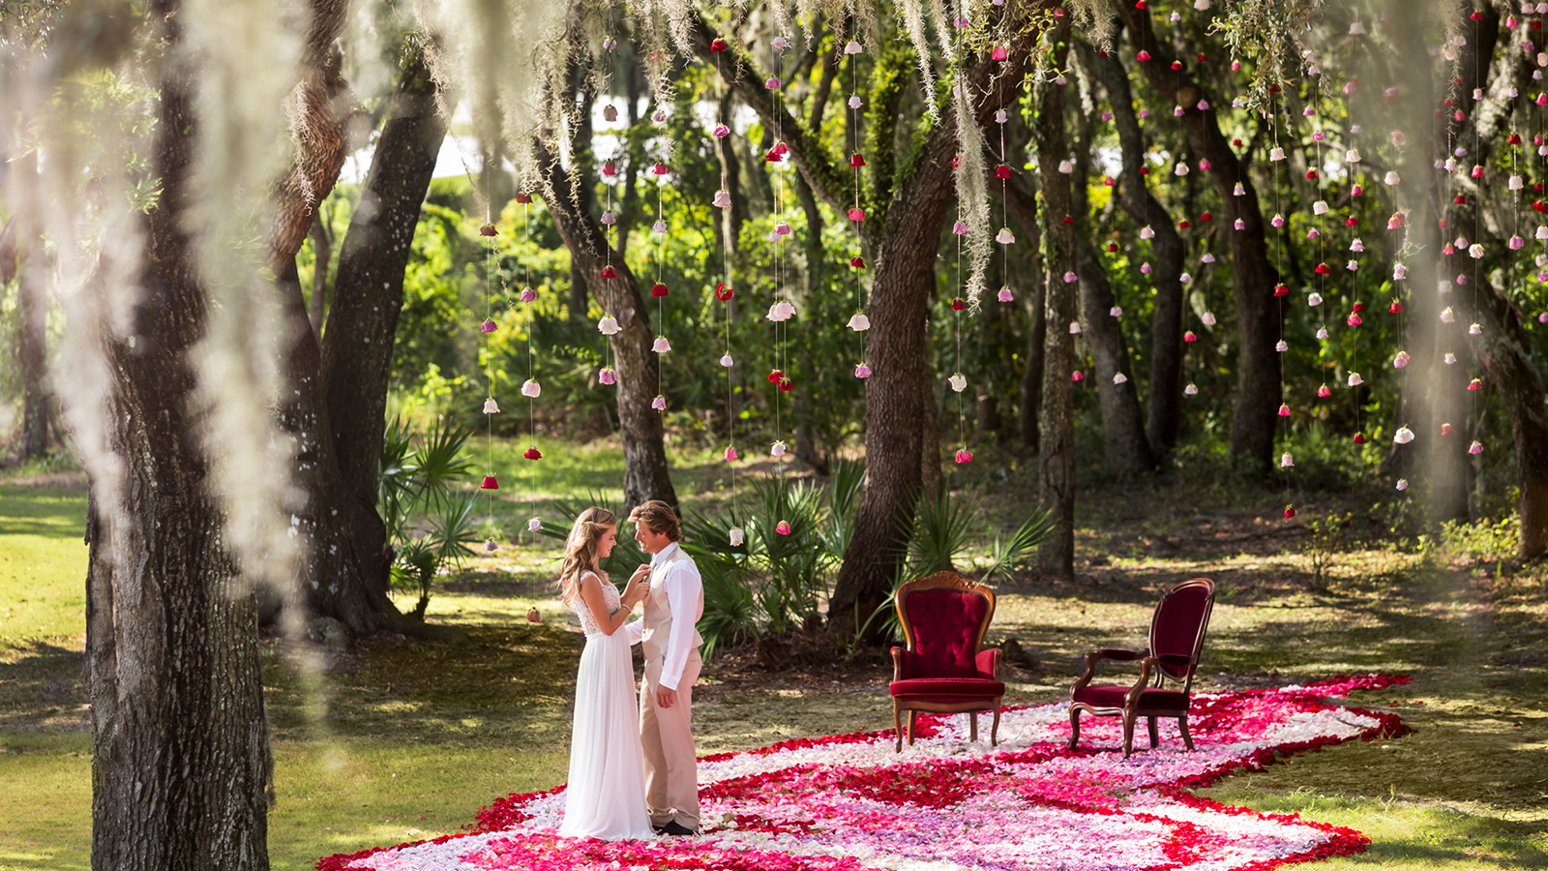
It’s no wonder many couples desire a woodland wedding, as a quiet, naturally beautiful setting is ideal to say “I do.”
With a 26-acre (10.5 hectare) setting surrounded by natural wetlands and many mature trees, including gorgeous live oaks with delicate Spanish moss,
Four Seasons
Resort Orlando has several options for those who want a woodland wedding with a touch of modern luxury. The Resort’s event spaces give brides and grooms the “something new" with the new, immaculate facilities, including pristine event lawns and stunning ballrooms with floor-to-ceiling windows. The “something old” is the Resort grounds, with many established trees dotting the meticulously maintained landscape. For a woodland wedding, the “something blue” at
Four Seasons
Resort Orlando is the blue sky, typically featuring picture-perfect billowing clouds. For the “something borrowed,” couples can opt to “borrow” a tree branch to decorate with floral garland or hang place cards or lanterns. The picturesque setting is truly magical, offering couples a luxurious wedding that has just the right touch of woodland chic.

RELATED

March 27, 2017, Orlando at Walt Disney World Resort, U.S.A.
Experience the Ultimate Summer Vacation at Four Seasons Resort Orlando
http://publish.url/orlando/hotel-news/2017/summer-vacation.html

March 27, 2017, Orlando at Walt Disney World Resort, U.S.A.
Férias com ofertas especiais no Four Seasons Resort Orlando
http://publish.url/br/orlando/hotel-news/2017/summer-vacation-2.html

PRESS CONTACTS

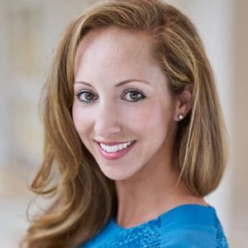 | Dana Berry  Director of Public Relations  10100 Dream Tree Boulevard  Orlando  U.S.A.  dana.berry@fourseasons.com  1 (407) 313-7777

