Four Seasons Resort and Residences Whistler Launches the Ultimate Whistler Residential Package

Alpine home away from home: ultra-spacious accommodations, skiing with an Olympian, private chef experiences and luxe touch points guests love
October 18, 2017, Whistler, Canada

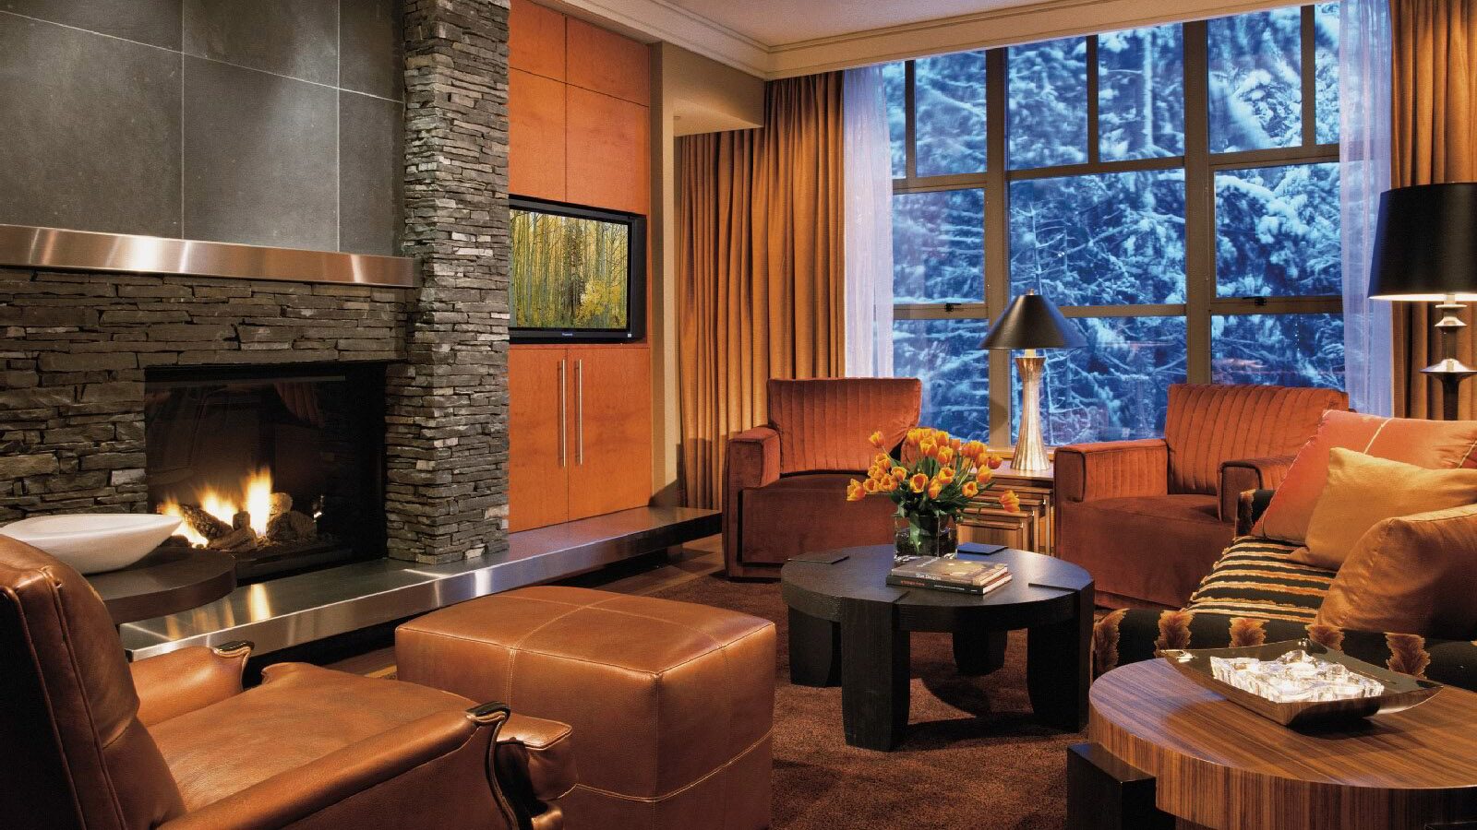
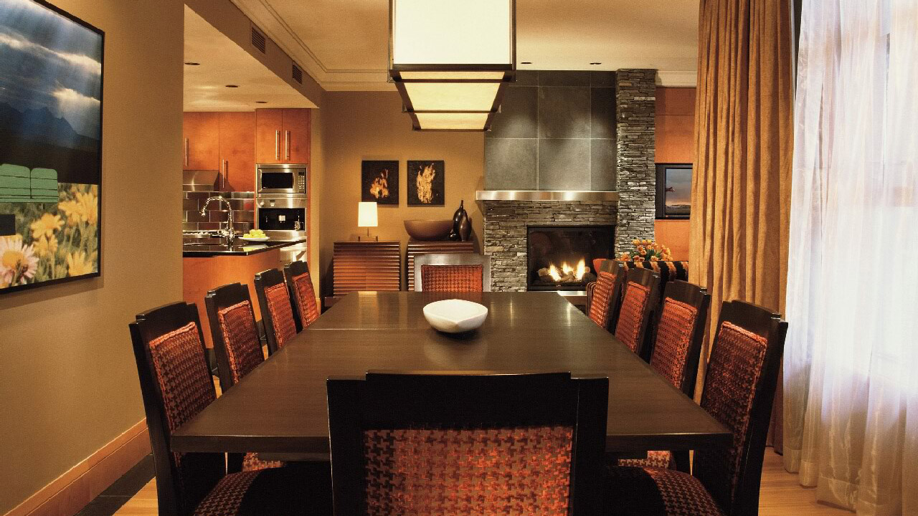 | 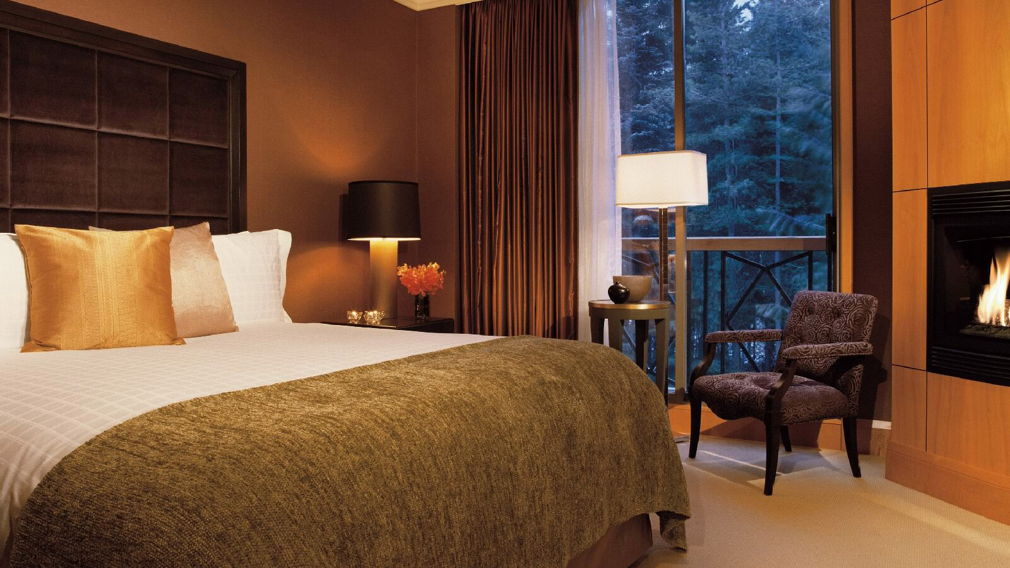 | 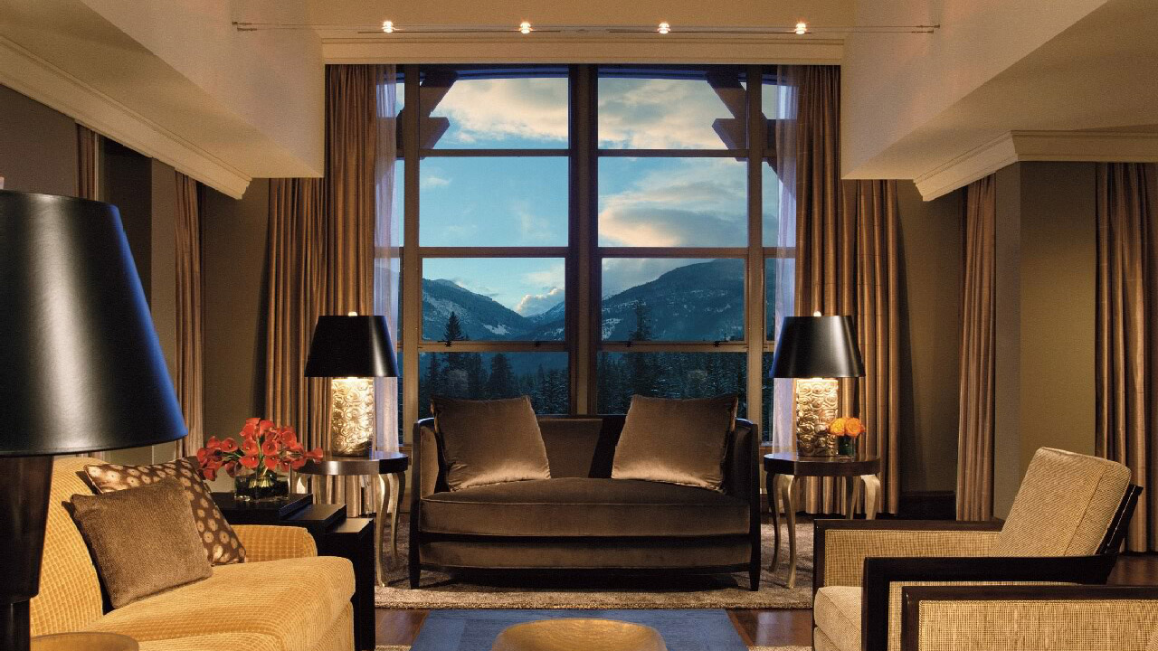
The Residences at
Four Seasons
Resort and Residences Whistler are the essential mountainside locale to experience true luxury in Canada's most exclusive mountain resort. Perfect for family vacations, longer stays and throwing fabulous parties and gatherings, The Residences offer both luxury and privacy to maximise leisure time. The new Ultimate Whistler Residential package elevates the experience even further with the option of a private chef experience or skiing with an Olympian, along with a daily breakfast at SIDECUT, a welcome gift, seamless transfers and more.
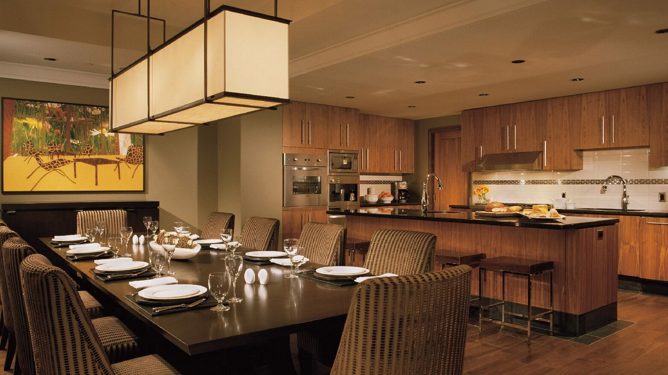
After touchdown in beautiful British Columbia, home of the 2010 Winter Games, guests are invited to sit back and enjoy a private luxury transfer along the picturesque Sea-to-Sky highway. The epic landscape is sure to inspire guests to get outdoors and retrace the steps of Canada’s record number of Olympic medalists. Upon arrival at the multi-lingual Resort, tucked in the hills of Blackcomb mountain, guests will receive a “Taste of BC" amenity basket highlighting the best purveyors and artisans from the region. Opt in to “Fill the Fridge” for a warm welcome of two, three or four bedroom Residence full stocked with family favourites. With more than enough room for the whole family, kids, parents and grandparents will enjoy a vacation that strikes the perfect balance of adventure, excitement, relaxation and connection.
Next, the hardest choice of the day will be whether to experience hitting the slopes with a local Olympian or sitting down to a three-course dining experience with a well-known local chef without leaving the luxurious kitchen and dining area of the private Residences. Guests can enjoy an insider’s look of what their Residence stay will include by checking in with Pet-in-Residence Maola’s artistic debut here.
Ski with an Olympian
Whistler Village was the global stage for many of the winter sport competitions during the 2010 Winter Games. As the world watched, Canada captured many of its gold medals on the hills of Whistler Blackcomb. Today, teams from countries all over the world visit year-round to train and compete on these world-class venues for future competitions including the Olympic and World Cup circuits.
Make like an elite athlete and spend the day “Skiing with an Olympian.” Groups of up to four people get a chance to ski and après with Whistler Olympian Robbie Dixon. Follow in Dixon’s tracks, get tips on technique and hear stories of his time to shine for Canada in 2010. As part of Whistler Blackcomb’s Ski or Ride with an Olympian program,
Four Seasons
Resort Whistler has a dedicated relationship with Dixon exclusively for guests.
Whistler has always held a special place in Robbie Dixon’s heart. As a local, Dixon takes a great sense of pride in guiding his guests around his "backyar"d where he grew up. He loves seeing the satisfaction and pure enjoyment of guests exploring the mountains and skiable terrain. “Whether it’s hot laps on 7th Heaven under bluebird skies or chasing the pow through the trees and in the high alpine, Whistler is my happy place and there’s nowhere else I’d rather be.”
Chef Experience
Chef Greg Edkins is a classically-trained Vancouver based chef. He has honed his craft with more than 20 years experience cooking in some of the best restaurants in Vancouver, Toronto and the Bahamas, including Le Crocodile, Bearfoot Bistro and Pastis. Edkins prepares a private, interactive and delicious three-course menu for up to six guests in the privacy of their personal Residence. This is a hands-on kitchen education at its best; guest will learn useful skills, such as hand-making ravioli from scratch and how best to put specific pans, knives and tools to work. Menu options include dishes such as mushroom ravioli, parmesan soufflé, black cod, beef tenderloin, pana cotta and dark chocolate cremeux. “The Residences’ luxurious kitchens are fantastic for preparing meals and wining and dining family and friends. I’m thrilled to bring my skills to the table and look forward to having a great time together with
Four Seasons
guests.”
About The Residences
The Residences offer more of what fans love about
Four Seasons
Resort Whistler, making it effortless to settle into their stay. Inviting fireplaces and gorgeous gourmet kitchens are favourite hangouts to connect and get cosy while enjoying stunning views of the forest, valley or mountains. Access to mountain air and breathtaking backdrops is as easy as opening the curtains and kicking back on the private furnished terraces.
The Residences at
Four Seasons
Resort Whistler offers all kinds of creature comforts, including cinematic entertainment, one-touch heating, air-conditioning, premium wireless internet, work areas and in-suite laundry. The Residences offer a private pool deck with secluding hot tubs, dedicated gym and separate valet parking. Guests of The Residences enjoy all it offers in addition to Resort amenities, restaurants and services.
Now is the perfect time to book a vacation at
Four Seasons
Resort and Residences Whistler. Contact the Reservations Department at +1 604 984 3500 or check out this package online.

Package needs to be booked two days prior to arrival in order to facilitate the inclusions. Ski with an Olympian experience does not include lift passes, only access to Whistler Blackcomb mountains through ski school. Chef experience includes an interactive three-course dining experience and excludes beverages.

RELATED

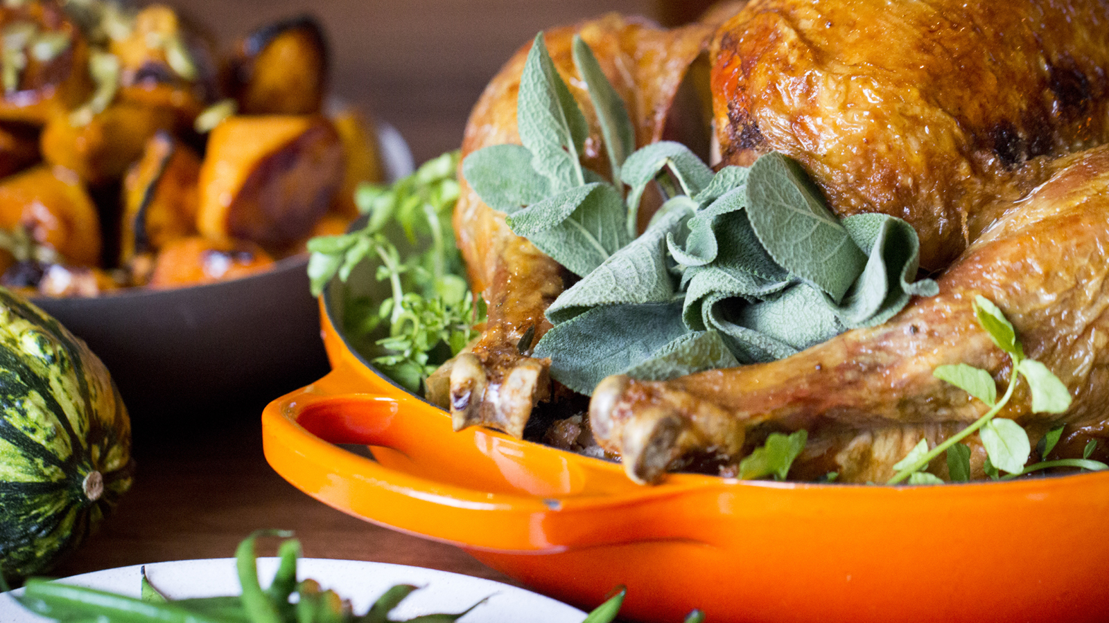 | October 5, 2017, Whistler, Canada  Thanksgiving is a Breeze with SIDECUT at Four Seasons Resort Whistler with Feasts, Turkey on the Fly and the Turkey Bowl  https://publish.url/whistler/hotel-news/2017/thanksgiving.html
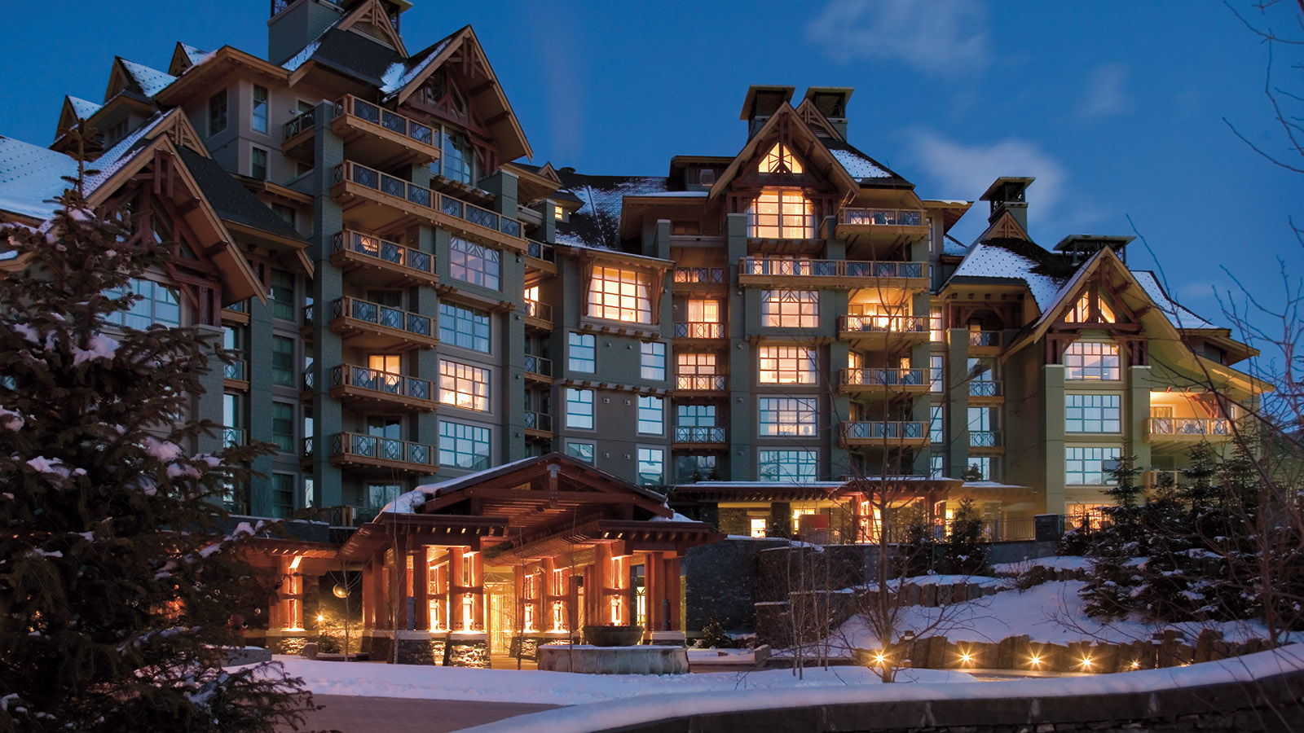 | September 27, 2017, Whistler, Canada  SIDECUT at Four Seasons Resort Whistler Goes Global with a Wealth of Wow Cornucopia Culinary Experiences with Partners from Mexico City, Hawaii, Vail and Jackson Hole  https://publish.url/whistler/hotel-news/2017/cornucopia-culinary-experiences.html

PRESS CONTACTS

Christine Kim
Public Relations and Communications Manager
4591 Blackcomb Way
Whistler
Canada
christine.kim@fourseasons.com

+1 (604) 966-2666

Kate Colley
Director of Public Relations and Communications
4591 Blackcomb Way
Whistler
Canada
kate.colley@fourseasons.com

+1 (604) 844-6769

