Nobu Singapore Celebrates First Anniversary with Dinner Featuring Acclaimed Michelin Starred Chef at Four Seasons Hotel Singapore

Two-night dinner collaboration with Michelin-starred Chef Dani García and a birthday special
May 26, 2023, Singapore

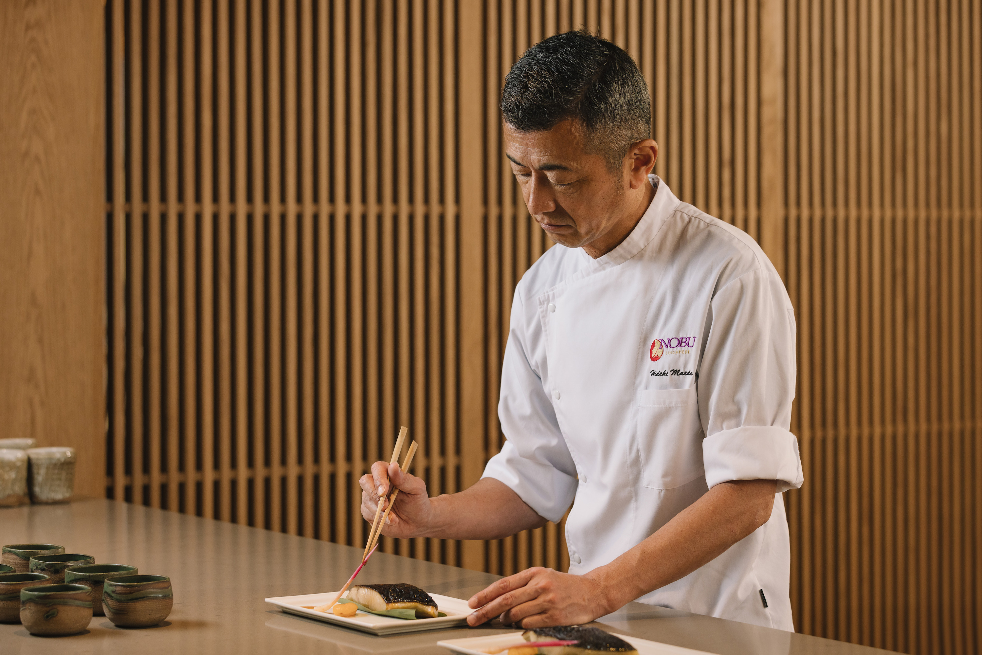
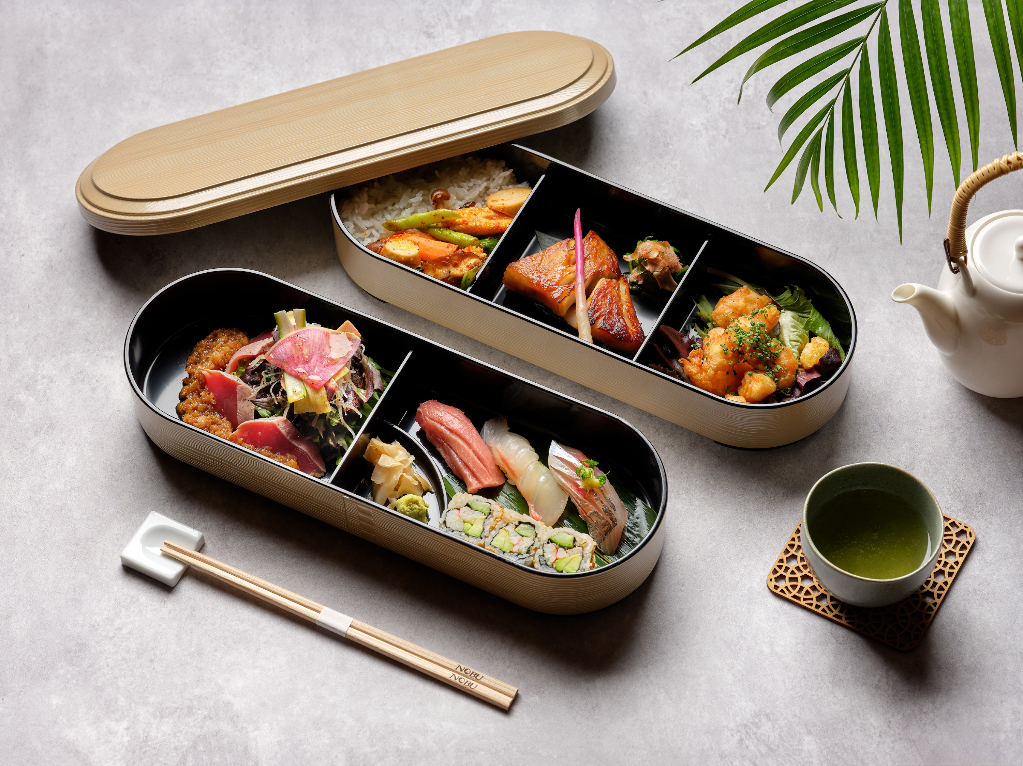 | 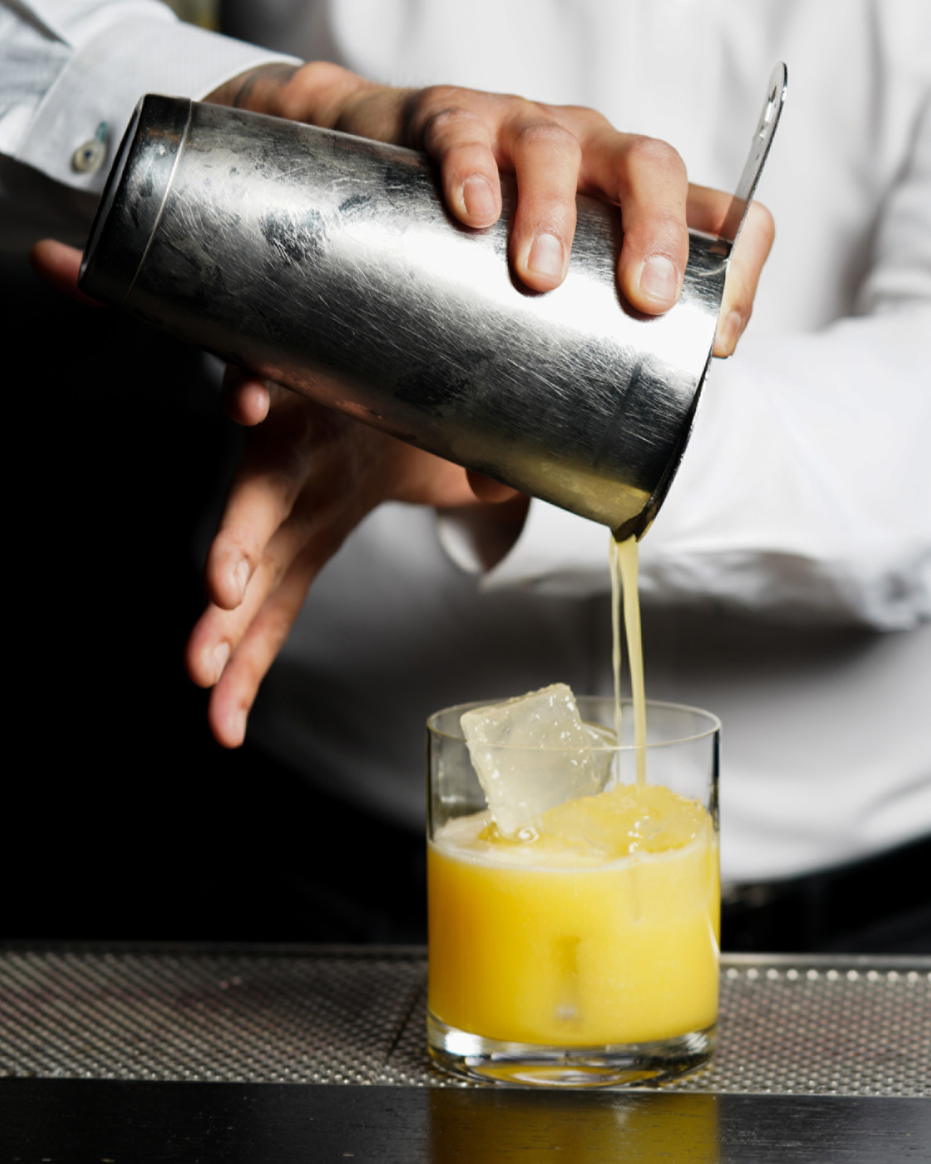 | 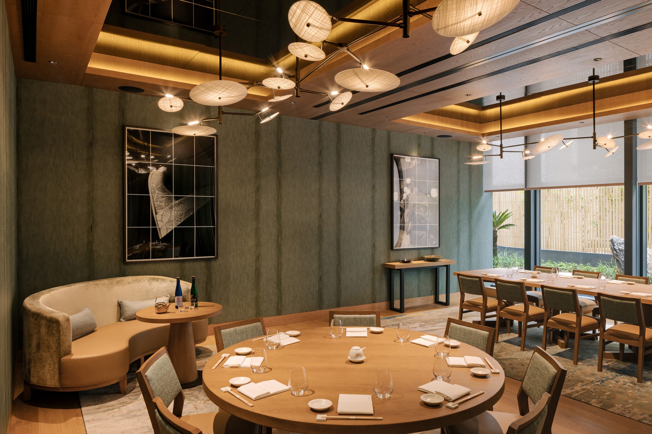
To mark its first anniversary, Nobu Singapore Executive Chef Hideki Maeda will be collaborating with renowned Chef Dani García of Madrid’s two Michelin-starred Smoked Room to present a unique eight-course omakase dinner menu.
The special dinner event will take place for two nights only on May 31 and June 1, 2023 at the restaurant at Four Seasons Hotel Singapore, promising to be an extraordinary culinary journey that will delight the senses and leave guests with an unforgettable dining experience.
Also the Consulting Chef and creative force behind the concept and menu of Dani, the rooftop restaurant at Four Seasons Hotel Madrid, Chef Dani García is a renowned chef from Andalusia, known the world over as one of the top chefs of Spanish gastronomy, and a culinary visionary who pushes boundaries of taste and presentation.
The dinner experience at Nobu Singapore will feature an exquisite multi-course omakase menu, carefully curated with the finest seasonal ingredients. From delicate seafood creations to artfully crafted meat dishes, guests can anticipate a symphony of flavours and textures, with each dish thoughtfully designed to showcase the culinary finesse of Chef Dani García and Nobu Singapore Executive Chef Hideki Maeda, a protégé of celebrity Chef Nobu Matsuhisa.
“We are absolutely thrilled to be celebrating our first anniversary with this special collaboration dinner. It is a testament to our commitment to culinary excellence and our dedication to providing our guests with truly exceptional dining experiences here in Singapore. We could not think of a better way to mark this milestone than by joining hands with the extraordinary talent of Chef Dani García,” says Director of Food and Beverage Tomas Stoila.
Menu highlights include the Grilled Lobster with Green Pepper Sauce by Chef Dani Garcia and the Sea Bass Yuzu Shio Koji by Chef Hideki Maeda, among other creations.
Elevating dining at Nobu Singapore, the beverage program complements the menu with bespoke craft cocktails along with world-class Nobu sake brewed exclusively by Hokusetsu brewery for Nobu restaurants worldwide.
A Gastro Journey: Eight-Course Omakase Set Menu
Nobu Singapore Executive Chef Hideki Maeda joins hands with culinary luminary Chef Dani García of Madrid’s two-Michelin-starred Smoked Room for a special two-night only dinner experience showcasing their repertoire of signatures.
- May 31 and June 1, 2023, 6:00-10:00 pm
- SGD 198++ per person, inclusive of a welcome cocktail
Birthday Bento Box Special
Lunch-goers are invited to celebrate Nobu Singapore’s first anniversary and be spoiled for choice with a specially curated lunch selection.
Ideal for diners who prefer the familiarity of dining on their favourite Nobu creations, Chef's Lunch Bento Box is set to please, providing an indulgent tasting platter of the restaurant's signatures.
- Available for weekday lunch only, Monday to Friday June 1-30, 2023, 12:00 noon to 2:30 pm
- Birthday Special at SGD 65++ per box (usual price at SGD 85++)
For enquiries or reservations, call +65 6831 7653 WhatsApp +65 9455 3466 or email Dining.Singapore@fourseasons.com.
About Dani García
Dani García is one of Andalusia chefs with the biggest international profiles. In a single dish, Dani manages to combine traditional products from his part of the world with techniques and ingredients used in more international ways of cooking. His restaurant Smoked Room, in Madrid, debuted in the Michelin Guide with two stars, a recognition that no other restaurant had received since 1936.

All prices stated above are subject to prevailing government taxes and service charge.

RELATED

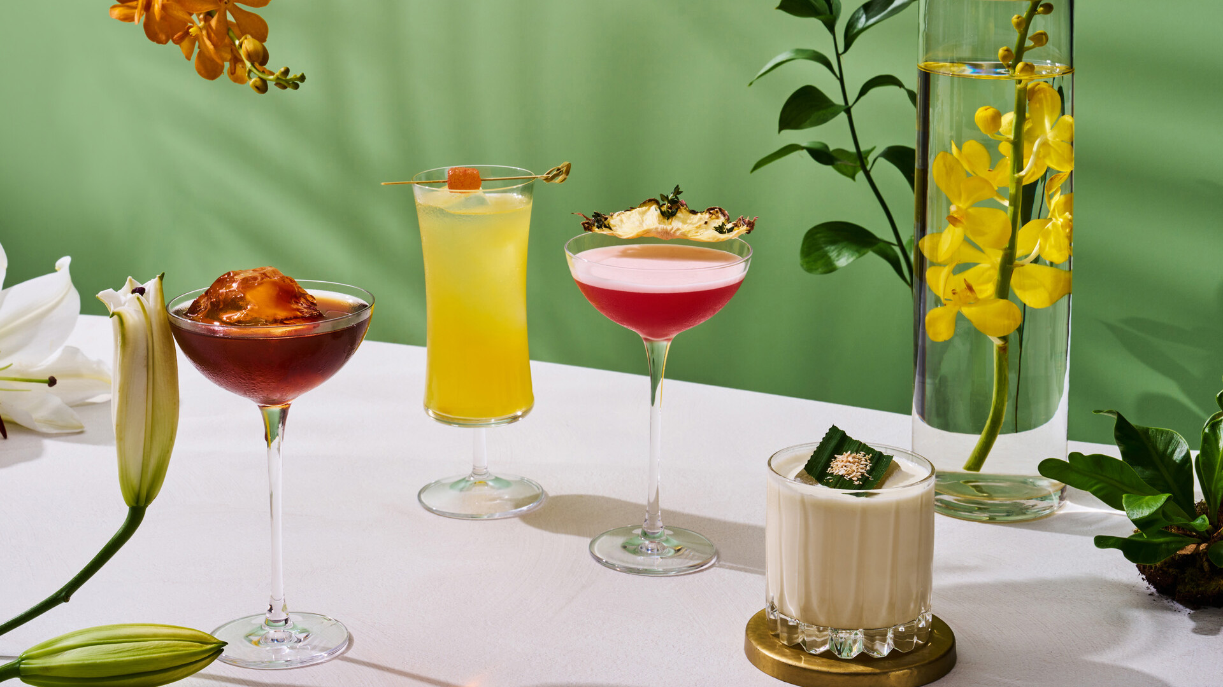 | May 18, 2023, Singapore  Uncover a Botanic Wonderland with One-Ninety Bar’s New Secret Gardens Menu at Four Seasons Hotel Singapore  https://publish.url/singapore/hotel-news/2023/secret-gardens-cocktail-menu-at-one-ninety.html
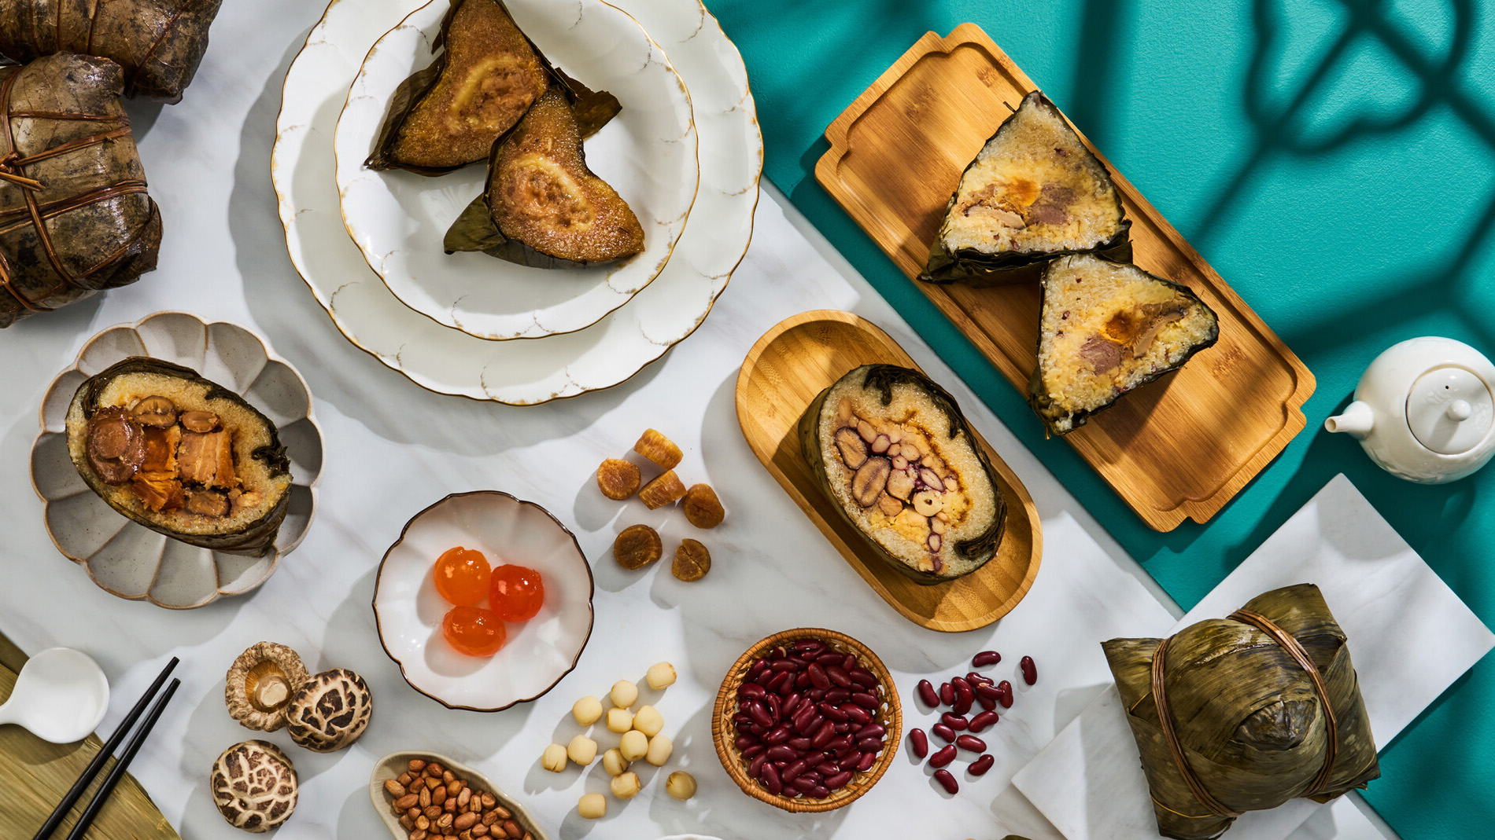 | May 17, 2023, Singapore  Commemorate the Annual Dragon Boat Festival with Four Seasons Hotel Singapore  https://publish.url/singapore/hotel-news/2023/dragon-boat-festival-dumplings.html

PRESS CONTACTS

Andreana Soh
Director of Public Relations and Communications
190 Orchard Boulevard
Singapore
Singapore
andreana.soh@fourseasons.com

(65) 6831 7130

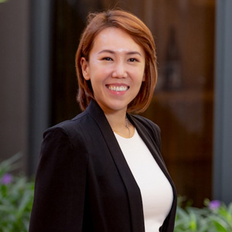 | Hannah Chia  Manager, Public Relations and Social Media  190 Orchard Boulevard  Singapore  Singapore  hannah.chia@fourseasons.com  (65) 6831 7023

