A Taste of Seychelles, in Your Villa

October 19, 2015, Seychelles

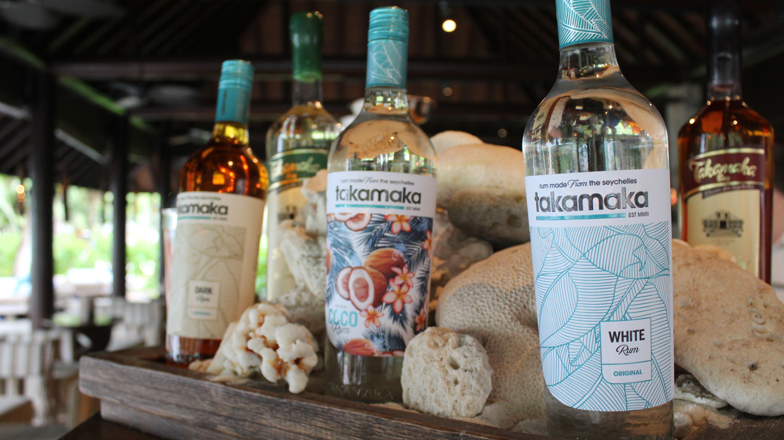
When travelling to Seychelles, guests have the opportunity to experience much of the local culture and flavours, yet at
Four Seasons
Resort Seychelles the journey begins before even leaving the villa. Created nearby at a distillery local to the Resort, Takamaka rum is a Seychellois favourite and delivers a true island flavour, with both dark and light rums as well as a distinctive coconut rum offered to make any cocktail or drink taste instantly tropical! This taste of Seychelles is available for all guests to enjoy from the convenience of their in-room mini-bar, with two bottles uniquely displayed in a carved wooden box in each villa, and that is also used in many of the cocktails created in the Resort’s bar.
To learn even more about this island favourite, guests can also venture out to La Plaine St André, the official Takamaka Distillery, which is only a 10 minute drive from the Resort, to experience the traditional fermentation processes and family recipes that make this rum so special. A tour can be arranged to take guests around the distillery, where they may also enjoy a bite (and a glass of rum!) in the onsite restaurant.

RELATED

November 13, 2017, Seychelles
Soak in the View: Four Seasons Resort Seychelles Launches New Menu of Luxurious In-Villa Spa Baths
https://publish.url/seychelles/hotel-news/2017/in-villa-spa-baths.html

October 4, 2017, Seychelles
New Oud Renewal Therapy by Sodashi to Launch at Four Seasons Resort Seychelles
https://publish.url/seychelles/hotel-news/2017/new-oud-renewal-therapy.html

PRESS CONTACTS

Amy Sefton
Public Relations Coordinator
Petite Anse, Baie Lazare, P.O. Box 1397
Victoria, Mahe
Seychelles
amy.sefton@fourseasons.com

+248 439 3016

Debbie Duval
Director of Public Relations and Communications

Beau Champ
Mauritius
debbie.duval@fourseasons.com

(230) 402 3100

