Valentine’s Day at Four Seasons Hotel Bengaluru

February 5, 2020, Bengaluru, India

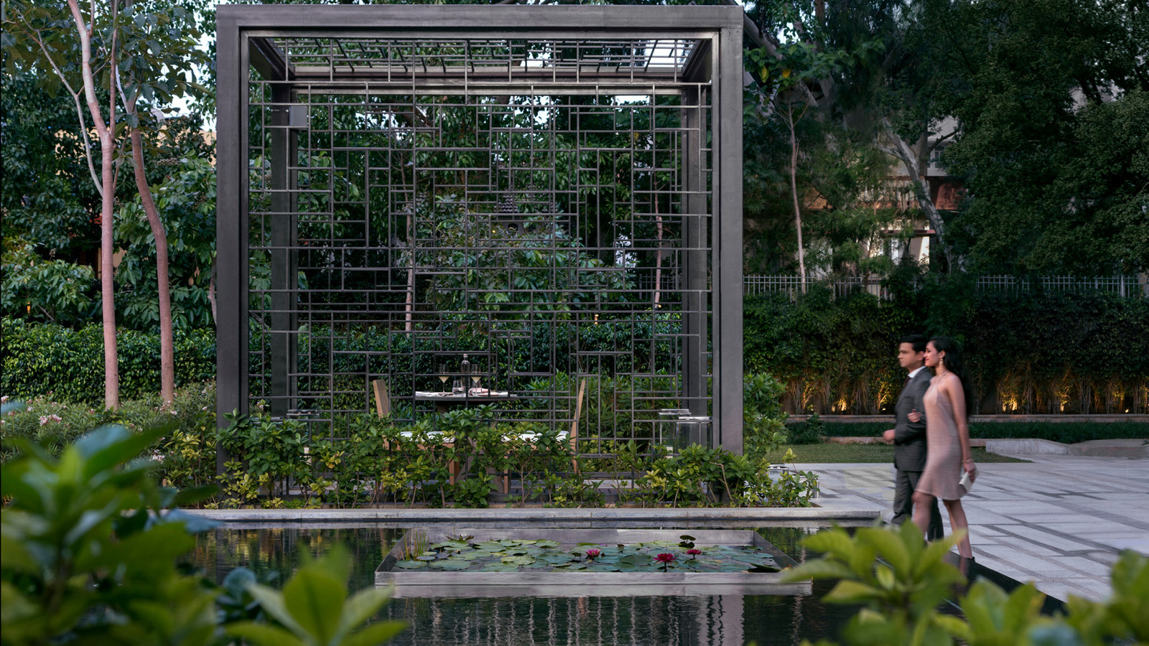
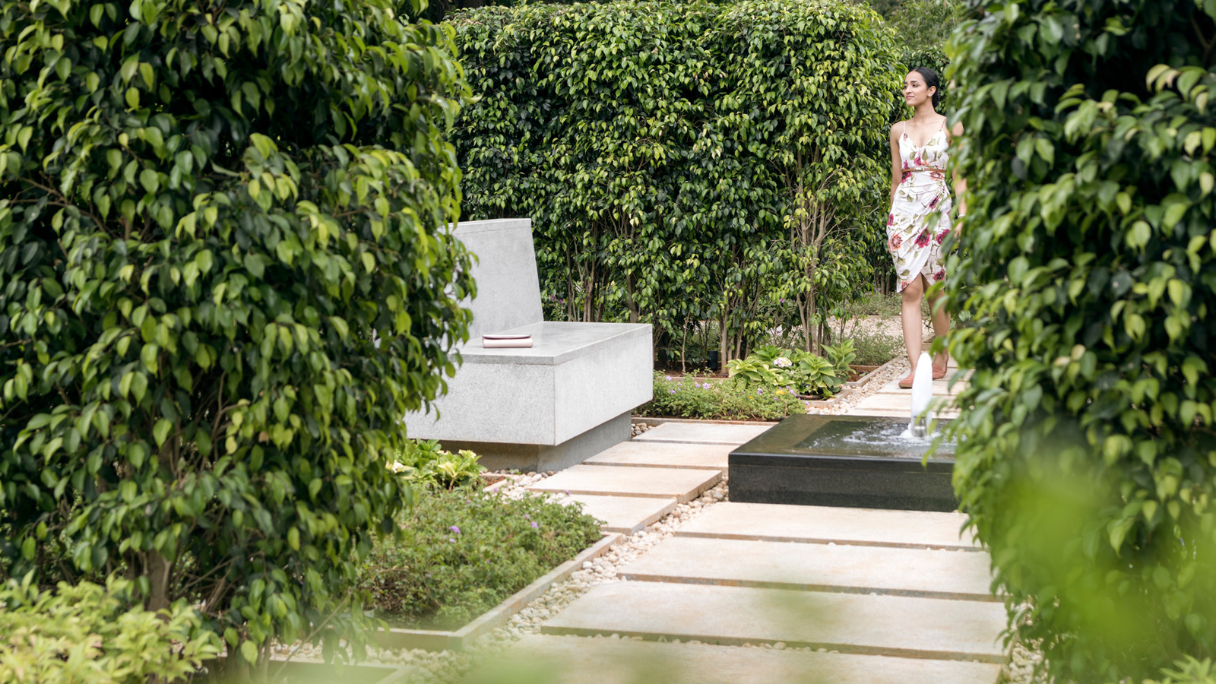 | 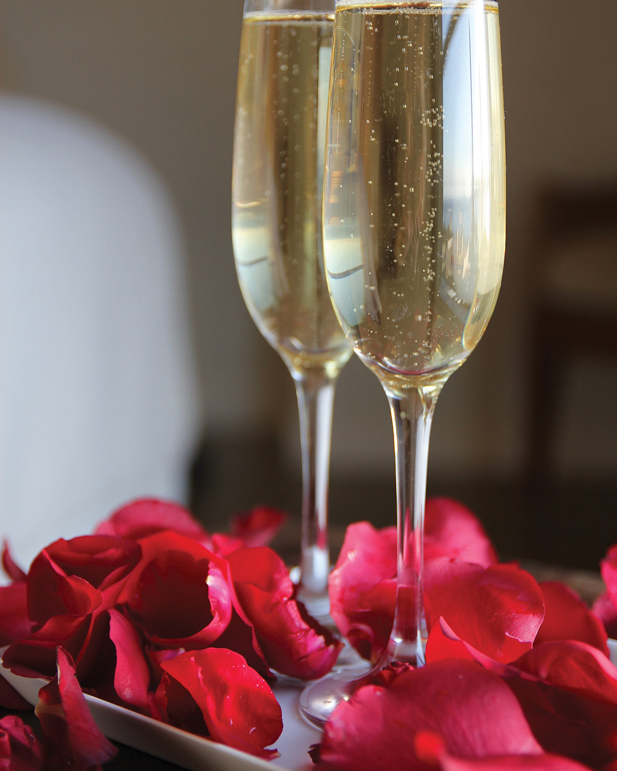 | 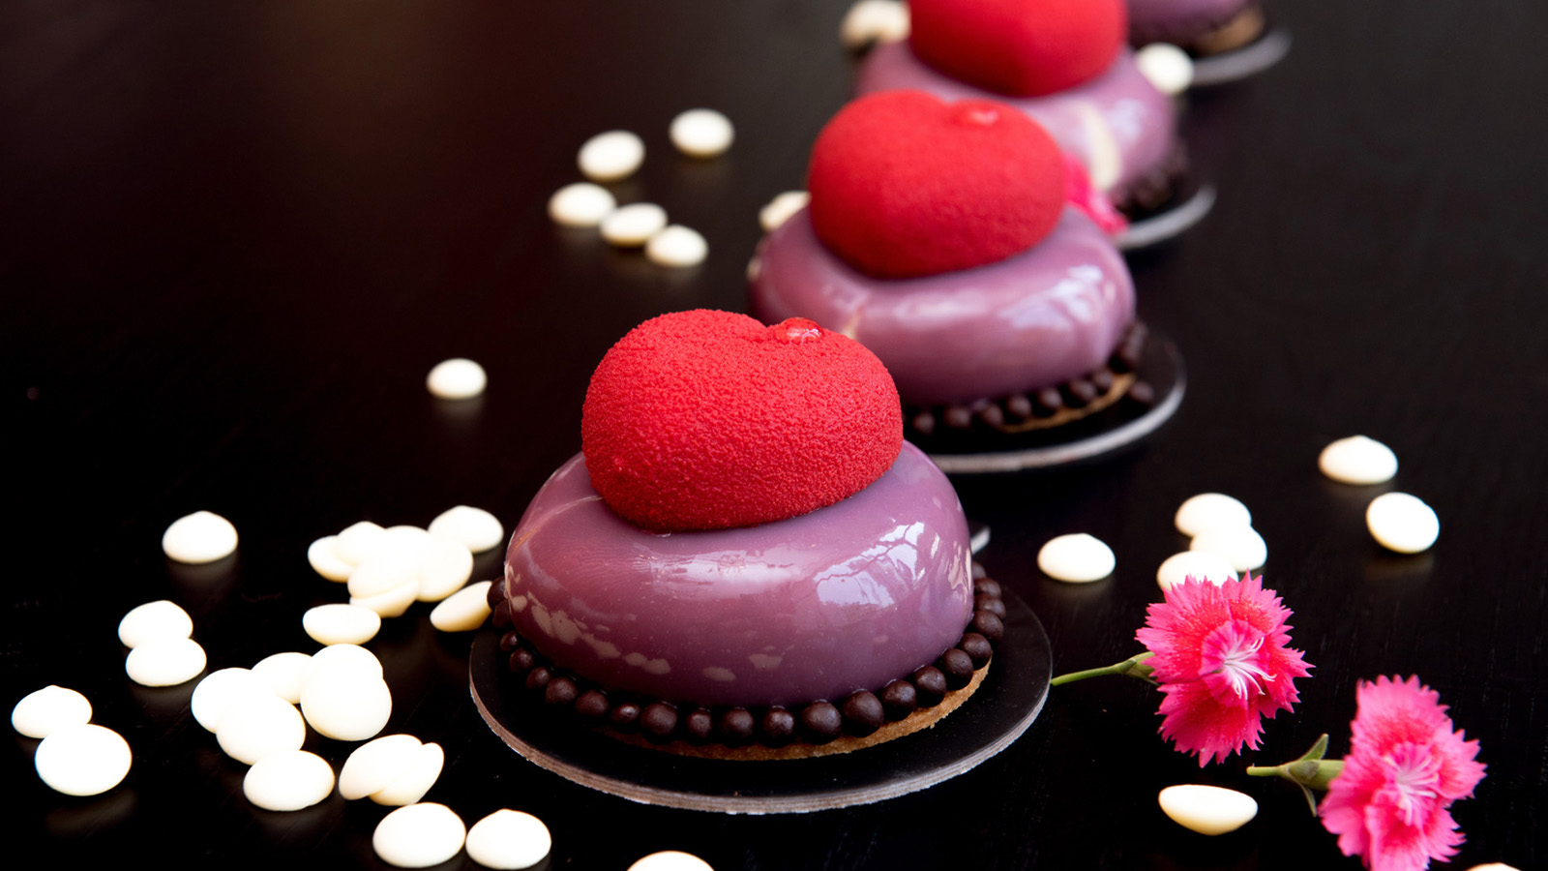
A true tribute to all things love, from intimate conversations to sweet strains of the violin and softly lingering fragrances" February has arrived in the Garden City and will be venerated at Four Seasons Hotel Bengaluru as the month of love.
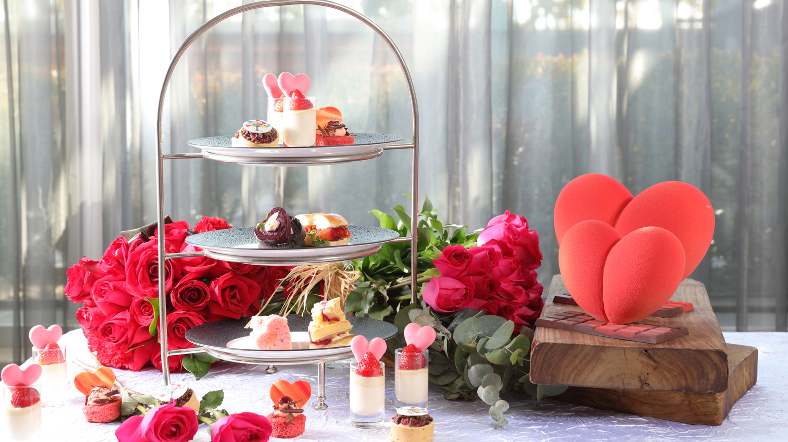 | 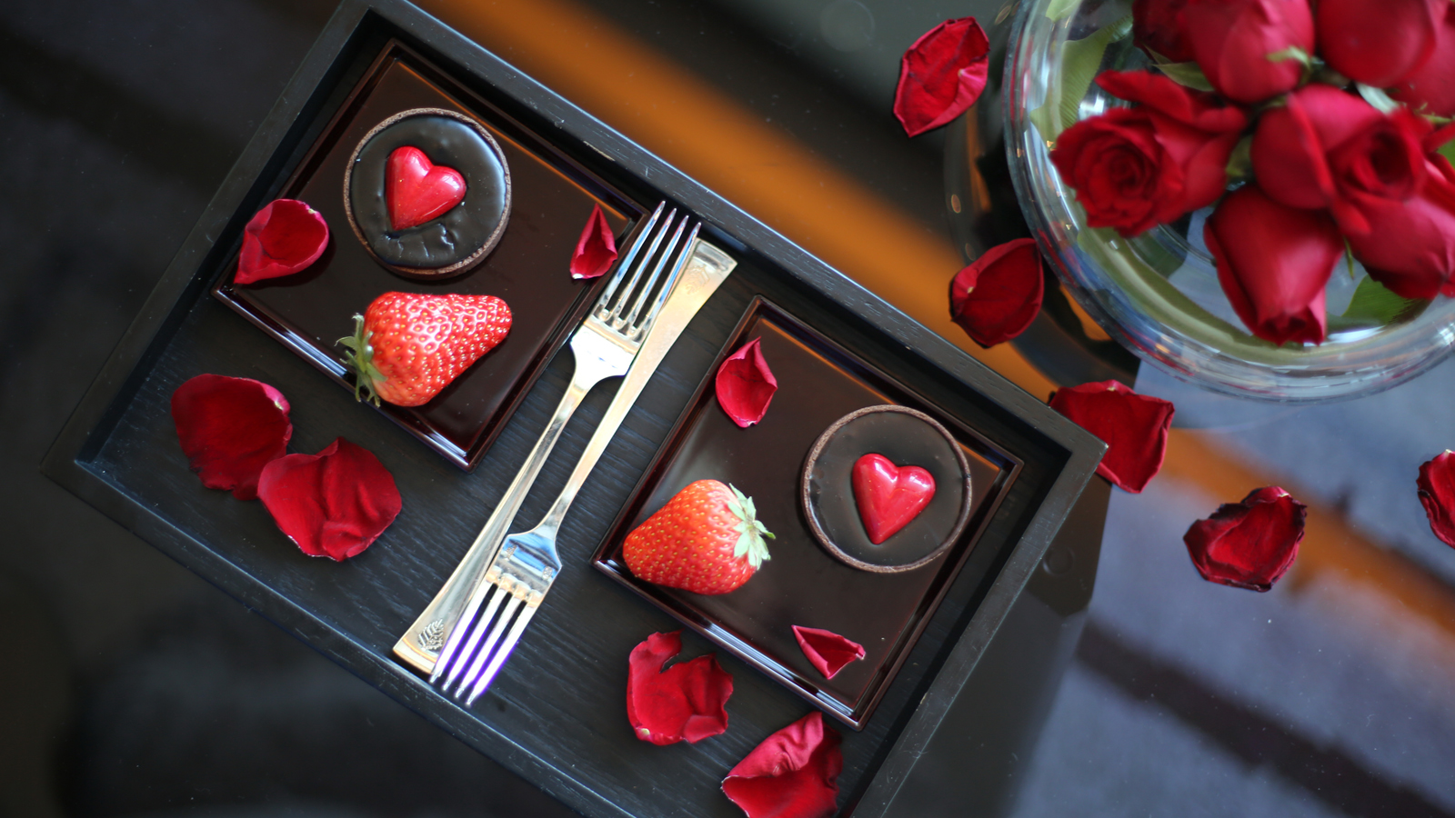 | 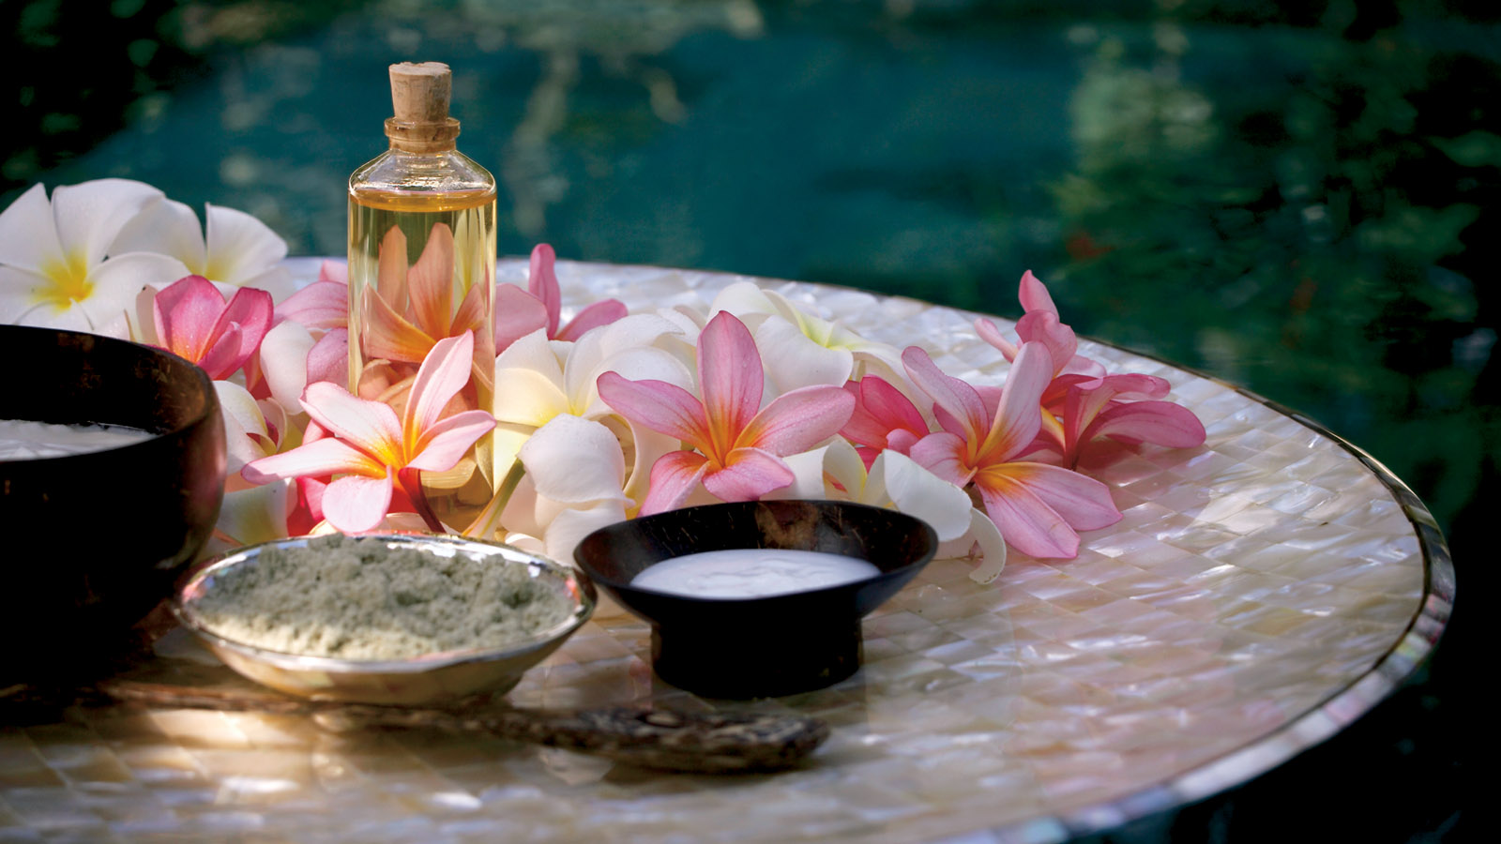
Valentine’s Dinner at CUR8
Guests have three options to choose as their dining experience on the day of love.
Couples Package 1: A sumptuous five-course meal experience has been curated at the most romantic setting, the two outdoor pergolas at CUR8. The menu has a choice of Indian as well as Mediterranean with exotic dishes such as river prawn bisque, confit salmon, ricotta timbale, murgh khichadi risotto and asparagus panna cotta featuring as highlights. A bottle of bubbly to go along and the live strains of violin add to the experience.
- INR 15,000 all-inclusive, per couple
- There are only two tables for this decadent experience
Couples Package 2: An intimate dinner in the lush, green surrounds of the Butterfly Garden. Candlelit tables hold promises of the perfect four-course menu with a bottle of bubbles. The menu has a choice of Indian as well as Mediterranean with dishes such as chocolate pani puri, seabass vanilla, vegetable tian, gucchi dum anari or the adored tiramisu.
- INR 10,000 all-inclusive, per couple
- There are only six tables for this decadent experience
Expansive Buffet Dinner: The spread at CUR8 will feature an abundant spread of decadent dishes with some special themed desserts. A serenading violinist will set the note for the evening.
- INR 1,950 + taxes, per person
- Buffet timing: 7:00-11:30 pm
For more details, guests can call +91 76191 46004 or email sandesh.dhume@fourseasons.com
Elevated Dining Experience at Far & East
Bengaluru’s newest and must-visit Asian brasserie Far & East presents itself as the perfect venue to have a cosy dinner with a loved one. Dark, moody interiors, fragrant Asian-inspired cocktails and the most exotic dishes from the Far East are the perfect excuse to whisk away a special someone to the chic perch on the Hotel’s Level 21.
- A la carte or set menu options are available
To make a reservation, call +91 76191 46006 or email farandeast@fourseasons.com
Festive Afternoon Treat
The Lobby Lounge and Terrace will feature special treats all weekend long as the afternoon treat ritual gets a twist of love. Valentine’s Afternoon Treat will be available between February 14 and 16, 2020, from 3:00 to 5:30 pm.
To make a reservation, call +91 80 4522 2271
Valentine’s Retail
Freshly-baked cakes, artisanal confectionaries, gourmet chocolates, macarons, pastries and delectable sweet treats will be on sale from February 10 to 16, 2020 at CUR8.
For more details, call +91 88844 77125 or email mousumi.sharma@fourseasons.com
Spa Offer
Special savings on the curated Flower at Four Seasons treatment at Infuse Spa are available through the Valentine week. Inspired by the garden walks in Bangalore’s iconic neighbourhoods, this is a full body massage that hydrates and realigns with the four different essence of flowers growing in the city gardens.
To make a reservation, call +91 96064 87959 or email minu.budhatoki@fourseasons.com

RELATED

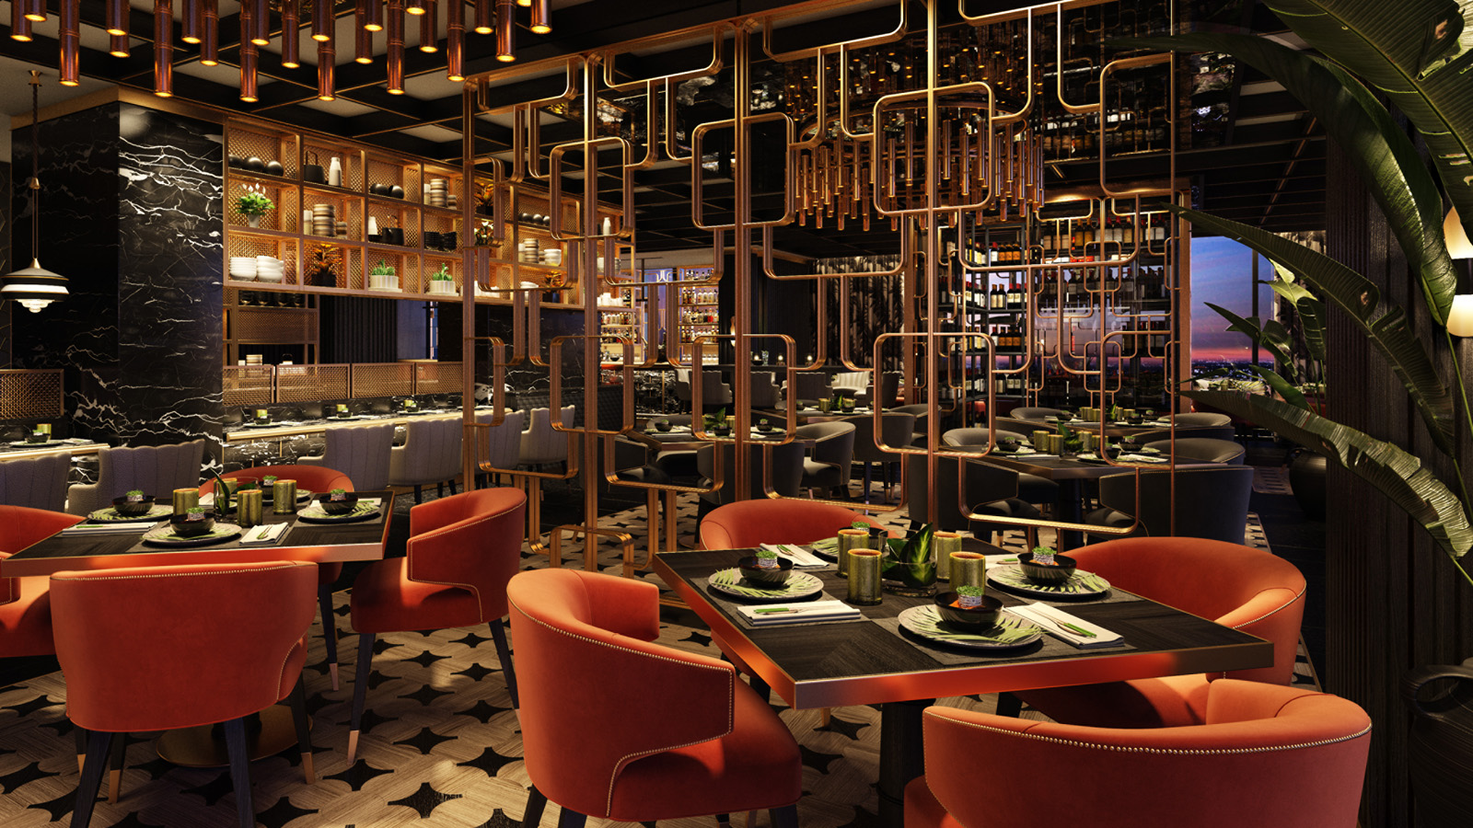 | January 22, 2020, Bengaluru, India  Dining Sky High on Level 21: Four Seasons Hotel Bengaluru Brings the Orient to Bangalore with Far & East  https://publish.url/bengaluru/hotel-news/2020/far-and-east-restaurant-opening.html
January 15, 2020, Bengaluru, India
Feel Good Saturdays at Four Seasons Hotel Bengaluru
https://publish.url/bengaluru/hotel-news/2020/feel-good-saturdays.html

PRESS CONTACTS

Gargi Guha
Director of Public Relations
8, Bellary Road, Ganganagar
Bengaluru
India
gargi.guha@fourseasons.com

+91 80 4522 2222

