Four Seasons Resort Rancho Encantado Santa Fe Announces Reopening on June 4, 2020

Resort introduces series of custom experiences, touch-free services and activities to welcome guests back for an exclusive “home away from home” vacation
June 4, 2020, Santa Fe, U.S.A.

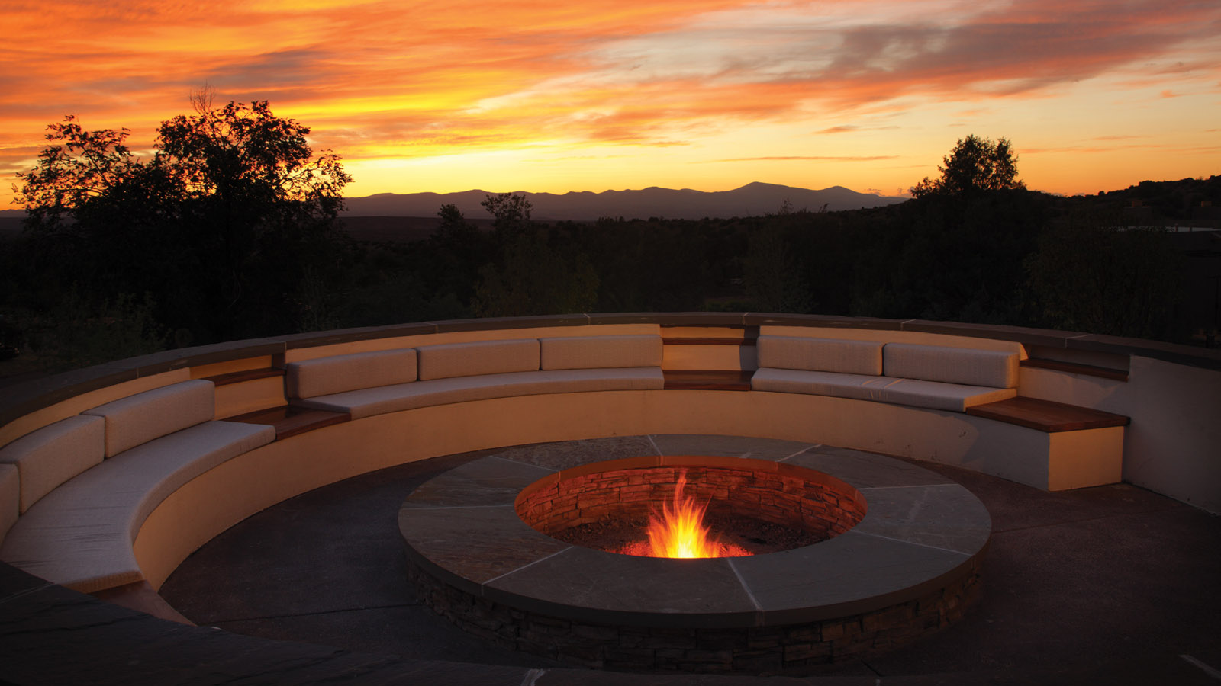
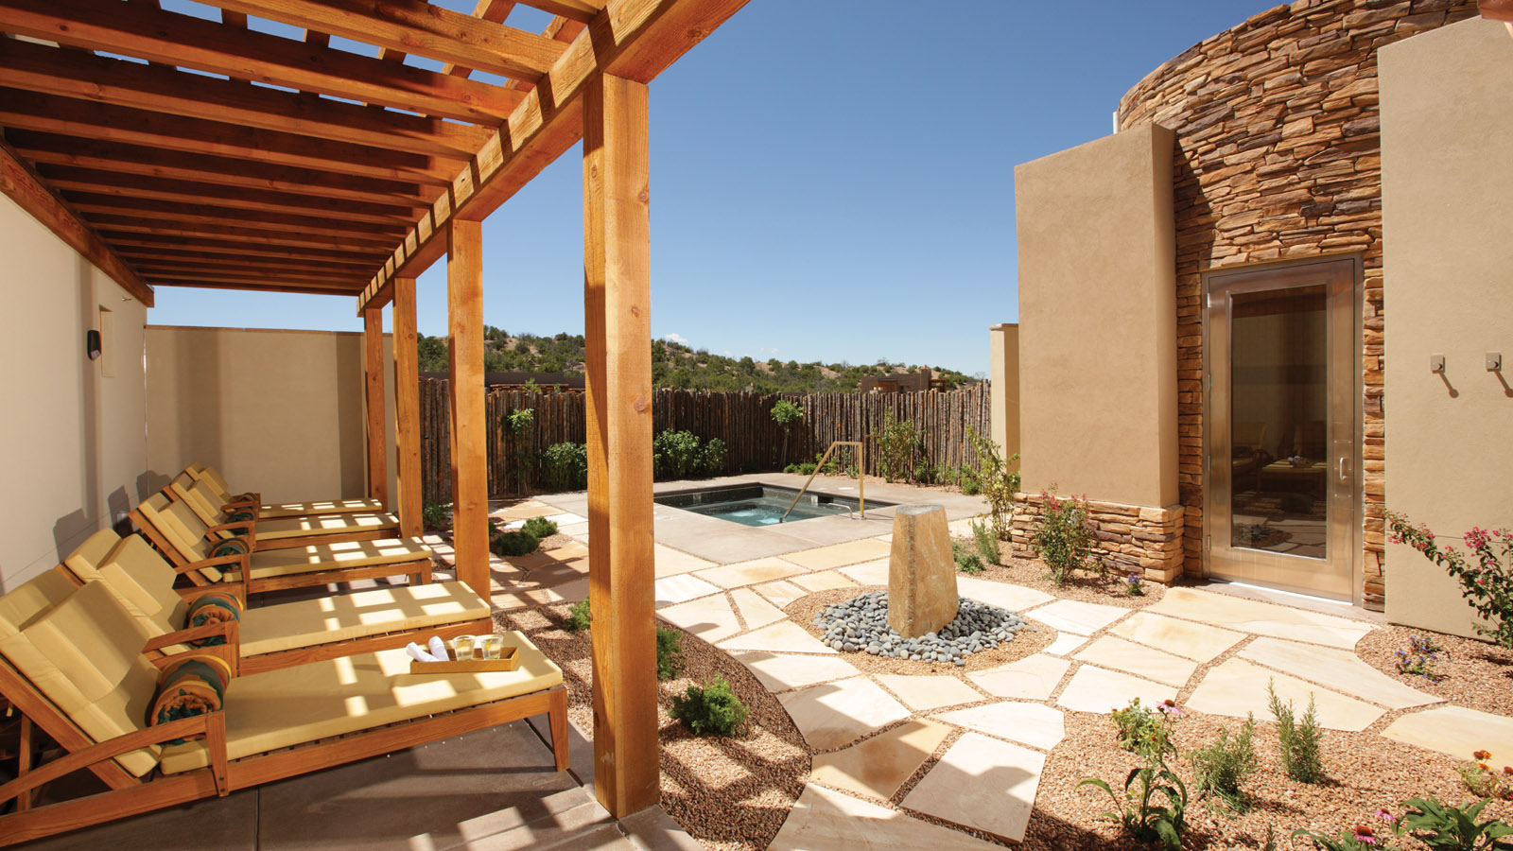 |  | 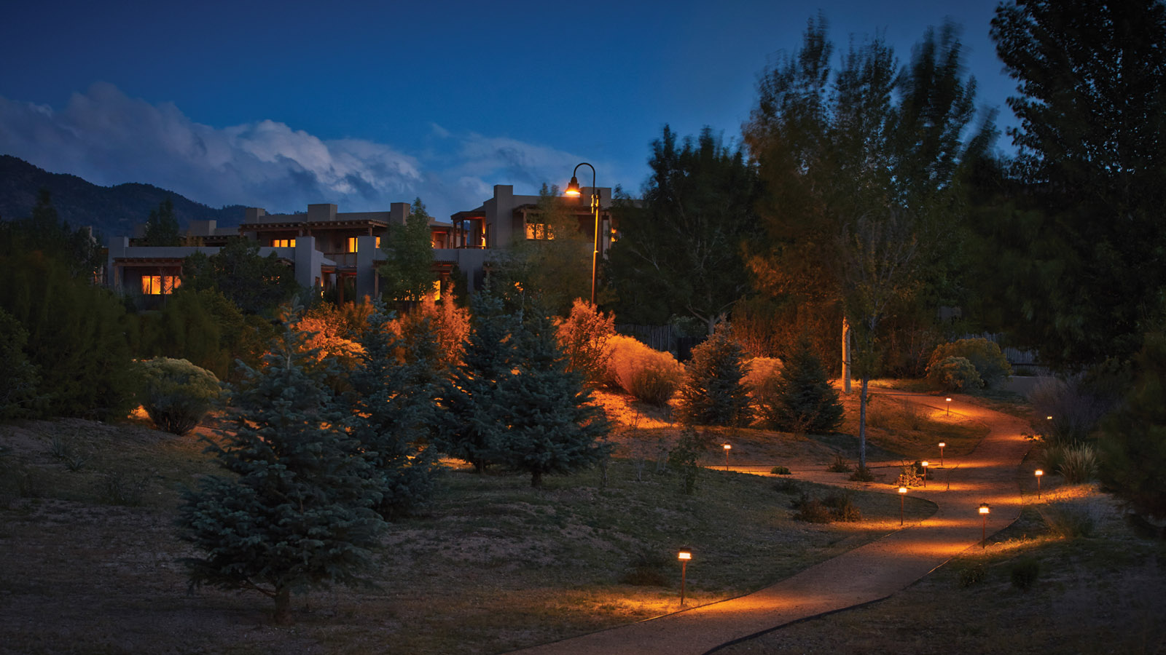
Set on 57 sprawling acres (23 hectares) in the foothills of the Sangre de Cristo mountains outside Santa Fe, Four Seasons Resort Rancho Encantado Santa Fe is a luxury boutique retreat steeped in adventure, culture, culinary and wellness experiences.
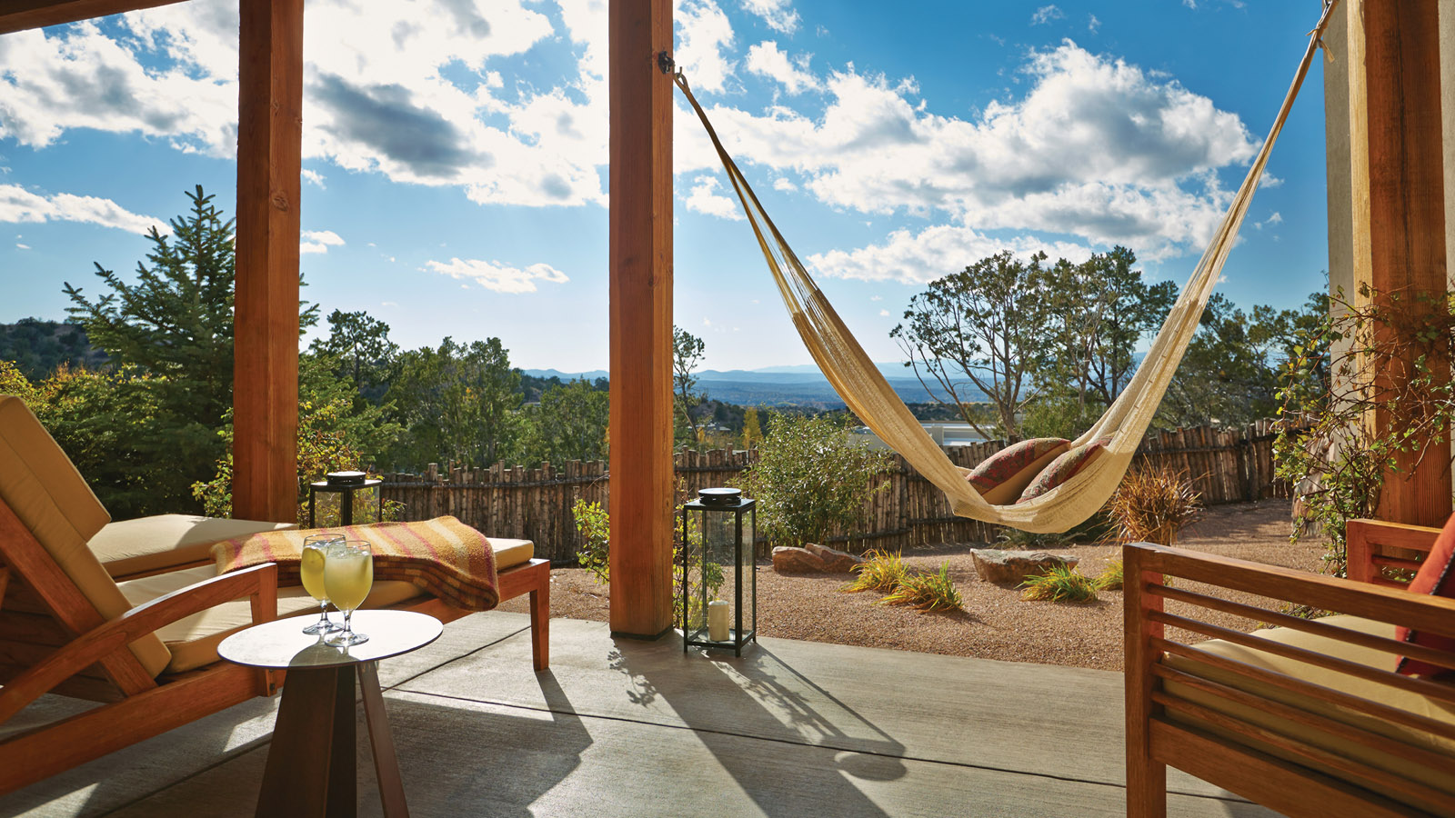 | 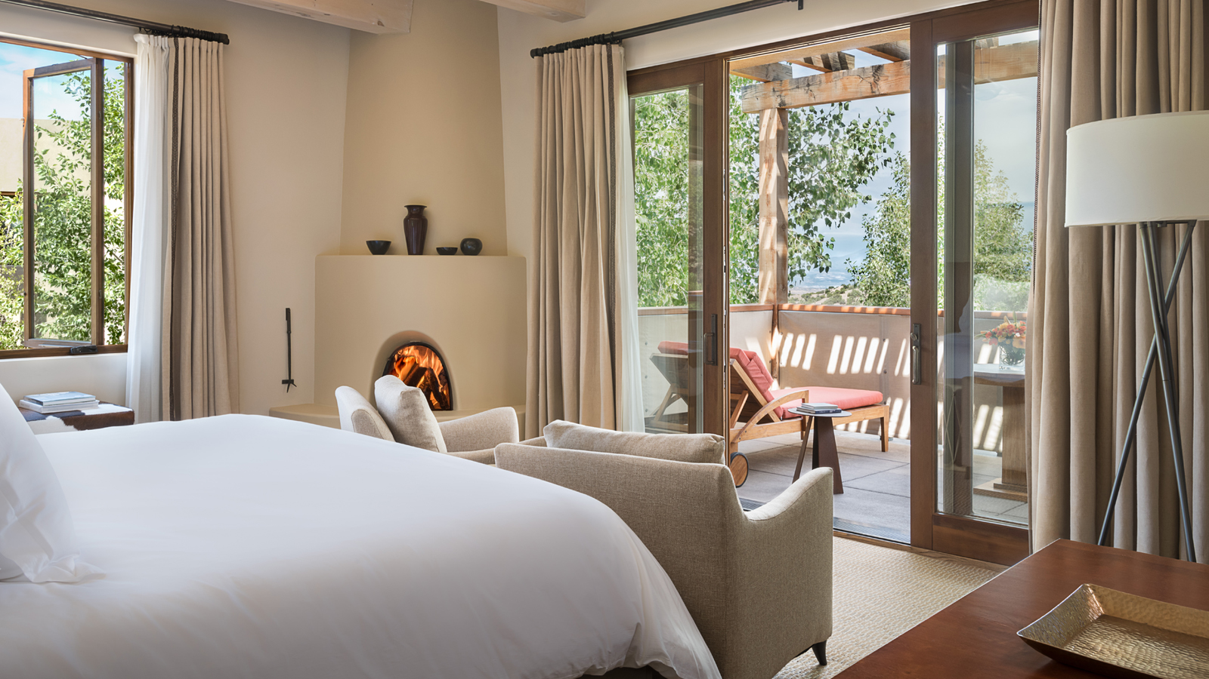 | 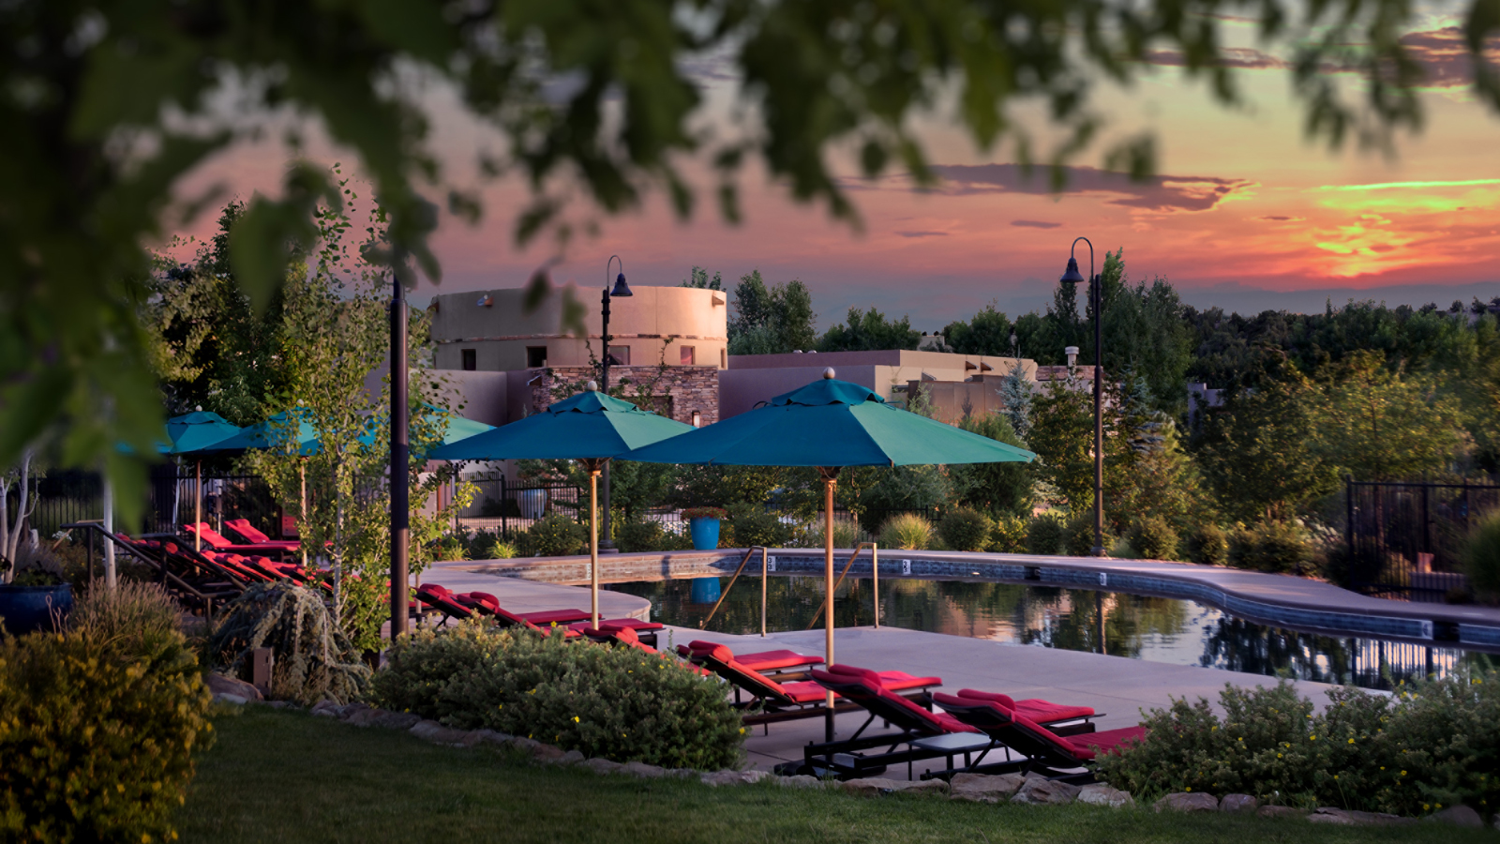
A distinct “home away from home” getaway, the Resort’s remote location surrounded by the outdoors, naturally spacious layout and private stand-alone casitas make for an ideal escape to get out of the house, enjoy some fresh air, epic sunsets and a relaxing vacation experience in a safe, comfortable environment.
The Resort has also introduced a series of curated experiences, outdoor activities, new offerings and amenities for guests to completely customise their stay. It’s Four Seasons Santa Fe, your way...
Highlights of property updates, services and experiences include:
Home Away From Home Retreat
Offering only 65 guest rooms and suites, the casita-style accommodations are spread out across the property, offering plenty of room to enjoy a secluded retreat. Luxurious casitas feature spacious private patios, complete with lounge furniture, dining table and views of the high desert landscape/mountains; indoor and outdoor fireplaces; and large spa-inspired bathrooms; coupled with a host of new “contactless” services and unique amenities to enhance guests’ stay and tailor their casita experience.
Experience More, Your Way
When guests book the new “Experience More” Offer, they receive a Resort credit up to USD 200 to use towards food and beverage, wellness outdoor adventures and more. Additionally, guests can choose two complimentary experiences during their stay - a wide variety of options are available, such as a private guided hike, in-casita s’mores night, spa welcome basket, private yoga session, use of resort bikes, and more.
Get Outdoors: Nature is Calling
The expansive outdoor playground that surrounds the property offers countless opportunities to explore. With the Resort’s signature “Adventure by Design” program - led by an in-house team of expert guides - guests can choose from myriad activities and customised “off the beaten track” adventures to craft their own outdoor experience to enjoy with or without a private guide.
- From hiking and mountain biking to fly fishing, horseback riding and more, guests can journey to remote locations, explore hidden gems and wide open trails to discover an unexpected side of Santa Fe.
- Also, chef-prepared custom picnics are available to take on any excursion, or enjoy “après adventure” bites and beverages back at the property.
Food and Beverage: Culinary Delights
Signature restaurant Terra is now open, with limited capacity, required social distancing and enhanced safety practices in place. Here is what’s new:
- Executive Chef Kai Autenrieth and Terra’s talented team have introduced all-new seasonally-inspired menus for the restaurant, bar, casita dining and take out, featuring an extensive selection of innovative dishes that blend fresh, local ingredients (from on-site culinary gardens) and New Mexico flare with inspired worldly cuisines.
- Al Fresco Private Dining - whether dining or imbibing at the new spacious Courtyard Lounge (with live music), on Terra’s expansive terrace, in the Chef’s Garden, poolside; or on a gourmet picnic, there’s an abundance of outdoor locations around the property to choose from for a personal, curated culinary experience.
- Guests can also enjoy a Terra experience (with new, expansive in-room offerings) in the comfort of their own private casita patio - from lounging fireside with wine, craft cocktails or s’mores kits, to indulging in a delicious dinner at sunset - multiple options are available with contactless delivery.
- Plus, curious foodies and beverage enthusiasts can learn first-hand from the experts with a series of creative, chef-led and bartender-led cooking and mixology demos and private tasting experiences (such as “The Art of Mixology” Tequila and Mezcal Lesson with a certified Tequila Master, and more)
R&R and Wellness
For those seeking a wellness-focused getaway, the Resort’s fitness centre and movement studio are open (with limited capacity, required physical distancing and safety practices in place). Additionally, the Resort is offering a variety of personalised wellness experiences from private poolside yoga sessions, hike-to/bike-to yoga or meditation, and new wellness/fitness kits that can be delivered to the casita.
- For spa lovers, customised Spa Kits are available for a spa-inspired experience in the comfort of their casita, including items to create their own ultimate bath soak, do a rejuvenating face mask, and more.
- Pool time - guests can also lounge by the large outdoor infinity pool with plenty of space to swim and comfortably relax, while enjoying a tasty menu of snacks and drinks from the Pool Shack.
Private Escapes: It’s All Yours...and Yours Alone
For families, groups and close friends who want to vacation together and have ultimate privacy, guests have the opportunity to buy out the entire Resort and enjoy an exclusive, intimate retreat all to themselves. With personal service, endless activities and one-of-a-kind experiences, there’s something for everyone at the Resort for a secluded getaway to call your own.
Additionally, a key part of the guest service experience will continue to be the Four Seasons App and Chat. As one of the only industry platforms powered by employees on property, not chatbots, this award-winning service will further allow guests to control how they engage with employees and remain as connected as ever. With the App and Chat, guests will have direct access to the property teams at Four Seasons Resort Rancho Encantado property. From the comfort of their own device, the App provides a contactless experience that does not compromise Four Seasons genuine care and signature service.

RELATED

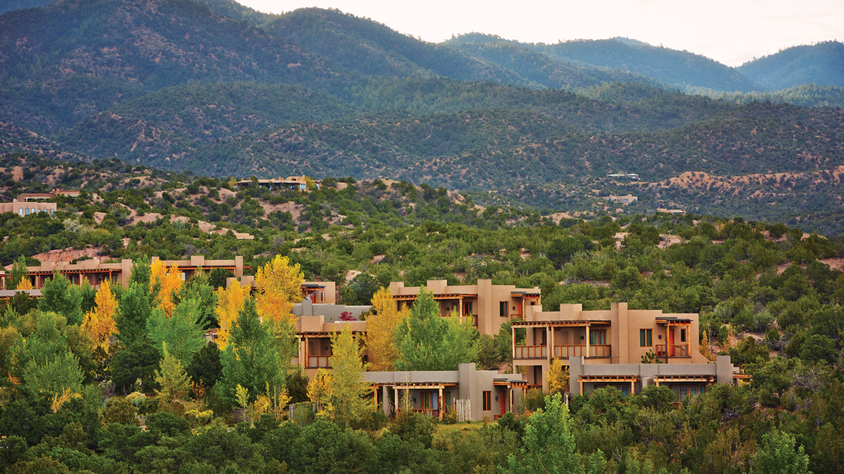 | May 4, 2020, Santa Fe, U.S.A.  Four Seasons Resort Rancho Encantado Santa Fe Introduces Virtual “At-Home” Experiences  https://publish.url/santafe/hotel-news/2020/at-home-experiences.html
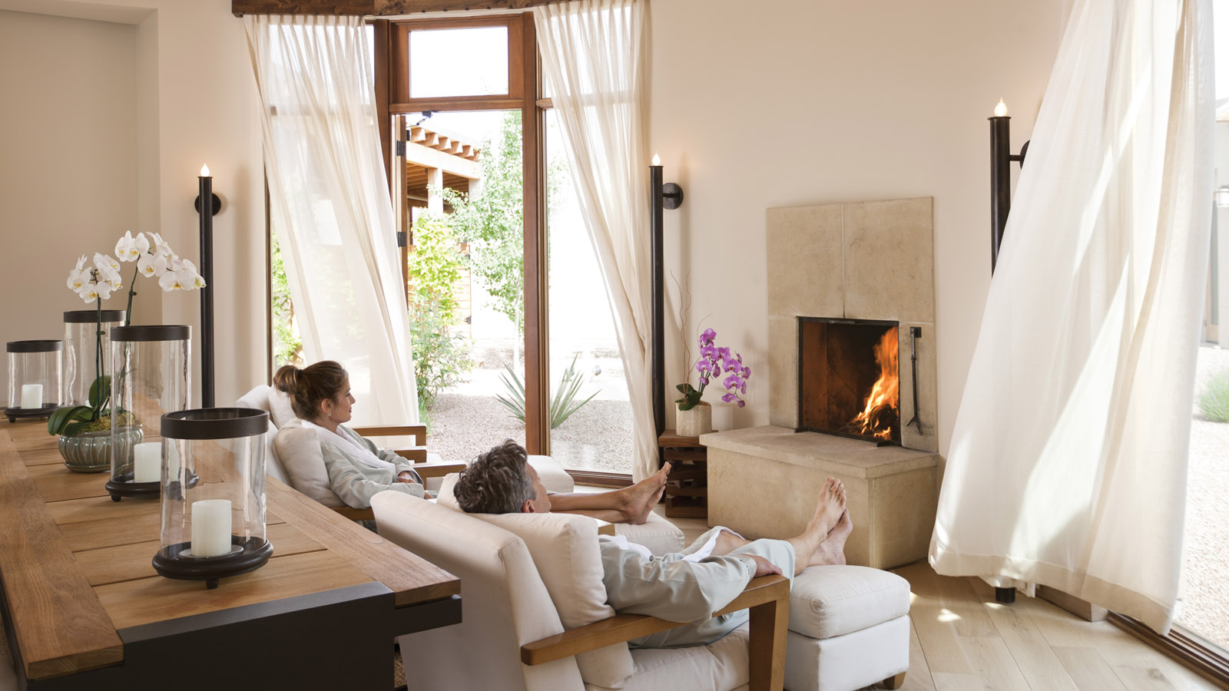 | January 28, 2020, Santa Fe, U.S.A.  Four Seasons Resort Rancho Encantado Santa Fe Introduces “The Art of Valentine’s Day” Package  https://publish.url/santafe/hotel-news/2020/valentines-day.html

PRESS CONTACTS

Michelle Duncan
Director of Public Relations
198 State Road 592
Santa Fe
USA
michelle.duncan@fourseasons.com

+1 646 229 2797

