Four Seasons Resort Rancho Encantado Celebrates the End of Summer with Big Green Egg’s Barbecue Specialist and Pitmaster

Chef Jack Arnold teams up with Executive Chef Jose Fernandez to marry savoury barbecue with Santa Fe’s rich flavours
August 4, 2022, Santa Fe, U.S.A.

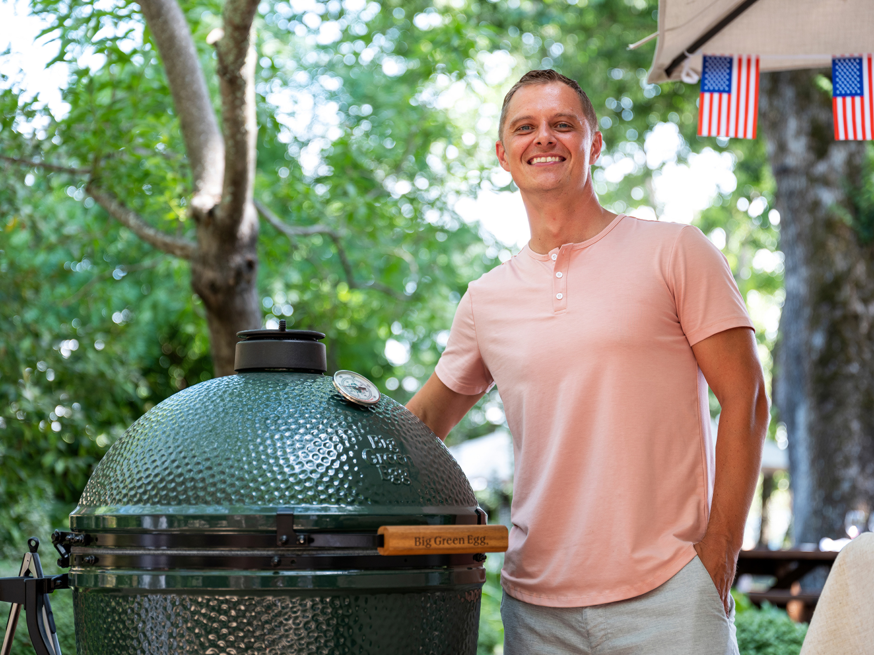
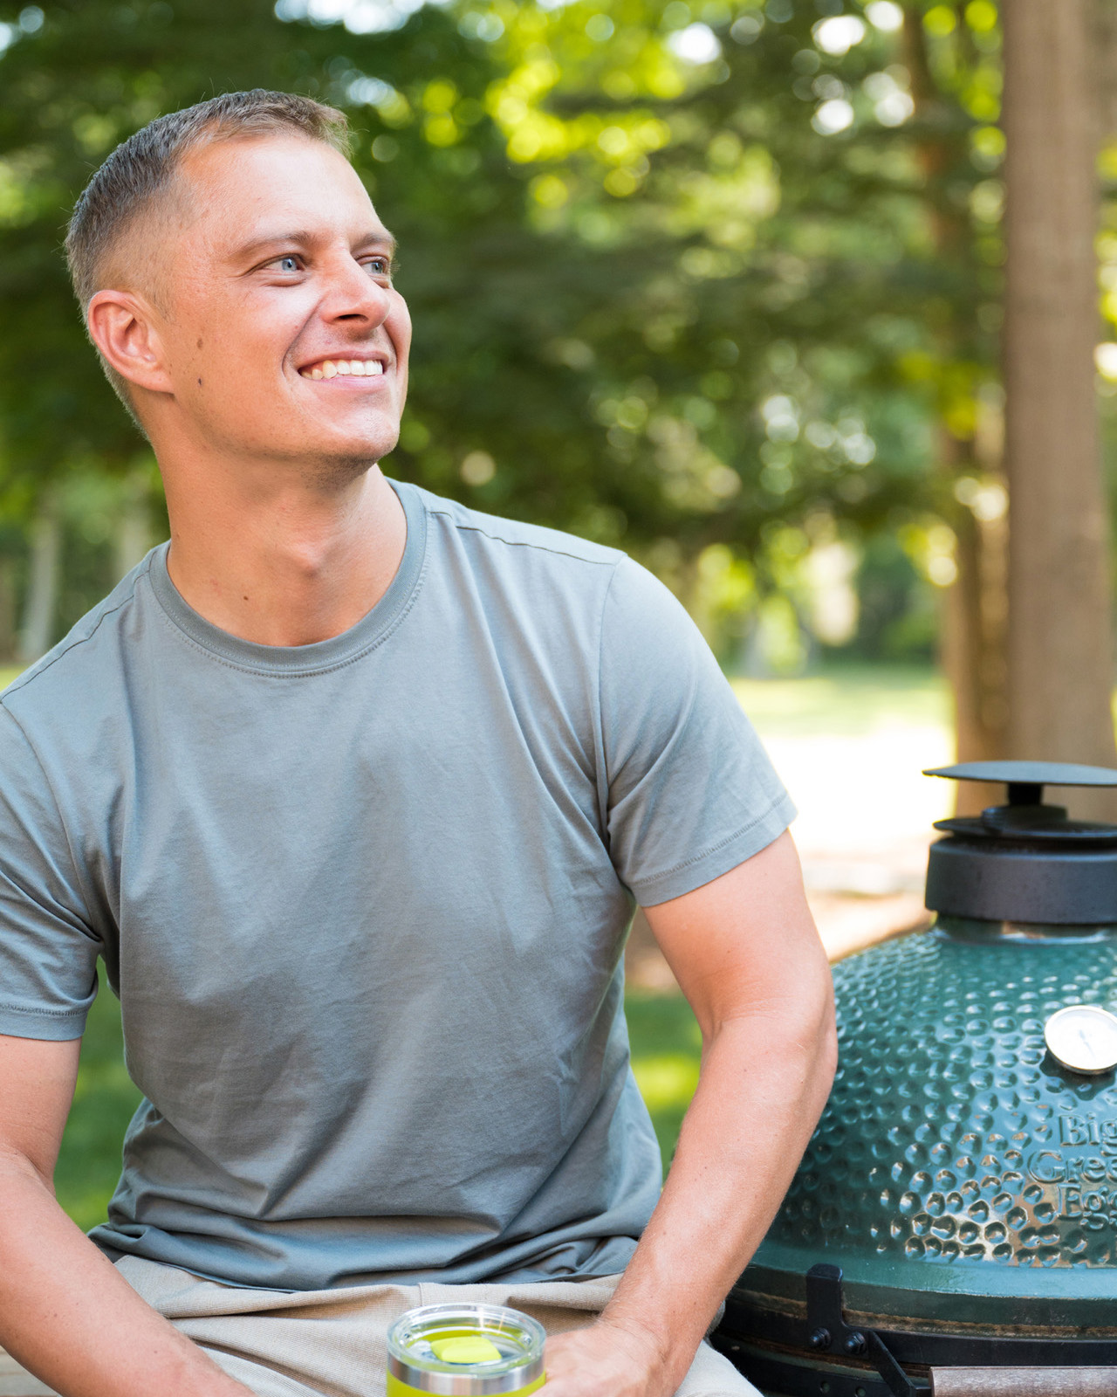 | 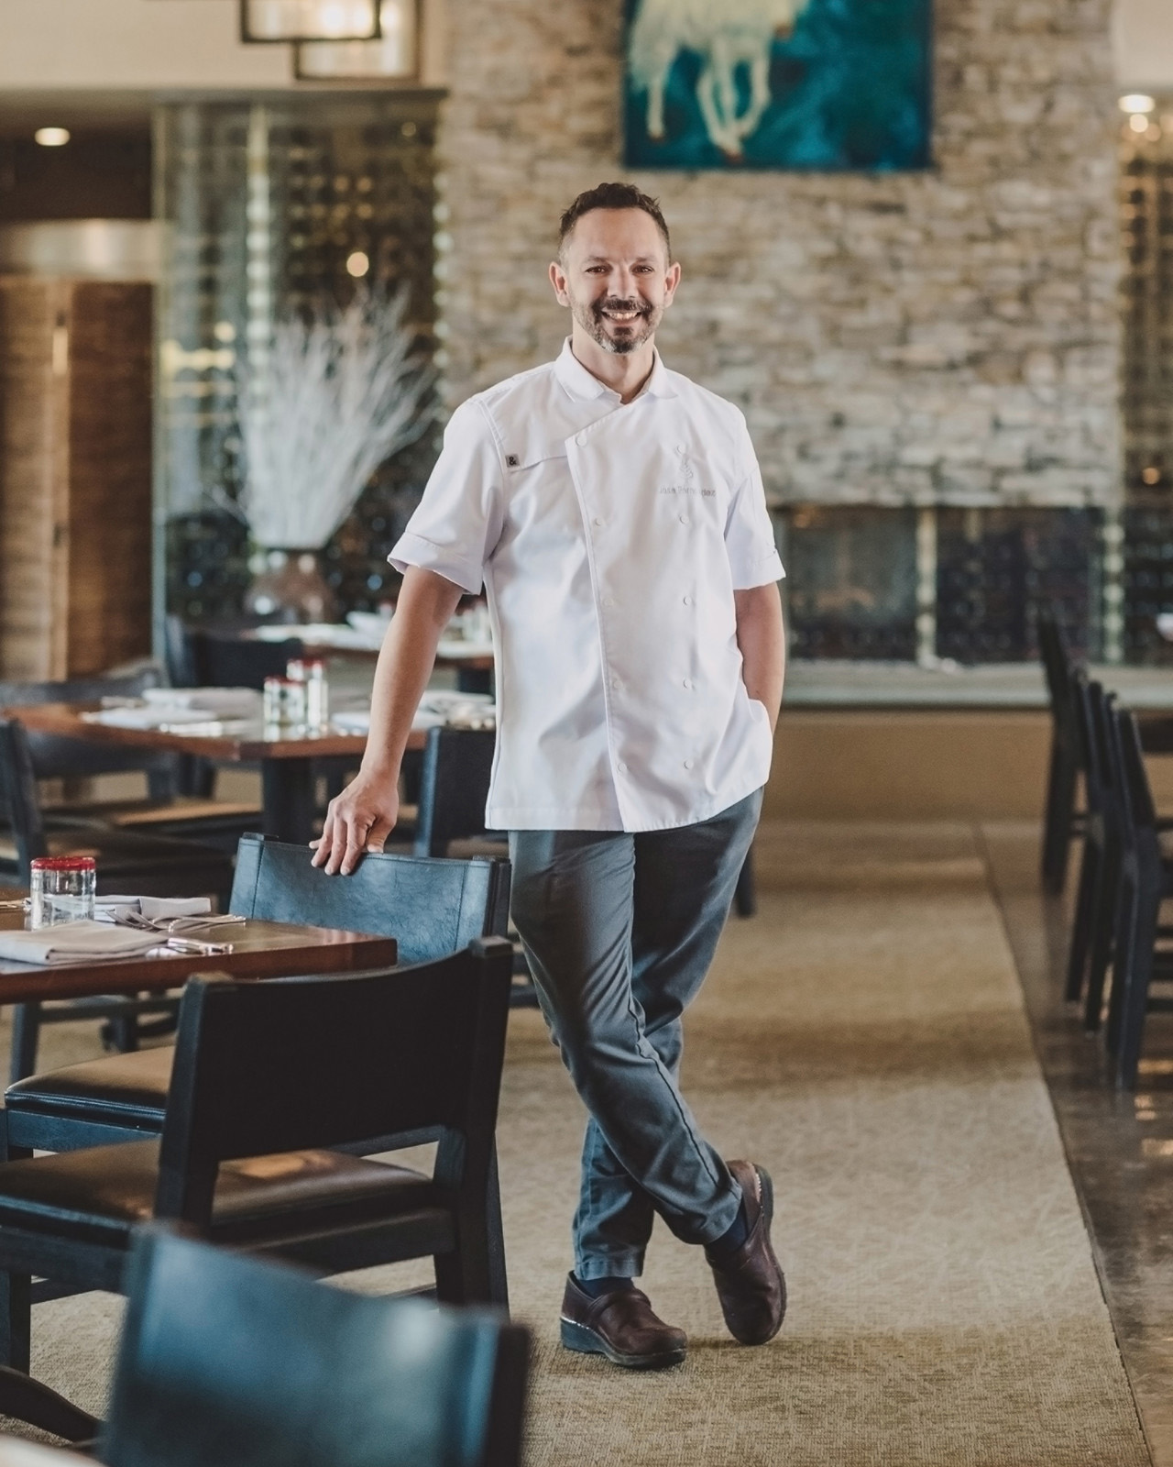 | 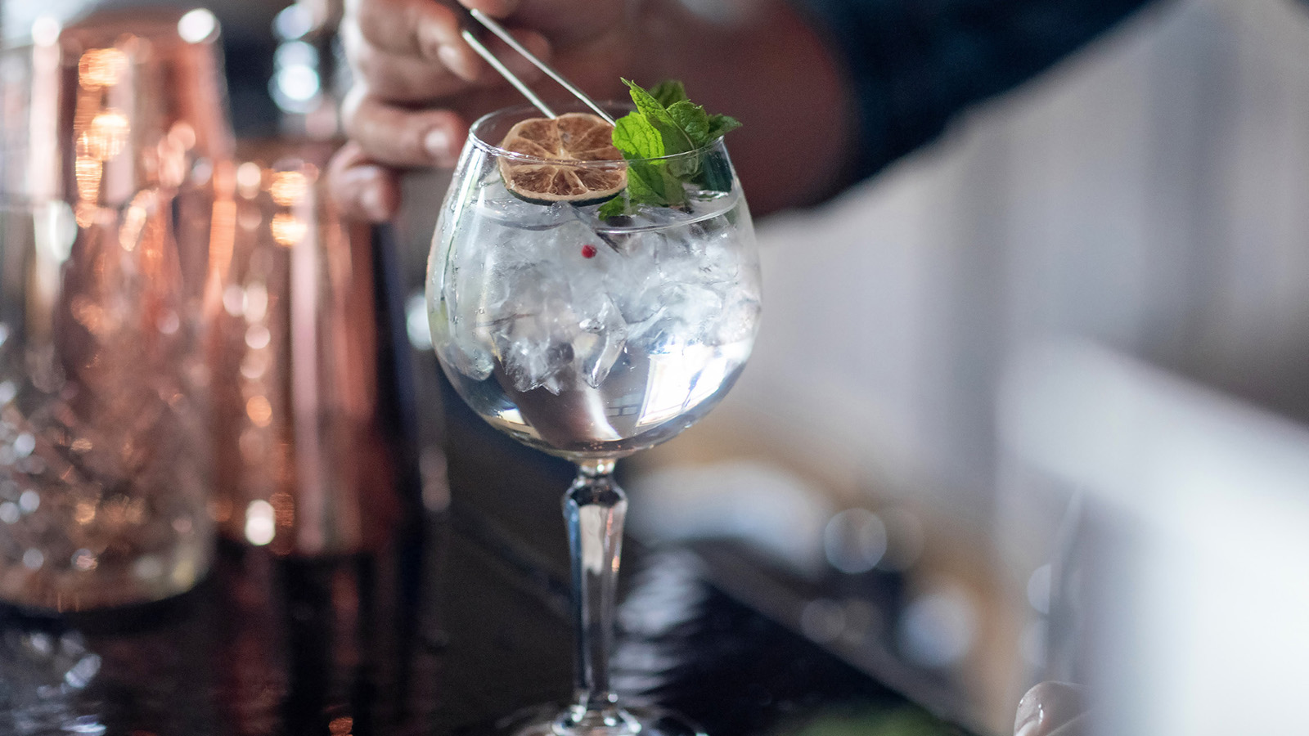
This Labor Day weekend, Four Seasons Resort Rancho Encantado is celebrating the end of the summer season with a weekend of limited-time barbecue delights and demonstrations with Chef Jack Arnold, Big Green Egg’s barbecue specialist and pitmaster, at Terra.
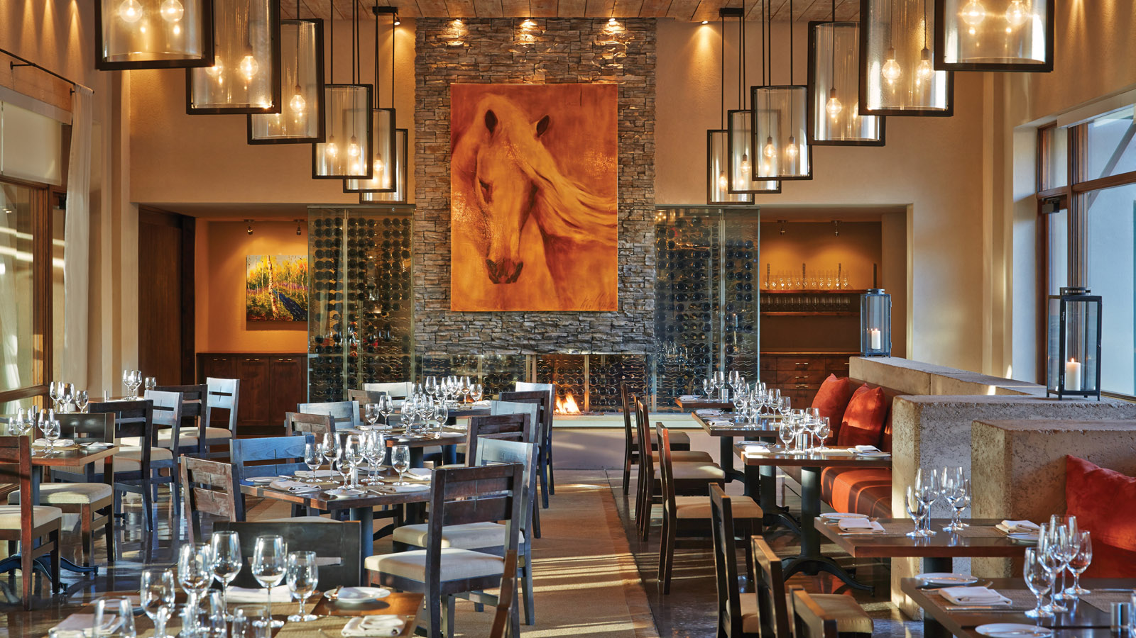
Taking place Saturday, September 3 and Sunday, September 4, 2022 from 5:30 to 8:00 pm, Chef Arnold will join forces with Four Seasons Resort Rancho Encantado Executive Chef Jose Fernandez for a lineup of straight-from-the-grill cuisine infused with traditional Southwestern flair. Served family-style, here is the lineup for the specialty menu:
Labor Day Weekend Barbecue Menu
- Grilled American Wagyu Tenderloins from KOW Steaks
- Jalapeño Cheddar Sausage from Southside BBQ
- Siberian Sturgeon Caviar from The Caviar Co.
- Point Reyes Farmstead Cheese Co. Tomas Truffle Mac & Cheese
- Green Chile Chicken Wings with TRUFF Hot Sauce
- Roasted Summer Corn, Piquillo Peppers and Garden Cucumber Salad with Ancho Chile Ranch
- Jalapeño and Cheddar Cornbread
Chef Arnold, who exclusively cooks on Big Green Egg grills, will also share tips and grilling techniques with guests along with how his family roots in south Texas inspired his passion for charcoal grilled and slow smoked beef.
In addition to Green Egg, partners for the event include KOW Steaks, CUTS, Southside BBQ, The Caviar Co., Jocko Fuel, VIDE, KOPU Water, Point Reyes Farmstead Cheese Co., Looft, TRUFF and Osmo Salt.
The event costs USD 135 plus tax per adult. For reservations, call 505 946 5700.

RELATED

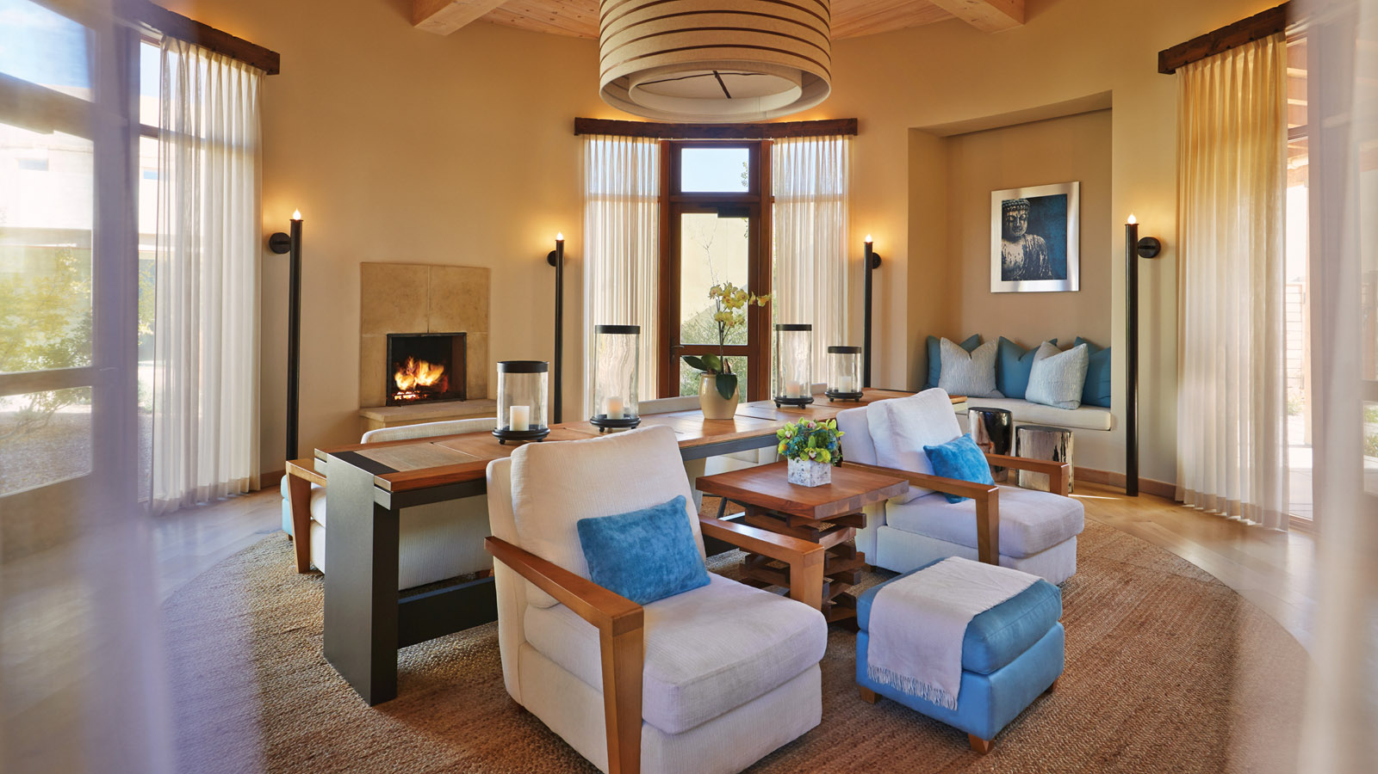 | July 27, 2022, Santa Fe, U.S.A.  Four Seasons Resort Rancho Encantado Provides High-Desert Healing with New Vortex-Inspired Spa Treatments  https://publish.url/santafe/hotel-news/2022/new-spa-experiences.html
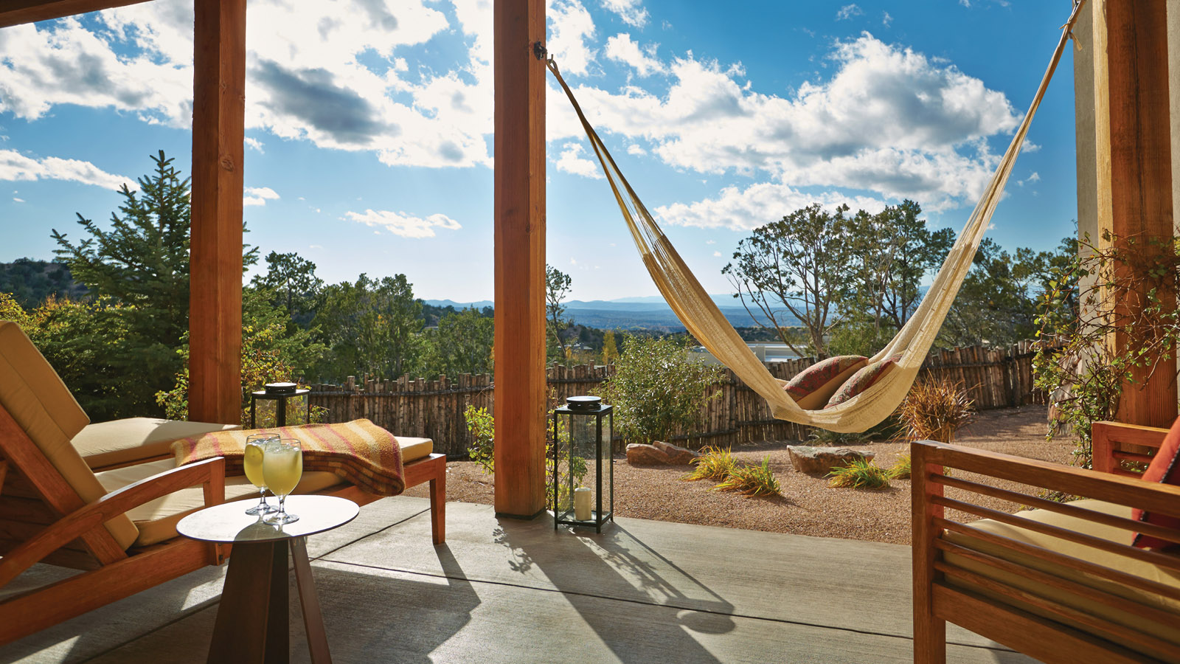 | June 2, 2022, Santa Fe, U.S.A.  Four Seasons Resort Rancho Encantado Makes Santa Fe a Must-Visit Spot This Summer with Exclusive Excursions  https://publish.url/santafe/hotel-news/2022/summer-activities.html

PRESS CONTACTS

Jan Bracamonte
President of J. Lauren PR & Marketing
21 E. 6th Street, #415
Tempe
USA
fourseasonssf@jlaurenpr.com

+1 480 540 3842

