FOUR SEASONS Bali at Jimbaran Bay
Tel: 62 (361) 701010 Email: press@fourseasons.com

OPENING DATE: June 1993
GENERAL MANAGER: Randy Shimabuku

Physical Features
Total Number of Rooms: 156
- Villas: 147
- Private residence rentals: 9
Design Aesthetic:
- Balinese village design with thatched-roof villas nestled among landscaped tropical gardens
- Each villa is comprised of a series of pavilions within a courtyard enclosure with private plunge pool
- More than 500 palinggih or small shrines reflecting Balinese culture
Interior Designer(s):
- Dale Keller & Associates, Hong Kong (Original villas)
- Jaya International, Jakarta (Renovation 2015-2016)
Location: Located on the southwestern tip of Bali, on the wide curve of Jimbaran's golden shores

Healing Village Spa
Signature Treatments:
- Celestial Light Ritual
- Baru Detox treatment
Special Features:
- The Illume Room
- Vichy Shower
- The Longevity Garden
Spa Director: Luisa Anderson

Dining
Examples of Locally Sourced Ingredients: 95 per cent of fruit, vegetables, fish and seafood

Recreation
Nirvana Shanti Yoga Bale, Yoga studio
Number of Pools: 3
Tennis:

For Younger Guests
- Jimba Kids’ Club facility with daily changing themes and activities including Balinese dance and dressups, kite flying, crab hunting and coconut bowling; Jimba Club is a safe, welcoming and adventure-filled space for kids ages 4 to 11 years

Coconut Grove Beach Retreat: Go on a family hobie cat expedition, team kayak or windsurfing race; non-motorised water sports are complimentary
Cultural Workshops: As part of its mission to actively support local artists, the Resort offers classes and workshops in Balinese art, music and crafts; recommended classes for younger guests include Balinese dance observation, canang making, painting, the art of Sokasi and ogoh-ogoh making

Meeting Rooms
Private Dining Room Capacity:

Corporate Social Responsibility
- Collaborate with PT. Jimbaran Hijau for its green tree-planting initiatives and culture initiative through tenun-machine donation and training which involving students and teachers at SLB Jimbaran (School for the Hearing Impaired)

- Internship program for hearing impaired students from the School for Special Needs, Nusa Dua. Each year, 5 students from the school complete 6 months of on-the-job training at Four Seasons Jimbaran Bay in their chosen department such as housekeeping or food and beverage. The Resort also donated traditional weaving machines to the school to preserve this ancient art and develop students’ skills in cultural crafts.
- Monthly clean-ups of the Resorts’ local areas – Jimbaran Beach and Ayung River Valley, and participation in annual clean-up events including Bali’s Biggest Beach Clean-Up (2017).
- Preservation of Bali’s arts heritage through Ganesha Cultural Centre, providing guests with the opportunity to meet and do workshops with local artists from around the island; painting, weaving, carving, dance/music and more.
- Recycling soap program in collaboration with ROLE Foundation to save the environment and help marginalised women in Bali.

Special Features
- Ganesha Cultural Centre, an interactive and experiential space dedicated to exhibitions and workshops in Balinese art, music and crafts

- Jala Cooking Academy, a stand-alone cooking school that gives food lovers of all ages and experience levels the hands-on opportunity to discover secret local cooking techniques using organic Indonesian ingredients
- Heli-Surfing Tours, surf exploration with Tropicsurf to discover a pristine wilderness that offers uncrowded, world-class waves at G-Land

PRESS CONTACTS
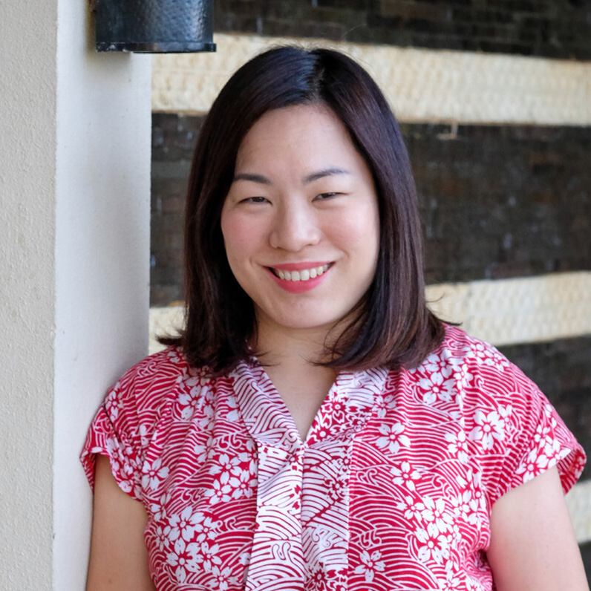 | Camilla Chiam  Senior Director of Public Relations and Communications  Jimbaran  Indonesia  camilla.chiam@fourseasons.com
Adrian Pardede
Assistant Director of Public Relations and Communications

Jimbaran
Indonesia
adrian.pardede@fourseasons.com

+62 (361) 701010

