Mangroves, Monkeys, Eagles, Lizards and Snakes, Oh My!

September 19, 2018, Langkawi, Malaysia

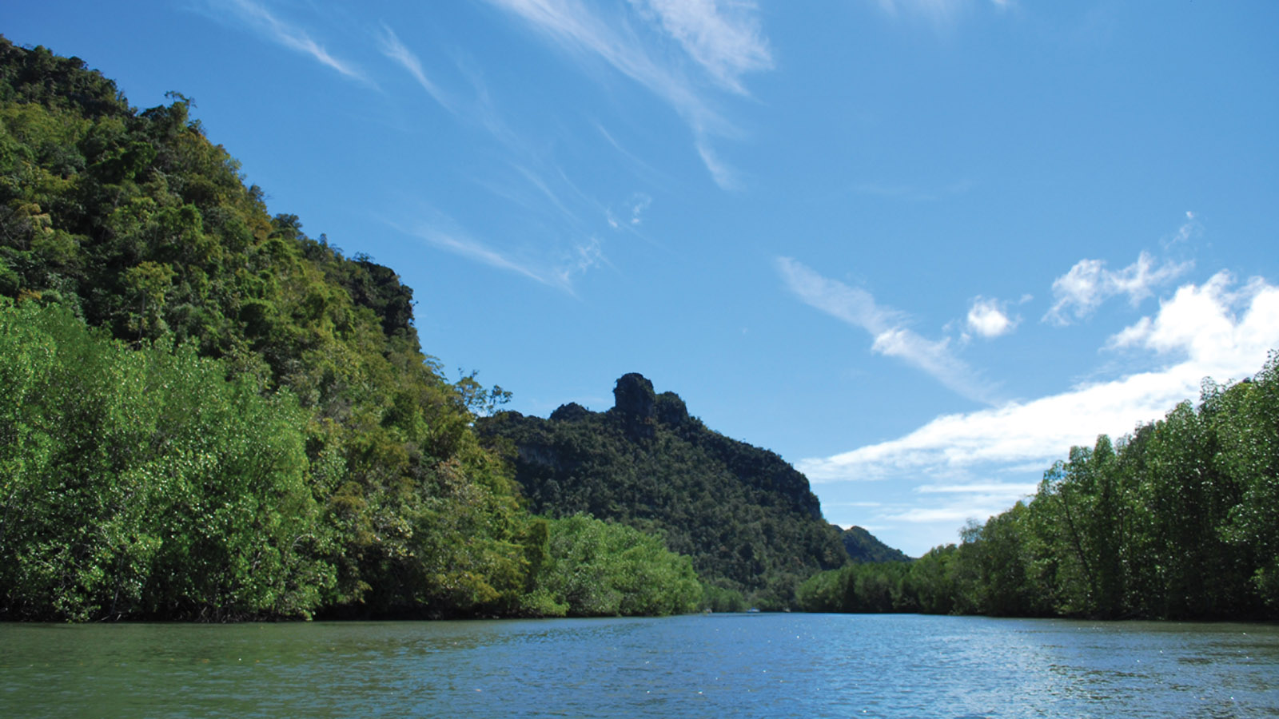
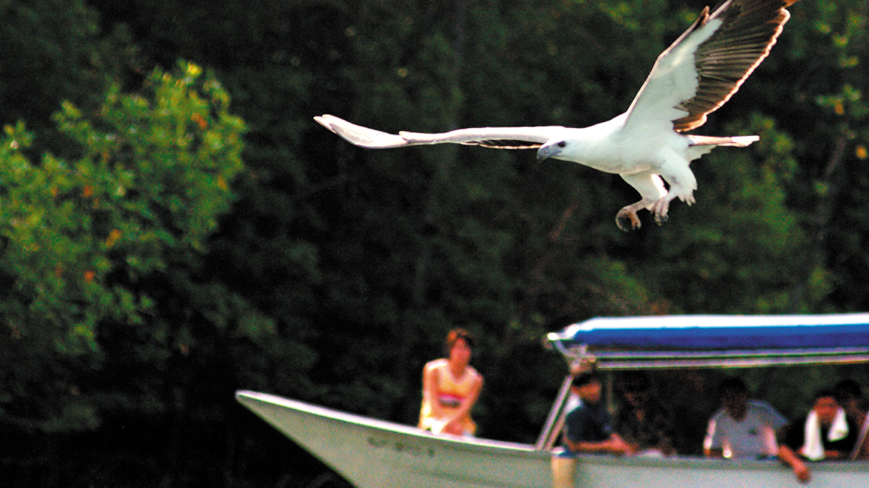 | 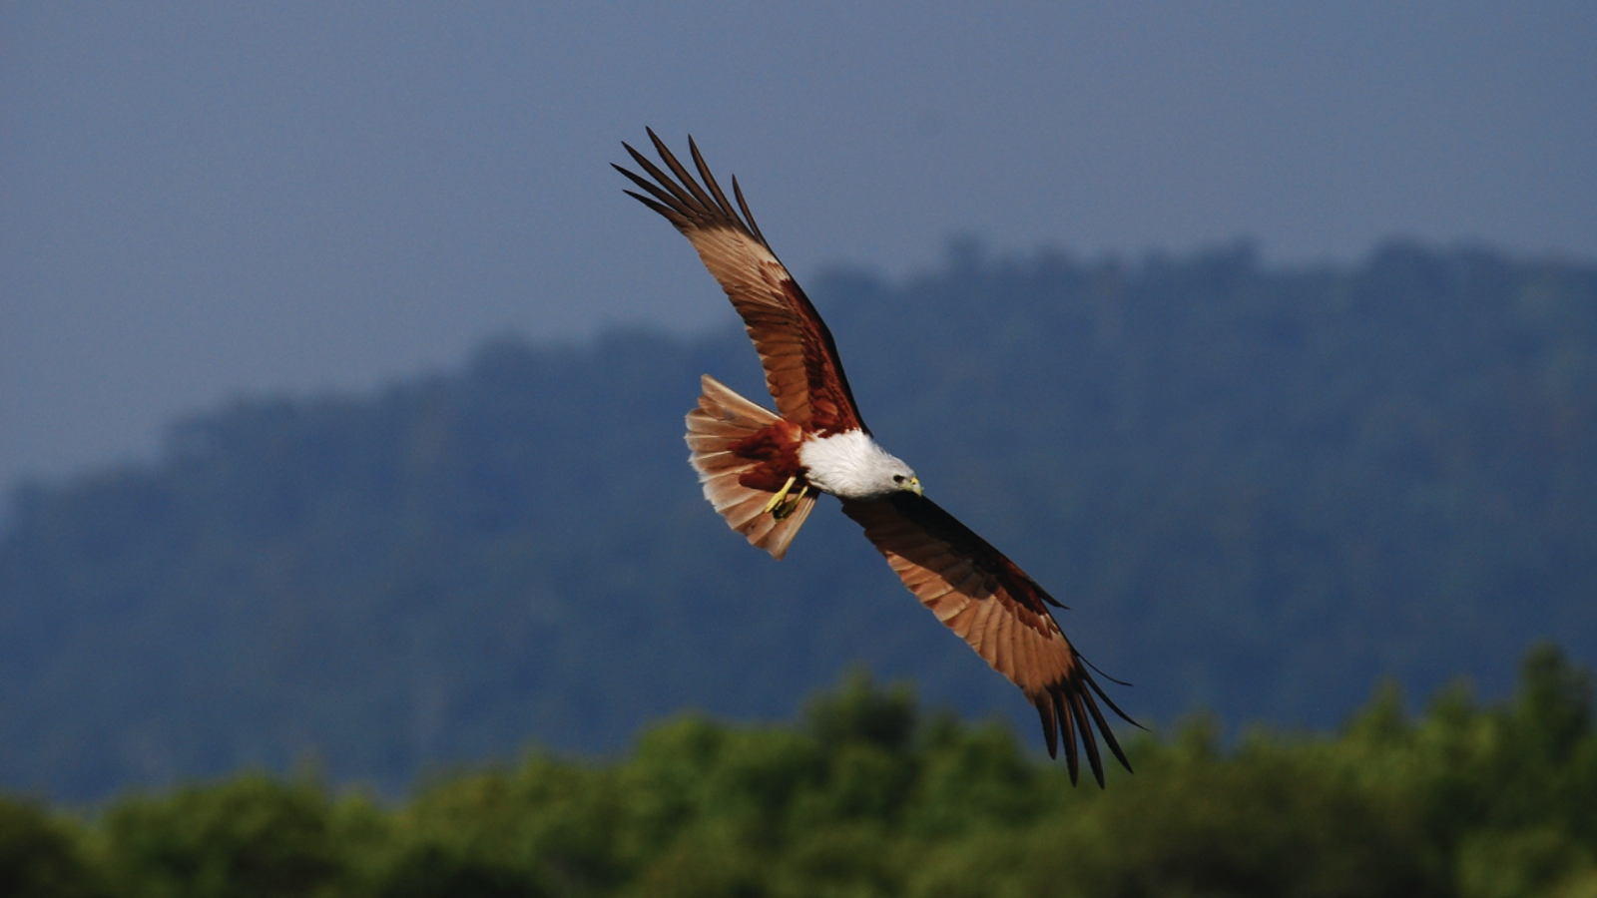 | 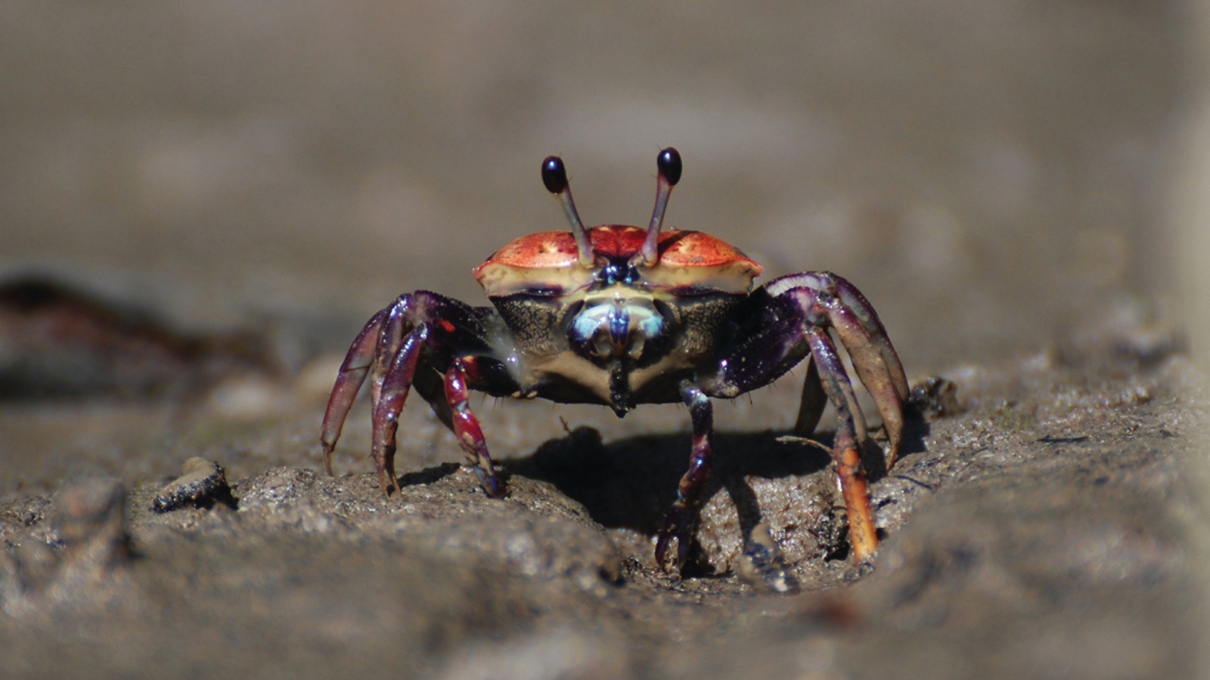
These are just a few of the unusual wildlife to witness aboard the Mangrove & Eagles river safari through Kilim Karst Geoforest Park, exclusive to guests of Four Seasons Resort Langkawi.
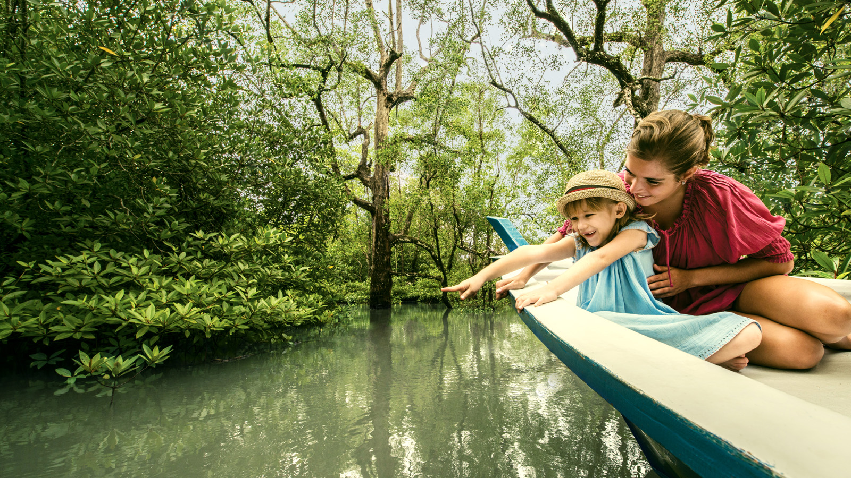 | 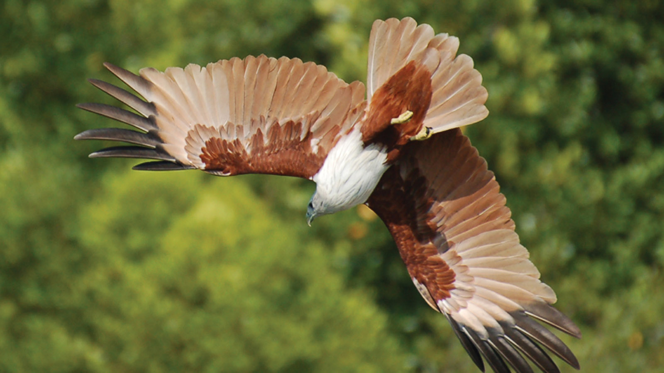 | 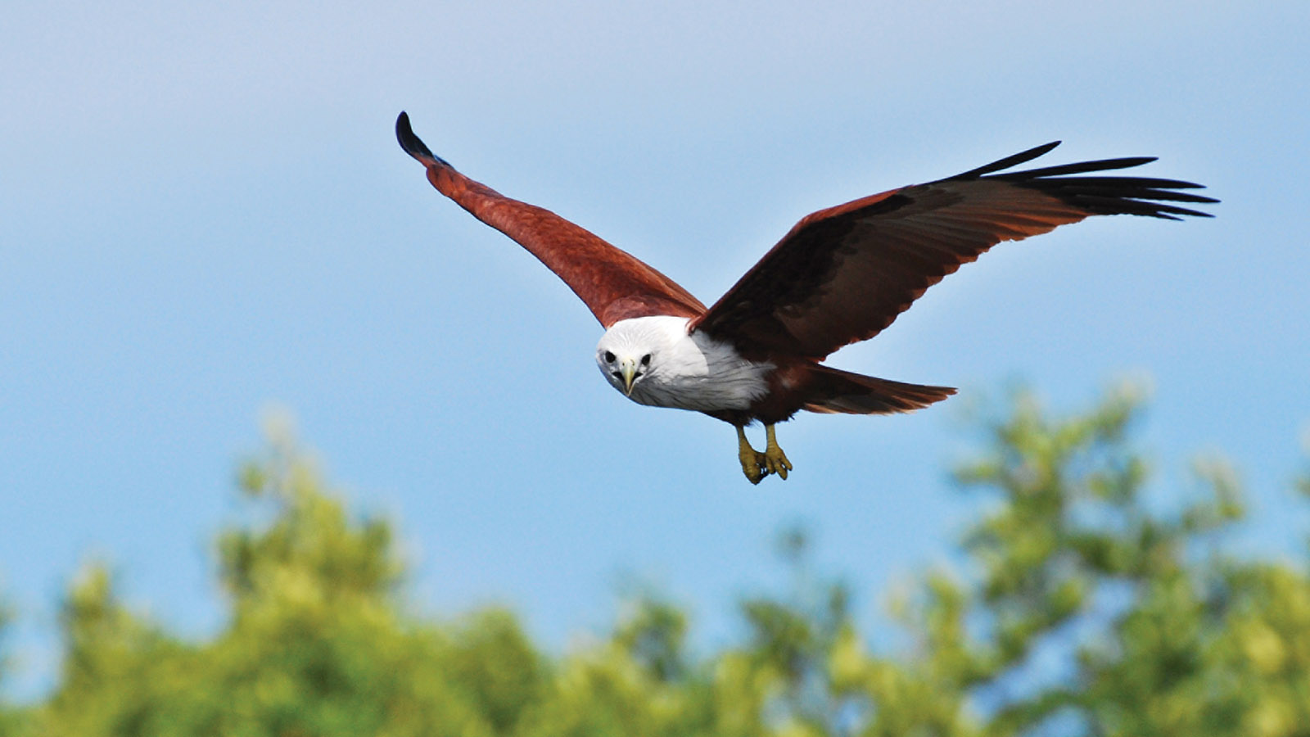
As part of the UNESCO-protected Geopark, Kilim Karst is one of the world’s most diverse tropical eco-systems, making for an extraordinary eco-adventure. Witness Langkawi’s “Flying Five,” which include airborne lemurs, lizards, frogs, tree snakes and squirrels, plus stunning geological formations that are more than 550 million years old, including limestone rocks, and caves, throughout the 2.5 hour river safari tour through the ancient and alluring maze of mangroves.
“Kilim Karst is an awe-inspiring natural system of streams and hidden coves, home to hundreds of endemic jungle species of wildlife,” says Aidi Abdullah, Chief Naturalist at Four Seasons Resort Langkawi. “It’s a humbling, and truly a once in a lifetime experience to witness these rare and fascinating creatures in their natural habitat.”
Ideal for families or couples looking to explore Langkawi’s rich natural heritage, each river safari is led by one of the Resort’s three Resident Naturalis, including Aidi. A 15-minute boat ride takes guests directly from the beach to the mount of Kilim River beyond which lies one of the world’s most protected mangrove forests. Once inside the jungle, the tour offers exciting up-close and personal encounters with a host of resident wildlife.
For younger guests, the Resort offers an engaging hour-long Mangrove & Monkeys Safari aboard a river boat. Essentially a floating classroom, the tour offers an eco-experience aimed specifically at intrepid adventurers aged between 4-12, with the opportunity to explore and discover the magical mangrove world.
“As will all conservation, awareness is key,” notes Aidi. “Our safaris cultivate awareness in both young and old alike, and offer the chance to experience a unique micro-community that is itself the root of all marine ecology. Protecting the mangroves is essentially protecting ourselves.”
Witness nature at its best and meet new friends during the Mangrove & Eagles Safari including monkeys, snakes, otters, and more, only at Four Seasons Resort Langkawi. To make a reservation, contact the Central Reservations Department of Four Seasons Resort Langkawi at tel: (60) 4 950 8888.

RELATED

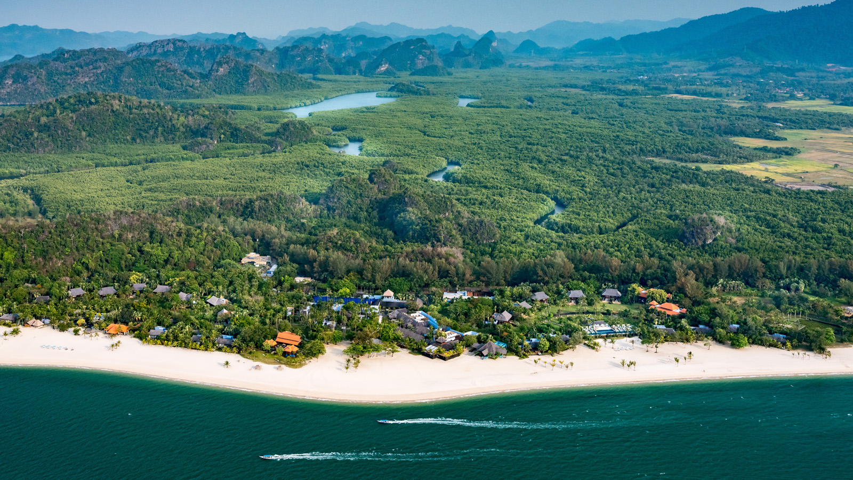 | September 6, 2018, Langkawi, Malaysia  Four Seasons Resort Langkawi Embraces Bold New Look  https://publish.url/langkawi/hotel-news/2018/renovation-plan.html
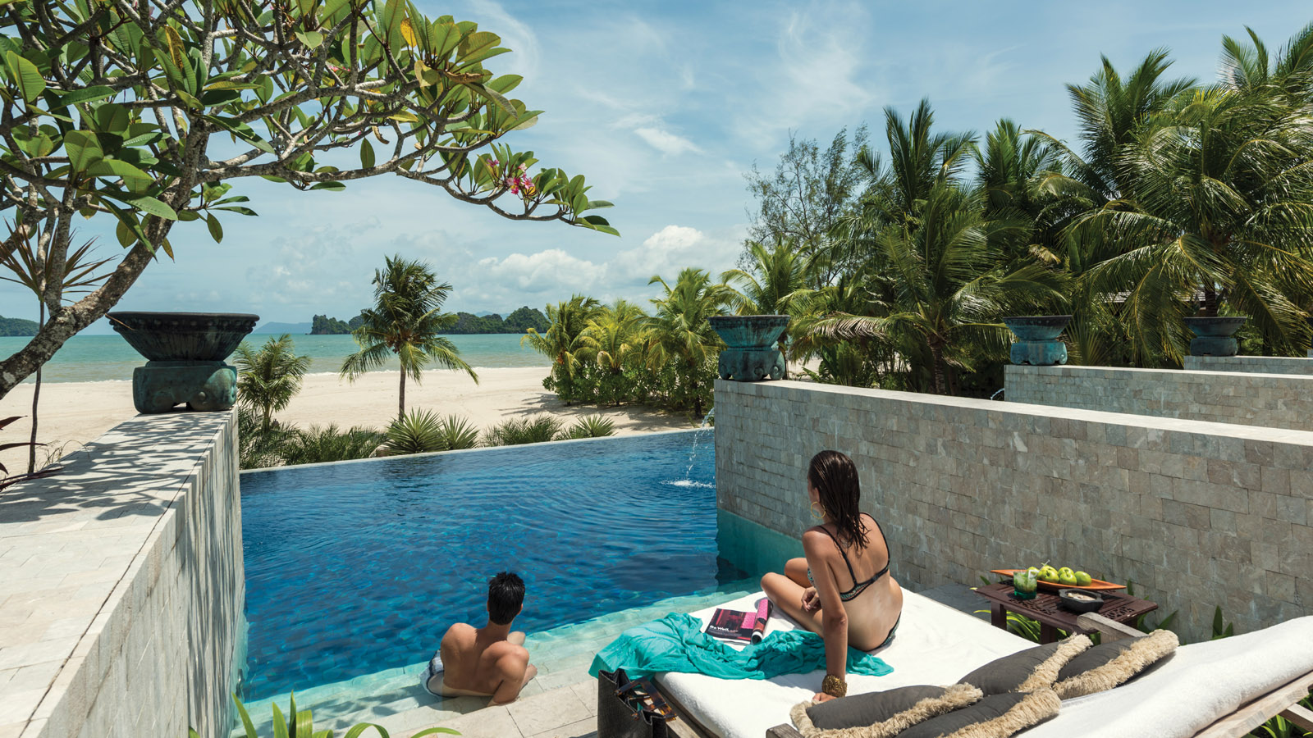 | August 21, 2018, Langkawi, Malaysia  Experience a Crazy-Good Escape at Four Seasons Resort Langkawi  https://publish.url/langkawi/hotel-news/2018/escape-to-paradise-package.html

PRESS CONTACTS

Venoshia Vellasamy
Public Relations Manager
Jalan Tanjung Rhu
Langkawi
Malaysia
venoshia.vellasamy@fourseasons.com

+604 950 8907

