Everyone Deserves a Vacation - Even the Furriest Members of the Family

Four Seasons Hotel St. Louis opens its arms to all of its guests in one of the most pet-friendly cities in the world
October 3, 2014, St. Louis, U.S.A.

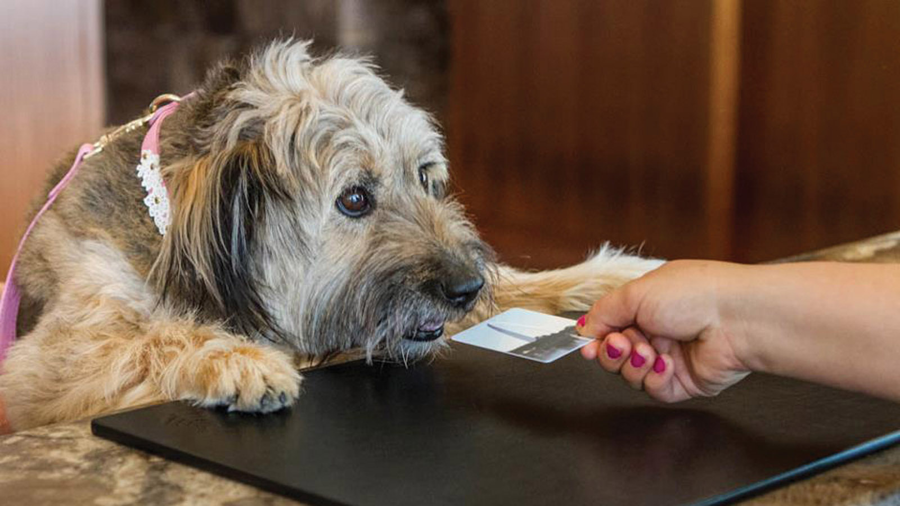
Four Seasons Hotel St. Louis is happy to welcome furry companions to the hotel. After all, what's a vacation without the whole family?
We currently provide the following complimentary amenities for dogs and cats; additional enhancements can be arranged by notifying the reservations team that a furry companion will be present, prior to arrival.
- Dog beds
- Milk Bone dog treats
- Two bowls
- One bottle of water
Enjoy easy access to nearby Laclede's Landing Dog Park, located within a five-minute walk of the Hotel. Additional dog-friendly parks, outdoor restaurants, wineries and gardens may also be recommended by contacting the Hotel Concierge.

RELATED

August 9, 2021, St. Louis, U.S.A.
Four Seasons Hotel St. Louis and Big Green Egg Host the Ultimate End of Summer “Grill + Chill” Barbecue
https://publish.url/stlouis/hotel-news/2021/barbecue-event.html

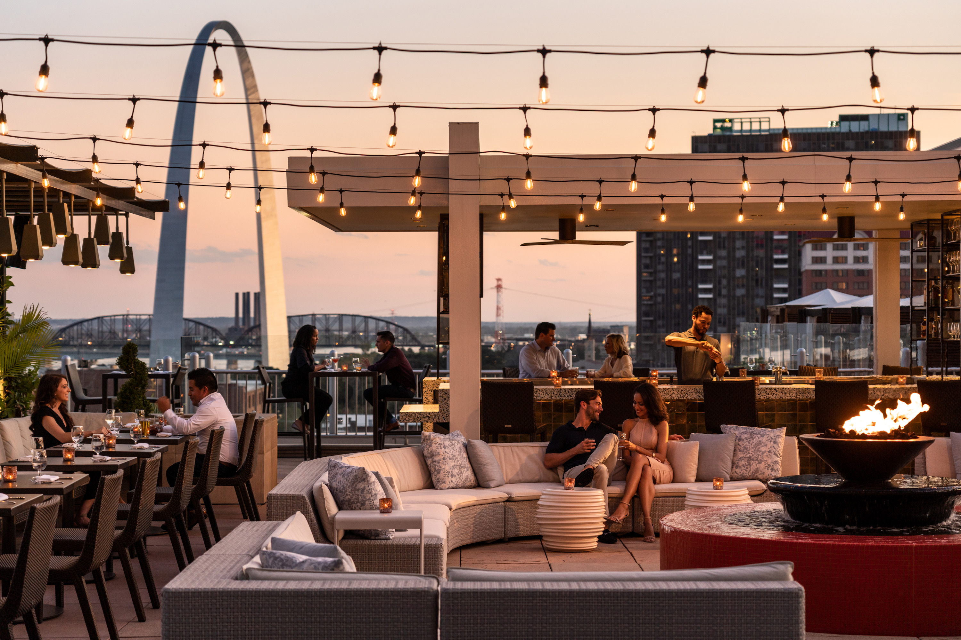 | June 7, 2021, St. Louis, U.S.A.  Cinder Bar Launches Rosé on the Rooftop at Four Seasons Hotel St. Louis This Summer  https://publish.url/stlouis/hotel-news/2021/rose-on-the-rooftop.html

PRESS CONTACTS

Chloe Caylor
Director of Public Relations and Communications
999 North 2nd Street
St Louis
USA
Chloe.Caylor@fourseasons.com

+1 (314) 881-2021

