Four Seasons Hotel Boston Maintains Prestigious Five Star Distinction in Forbes Travel Guide 2023 Star Awards

The iconic luxury property celebrates 24 consecutive years of Forbes Travel Guide’s highest rating
February 15, 2023, Boston, U.S.A.

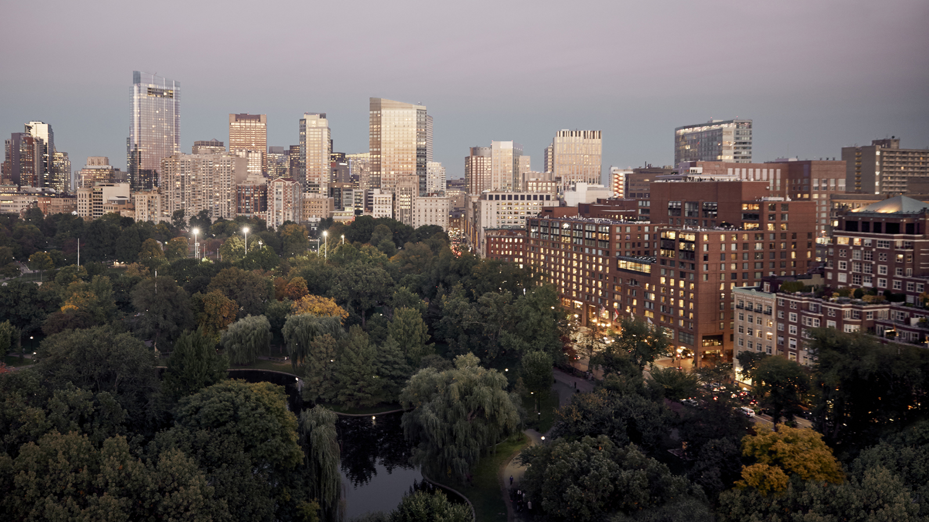
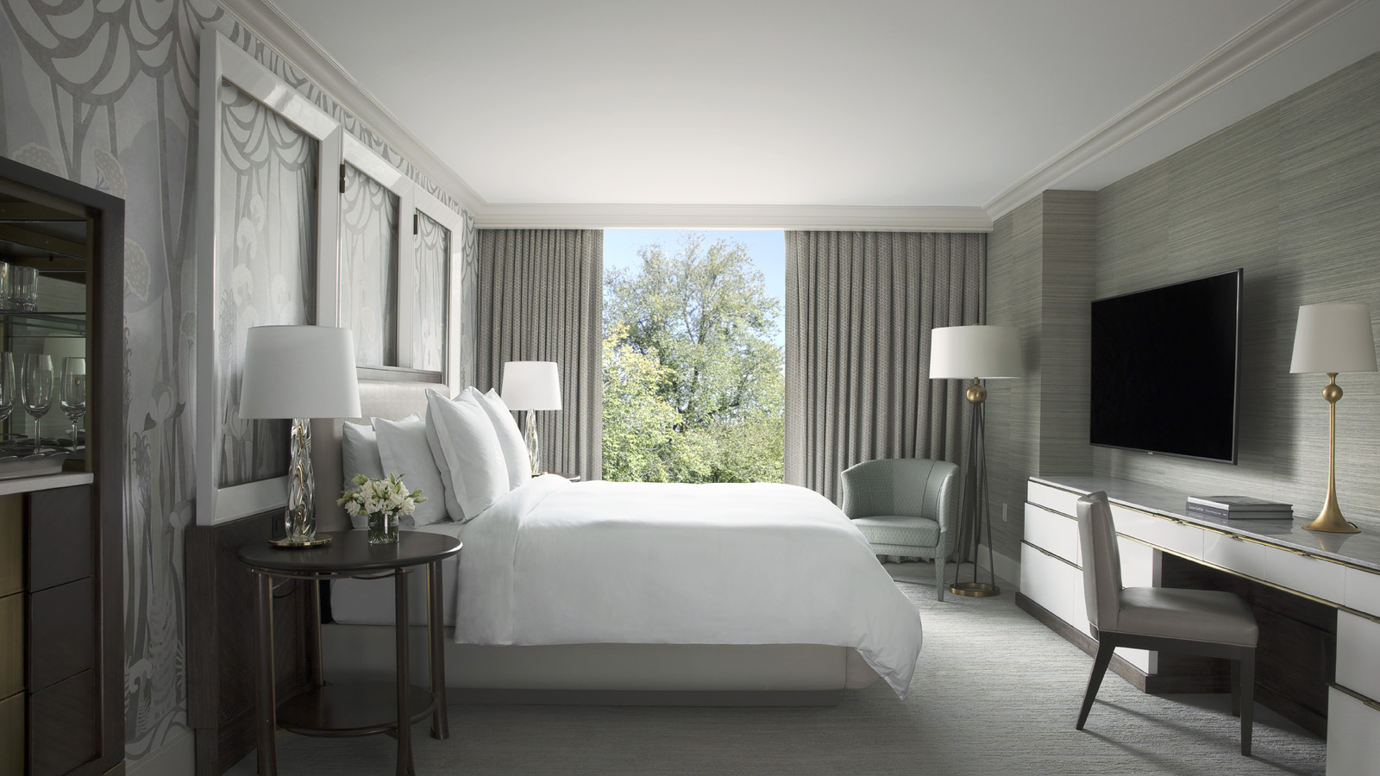 |  | 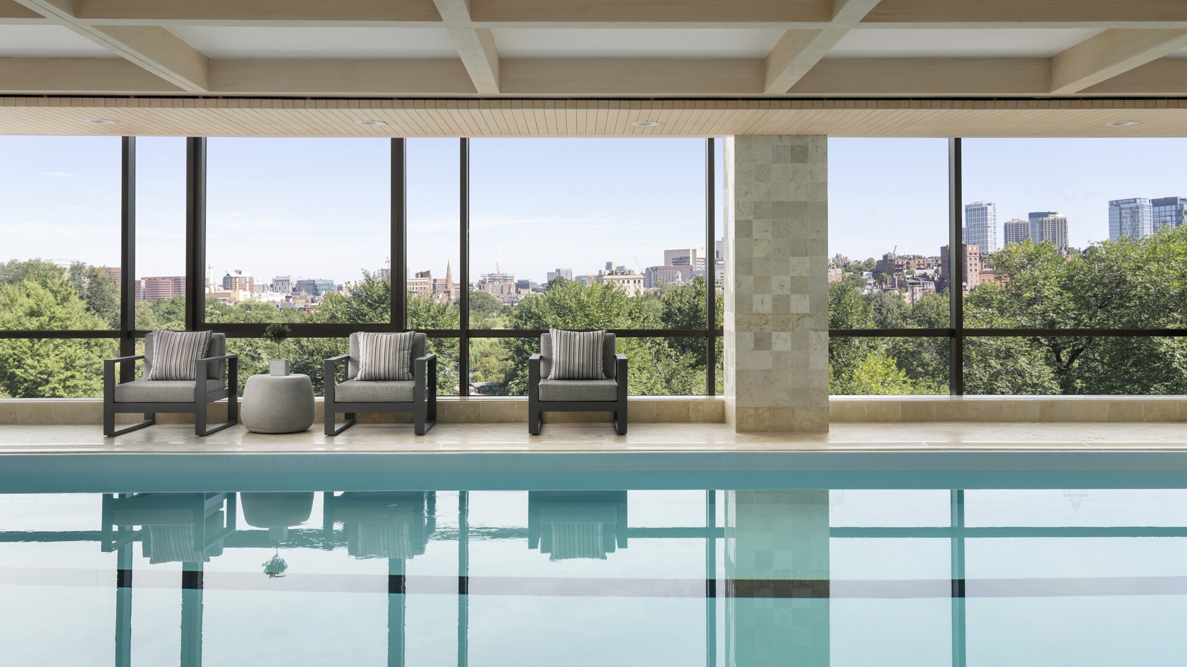
Forbes Travel Guide, the only global rating system for luxury hotels, restaurants, spas and ocean cruises, today announces its 2023 Star Award winners, recognizing Four Seasons Hotel Boston with the highest rating, Five Star. Described as “an exquisite Boston classic” by Forbes Travel Guide, the Hotel is the longest-running Five Star property in the city. This is the 24th consecutive year Four Seasons Hotel Boston has been awarded this prestigious honour, a tribute to the Hotel’s earned timelessness and effortless luxury.
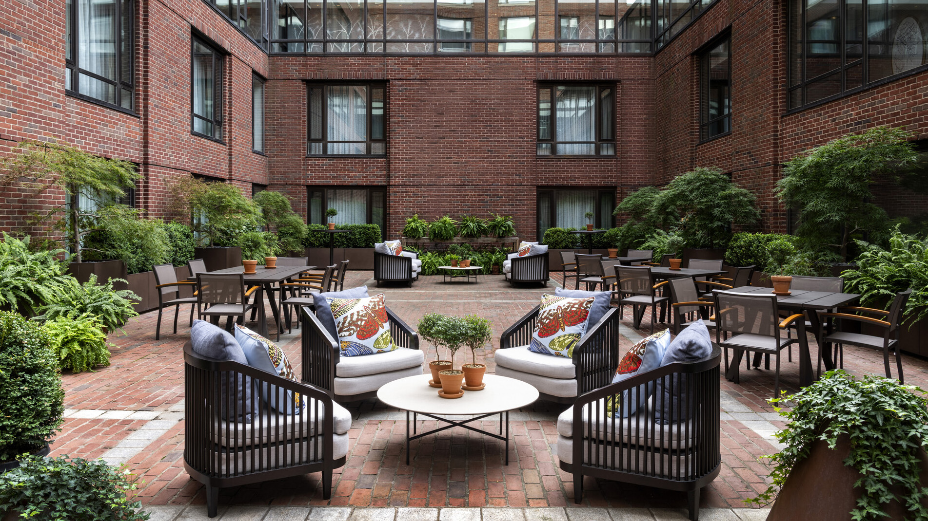
Enjoying Boston’s most coveted location, the luxury hotel overlooks the Public Garden and adjacent Boston Common and is the perfect locale for easy access to the rich history and attractions of the nation’s most walkable city. With 273 well-appointed guest rooms, 77 expansive suites, an indoor pool, and spectacular, light-filled event spaces overlooking the garden, Four Seasons Hotel Boston remains a true beacon of luxury in Massachusetts’ capital city.
“The Five Star award is a testament to the team’s dedication to our guests,” says General Manager Michael Pedder. “I could not be prouder to work alongside such passionate professionals who are committed to delivering an extraordinary experience to every guest who walks through our doors.”
Forbes Travel Guide star ratings are awarded by a team of anonymous professional inspectors who travel the world to assess hotels, restaurants and spas based on 900 objective standards. Star ratings ultimately emphasize quality of service. Five Star properties are defined as “outstanding, often iconic properties with virtually flawless service and amazing facilities.”
For reservations at Four Seasons Hotel Boston, book online or call 1 617 338 4400.

RELATED

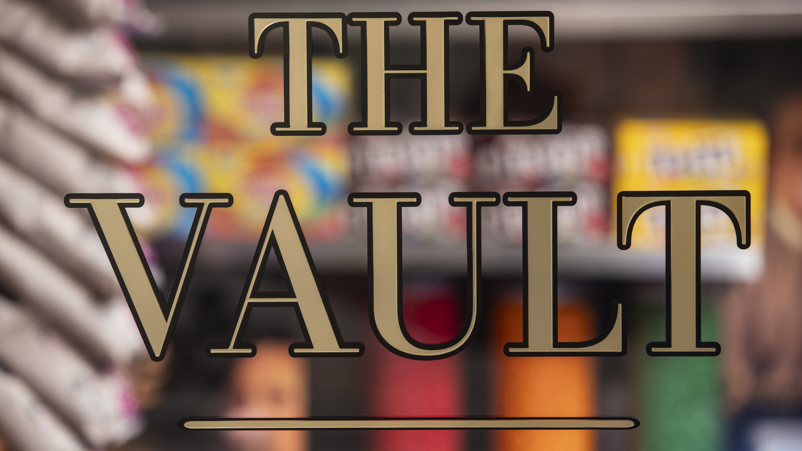 | December 7, 2022, Boston, U.S.A.  Four Seasons Hotel Boston Unlocks “Vaults” of Complimentary Snacks and Beverages  https://publish.url/boston/hotel-news/2022/complimentary-snacks-and-beverages.html
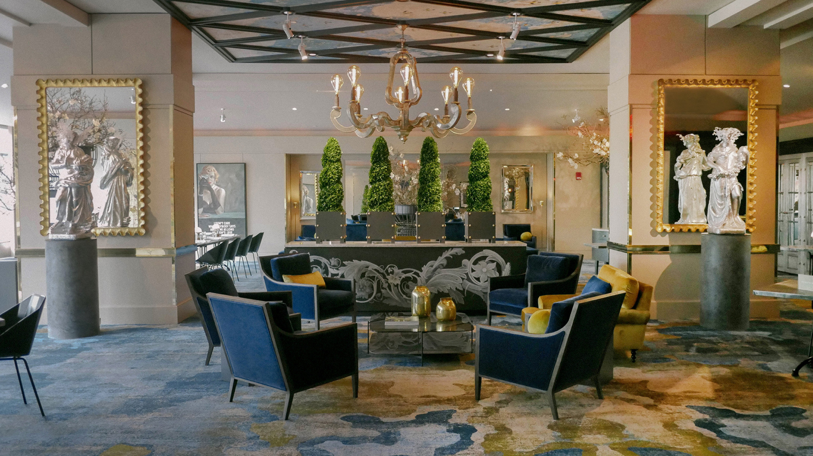 | June 21, 2022, Boston, U.S.A.  Four Seasons Hotel Boston Unveils Art Collection  https://publish.url/boston/hotel-news/2022/new-art-collection.html

PRESS CONTACTS

Crissa Hiranaga
Senior Director of Public Relations and Communications
200 Boylston Street
Boston
USA
crissa.hiranaga@fourseasons.com

+1 808 268 9644

Brianna Roberts
Digital Marketing Manager
200 Boylston Street
Boston
USA
brianna.roberts@fourseasons.com

+1 617 351 2141

