Four Seasons Hotel Chicago Unveils USD 25,000 Valentine's Day Package, Element 79

From the Moonstruck on Michigan package to the new Skylight Swim, the Hotel is poised to be the ultimate romantic destination this February
January 9, 2019, Chicago, U.S.A.

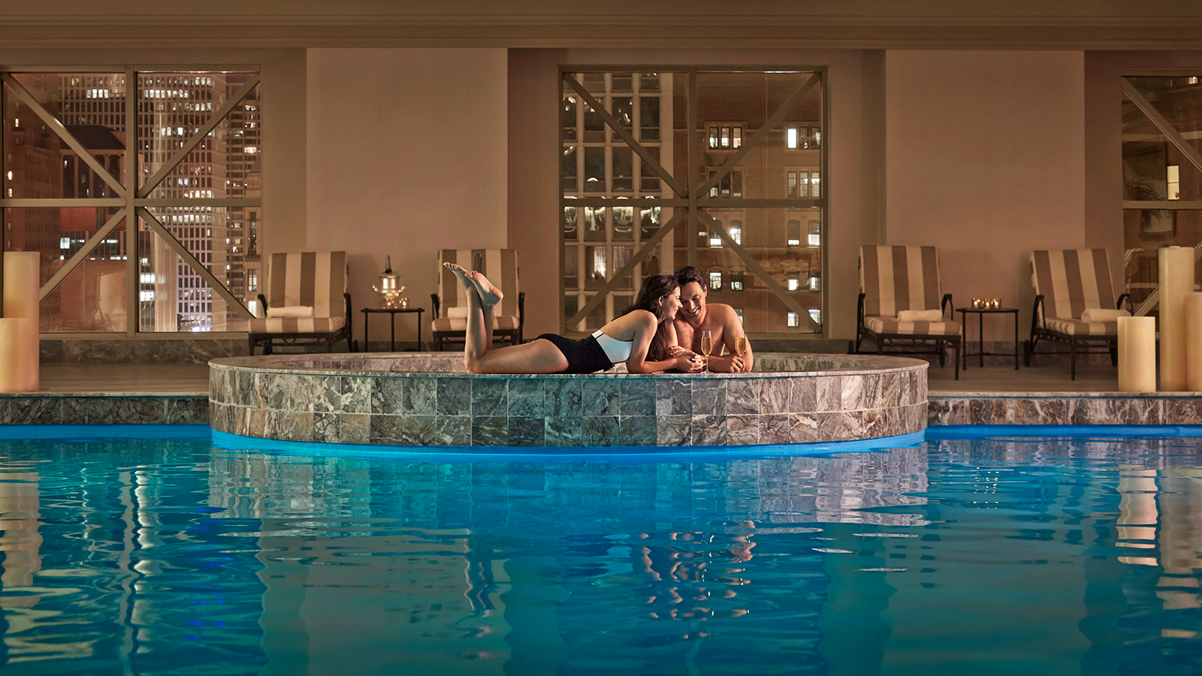
This Valentine's Day, Four Seasons Hotel Chicago invites smitten sweethearts to experience its extravagant package, Element 79, or the Moonstruck on Michigan offer at the Hotel, The Spa and Allium Restaurant & Bar.
Element 79: Gold Coast Grandeur
Referencing gold, the 79th element on the periodic table, Four Seasons unveils its indulgent USD 25,000 Element 79 package for Valentine's Day:
- Presidential Suite: At 2315 square feet (215 square metres), the sprawling Presidential Suite occupies an entire corner of the Hotel's 46th floor
- An in-room welcome amenity of Veuve Clicquot La Grande Dame 2004, an exclusive blend of eight traditional grand crus
- 80-minute couple's massage, performed in the suite
- 80-minute Gold Coast's Ultimate Secret Facialfor two: Referencing the Hotel's neighbourhood along Lake Michigan, this treatment unveils the ultimate facial treatment from Secrets de Sothys Soin Excellence. This incomparable anti-ageing treatment envelops the skin with soft, rich textures and light delicate scents to plunge the senses into a peaceful and serene sanctuary
- Gold jewellery from Bloomingdale's: An 18-karat yellow gold caviar, three pavé diamond station statement bracelet by Lagos
- Five-course dinner for two from Allium Executive Chef Michael Zachman with wine pairings, served in the Presidential Suite
This package requires a five-day advance booking. For more information, contact Jim Guttau at jim.guttau@fourseasons.com.
Moonstruck on Michigan
For a romantic stay on a more moderate budget, couples can take advantage of the Moonstruck on Michigan package from February 1 through 28, 2019:
- Overnight stay in a Lake View or City View Room
- Bottle of Mo&euml;t & Chandon Imperial
- Sweet treat from Executive Pastry Chef Scott Gerken
- USD 50 food and beverage credit for in-room dining or Allium Restaurant & Bar
During the stay, luxuriate at The Spa with a Magnificent Mile Massage, customised to meet individual needs, or take advantage of the new exclusive experience for couples, Skylight Swim. Closed to all other guests, the Roman-style indoor pool is open to just one couple at a time. At 8:30 pm, the experience begins with the Spa's signature couple's 80-minute massage and concludes in the pool area with a bottle of Champagne and canapes prepared by the talented culinary team. This romantic experience under the stars is available nightly from 8:30 to 11:00 pm. For Skylight Swim or spa reservations, call 312 280 8800.
Valentine's Day Dinner at Allium Restaurant & Bar
Allium Executive Chef Michael Zachman presents a delectable four-course dinner at USD 85 per person that will be offered the evenings of February 14, 15 and 16, 2019 at Allium Restaurant & Bar:
Amuse-bouche
First Course
- Borscht soup with lump blue crab, ruby red beets and horseradish crème, or
- Arugula salad with pickled strawberries, Moody blue cheese, pepitas and spiced pecan vinaigrette
Entrée
- Snake River Farms beef tenderloin with butternut squash purée, chestnut pudding, broccolini and black truffle jus, or
- Sea scallop and prawn duo with lobster ravioli, smoked bacon, asparagus and piquillo pepper cream, or
- Andean quinoa with ancient grains, black beans, sweet potato, crispy tofu and salsa verde
Dessert for Two
- Chocolate passionfruit bar with white chocolate chantilly, strawberry sauce and strawberry gelato - accompanied by heart-shaped macarons and passionfruit pears
For dinner reservations, call 312 799 4900.

RELATED

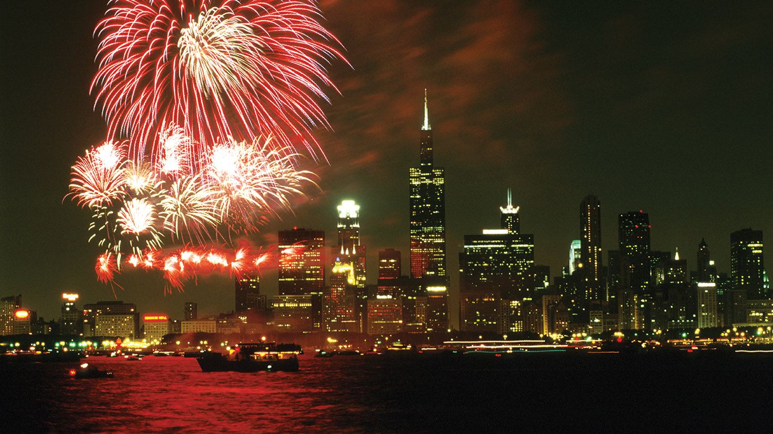 | December 5, 2018, Chicago, U.S.A.  Ring in the New Year - Chicago Style – at Four Seasons Hotel Chicago  https://publish.url/chicago/hotel-news/2018/new-year.html
October 15, 2018, Toronto, Canada
Four Seasons Hotels Offer Special City Getaways This Holiday Season
https://publish.url/news-releases/2018/stay-longer-with-four-seasons-this-winter.html

PRESS CONTACTS

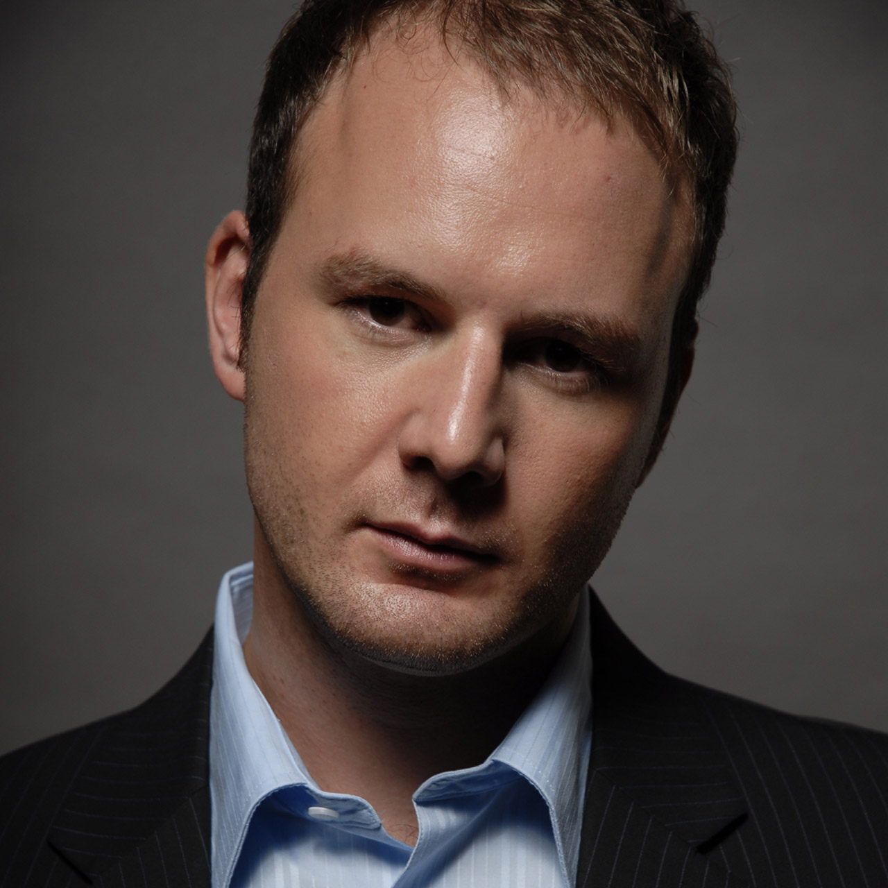 | Jim Guttau  Director of Public Relations  120 East Delaware Place  Chicago  U.S.A.  jim.guttau@fourseasons.com  +1 (312) 280-8800

