ONYX Welcomes Hakkaisan Sake Brewery for Collaboration Dinner at Four Seasons Hotel Westlake Village

Chef Masa Shimakawa of ONYX and Sake Samurai Timothy Sullivan team up for the perfect Japanese pairing
January 14, 2020, Los Angeles, Westlake Village, U.S.A.

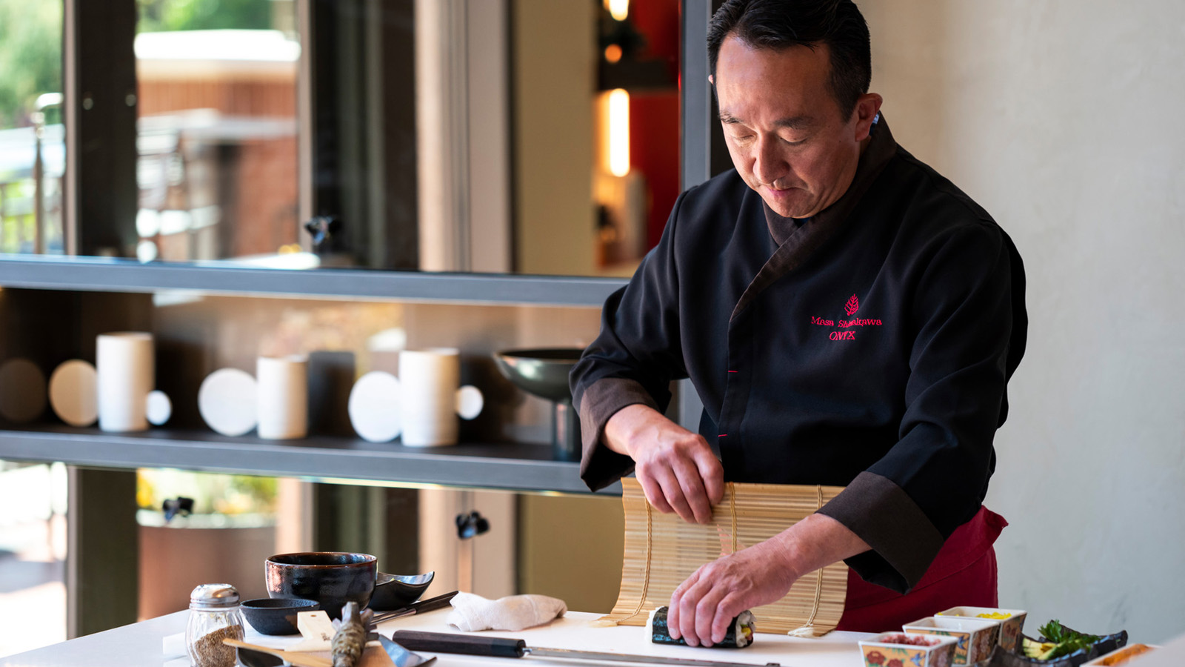
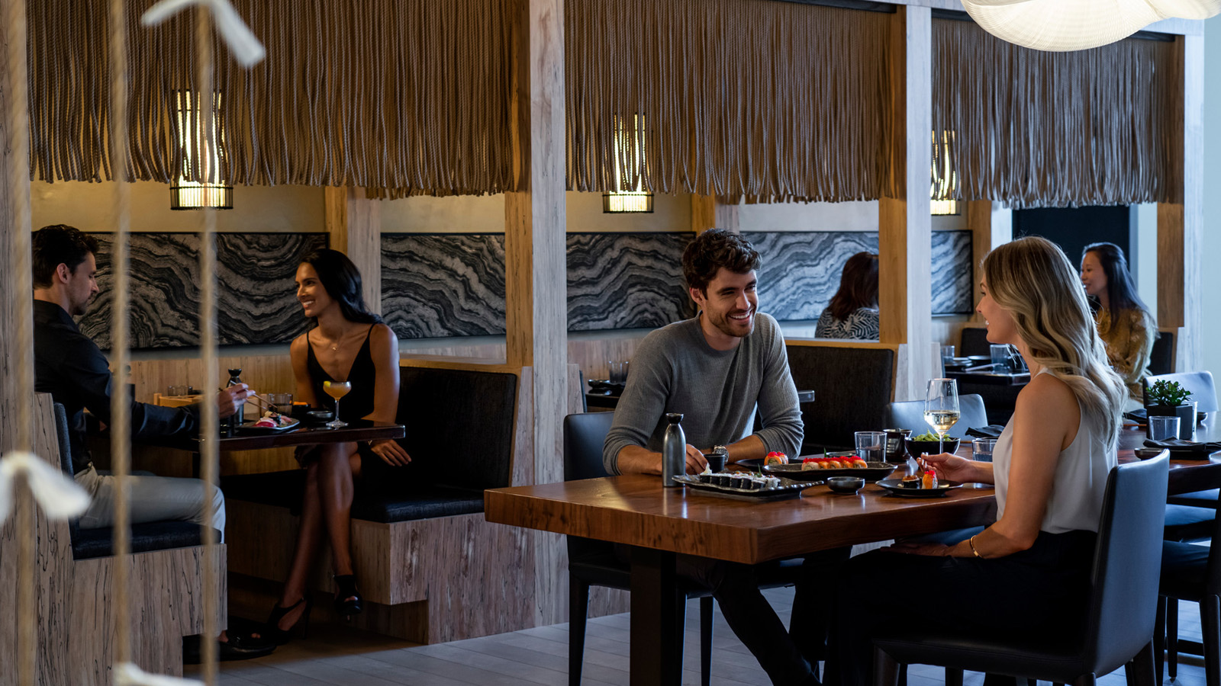 | 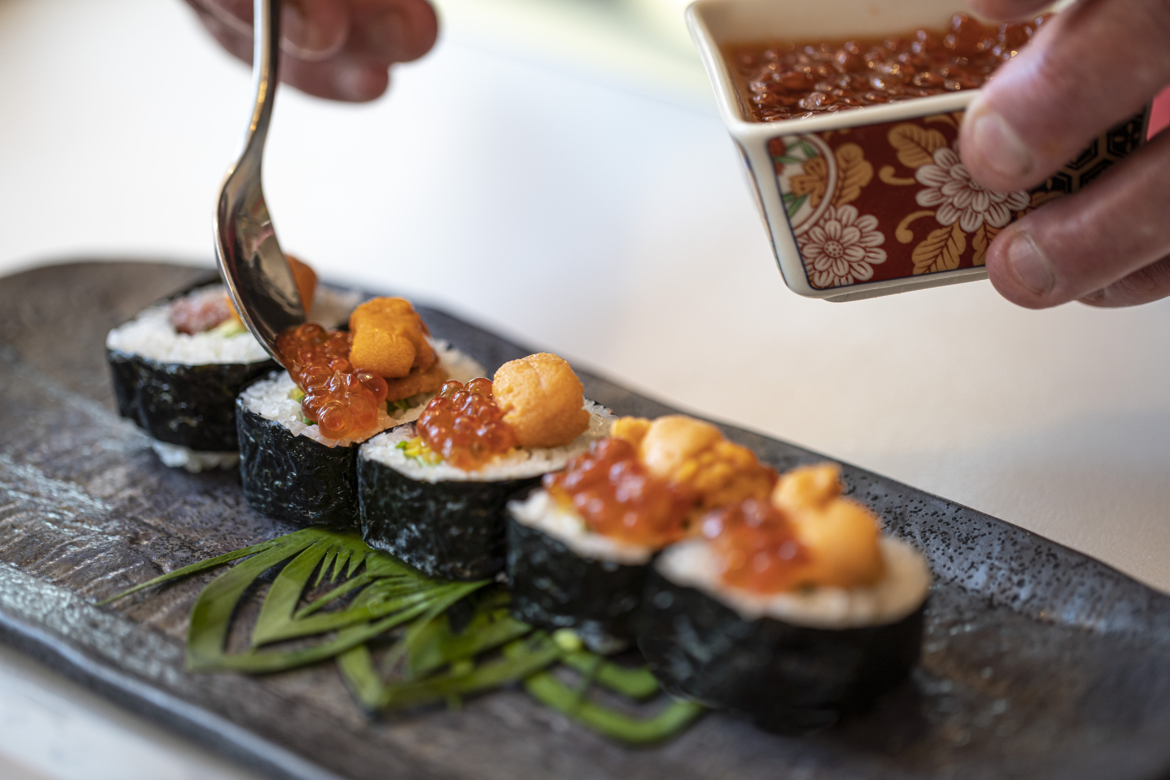
Chef Masa Shimakawa of ONYX presents a special collaboration dinner with Hakkaisan Sake Brewery and Sake Samurai Timothy Sullivan this Friday, January 17 and Saturday, January 18, 2020 at Four Seasons Hotel Westlake Village, California.
Chef Masa will feature a five-course menu alongside Timothy Sullivan’s thoughtfully paired Japanese sake from Hakkaisan Sake Brewery. Price per person is USD 125 plus taxes and gratuities. For reservations call 818 575 3000.
Sakizuke Selection
- HoKomochi Konbu - herring roe, bonito, umami dashi
- Umaki Omelet - unagi, uni, ikura, black truffle
- Nanban-zuke - king salmon, vine pepper, sweet vinegar
- Hakkaisan - ‘AWA’ Clear Sparkling

RELATED

January 10, 2020, Los Angeles, USA
A Town and Country Romance: Beverly Wilshire
https://publish.url/westlakevillage/hotel-news/2020/town-and-country-valentines-day-package.html

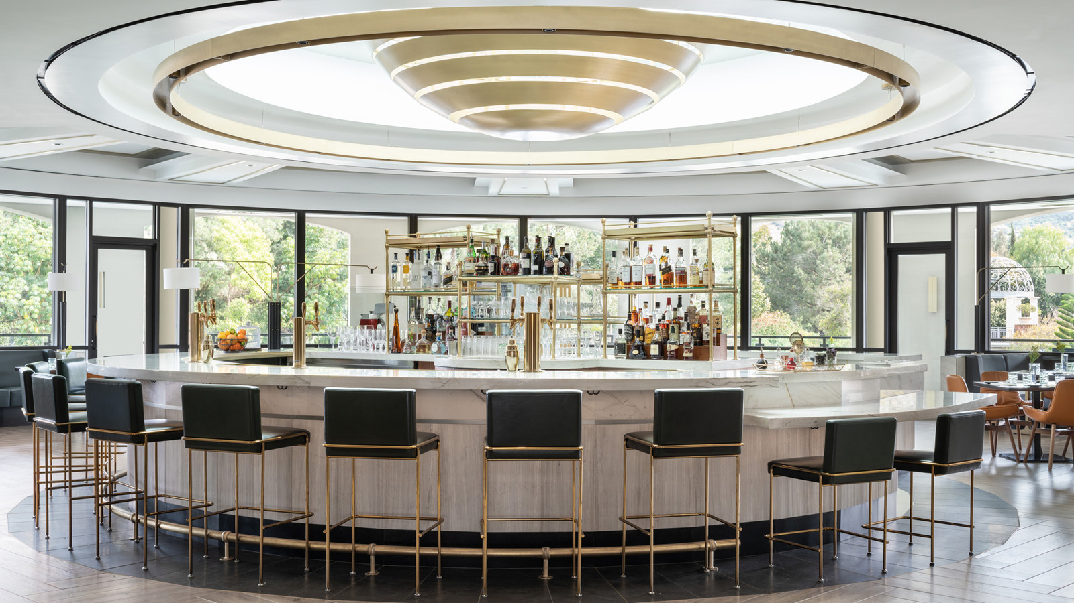 | January 9, 2020, Los Angeles, Westlake Village, U.S.A.  Four Seasons Hotel Westlake Village Welcomes the Return of dineL.A. to the City of Angels Culinary Scene This January  https://publish.url/westlakevillage/hotel-news/2020/dinela-winter-menus.html

PRESS CONTACTS

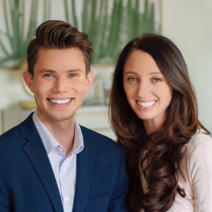 | Jacqueline Kerns and Harley Potter  Public Relations & Communications Team  Two Dole Drive  Westlake Village  USA  publicrelations.westlakevillage@fourseasons.com  +1 818 575 3089

