A Spa Journey Inspired by Ancient Egyptian Rituals

Travel back in time to discover the beauty secrets of Queen Cleopatra.
October 10, 2019, Alexandria, Egypt

In this fast-paced, automated and impersonal world, we yearn for moments to connect with the ones who matter the most. After an exciting day well spent exploring the city, steal an hour or two in the spa at Four Seasons Hotel Alexandria; a soothing oasis in the heart of Alexandria. A true authentic spa sanctuary in the city with treatments inspired by ancient Egypt evoking the grandeur of times past.
Take a cue from the legendary life of Cleopatra, one of Egypt’s greatest Queens, and soak in a decadent bath of milk, honey and fragrant rose petals in the soothing Spa Suite. At the end of the journey, our therapist will escort the guest like a Queen to her private relaxation lounge, to take her time and rejuvenate over an infused herbal drink.
A few hours can change everything.

RELATED

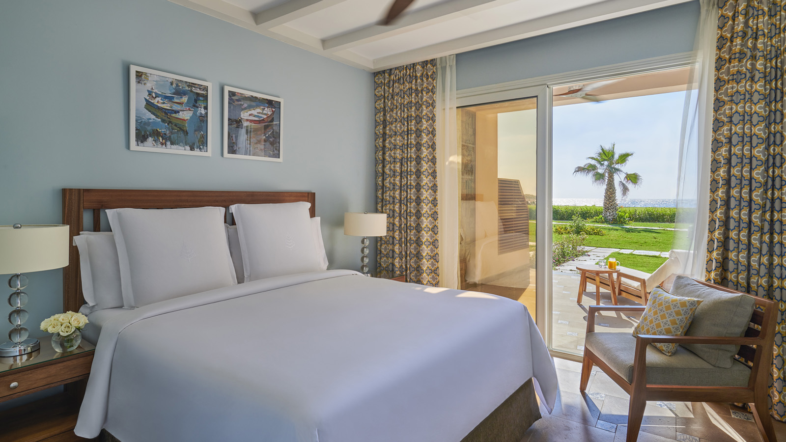 | March 14, 2019, Alexandria, Egypt  Four Seasons Hotel Alexandria at San Stefano Offers a Unique Resort Experience in the City on the Beach  https://publish.url/alexandria/hotel-news/2019/new-beach-features-and-experiences.html
March 14, 2019, Alexandria, Egypt
فندق فورسيزونز الإسكندرية سان ستيفانو يقدم تجربة فريدة تحاكي المنتجعات على ساحل البحر الأبيض المتوسط
https://publish.url/ar/alexandria/hotel-news/2019/new-beach-features-and-experiences-2.html

PRESS CONTACTS

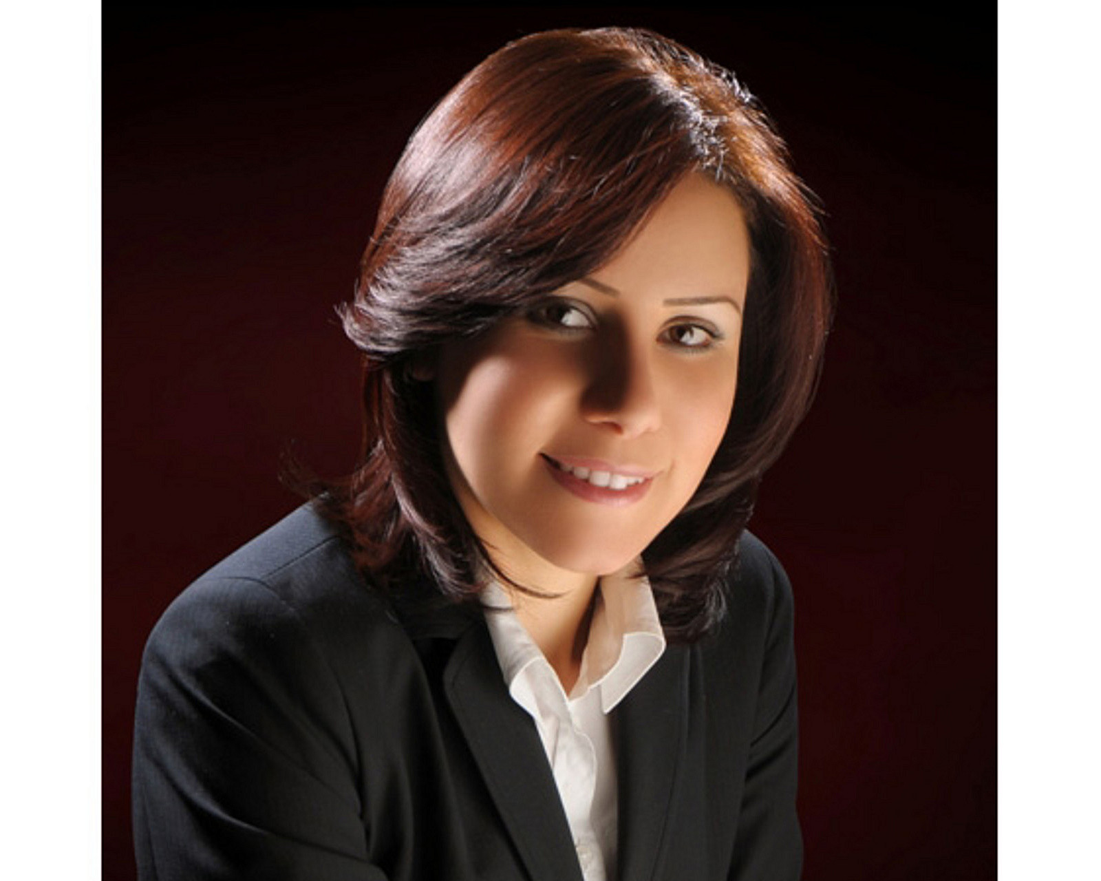 | Sarah Nabil  Director of Public Relations  399 El Geish Road  Alexandria  Egypt  sarah.nabil@fourseasons.com  20 3 581 8000

