A New Kind of Locker Room

June 3, 2022, Houston, U.S.A.

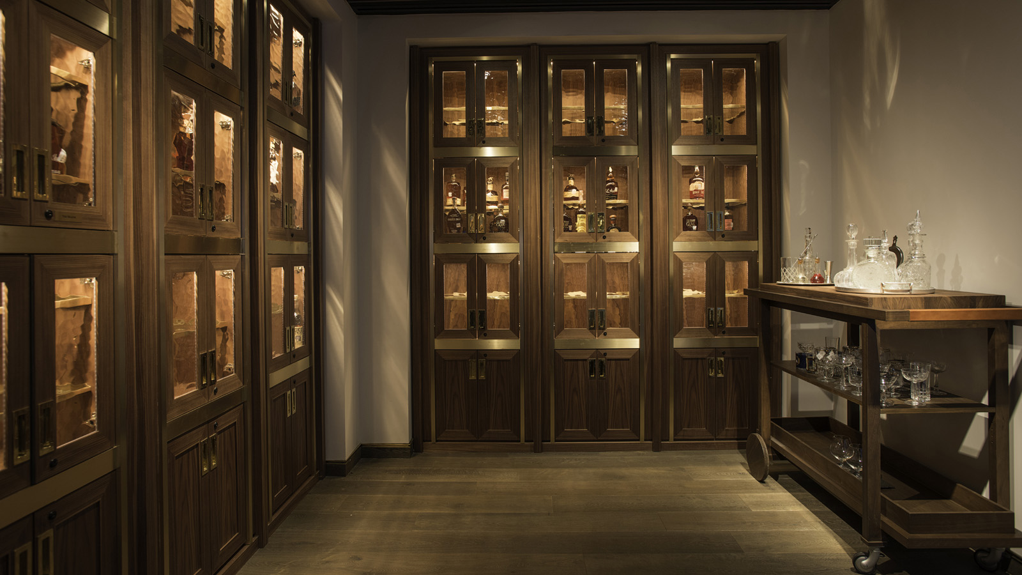
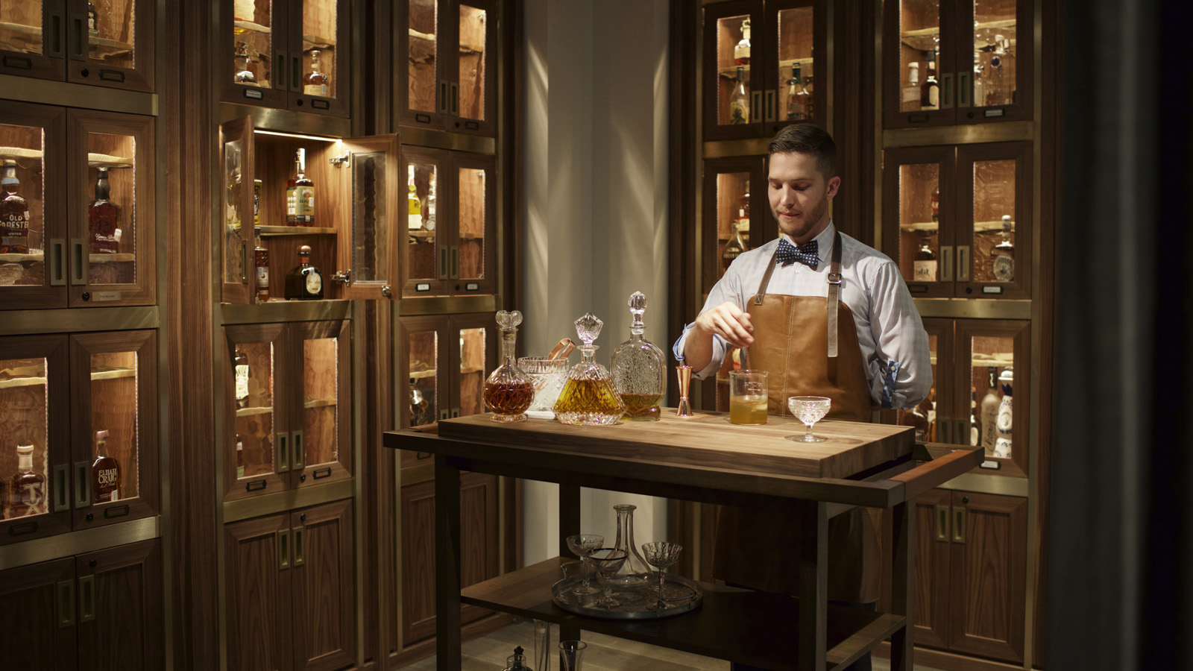 | 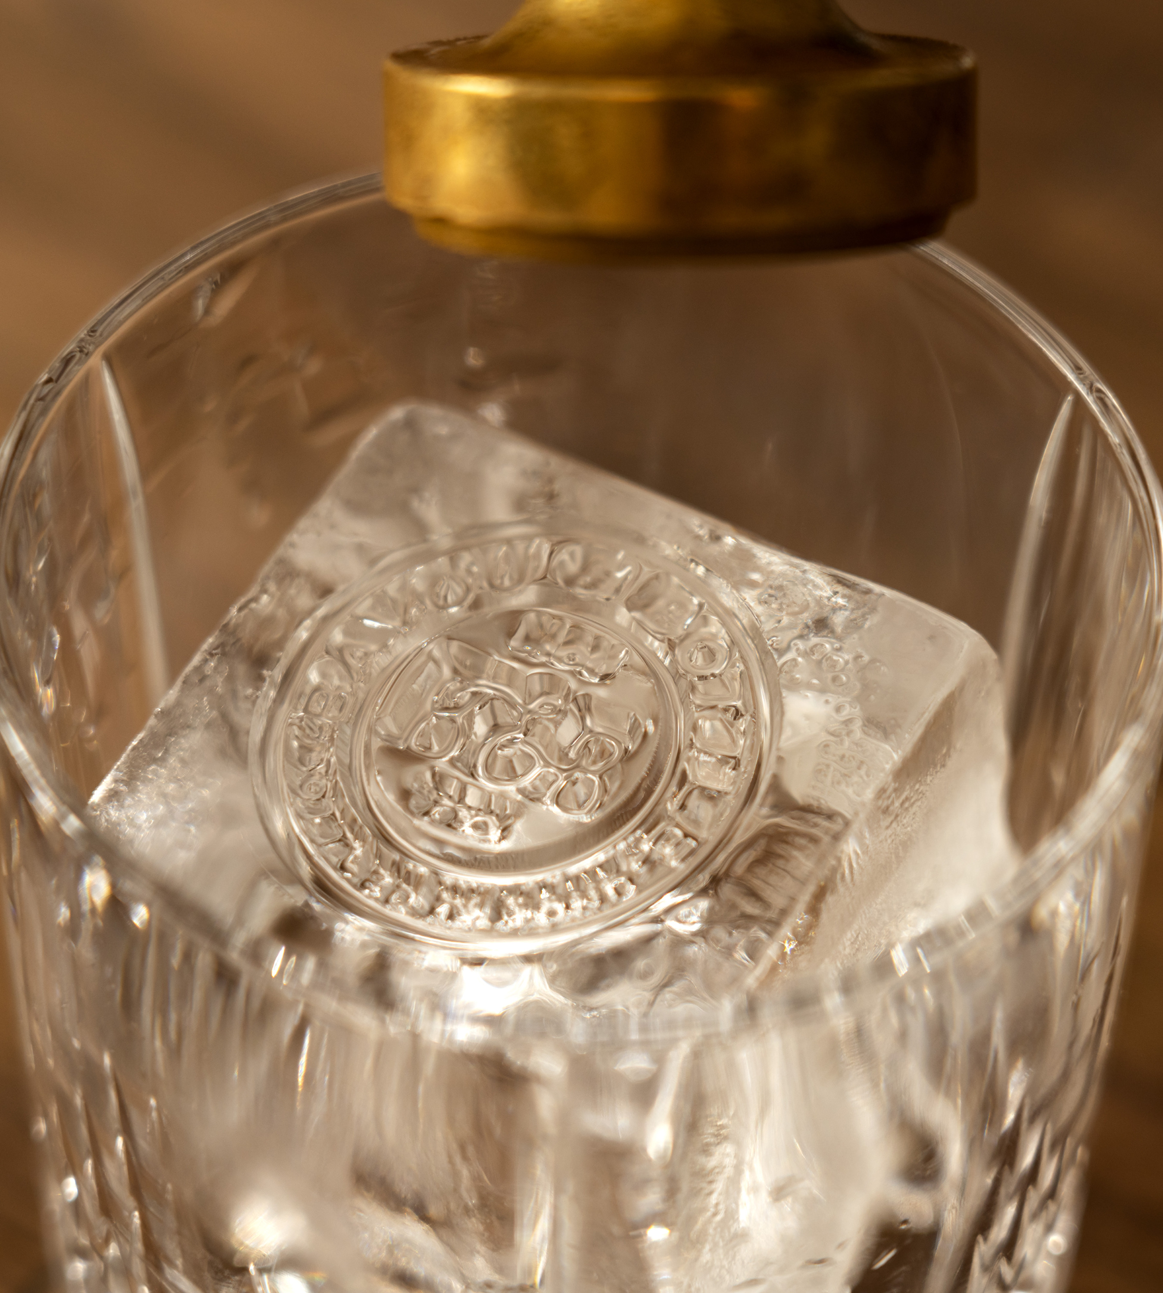

RELATED

June 3, 2022, Houston, U.S.A.
This Summer of Fun Sizzles at Four Seasons Hotel Houston
https://publish.url/houston/hotel-news/2022/summer-events-and-promotions.html

April 12, 2022, Houston, U.S.A.
Four Seasons Hotel Houston Celebrates Ruby Anniversary with Completion of Multi-Year Transformation
https://publish.url/houston/hotel-news/2022/40th-anniversary.html

PRESS CONTACTS

Brad Packer
Director of Public Relations and Communications
1300 Lamar Street
Houston
USA
brad.packer@fourseasons.com

+1 310 712 1493

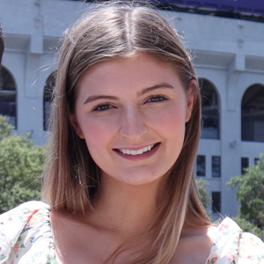 | Grace Ryan  Digital Marketing Coordinator  1300 Lamar Street  Houston  USA  grace.ryan@fourseasons.com  +1 713 553 5384

