Balance and Align with Seasons of Chakras Sensorial Journey at Four Seasons Hotel Philadelphia

Ancient practice of chakra balancing meets modern needs with this holistic massage for body, mind and spirit
January 12, 2021, Philadelphia, U.S.A.

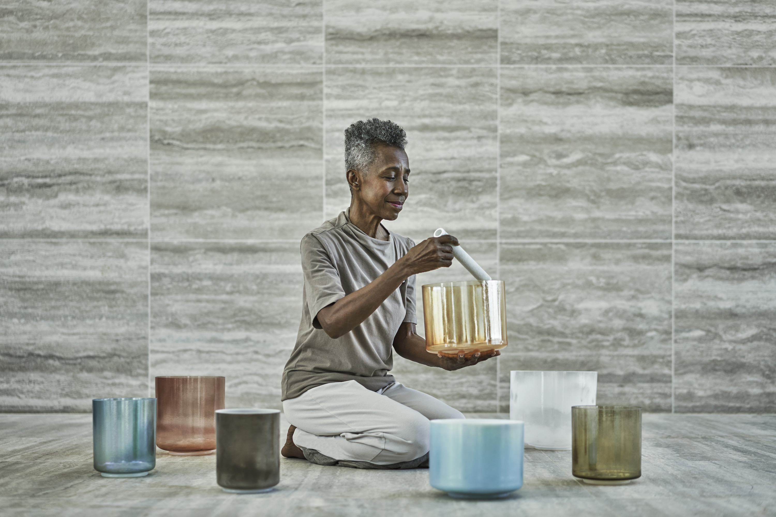
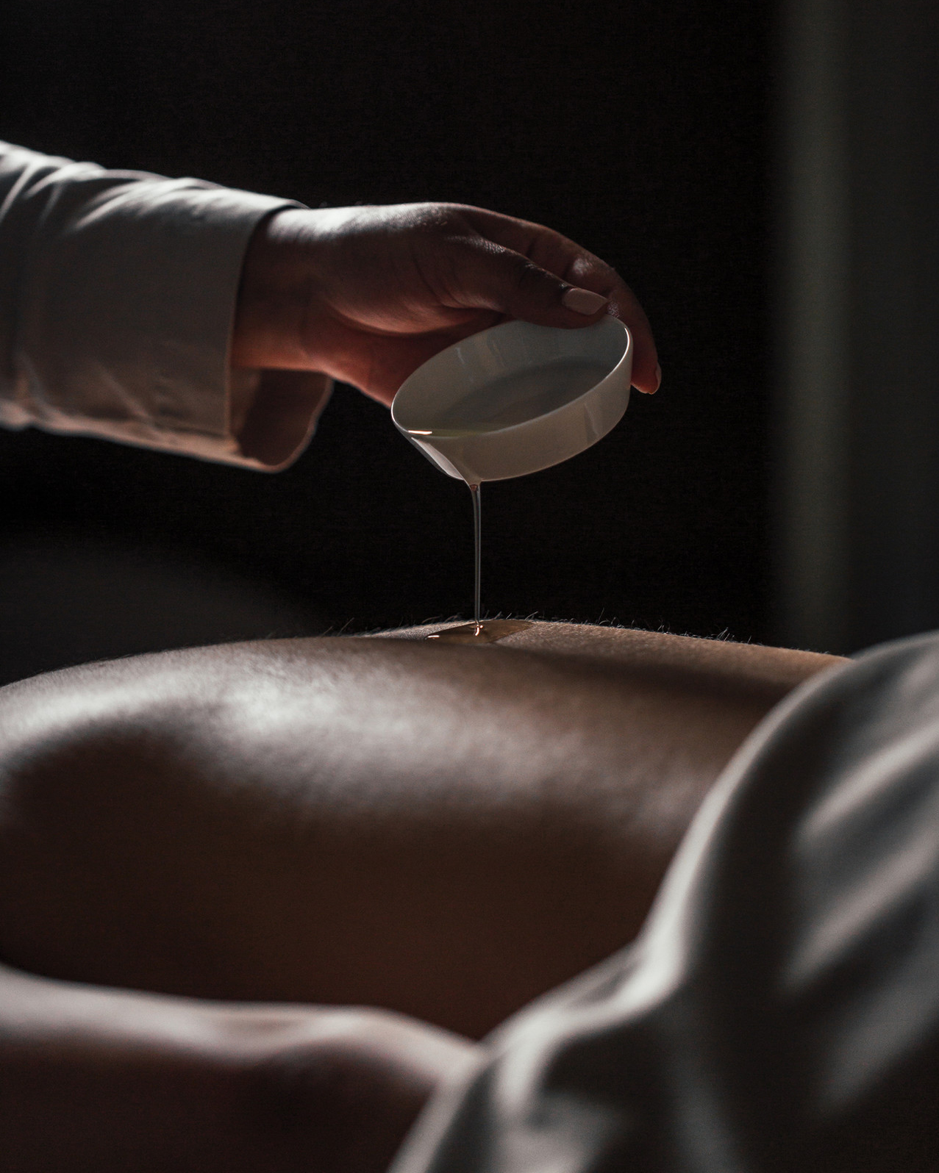 | 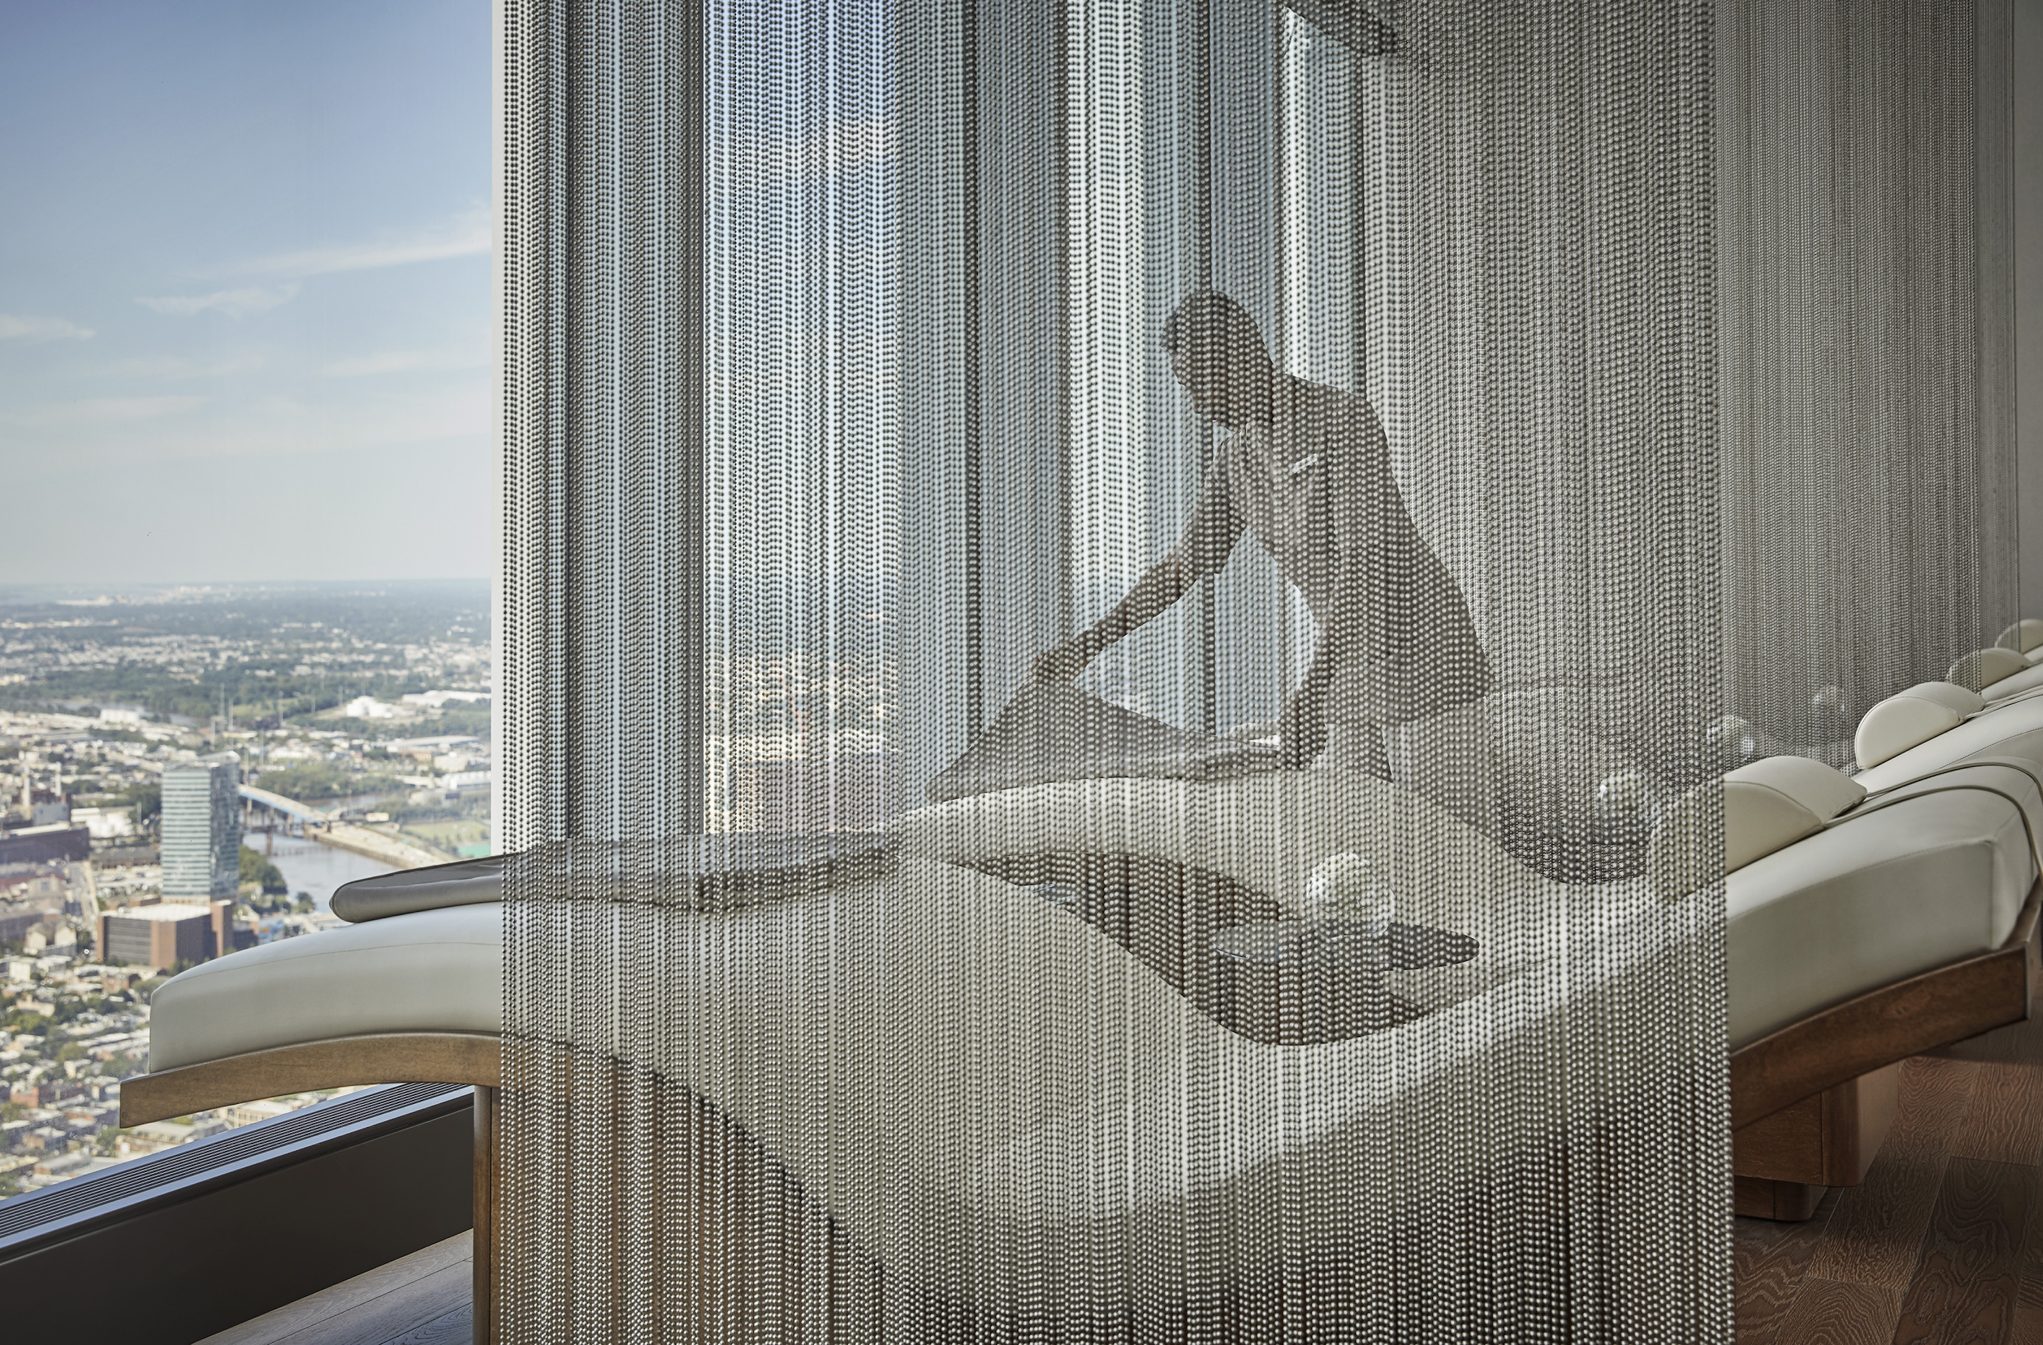 | 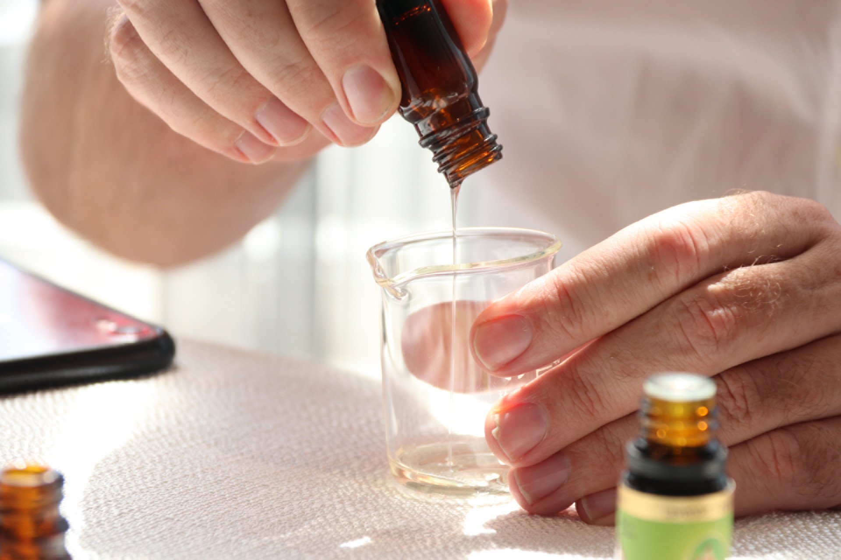
The Spa at Four Seasons Hotel Philadelphia, Forbes Travel Guide’s first and only spa in the city to earn the coveted 2021 Five Star Award, debuts the practice of chakra balancing to relax and enhance the body’s energy centre. Seasons of Chakras Sensorial Journey is a sixty-minute treatment that stimulates all five senses through different massage techniques, herbaceous aromatherapy and the healing power of singing crystal bowls. The ancient practice of chakra balancing originated more than 4,000 years ago in India. Each chakra refers to an energy centre in the body and is believed to function its best when opened and balanced.
Seasons of Chakras Sensorial Journey is inspired by the seven chakras, and the massage will target key areas of the body along with seasonal essential oils to stimulate and open each chakra. The journey starts with a brief singing bowl session to activate and harmonise the crystals in the structure of each room and are also attuned to the chakra of each room. A leg and foot massage begins to awaken to root chakra using nutmeg essential oil to assist the immune system, followed by a back massage with a focus on the lower back, activating the sacral chakra to alleviate stress and fatigue. Moving on, a gentle tummy massage influences the solar plexus chakra with eucalyptus and juniper berry essential oils, rich in antioxidants.
Next, to support the opening of the heart chakra, is a chest massage using an orange essential oil blend applied to the breastbone, igniting the emotional centre using its power to lift one's mood or reduce stress. A clove body spray is applied to chest and neck areas to promote expressiveness and communication, encouraging the opening of an inactive throat chakra. Following this is a forehead and scalp massage with rosemary essential oil to stimulate a sleepy third eye chakra. To finish the treatment, a tuning fork and its stimulating vibrations is used with a complementing vetiver oil diffuser that is activated to the airspace around the guest, balancing the transcendent crown chakra.
Each Four Seasons treatment room is embedded with a specific healing crystal that corresponds with one of the seven chakras. The same room is equipped with a matching crystal singing bowl that is played at the beginning and completion of each treatment, the healing vibrations of which resonate around and within.
The combination of essential oils used throughout the journey stimulates all the chakras, the energy is evened out and becomes balanced, leading to mental and spiritual well-being.
After the massage enjoy a fragrant and full-bodied masala chai tea from Rishi in the relaxation lounge. Prominent notes of ginger, cardamom and cinnamon are enhanced with just the right touch of seductive cloves and black pepper topped by a dust of nutmeg.
To continue and elongate the effects of the Seasons of Chakras Sensorial Journey, each guest is given an aromatherapy menu to select the scent that best resonates with them to take home and enjoy.

RELATED

December 4, 2020, Toronto, Canada
Discover the Holidays Along the US North East Coast with Four Seasons Hotels
https://publish.url/news-releases/2020/urban-festive-getaways.html

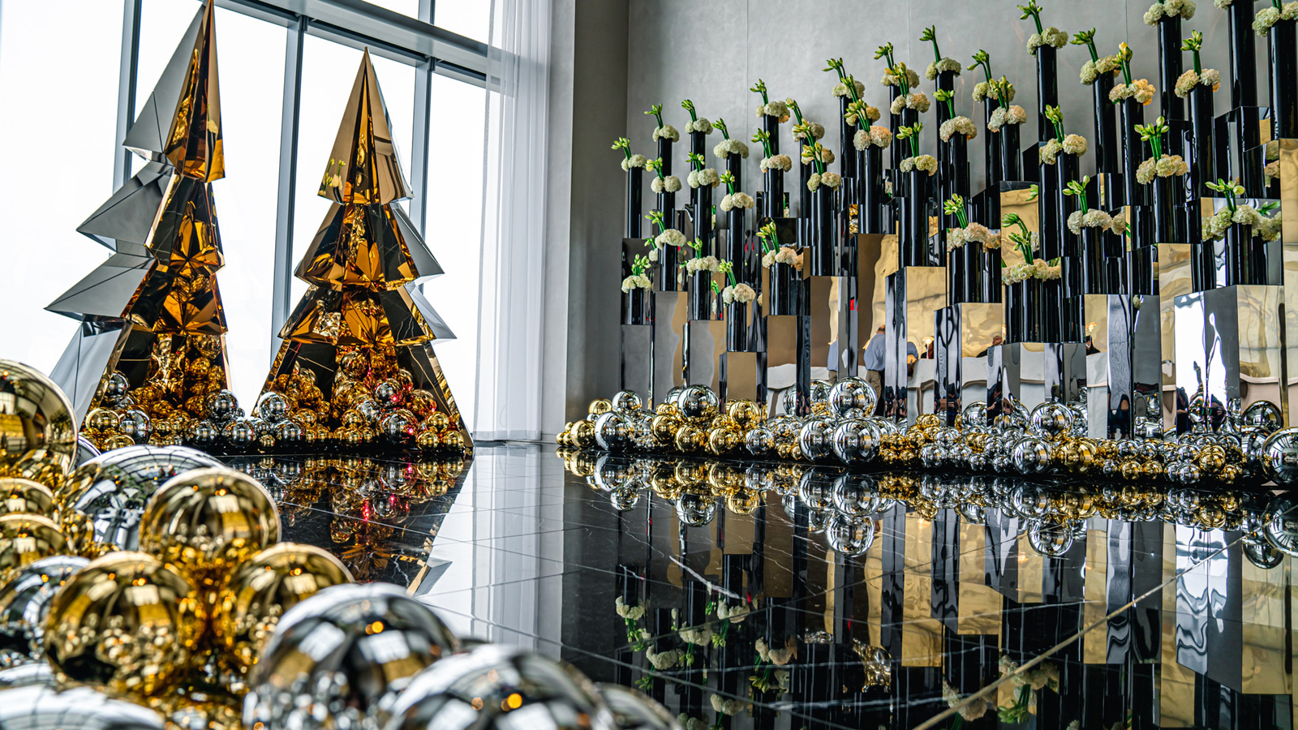 | November 3, 2020, Philadelphia, U.S.A.  At Four Seasons Hotel Philadelphia, A Holiday Season Unlike Any Other  https://publish.url/philadelphia/hotel-news/2020/festive-season.html

PRESS CONTACTS

Melissa Quiñones DeShields
Director of Public Relations
One North 19 Street
Philadelphia
USA
melissa.quinones@fourseasons.com

+1 215 419 5033

