Four Seasons Hotel Baku, Azerbaijan: The Elite Address for Meetings and Social Occasions

Whether for ultra-private negotiations or a chic social reception for 400 guests, Four Seasons combines smooth efficiency with elegant warmth
February 10, 2017, Baku, Azerbaijan

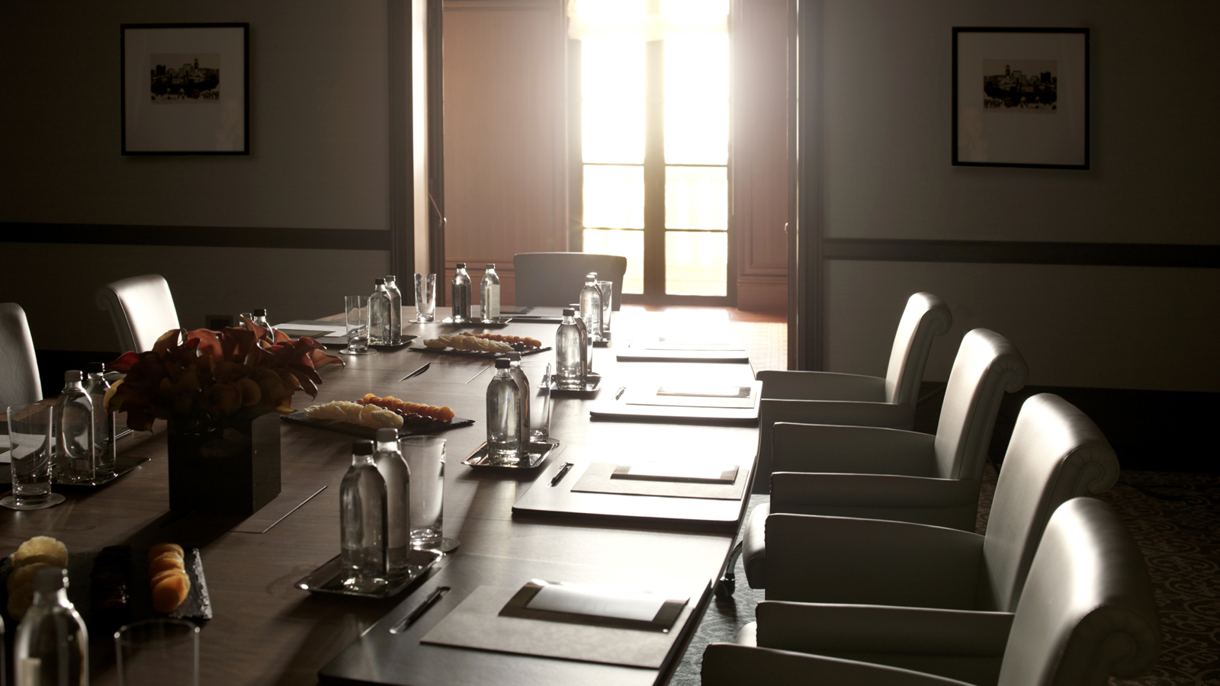
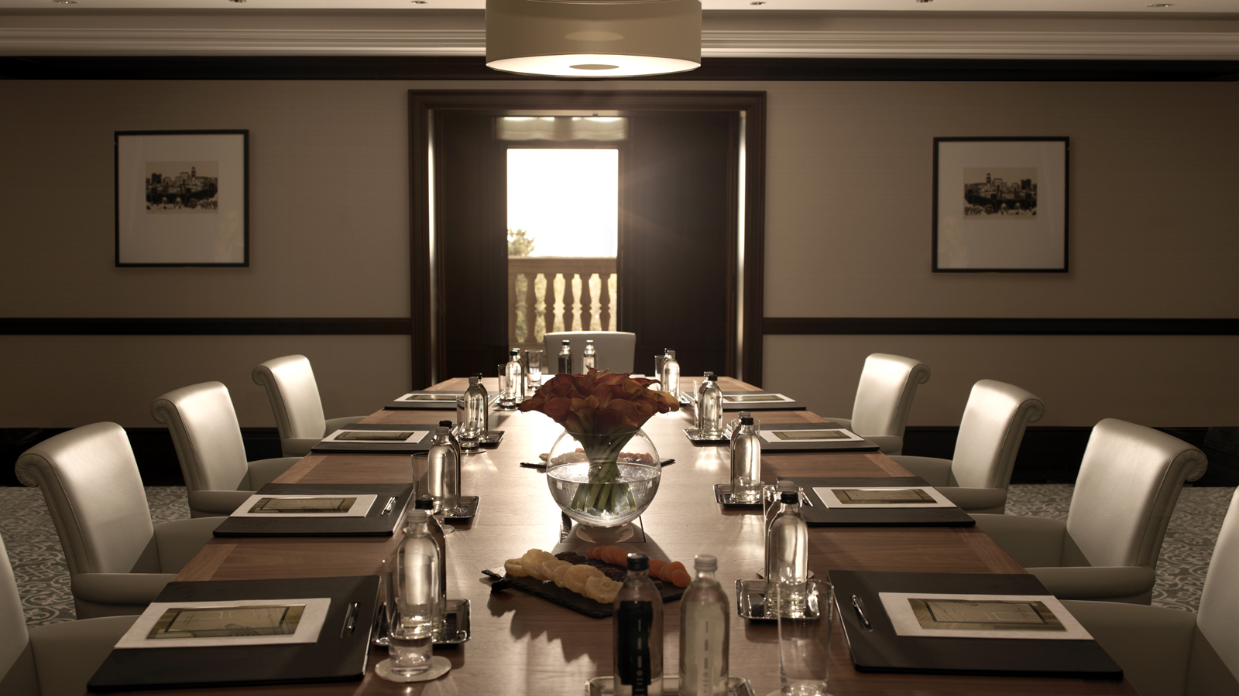 | 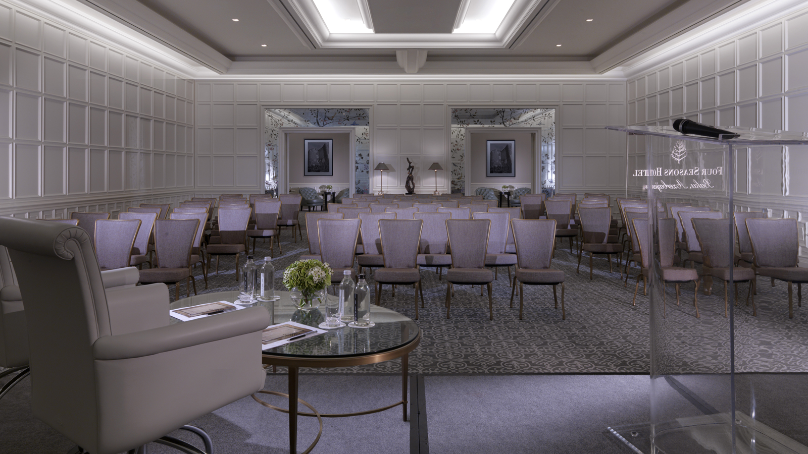
For the most prestigious events in the Azeri capital – whether business functions or weddings or other social occasions – there is no question that
Four Seasons
Hotel Baku provides the most impressive hotel setting.
With more than 1,865 square metres (20,075 square feet) of function space, the Hotel offers a wide variety of meeting rooms that are flexible for gatherings both small and large. Whatever the occasion, attentive service is what sets
Four Seasons
apart, perfectly orchestrating every detail from audio-visual technology to creative catering.
First Floor Ballrooms for Major Events
Guests ascend the lobby’s dramatic curving staircase to the first floor event venue, focused around a central pre-function area. The space is inspired by the grand classical spaces of French buildings of the late 18th century – formal but with an atmosphere that feels fresh and light.
Measuring 640 square metres (6,900 square feet), the ornate, marble-columned Segah Grand Ballroom is divisible in two and opens to a private garden terrace. The classical Rast Banquet Room – 421 square metres (4,531 square feet) – is divisible in three and features arcaded windows overlooking Philharmonic Park. Both rooms feature state-of-the-art technology for business presentations.
Large-scale events may book the entire first floor for free-flowing receptions of up to 400 guests.
Private Meeting Rooms and Business Centre
A complete Baku conference centre on the second floor is a handsome, wood-panelled enclave with five high-tech meeting rooms ranging from 46 to 147 square metres (495 to 1,582 square feet) and including a dedicated boardroom with videoconferencing capabilities.
The adjoining Business Centre provides 24-hour professional support – including secretarial services, translations, photocopying and creating presentations.
The best destination for business travellers in Baku,
Four Seasons
provides a luxurious home away from home – with easy technology, full secretarial assistance, airport greetings and a 24-hour Concierge to solve any problem.

RELATED

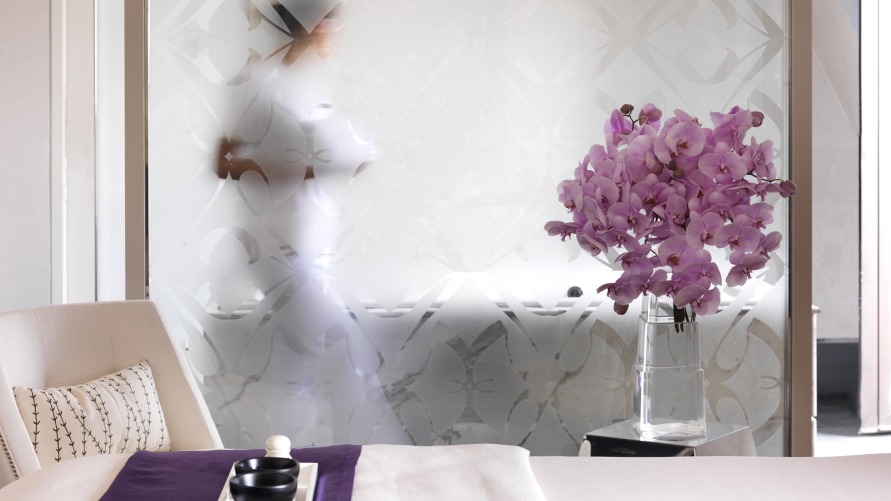 | March 14, 2017, Baku, Azerbaijan  Jaleh Spa at Four Seasons Hotel Baku Presents Arabian Oud Renewal Therapy from Sodashi  http://publish.url/baku/hotel-news/2017/arabian-oud-renewal-therapy.html
March 14, 2017, Baku, Azerbaijan
Jaleh Spa представляет арабскую реабилитационную терапию на основе удового масла от Sodashi
http://publish.url/ru/baku/hotel-news/2017/arabian-oud-renewal-therapy-2.html

PRESS CONTACTS

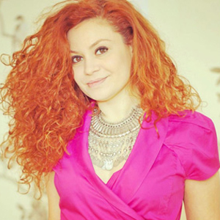 | Aynur Mamedova  Director of Public Relations  1 Neftchilar Avenue  Baku  Azerbaijan  aynur.mamedova@fourseasons.com  +994 12 404 2424

