Celebrate Santa Fe Wine & Chile Festival with Two Original “Fiesta” Dinner Events at Four Seasons Resort Rancho Encantado

Resort partners with Big Green Egg, Snake River Farms and Frank Family Vineyards for unique “wine & BBQ fusion” experiences
August 31, 2020, Santa Fe, U.S.A.

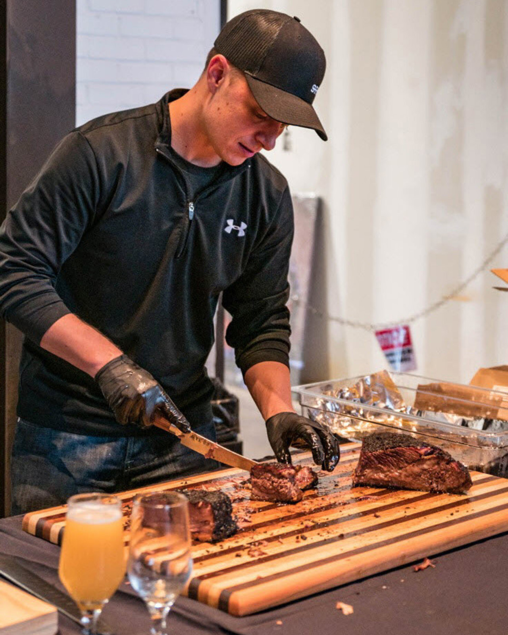
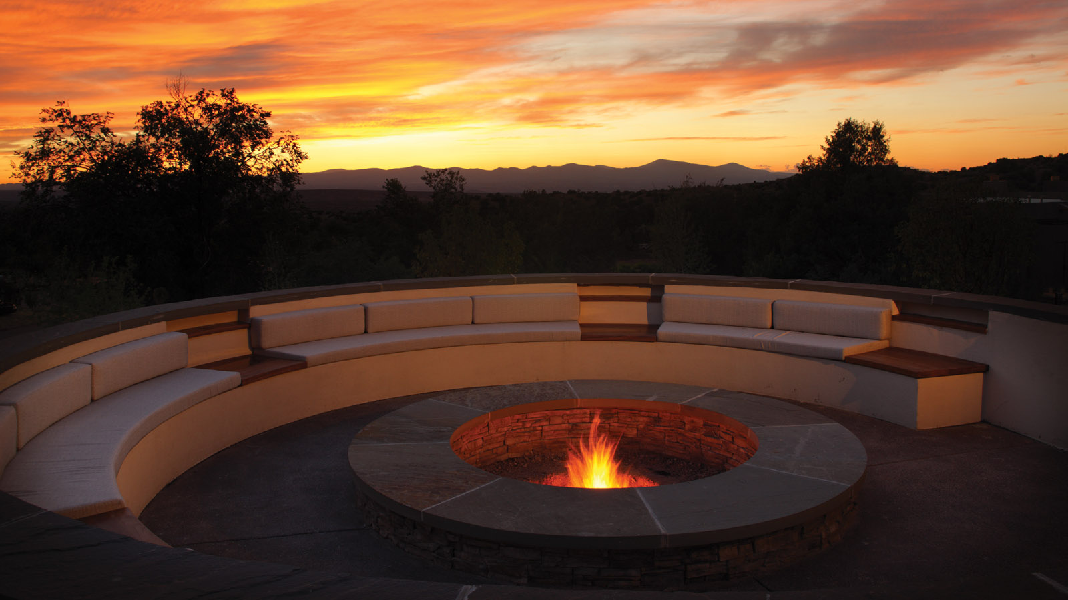 |  | 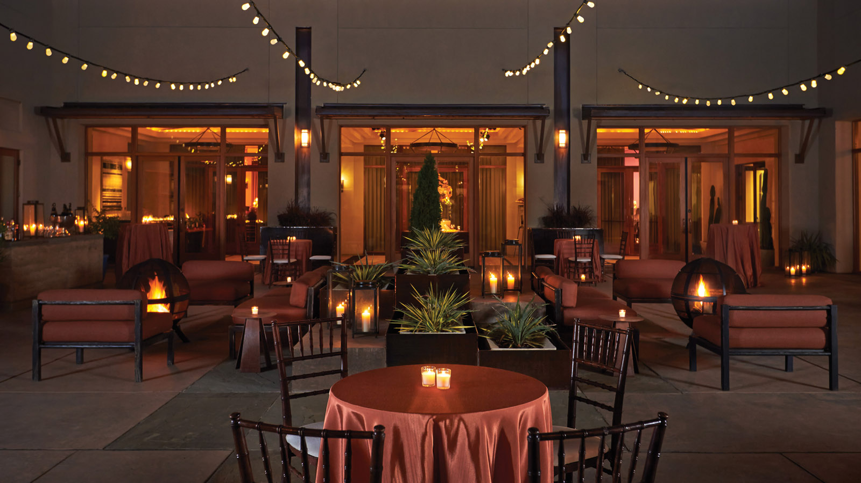
This September 25 and 26, 2020, Terra, the signature restaurant at Four Seasons Resort Rancho Encantado, invites guests to celebrate Wine & Chile Fest in a new way, with a fun, lively culinary experience on Terra’s expansive sunset terrace.
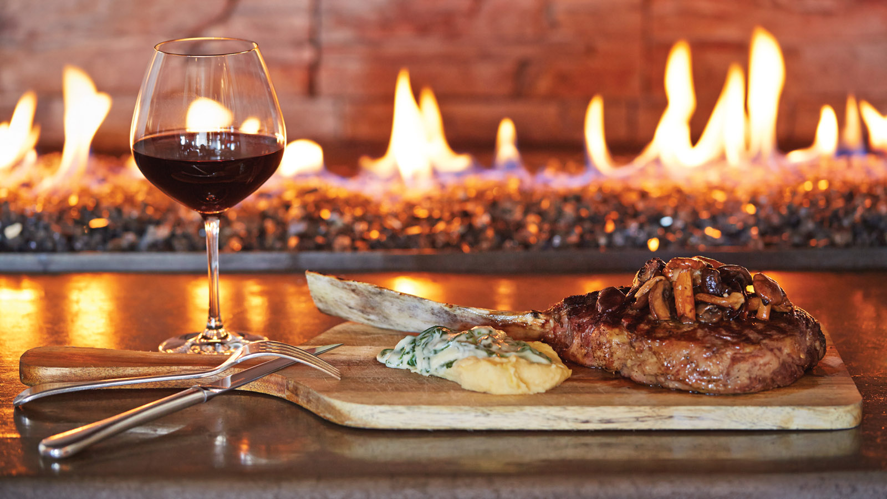
Transcending the traditional wine dinner, Terra has teamed up with Big Green Egg, Snake River Farms and Frank Family Vineyards to create two special nights of unforgettable food, excellent wine, live music and entertaining cooking demos.
Terra’s Executive Chef Kai Autenrieth will join forces with Jack Arnold, Big Green Egg’s official pitmaster and featured guest chef, to serve up an inventive “northern New Mexico meets BBQ fusion” menu, with stations highlighting regional specialties, local flavours and fresh ingredients, alongside a variety of Snake River Farms’ famed meats, grilled to perfection by Arnold in a variety of styles.
From “the art of roasting” to wagyu + lobster tail surf & turf, dine under the stars with epic views and watch first-hand as the culinary experts masterfully prepare a selection of distinct courses throughout the evening.
Featuring wines from renowned Frank Family Vineyards, guests will also learn about the celebrated winery, its diverse varietals and latest releases, and taste an array of award-winning wines impeccably paired to complement each unique dish.
Plus, enjoy live Spanish guitar from popular local musician Tito Rios.
Event Details:
- Where: Terra Restaurant’s terrace at Four Seasons Rancho Encantado
- When: Friday, September 25 and Saturday, September 26, 2020 and 6:30 pm
- For more info, pricing and the Wine & Chile Fiesta Dinner Menu, click here.
To book a reservation, call 505 946 5800.

RELATED

June 4, 2020, Santa Fe, U.S.A.
Four Seasons Resort Rancho Encantado Santa Fe Announces Reopening on June 4, 2020
https://publish.url/santafe/hotel-news/2020/re-opening.html

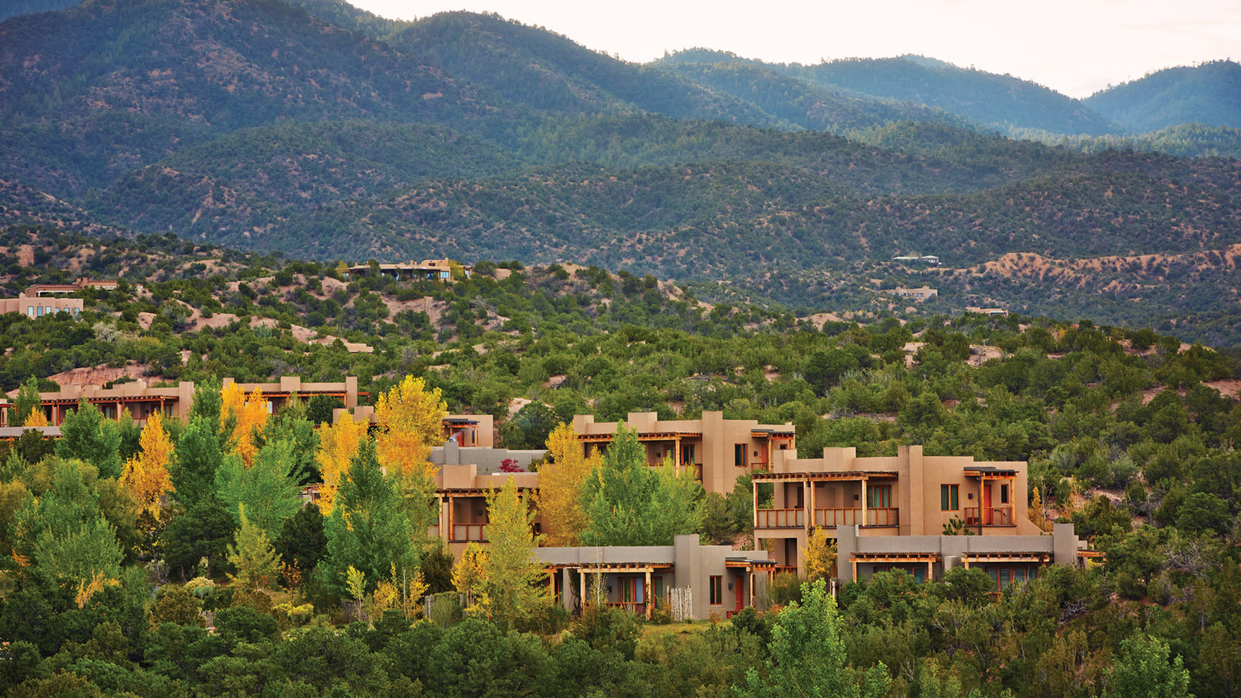 | May 4, 2020, Santa Fe, U.S.A.  Four Seasons Resort Rancho Encantado Santa Fe Introduces Virtual “At-Home” Experiences  https://publish.url/santafe/hotel-news/2020/at-home-experiences.html

PRESS CONTACTS

Michelle Duncan
Director of Public Relations
198 State Road 592
Santa Fe
USA
michelle.duncan@fourseasons.com

+1 646 229 2797

