Of Hyderabad and Niharis: A Jashn-e-Rivayat to Remember at Four Seasons Hotel Mumbai

Set forth on a culinary voyage through one of India's royal heartlands where timeless recipes and culinary classics await
July 19, 2021, Mumbai, India

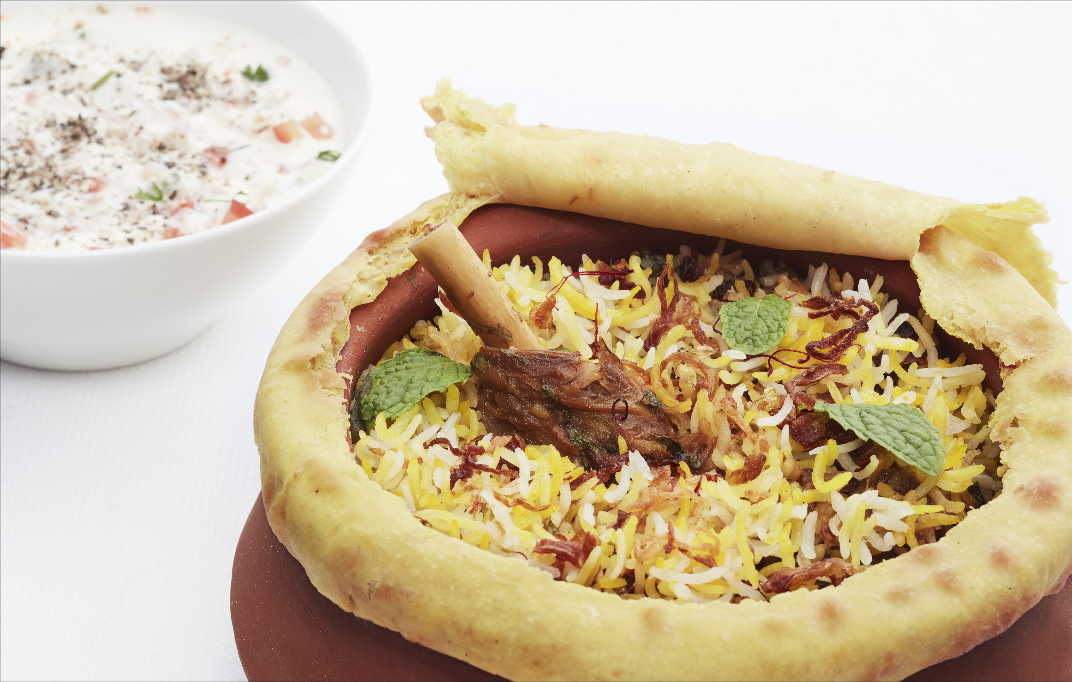
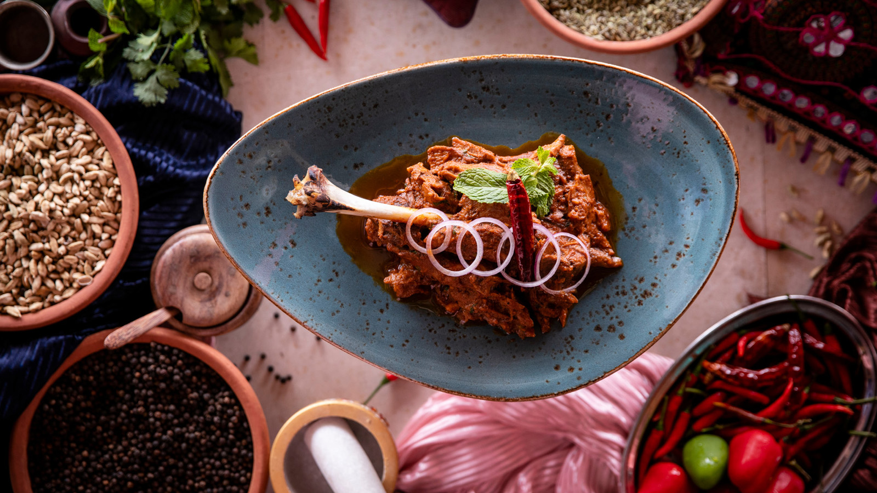
Hyderabadi cuisine needs no introduction. Its popularity is well-known not just in India but also across the world. Its culinary masterpieces such as the dum biryani, paye ki nihari and haleem are delicacies treasured and savoured by all.
From July 19 to 31, 2021, experience culinary artistry in all its glory as Four Seasons Hotel Mumbai Executive Chef Anupam Gulati and his team curate an authentic regal menu brimming with the mesmerising aromatic flavours, an ode to the Nawabi essence of Hyderabad.
Guests can indulge in a princely feast at San:Qi, the Hotel's Pan-Asian restaurant, and in the comfort of their home, featuring favourites such as gosht yakhni pulao, zaffrani biryani, pushtaini murgh qorma and paye ki nihari, and San:Qi signatures such as the tandoori raan and macchi ki rubayat. Vegetarian selections on the menu include makai ki chui mui, subz chilgoze ke kebab and subz dahi ke koftey to satisfy every palate. End the meal on an extravagant note with some delicious gud kesar ki phirnee and sheer khurma.
Witness the heritage of heirloom recipes and savour rich and timeless delicacies infused with exquisite spices, a true treat for the palate.
To make a table reservation, call +91 22 2481 8333. San:Qi is open to non-resident guests for dine-in from Monday to Friday for lunch between 12:00 noon and 3:00 pm. Advance reservations are recommended.
For deliveries across Mumbai between 11:00 am and 10:30 pm daily, call +91 22 2481 8042 or +91 7710033143.

RELATED

July 19, 2021, Mumbai, India
Discover A Suite Serenity with Loved Ones as Four Seasons Hotel Mumbai Introduces Its New All-Inclusive Staycation Package
https://publish.url/mumbai/hotel-news/2021/suite-serenity-package.html

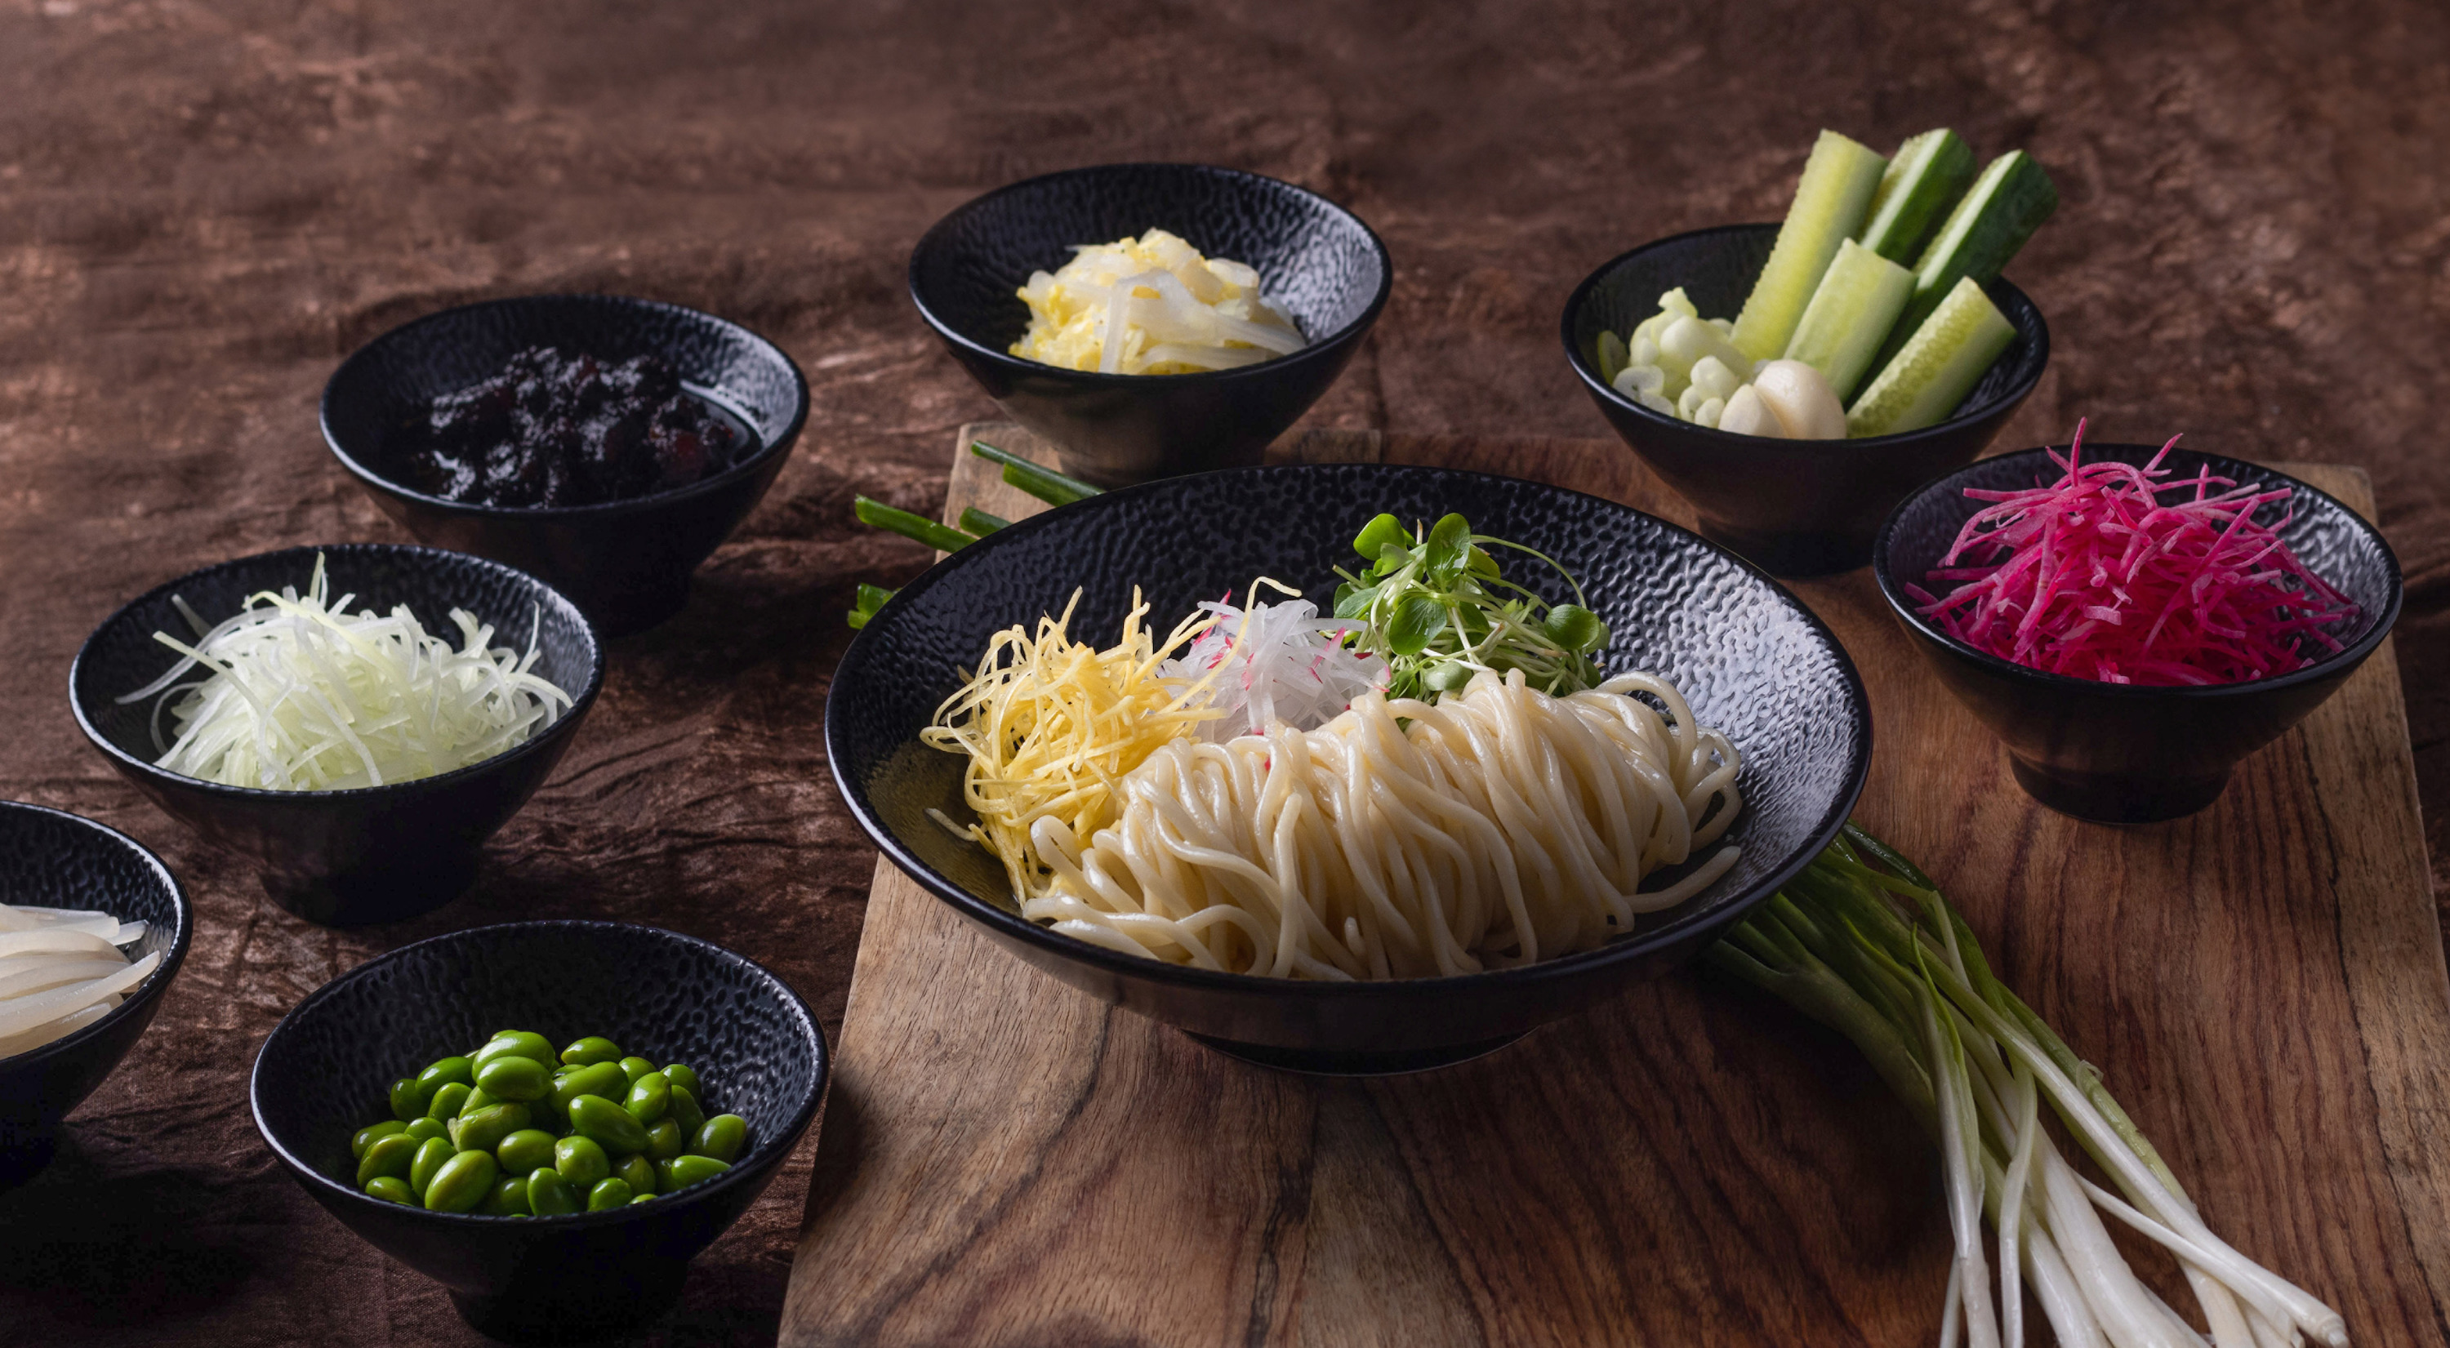 | June 22, 2021, Mumbai, India  Welcome the Monsoon Season with A Feast from the Foothills by Four Seasons Hotel Mumbai Featuring Flavours from North-East India  https://publish.url/mumbai/hotel-news/2021/a-feast-from-the-foothills-menu.html

PRESS CONTACTS

Stephanie D'Silva
Director of Marketing
1/136 Dr. E. Moses Road, Worli
Mumbai
India
stephanie.dsilva@fourseasons.com

986 706 1900

Neha Nair
Marketing Communications Manager
1/136 Dr. E. Moses Road, Worli
Mumbai
India
neha.nair@fourseasons.com

+91 (22) 2481 8062

