Discover Authentic Ramadan Experiences at Four Seasons Hotel Riyadh

April 12, 2021, Riyadh, Kingdom of Saudi Arabia

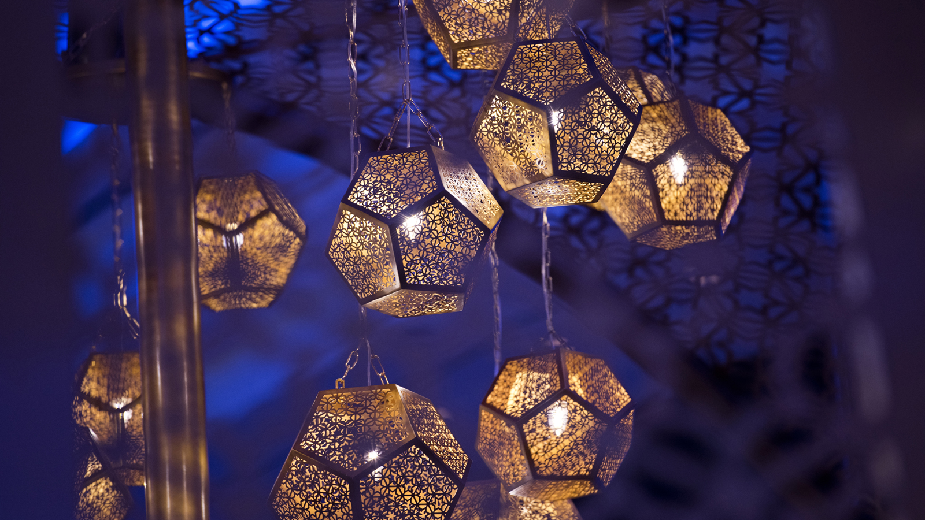
The anticipation is over, joyous family and friends gatherings, and expressions of gratitude and generosity, are finally here through the Holy Month of Ramadan. This year Four Seasons Hotel Riyadh is commemorating the season with crafted Ramadan experiences enhanced with global health and safety measures through the Hotel’s Lead With Care program.
Iftar and Sohour at Elements
In keeping with the spirit of Ramadan, Elements has prepared a selection of splendid Iftar and Sohour offerings, serving delicious authentic flavours enhanced with spectacular Ramadan decorations that embrace the spirit of the Holy Month.
- Iftar Family Style Set Menu – every day during Ramadan; SAR 350 for adults, SAR 160 for children (ages 5-12), Sohour SAR 280
For reservations contact +966 11 211 5500.
Iftar and Sohour at The Grill
Opt for a table on the terrace to dine under the moonlight for an extra special Iftar or Suhour. Choose from the specially-curated family-style set menu designed by The Grill talented chefs to tantalise taste buds.

RELATED

March 9, 2021, Riyadh, Kingdom of Saudi Arabia
تجربة مميزة في عيد الأم في فندق فورسيزونز الرياض
https://publish.url/ar/riyadh/hotel-news/2021/mothers-day-2.html

March 9, 2021, Riyadh, Kingdom of Saudi Arabia
Special Mom-ments Await This Mother’s Day at Four Seasons Hotel Riyadh
https://publish.url/riyadh/hotel-news/2021/mothers-day.html

PRESS CONTACTS

Nada Atieh
Director of Public Relations and Communications
Kingdom Centre, P.O. Box 231000
Riyadh
Kingdom of Saudi Arabia
nada.atieh@fourseasons.com

