From the Kitchens of Four Seasons Hotel Kuala Lumpur to Your Doorstep

Bring Four Seasons home
April 20, 2020, Kuala Lumpur, Malaysia

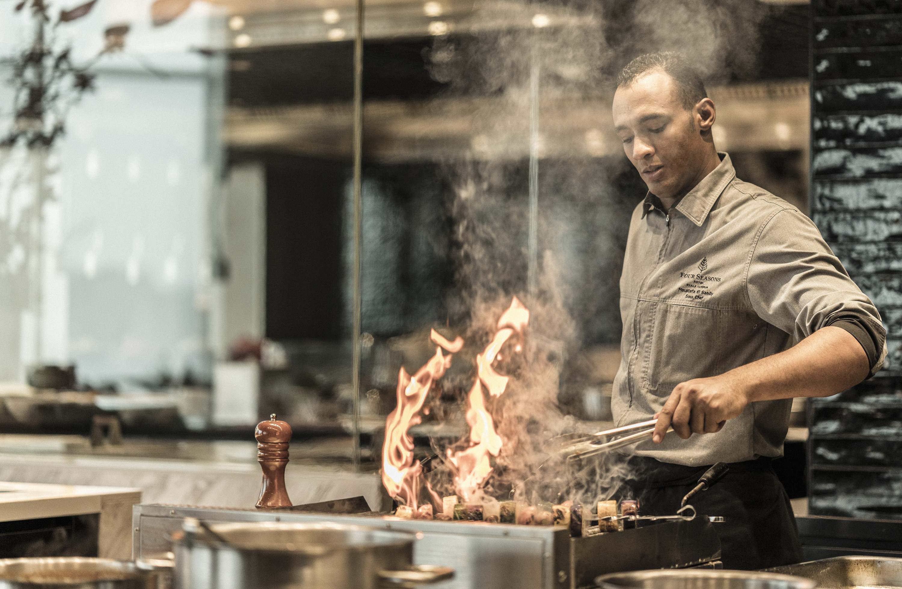
Savour award-winning and all-time favourite dishes from Four Seasons in the comfort and privacy of one's own home. Whether celebrating a special occasion, working from home or simply enjoying a quiet evening, let Four Seasons Hotel Kuala Lumpur take care of culinary needs with a new delivery and takeaway service, launching today.
Comforting Festive Menus
This Holy Month, come together in gratitude with loved ones, with a little help from Four Seasons. Chef Muhd Mujtahid Lukman presents an array of Malaysian favourites that are best enjoyed in the company of family and close friends, whether around the dining table or over video calls.
Share timeless a la carte delights such as mee mamak, nasi goreng and Hainan chicken rice. Or personalise the dining experience with four-course set menus featuring choice of main dish, including ayam masek merah, beef shortrib rendang and udang sambal petai. Rich dates and local sweets lend a festive air to every meal.
A World of Flavours
With the new delivery menu from Four Seasons, foodies in Kuala Lumpur can go on a delicious journey across India, China, Europe and the Middle East. As Executive Chef Junious Dickerson notes, “Guests may be unable to visit our Hotel for now, but there’s no reason for them to miss out on our delectable international cuisine.”
- Yun House: Pamper loved ones with signature dishes straight from Chef Jimmy Wong’s magic wok, including kung pao chicken and wok-fried garoupa with spicy scallop sauce.
- Curate: Pick a region, or sample a little bit of everything – from Western classics such as seafood pasta and Catalan meatballs by Chef Junious, to Indian crowd-pleasers such as butter chicken and dhal makhani by Chef Raman Durairajan. Healthy eaters can choose from light and nutritious meals, including caesar salad, harra roasted cod and charred Tasmanian salmon by Chef Moustafa Elsaady.
Delivery and Takeaway
This service is available daily from 9:00 am to 6:00 pm and advance order is advisable. Order will be ready for collection or delivered within 60 minutes.
- Delivery: Available within 10 kilometres (6.2 miles) of the Hotel, with a minimum charge of MYR 5-10.
- Takeaway: Orders can be collected at the Concierge counter on Level G.
See the Four Seasons menu at here. To place an order, call 03 2382 8888 or send a WhatsApp to +6017 238 9670.

RELATED

February 24, 2020, Kuala Lumpur, Malaysia
Take the Leap with Four Seasons Hotel Kuala Lumpur
https://publish.url/kualalumpur/hotel-news/2020/take-your-time.html

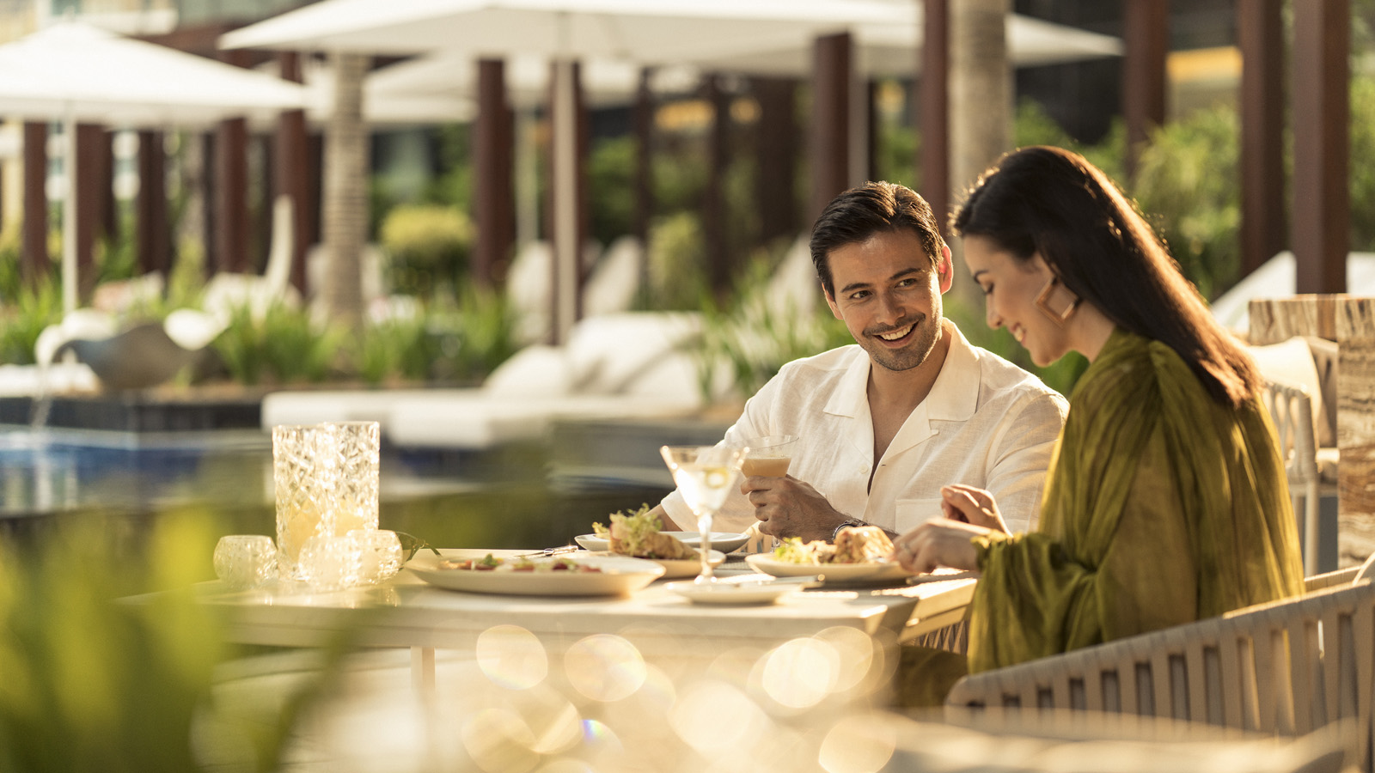 | January 31, 2020, Kuala Lumpur, Malaysia  An Elevated Romance at Four Seasons Hotel Kuala Lumpur  https://publish.url/kualalumpur/hotel-news/2020/valentines-day.html

PRESS CONTACTS

Kanchana Ganglani
Director of Public Relations
145 Jalan Ampang
Kuala Lumpur
Malaysia
kanchana.ganglani@fourseasons.com

+6(03) 2382 8740

