First Taste of MARCUS at Four Seasons Hotel Montreal

Marcus Samuelsson gives a first look at his menu, introduces his executive team, and announces community outreach partnership with DESTA
April 15, 2019, Montreal, Canada

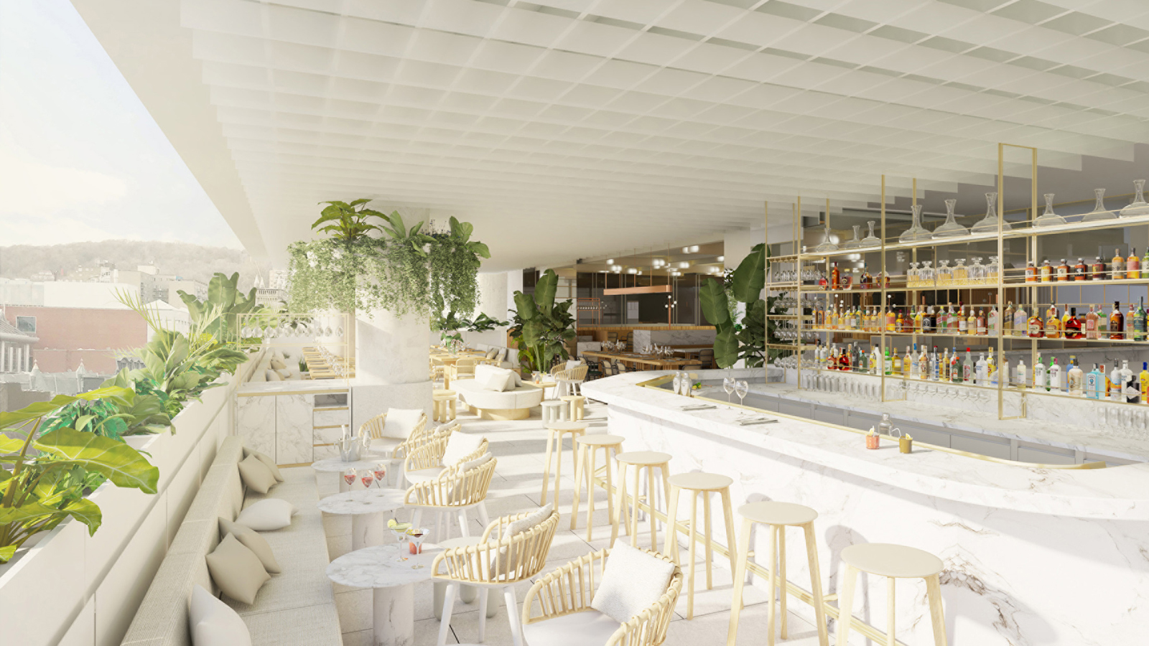
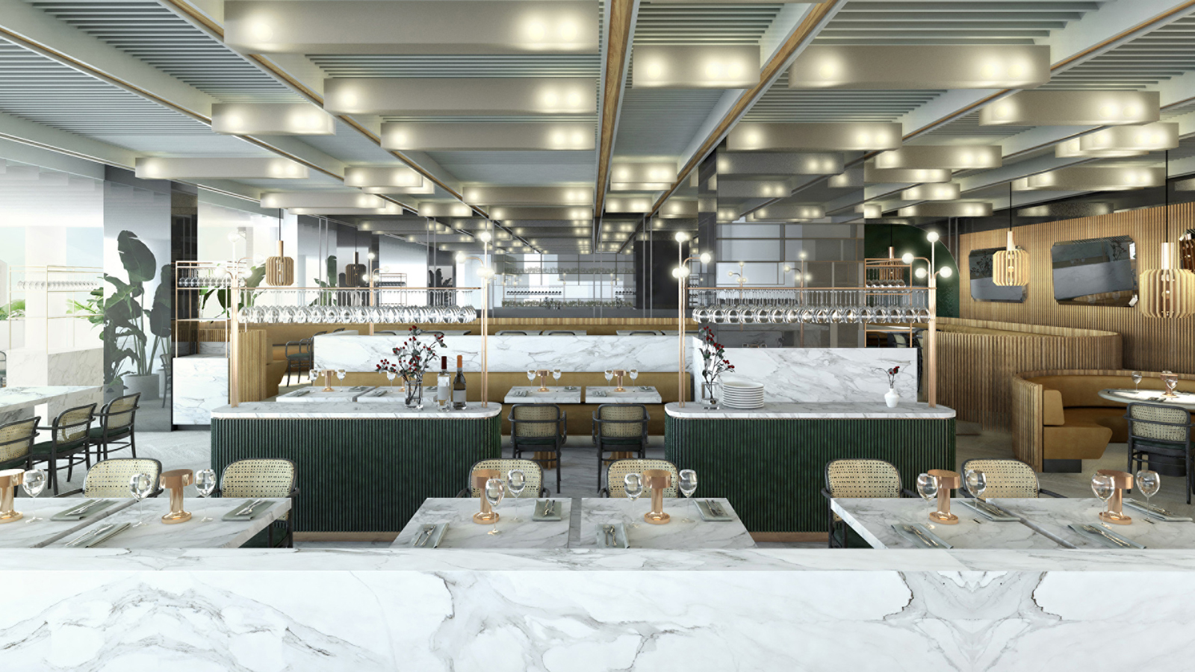 | 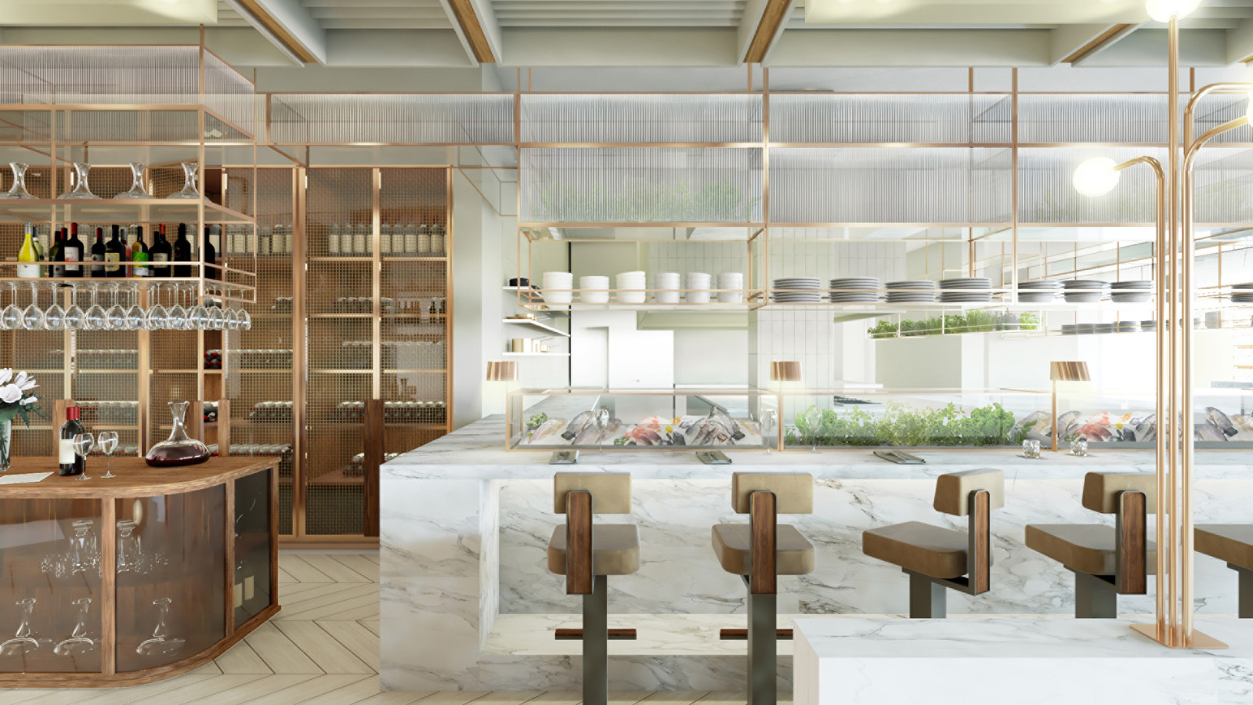 | 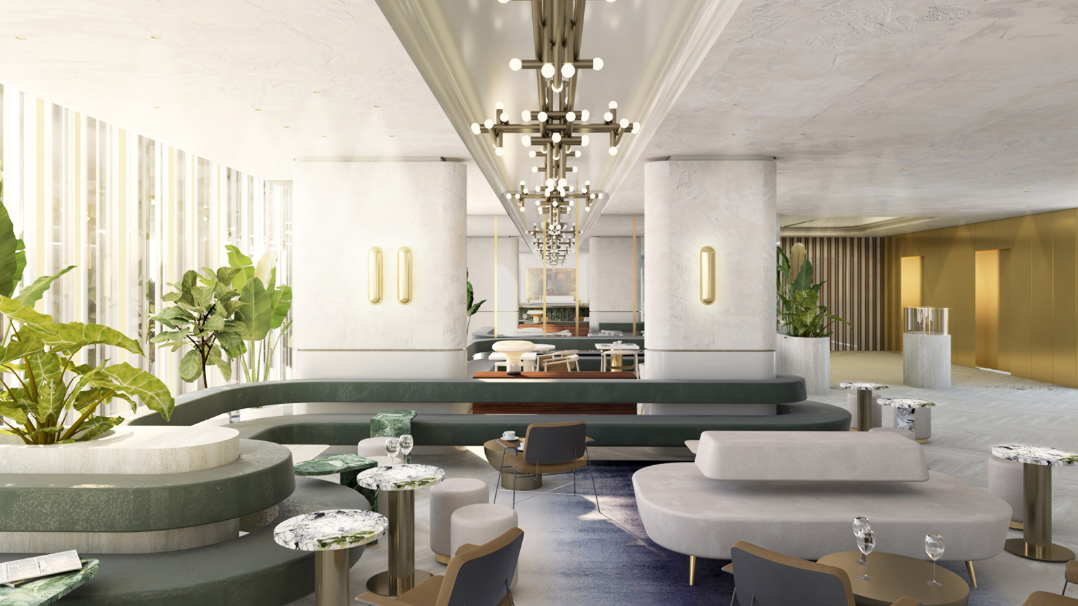
Inspired to offer guests a destination where world-class cuisine, vibrant culture and unparalleled service would intersect, Four Seasons Hotel Montreal presents MARCUS, a new-concept brasserie located in the heart of the Hotel’s Social Square.
 | 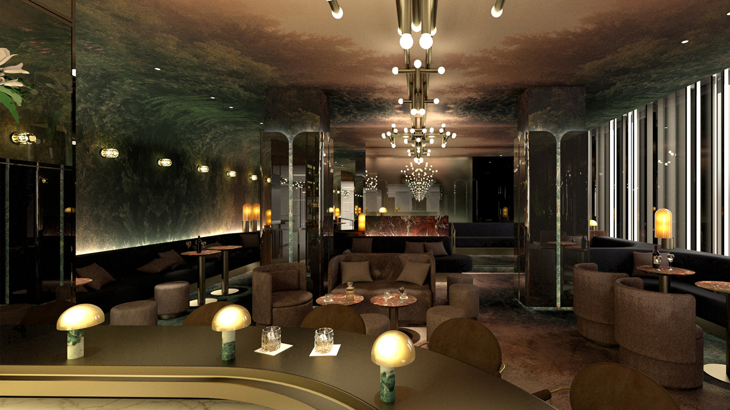 | 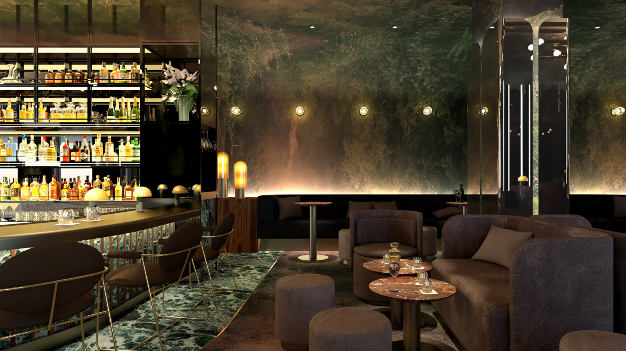
Highlighting the bounty Montreal’s ports and purveyors offer, the restaurant focuses on local seafood prepared with seasonal vegetables and fresh flavours. Spearheaded by award-winning Chef Marcus Samuelsson, the teams leading the dining room and kitchen pair their passion and precision to offer guests memorable and delicious experiences.
MARCUS is more than simply a restaurant: It is a meeting place where visitors and locals can feel both inspired and at home. A hub of creativity and connection, MARCUS harnesses the power of good food and community to broaden the horizons of its guests.
Concept
Montreal - with its bustling energy, global visitors and sophisticated locals - proved to be the ideal location for MARCUS. Set inside Four Seasons Hotel Montreal, MARCUS gives its guests the option to enjoy the restaurant in a variety of ways. From a casual lunch at the Day Bar or Lounge, to an elegant dinner in the dining room, or a nightcap at the Night Bar or on the terrace that overlooks the city - the restaurant’s distinct areas offer unique-yet-cohesive dining experiences for every occasion.
The menu at MARCUS defines fresh. Local seafood - including daily catches from Quebec’s surrounding waters - takes centrestage through myriad preparations. Chilled oysters are served with crisp cucumber and sweet apple. Salmon belly is grilled with maple and nori for a salty-sweet contrast. Tuna is dried and cured to create a braesola - a seafood charcuterie that’s as satisfying as it is innovative. Roasted king oyster mushrooms, seafood stew and a seafood tower are just a few examples of the many delectable offerings guests can expect at MARCUS.
With a diverse playlist streaming through the space, interesting pieces of art adorning the dining room, and local DJs and musicians slated to perform late night in the Night Bar, music will be at the centre of the Social Square.
Earlier today, Chef Samuelsson proudly presented the executive team behind MARCUS, served a first taste of the menu, and also unveiled the restaurant’s partnership with DESTA, a not-for-profit organisation that will offer one of its youth members the opportunity to intern at MARCUS.
Team Reveal
Among an intimate gathering of press and select guests, Chef Samuelsson and the Hotel’s General Manager Gonçalo Monteiro welcomed the celebrated team charged with bringing the vision of MARCUS to life:
“I am so excited and proud to introduce the executive team behind MARCUS,” said Chef Samuelsson. “Each team member has been carefully selected for their immense talent, dedication, and passion for food. They are all welcome additions to the MARCUS family.”
- Nicholas Bramos, Chef de Cuisine, has lent his dedication and talent to a number of notable Quebec restaurants, including Toqué!, Decca77, and 1909 Modern Taverne. A former Chopped Canada contestant, Bramos injects his focused and collected demeanour into the kitchen at MARCUS. “There’s no limit when it comes to the Montreal food scene,” says Bramos. “MARCUS will definitely break the mold.” Pairing top quality ingredients with impeccable service, Bramos is excited to serve guests who are as in love with food as he is.
- Gabriel Bélanger, Sommelier, has travelled the world with a thirst for refining his palate as he unearths complex wines. Crowned Sommelier of the Year at the 2018 Caterer Middle East Awards, Bélanger is known for taking risks and exploring interesting varietals and winemakers across the globe. However, his vision for Four Seasons Hotel Montreal is modest: To simply share his knowledge and deep love of wines with guests. “For me, it’s not the pleasure of drinking,” says Bélanger. “It’s the pleasure of being surprised—the pleasure of discovering something new. I want to change people’s ideas about wine, and surprise even the most knowledgeable of guests.”
- Simon Lespérance, Bar Manager, will oversee the entire mixology program at MARCUS and Four Seasons Hotel Montreal. A Montreal-native, Lespérance has honed his craft at a number of bars, including 13 venue openings across the city, including taking the top spot at the 2014 Drunken Master mixology competition. As an avid traveller, Lespérance is passionate about bringing the ingredients and flavours he discovers abroad to his nuanced, creative cocktails. Recruiting some of the city’s best bartenders, Lespérance’s team is at the forefront of the cocktail scene, looking to push boundaries, reduce waste, and use local and innovative ingredients to create unforgettable cocktails for their guests. “My goal is not to be the best bar in Montreal, but to be one of the best bars in the world,” he says.
- Simon Thibeault, Restaurant Manager, joins Four Seasons Hotel Montreal with notable experience as an international manager for The Ritz-Carlton chain of hotels and restaurants. From Spain and Portugal to Thailand and Toronto, he looks forward to extending unparalleled hospitality to the guests at MARCUS and Four Seasons Hotel Montreal. “What makes the Montreal food scene unique is our understanding and knowledge of the clientele,” he explains. “In Montreal, people really understand and appreciate cooking techniques, refined ingredients, wine products and spirits. You cannot come to Montreal with a mediocre product or experience. You need to deliver at a consistently high level, and we plan to do just that.”
Community Involvement
Chef Samuelsson and Monteiro also proudly announced MARCUS’ internship partnership with DESTA, a partnership that will see one of its members win an internship at the restaurant. Philanthropy plays a large role in Chef Samuelsson’s life and work, and as a new restaurant owner in Montreal, he was adamant on supporting the local community by providing work opportunities and guidance to the city’s youth.
As co-chair of C-CAP (Careers Through Culinary Arts Program), a national non-profit that educates and guides underserved high school students towards a successful future, providing career readiness and development in the culinary world, Chef Samuelsson immediately connected with DESTA’s mission, highlighting his commitment to mentorship and inclusion across the hospitality industry.
“I’m truly humbled for the opportunity to make DESTA my philanthropic focus in Montreal,” said Chef Samuelsson. “I’ve had the opportunity to witness DESTA’s work firsthand, and look forward to helping guide young talent in their culinary pursuits through the internship program at MARCUS.”
Based in Little Burgundy and serving participants across Greater Montreal, DESTA supports black youth in reaching their educational, employability and entrepreneurial goals through a holistic and individualised approach. Chef Samuelsson will announce the internship details in the near future and looks forward to welcoming DESTA’s mentees to his restaurant.
“We’d like to thank Chef Samuelsson and Four Seasons Hotel Montreal for their generosity. This internship partnership at MARCUS is an incredible opportunity for DESTA. As an organisation serving Montreal’s black community, it is very meaningful for our participants to see Chef Samuelsson as a model for what is possible,” said Barkley Cineus Jr., DESTA Board Member.
Experience MARCUS at Four Seasons Hotel Montreal
Both MARCUS and Four Seasons Hotel Montreal will open on May 8, 2019.

RELATED

April 15, 2019, Montreal, Canada
Avant-gout du MARCUS de l’hôtel Four Seasons Montréal
https://publish.url/montreal/hotel-news/2019/marcus-team-and-community-involvement-2.html

April 11, 2019, Montreal, Canada
Four Seasons Hotel Montreal Announces May 8, 2019 Opening Date
https://publish.url/montreal/hotel-news/2019/opening-date-announced.html

PRESS CONTACTS

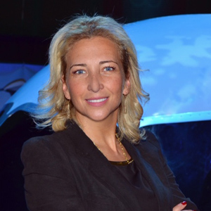 | Marlène Joubert  Director of Public Relations / Directrice des relations publiques  1440 Rue de la Montagne  Montréal  Canada  marlene.joubert@fourseasons.com  +1 514 975 8000

