The Perfect Weekend Retreat at Four Seasons Hotel Hong Kong

September 18, 2019, Hong Kong, China

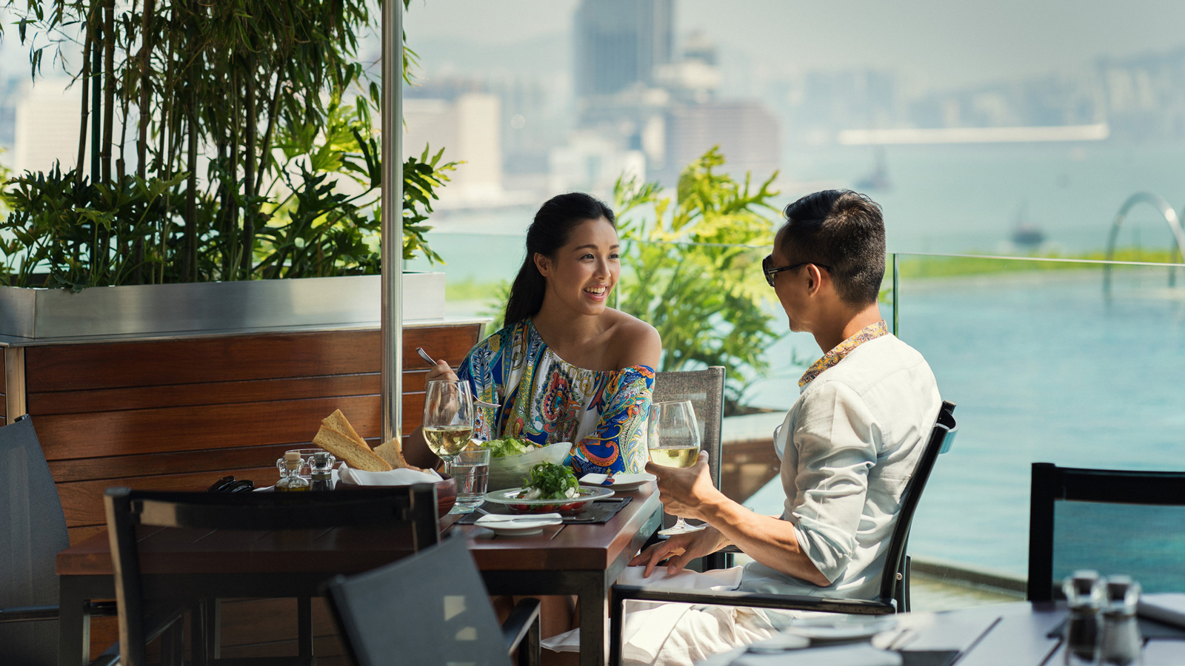
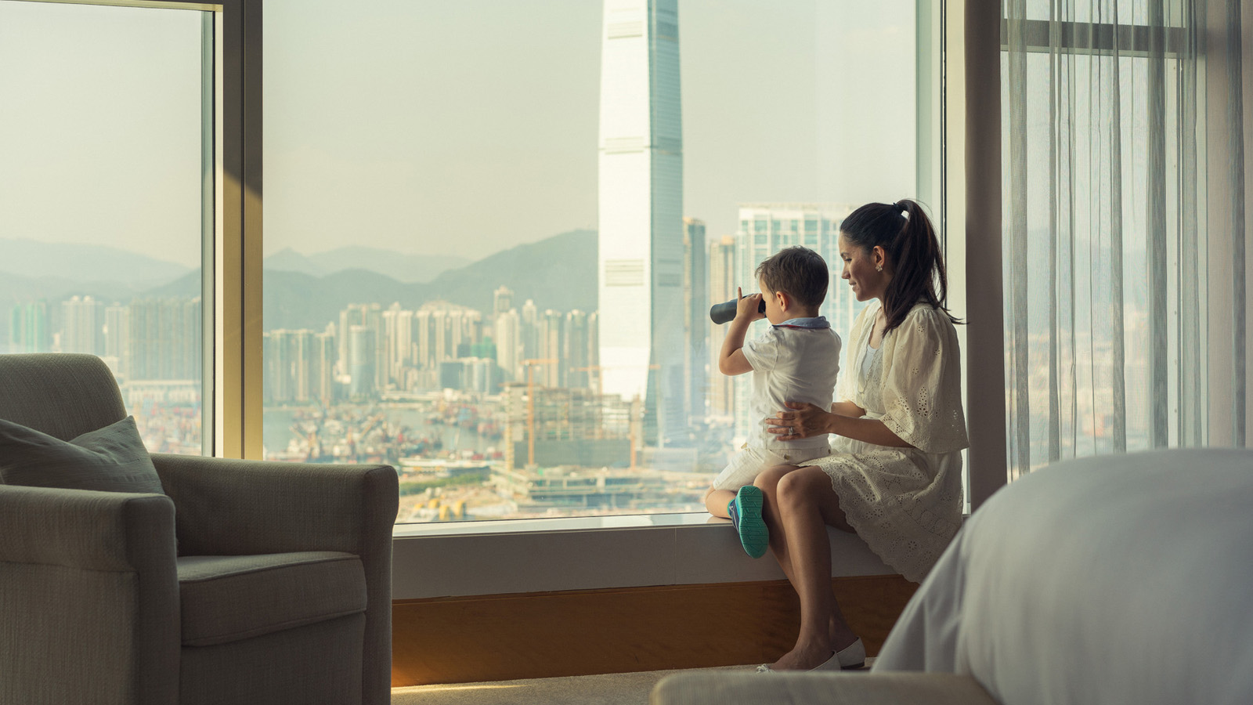
Enjoy the best of Hong Kong at Four Seasons Hotel Hong Kong with the Weekend Retreat package offering 15 percent savings off the best available room rate that includes a host of dining and spa benefits and late check-out.
Wake up to a hearty breakfast at The Lounge. Sit back and relax in plush leather chairs at the Nail Bar with 20 percent savings on any treatment during the stay, featuring classic manicures and pedicures to trendy nail art and executive grooming. Sleep in and linger a little longer in the comforts of the spacious room with a guaranteed late check-out at 4:00 pm.
To add to the experience, the package offers guests optional enhancements at supplementary rates for room upgrades and a star-studded culinary journey at some of Hong Kong's most sought after Michelin-starred restaurants, namely the 3 Michelin-starred Lung King Heen Cantonese restaurant, and 3 Michelin-starred Caprice French restaurant.
The Weekend Retreat package includes:
- Overnight accommodation at the Deluxe Peak View Room
- Complimentary daily American set breakfast for two adults at The Lounge, children aged 11 and below dine complimentary
- Late check-out till 4:00 pm
- 20 percent savings on nail treatments at the Nail Bar
For optimal pleasure, guests may choose to top-up with the following optional enhancements:
- Add HKD 200 supplement for next room category upgrade with Harbour View
- Set dinner at 3 Michelin-starred Caprice for two adults at HKD 3,640 plus 10 percent service charge
- Set dinner at 3 Michelin-starred Lung King Heen for two adults at HKD 2,200 plus 10 percent service charge
Between these experiences, soak in breath-taking Victoria Harbour views from the outdoor infinity pool or explore a luxury shopping spree in IFC Mall adjacent to the Hotel.
The special offer is available for arrivals and stays from Friday to Sunday, from now until February 29, 2020. Package is subject to availability and advance reservations are required.
Book the perfect weekend retreat now by emailing reservations.hkg@fourseasons.com, calling (852) 3196 8333 or booking online.

RELATED

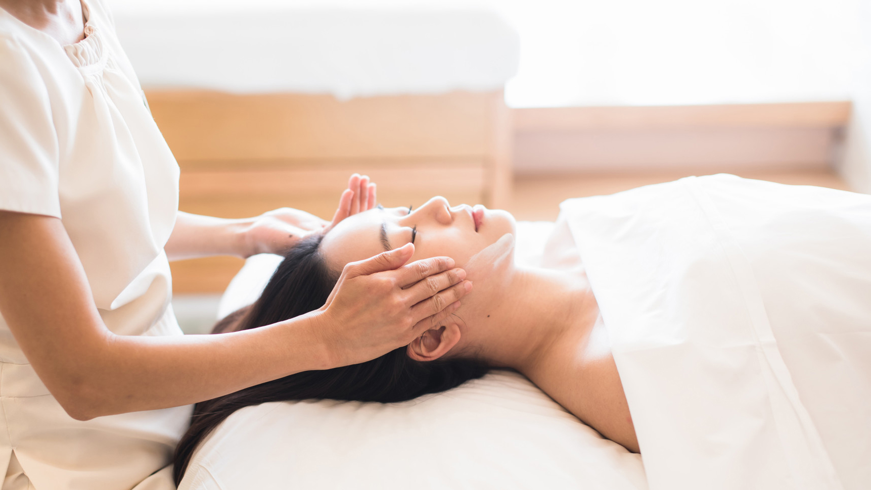 | November 14, 2019, Hong Kong, China  香港四季酒店呈獻亮肌美容療程 一個瞬間讓肌膚飽滿的氧氣面部護理  https://publish.url/zh_hant/hongkong/hotel-news/2019/new-luminous-facial-2.html
November 14, 2019, Hong Kong, China
Four Seasons Hotel Hong Kong Introduces Luminous Facial, A Skin Plumping Oxygen Treatment
https://publish.url/hongkong/hotel-news/2019/new-luminous-facial.html

PRESS CONTACTS

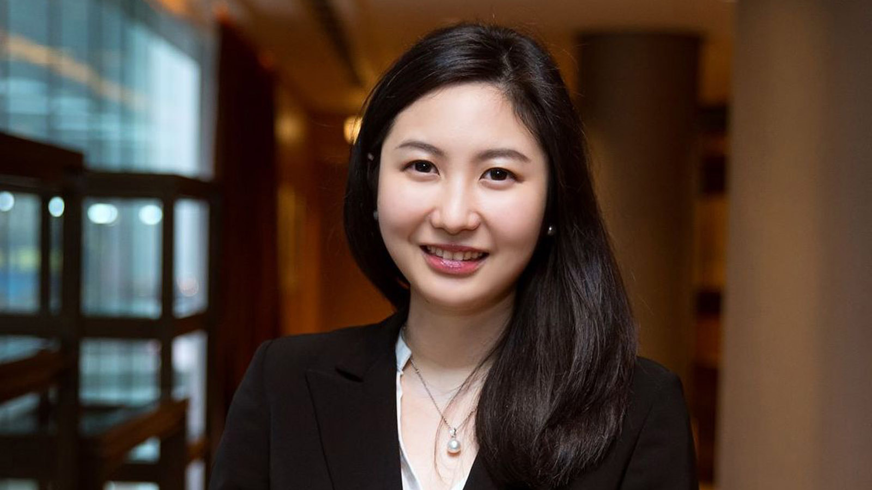 | Priscilla Chan  Assistant Public Relations Director  8 Finance Street, Central,  Hong Kong  China  priscilla.chan@fourseasons.com  (852) 3196 8307

