A New Look on Luxury

August 9, 2017, Mauritius

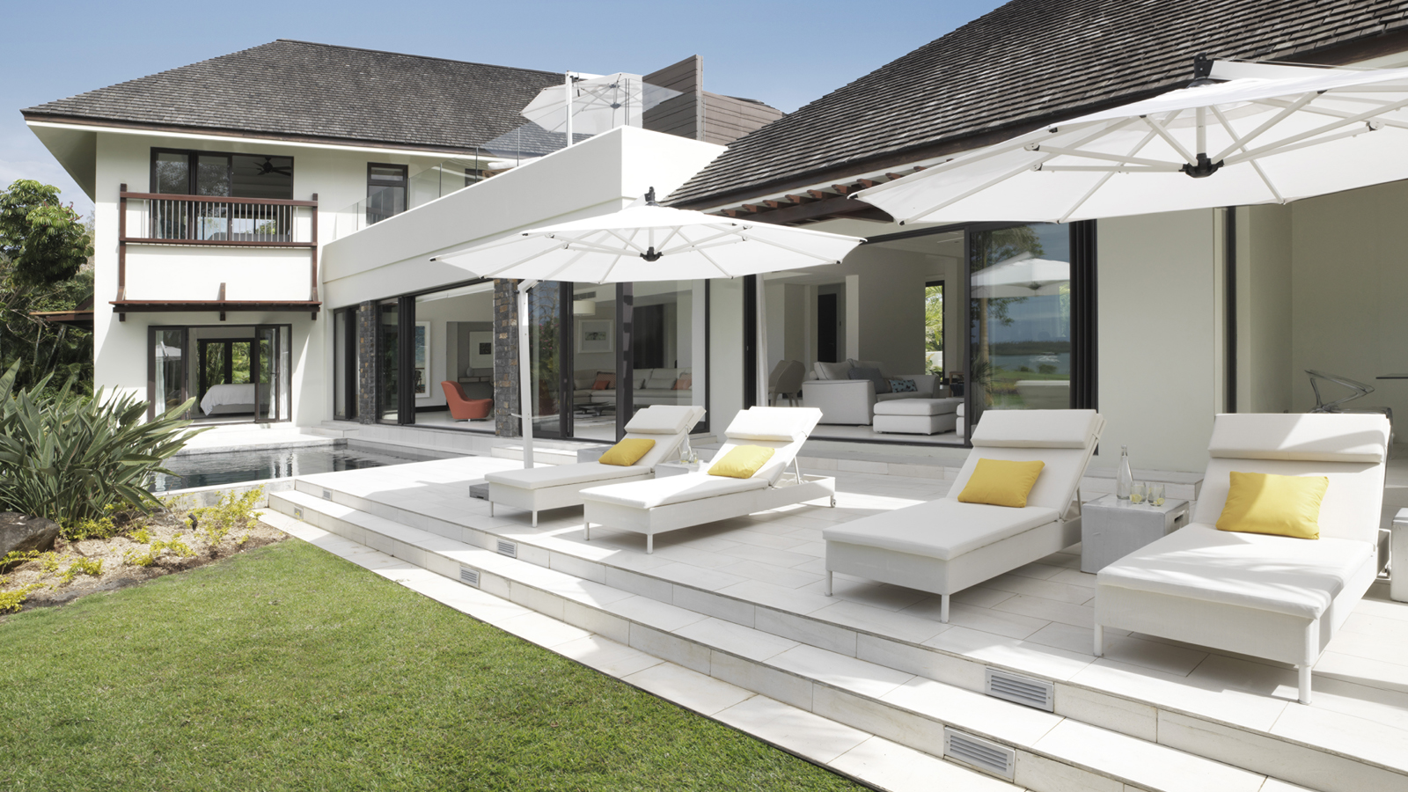
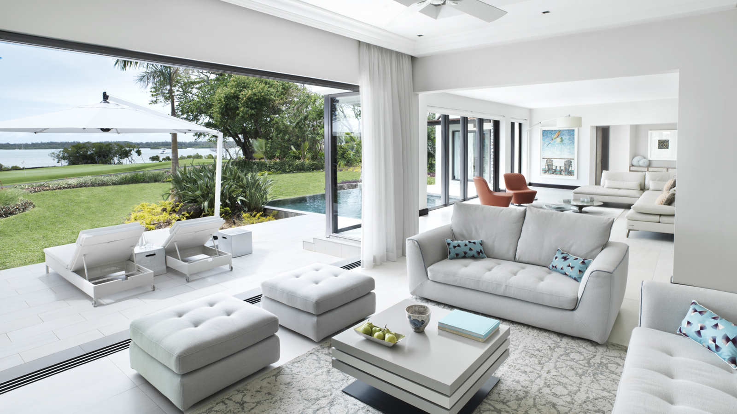 | 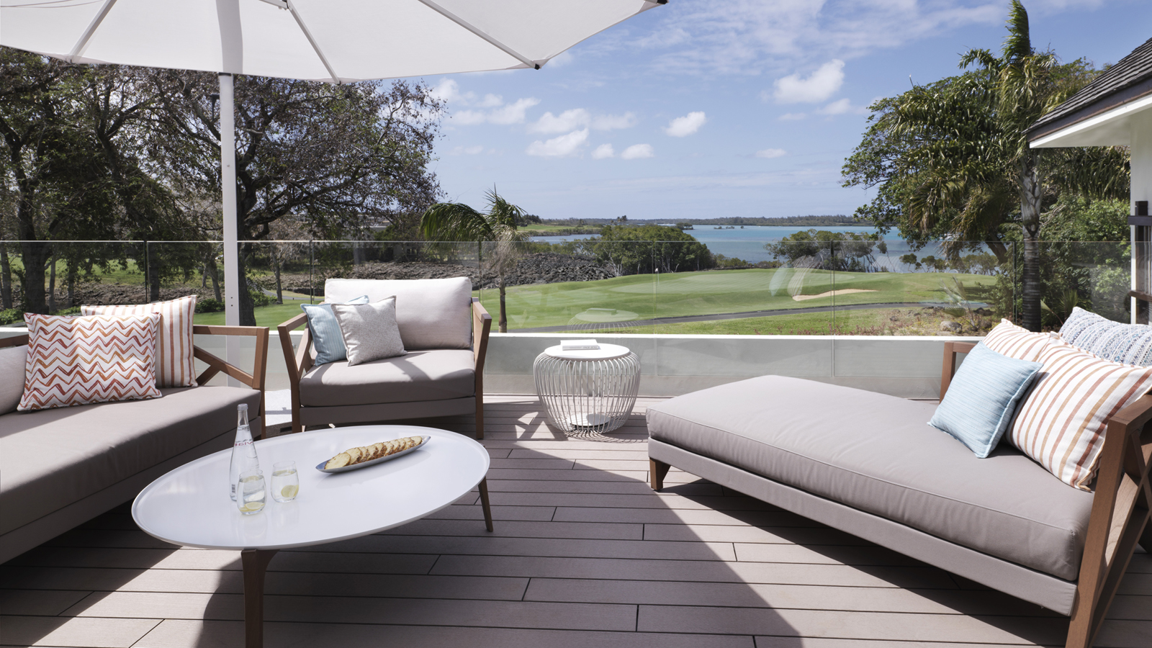
As the only accommodation at
Four Seasons
Resort Mauritius at Anahita to boast a private roof terrace, the new Four-Bedroom Premium Deluxe Residence Villa has everything to offer for extended families or friends travelling together. Following a full renovation, the spacious Residence Villa showcases a chic and contemporary design, filled with character furniture pieces and distinctive artwork, while an elongated panorama of the pool and garden is seen through the floor-to-ceiling glass doors in the open plan lounge.
Overlooking the Ernie Els Design golf course and Indian Ocean lagoon beyond, the Four-Bedroom Premium Deluxe Residence Villa boasts a prime resort location, with more than 510 square metres (5,488 square feet) of living space. A spacious, open plan lounge invites relaxed family living, just metres from a private plunge pool and garden, while on the outdoor terrace, a BBQ grill offers the perfect location for in-villa dining to complement a fully equipped kitchen.

RELATED

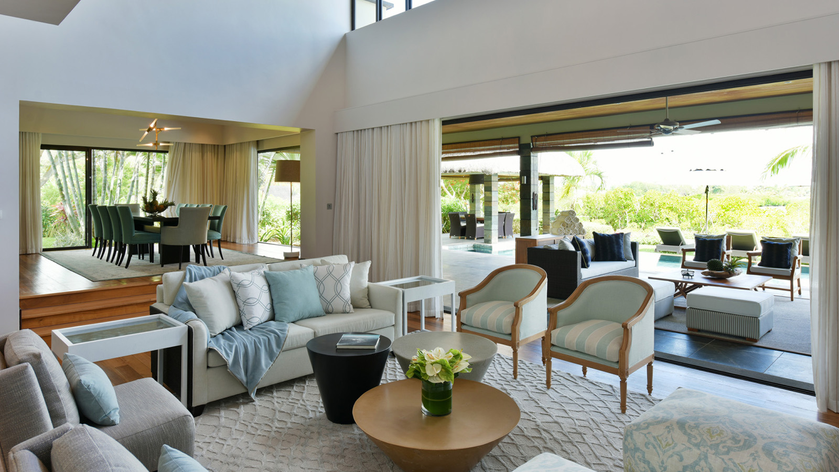 | June 6, 2017, Mauritius  Revealing the New-Look Royal and Grand Residence Villas at Four Seasons Resort Mauritius at Anahita  http://publish.url/mauritius/hotel-news/2017/renovated-royal-and-grand-residence-villas.html
June 6, 2017, Mauritius
Four Seasons Resort Mauritius at Anahita dévoile le nouveau look des Villas Résidentielles ‘Royal’ et ‘Grand’
http://publish.url/fr/mauritius/hotel-news/2017/renovated-royal-and-grand-residence-villas-2.html

PRESS CONTACTS

Debbie Duval
Director of Public Relations and Communications

Beau Champ
Mauritius
debbie.duval@fourseasons.com

(230) 402 3100

