Four Seasons Hotels and Resorts and NetJets Offer Exceptional Personalised Service and Seamless Luxury Travel with New Collaboration

Iconic luxury brands come together to create custom travel itineraries
October 11, 2017, Toronto, Canada

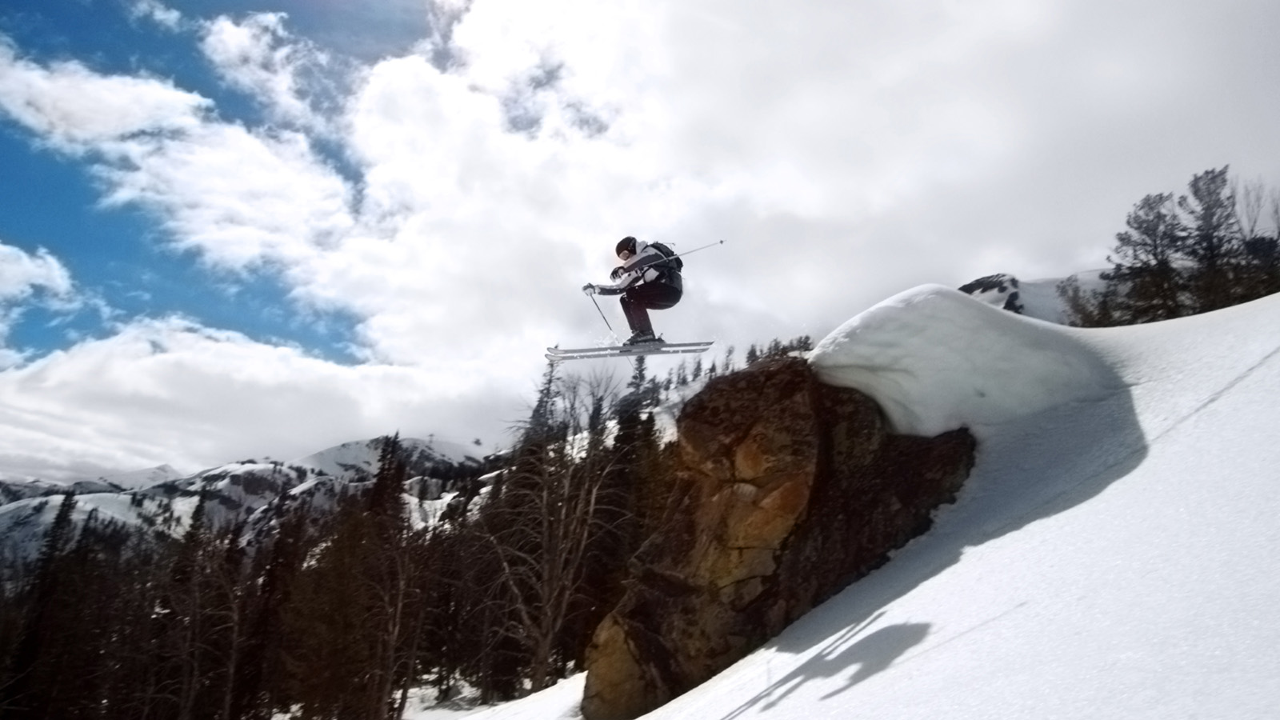 | 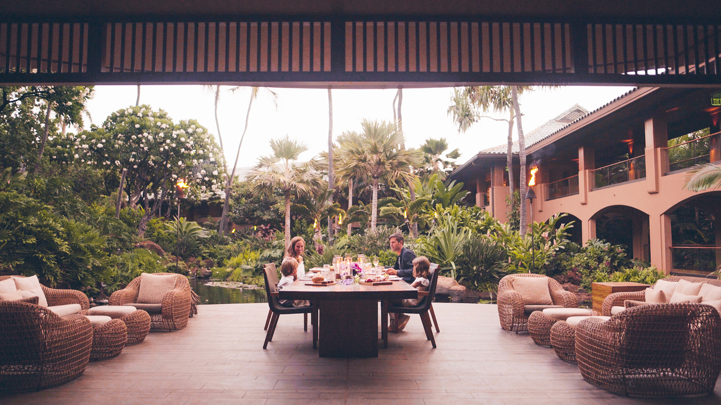 | 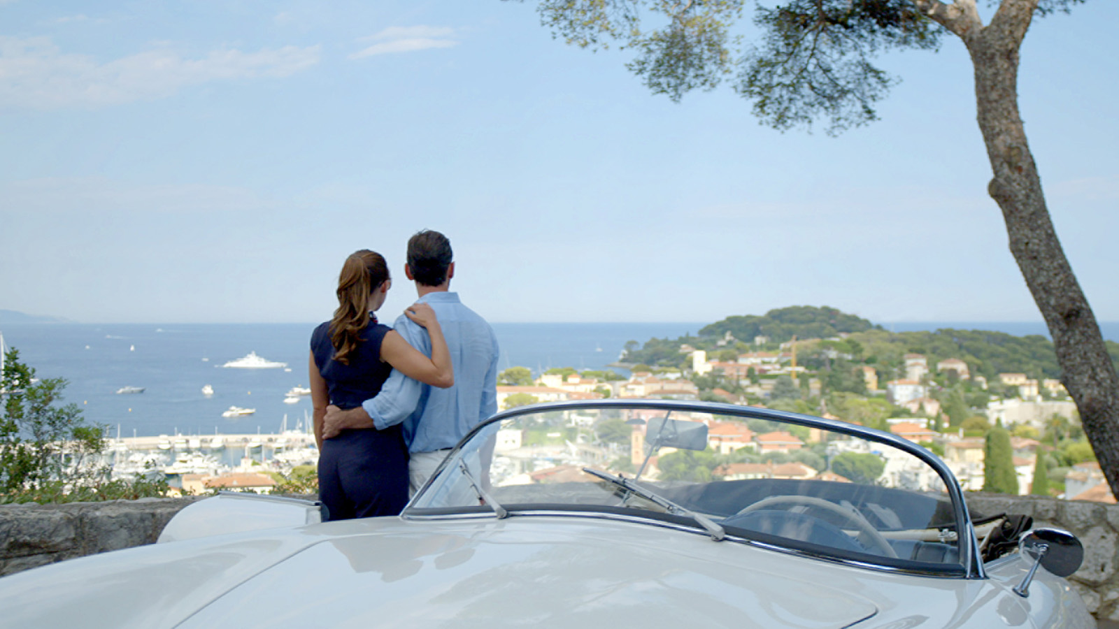
Born of the shared belief that travelling should be one of life’s most enjoyable and fulfilling endeavours,
Four Seasons
Hotels and Resorts, the world’s leading luxury hospitality company, and NetJets, the world’s largest private aviation company, are joining forces to offer the ultimate in luxury in the sky and on the ground.
As industry pioneers,
Four Seasons
and NetJets have been at the forefront of innovation, setting new standards for service excellence and introducing industry firsts for more than fifty years each. The icons are now coming together with the introduction of exclusive travel opportunities available to both NetJets Owners and
Four Seasons
guests.
“The complementary nature of our two companies lays the foundation for a strong global collaboration, combining the power of the NetJets private fleet – the largest in the world – with the renowned culture of service excellence that defines
Four Seasons
,” says J. Allen Smith, President and CEO,
Four Seasons
Hotels and Resorts. “
Four Seasons
has always been singularly focused on the luxury consumer – understanding their needs, looking at how they like to travel and recognising opportunities to extend our offering in ways that fit their lifestyles. These specially-designed itineraries offer the perfect opportunity for our guests - many of whom are already NetJets Owners - to enjoy exceptional service, flexibility and unmatched access to destinations around the world.”
In three uniquely designed itineraries – with each entirely customisable to suit traveller preferences - guests will be transported via a NetJets private jet to
Four Seasons
destinations, where they will have opportunities to enjoy a series of exclusive experiences. Guests can choose from a winter mountain adventure on the soaring slopes of Jackson Hole and Vail, a tropical escape to the unspoiled Hawaiian island of Lanai, and a cultural immersion in France and Italy. Throughout their journey, air transportation will be arranged by NetJets, while
Four Seasons
will provide all accommodations and a dedicated concierge will customise each guest’s local itinerary. Timing of these trips is flexible, and available for parties of up to 14 guests – ideal for families, couples seeking a romantic getaway, or an intimate group of friends travelling together.
“This collaboration will open new doors to travellers, welcoming them into a world of access that only
Four Seasons
and NetJets can offer,” says Patrick Gallagher, EVP of Sales and Marketing, NetJets. “Our goal is to make the impossible possible as we invite our guests to experience exceptional private aviation. Alongside the extraordinary experiences
Four Seasons
creates, our combined dedication to providing bespoke service in every detail creates a rare opportunity for our guests to travel without compromise.”
NetJets Owners and
Four Seasons
guests will enjoy the freedom of travelling with true peace of mind, never having to worry as every step of their journey is seamlessly executed. Passengers will have access to a
Four Seasons
Director of Guest Experience, a dedicated concierge who will work with each guest to customise the itineraries into one-of-a-kind experiences.
As the fifth largest airline in the world, NetJets offers an unrivalled network of global connectivity including access to 5,000 airports in 170 countries around the globe.
Four Seasons
is the world’s leading luxury hospitality company, with more than 100 hotels and resorts on six continents.
Learn more about travelling with Four Seasons and NetJets with Four Seasons Magazine here and here.
About the Itineraries
Offering a glimpse into the world of possibilities that
Four Seasons
offers, each of these three new itineraries is entirely customisable, should guests wish to substitute or add activities. Timing is flexible through July 2018, subject to availability and with certain restrictions depending on location. Trips may be booked by up to 14 guests travelling together.
Ski Adventure
- Accommodations at
Four Seasons
Resort and Residences Jackson Hole and
Four Seasons
Resort and Residences Vail, with air travel by NetJets
Upon landing in Jackson Hole, Wyoming, one of the world’s premiere snow destinations, guests will be treated to a sleigh ride through the National Elk Refuge en route to their
Four Seasons
Private Residence accommodations. A dedicated Ski Concierge will lead a fitting for custom handmade skis for everyone before dinner at the Chef’s Table. The next day is spent on the slopes with a US Olympian skier guiding guests through back country and out-of-bounds runs, highlighted by a special Four Seasons gourmet lunch in the mountains. Day three takes guests via helicopter over the Grand Teton Range to Yellowstone National Park for a wildlife safari via snowmobile before an afternoon reserved for pampering in the Resort’s Spa.
Travelling on to Vail via NetJets, guests will be greeted by a personal butler in a
Four Seasons
Private Residence boasting 360-degree mountain views. After dinner with the chef that evening, guests prepare for an exhilarating day of heli-skiing, now in the Colorado Rockies. Après-ski activities include a mixology class and bourbon tasting before taking a snowcat for dinner in a cosy chalet. On the trip’s final day, guests enjoy early mountain access and front-of-the-line privileges before a
Four Seasons
chef-prepared mountaintop lunch completes this incredible trip.
Island Getaway
- Accommodations at
Four Seasons
Resort Lanai, with air travel by NetJets
With virtually the entire island at one’s disposal, this trip promises a taste of old Hawaii with all the modern comforts of a five star resort. Upon arrival via NetJets, a dedicated
Four Seasons
ambassador greets the party, whisking guests to their oceanfront suite to settle in before a private al fresco dinner accompanied by island entertainment. The next morning is reserved for the Lanai Archery and Clay Shooting Range and a picnic lunch on the edge of a wooded valley. That evening, guests set sail aboard a 50-foot (15 metre) catamaran for a stargazing expedition accompanied by an expert in Polynesian mythology. On day three, guests buckle up for a 4x4 off-road exploration of the island, with stops in a traditional village and secluded beaches. An omakase dinner at NOBU Lanai is highlighted by a sushi-making class personally led by the restaurant’s Executive Chef Marlowe Lawenko. The next morning, guests tee up on the Jack Nicklaus designed golf course before departing – but not without a custom-created meal to enjoy in the air as a final taste of the islands.
European Escape
- Accommodations at
Four Seasons
Hotel George V, Paris and
Four Seasons
Hotel Firenze, plus either Grand-Hôtel du Cap-Ferrat, A
Four Seasons
Hotel or
Four Seasons
Hotel Milano, with air travel by NetJets
Gourmands will delight in the exclusive experiences that await in Paris. After a sommelier-led tour of the historic wine cellar with tasting of rare vintages at
Four Seasons
, three Michelin star Chef Christian Le Squer will personally host a tasting menu dinner in his private kitchen quarters. The next day, guests visit the private home and atelier of a leading French fashion designer. A cooking class with Michelin-starred Chef David Bizet of L’Orangerie or Chef Simone Zanoni of Le George back at the Hotel caps off the day.
Arriving in Florence via NetJets, guests are welcomed by a personal guide from Antinori to enjoy a tour of the famous vineyards in the Chianti Classico region followed by a dinner. The next day, a private tour of the Uffizi Gallery is followed by a candlelit dinner on the only open-air balcony on the famed Ponte Vecchio prepared by the Hotel’s Michelin-starred Chef Vito Mollica.
Guests may choose from either Cap-Ferrat or Milan to round out their journey. On the French Riviera, highlights include an opportunity to take the wheel of a classic vintage car, or embark on a sailboat cruise along the coast. A visit to an internationally acclaimed dance school precedes an unforgettable dinner accompanied by a private dance performance. In Milan, guests have access to one of the city’s most distinctive residences, the home of artist and collector Giampiero Bodino for a private dinner prepared by Chef Mollica. Relaxation in the Hotel’s Spa follows the next day before taking in the sunset on the Duomo’s private terrace.
About
Four Seasons
Four Seasons
has long been committed to transforming the way people travel, having launched the hospitality industry’s first fully-branded private jet experience with TCS World Travel in 2015. This collaboration with NetJets is another opportunity for luxury travellers to enjoy the benefits of private jet travel and elevate their journeys through
Four Seasons
accommodations and curated extraordinary experiences.
Founded in 1960,
Four Seasons
Hotels and Resorts is dedicated to perfecting the travel experience through continual innovation and the highest standards of hospitality. Currently operating 106 hotels, resorts and residences in major city centres and resort destinations in 44 countries, and with more than 50 projects under planning or development,
Four Seasons
consistently ranks among the world’s best hotels and most prestigious brands in reader polls, traveller reviews and industry awards. For reservations, visit fourseasons.com. For the latest news, follow @FourSeasonsPR on Twitter.
About NetJets
NetJets Inc., a Berkshire Hathaway company, is the worldwide leader in private aviation with the largest and most diverse private jet fleet in the world. NetJets celebrated its 50th Anniversary in 2014, having been established in 1964 as the world’s first private jet charter and management company. In 1986, NetJets pioneered the concept of fractional aircraft ownership - offering individuals and businesses all the benefits of whole aircraft ownership and more, at a fraction of the cost. Today, NetJets offers a full range of private aviation solutions, including fractional ownership, leasing, and jet cards through businesses bearing the NetJets, Executive Jet Management, and Marquis Jet Card service brands in North America and Europe. For more information on NetJets customer programs and services, visit netjets.com. Follow NetJets on Twitter @NetJets and Instagram NetJets.

RELATED

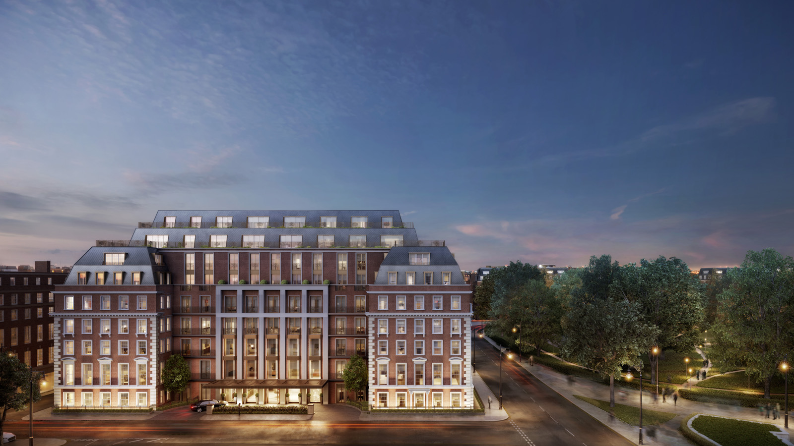 | September 15, 2017, Toronto, Canada  شركة فنشاتون تنفذ أول وحدات سكنية خاصة لمجموعة فورسيزونز لندن في مبنى "تونتي غروفنر سكوير"  http://publish.url/news-releases/2017/new-private-residences-in-london-2.html
September 15, 2017, Toronto, Canada
Four Seasons e Finchatton Annunciano: Le Prime Residenze Private di Four Seasons A Twenty Grosvenor Square
http://publish.url/news-releases/2017/new-private-residences-in-london-7.html

PRESS CONTACTS

Sarah Tuite
Director, Corporate Communications and Public Relations
1165 Leslie Street
Toronto
Canada
prsm@fourseasons.com

+1 (416) 441-4440

