Four Seasons Resort Palm Beach Continues Decades-Long Honour of Five-Star Distinction in Forbes Travel Guide’s 2021 Star Awards

Finalist for inaugural People First Star Award recognising people and culture trailblazers
February 16, 2021, Palm Beach, U.S.A.

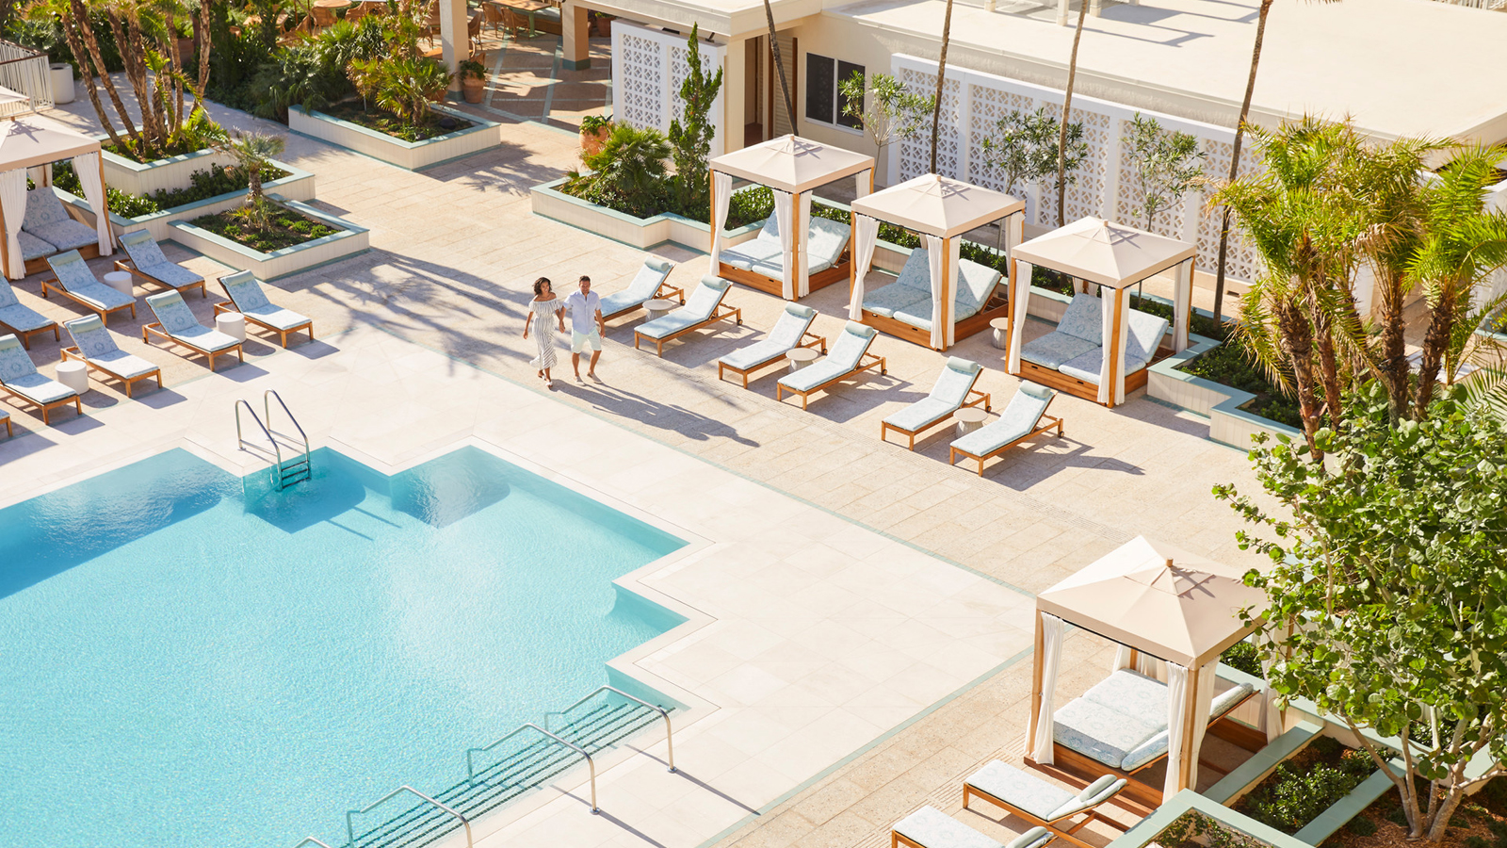
With the announcement of the 2021 Star Awards by Forbes Travel Guide, Four Seasons Resort Palm Beach celebrates twenty-three consecutive years as a Five-Star Resort and five consecutive years as a Five-Star Spa, the highest honour bestowed by the world-renowned authority in genuine Five-Star service. The Resort was also recognised as a finalist for the inaugural People First Star accolade, honouring an exceptional commitment to people and culture.
As Palm Beach’s most quintessential beach resort, Four Seasons Resort Palm Beach is an intimate getaway on the Island’s most expansive beach where guests can truly embrace the South Florida lifestyle.
"This year’s recognition is particularly momentous for us,” says Mohamed Elbanna, Regional Vice President and General Manager of Four Seasons Resort Palm Beach. “From our guests to our employees, our people-centric values are paramount. We believe that every moment is an opportunity to create a connection and lasting impression, whether it’s with our guests, our community, or each other.”
To honour those who particularly shined during the pandemic, Forbes Travel Guide introduced the new Hospitality Stars of the Year awards in 2021. The People First Star honourees adapted to numerous adversities all while maintaining a people-centred focus, including efforts related to improving staff health and happiness and overall support of the team’s mental wellbeing. Forbes Travel Guide received hundreds of entries and narrowed down to five finalists, including Four Seasons Resort Palm Beach.
While navigating a global health crisis unlike anything experienced before, Four Seasons Resort Palm Beach answered the call from a world-leading financial company to become a safe haven for the company’s employees to live, work, and maintain business continuity during the pandemic, undertaking extensive precautionary measures to ensure everyone’s health and safety. While focused on Lead With Care, the global enhanced health and safety program of Four Seasons Hotels and Resorts, the Palm Beach leadership team was also steadfast in honouring the belief that its greatest asset, and the key to its success, is its people. Spanning those working within the innovative bubble environment, those working outside, and those on furlough, the employee experience was grounded in consistent and genuine communication, assistive benefits, and the pursuit for every employee to be themselves, and to feel safe doing so.
“We are grateful to our guests that placed their trust with Four Seasons Resort Palm Beach to provide a safe and seamless experience for their employees and families,” says Elbanna. “Furthering the strength of our Lead With Care program, we can also now lead with experience, carrying on this trusted comfort to our future Four Seasons guests as we excitedly prepare to welcome them back to our Palm Beach paradise.”
“During a most challenging year for the hospitality industry, these brands not only persevered, they made a significant impact on guests and their communities,” said Filip Boyen, CEO of Forbes Travel Guide. “Each of these winners personifies the resiliency, ingenuity and graciousness of our community. They are an inspiration to us all.” He added, “We hope that these excellent properties will inspire travellers for when they are ready to venture out on their next trip.”

RELATED

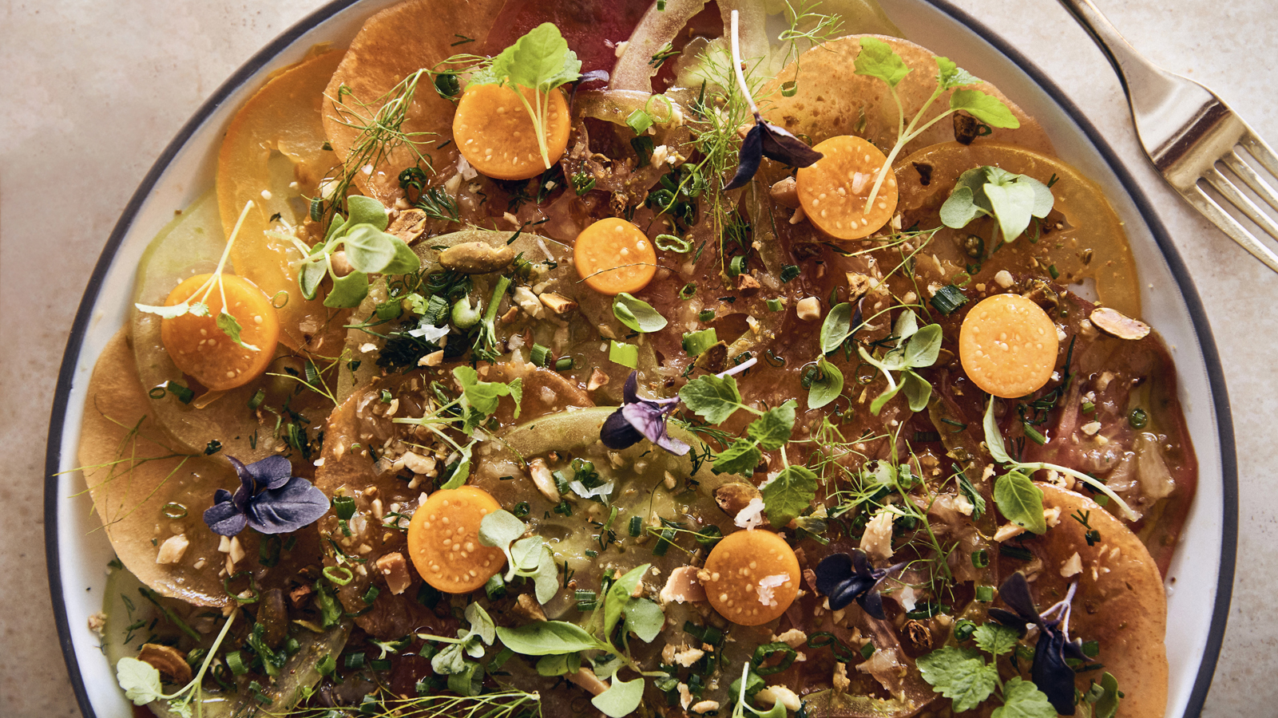 | February 1, 2021, Palm Beach, U.S.A.  Florie’s, Chef Mauro Colagreco’s Restaurant and Bar in Partnership with Four Seasons Resort Palm Beach, Launches “Home by Florie’s”  https://publish.url/palmbeach/hotel-news/2021/home-by-flories.html
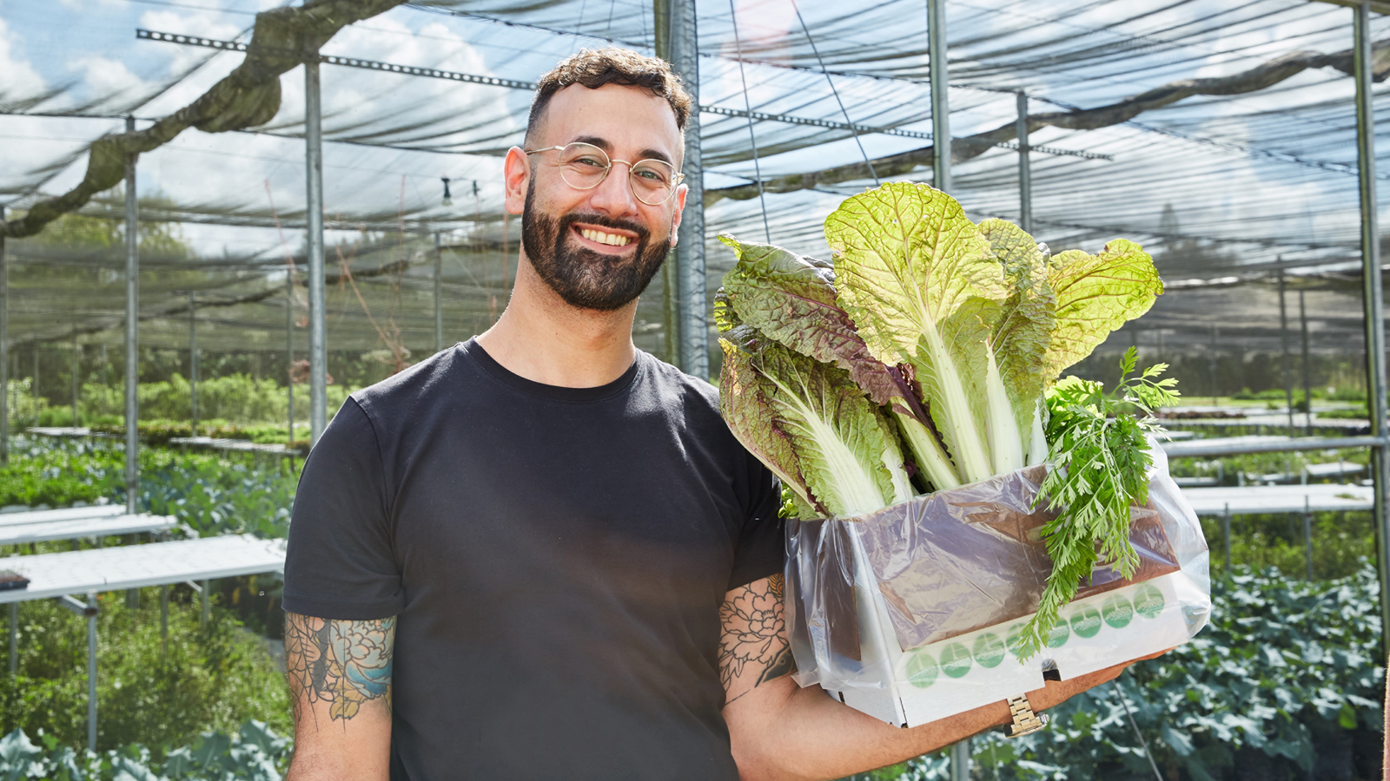 | April 23, 2020, Palm Beach, U.S.A.  Four Seasons Resort Palm Beach Offers At-Home Gardening Tips Along with Garden-Fresh Recipes  https://publish.url/palmbeach/hotel-news/2020/gardening-and-garden-fresh-ideas.html

PRESS CONTACTS

Laurie Herrick
Regional Director of Public Relations and Communications
2800 South Ocean Boulevard
Palm Beach
USA
laurie.herrick@fourseasons.com

1 561 493 5549

