A Blessed Ramadan Festivity at Four Seasons Hotel Jakarta

April 5, 2021, Jakarta, Indonesia

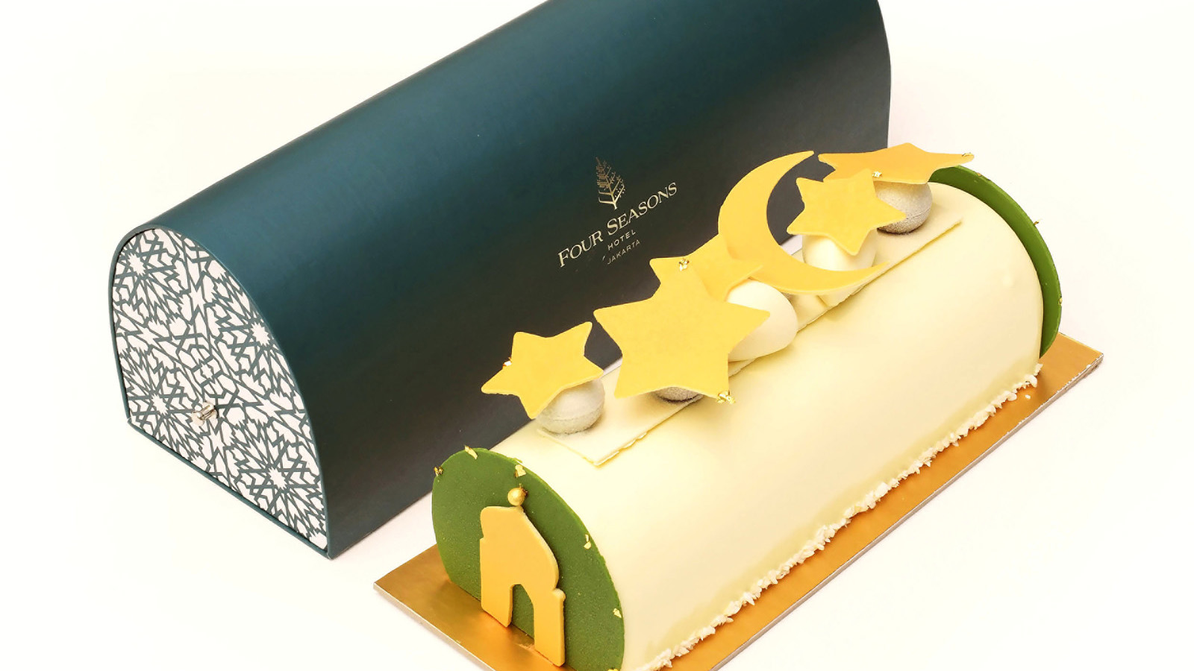
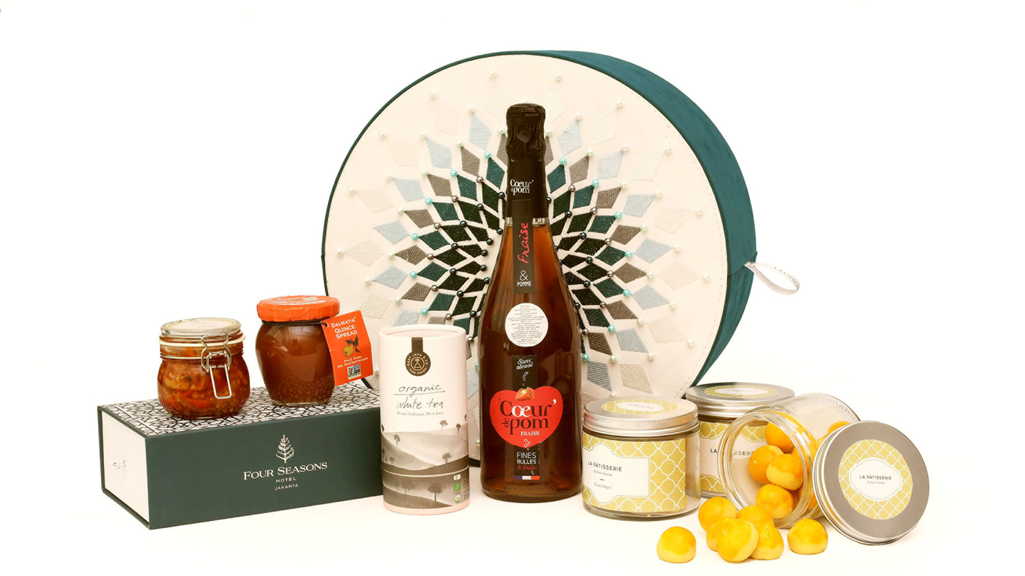 | 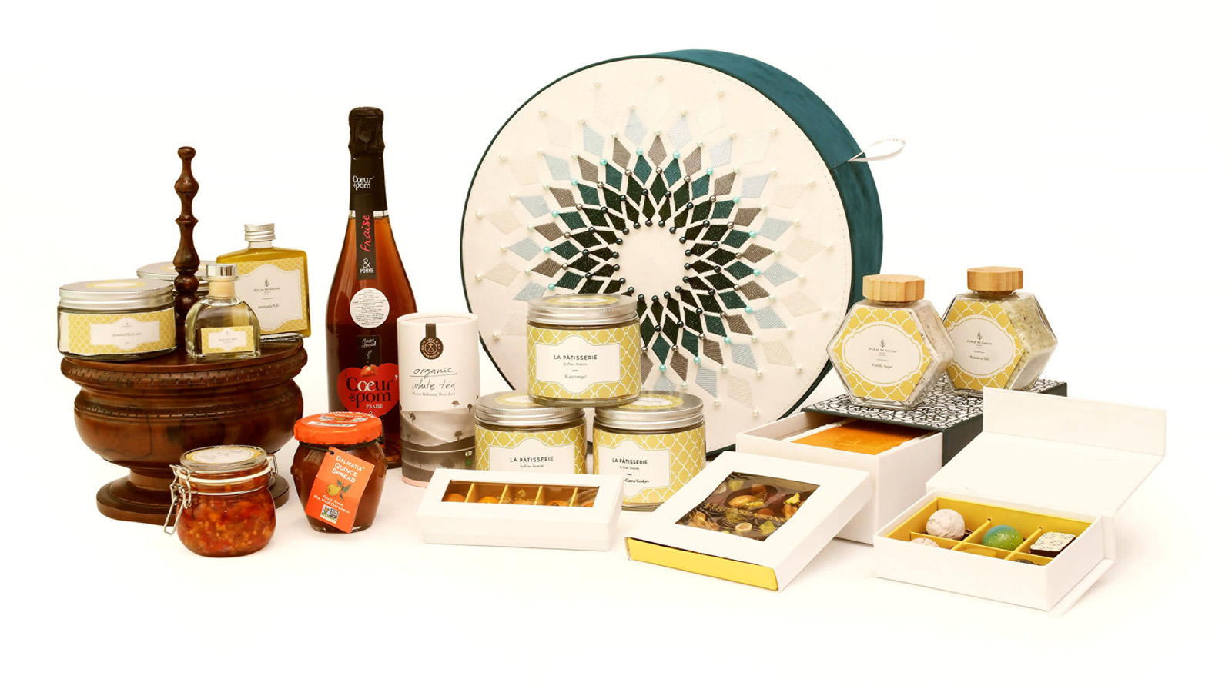 | 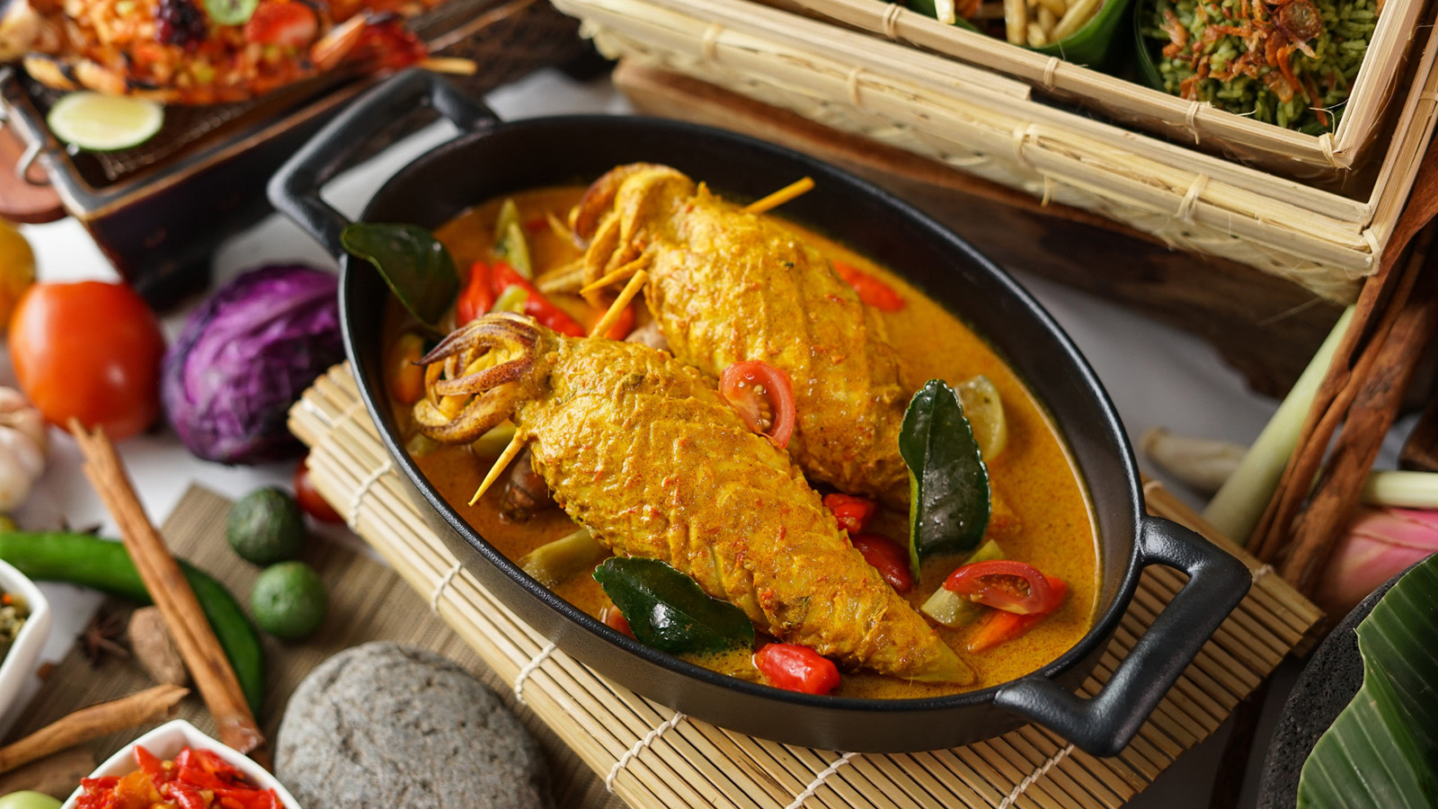
To celebrate the Holy Month of Ramadan, Four Seasons Hotel Jakarta will be featuring authentic Indonesian cuisines that reminisce generational recipes by the talented Hotel’s craftspeople. Savour the all-time favourite dishes in the comfort and privacy of home with “Iftar2Go” or rejoice and reconnect with beloved friends and family with a lavish breakfasting at Palm Court.
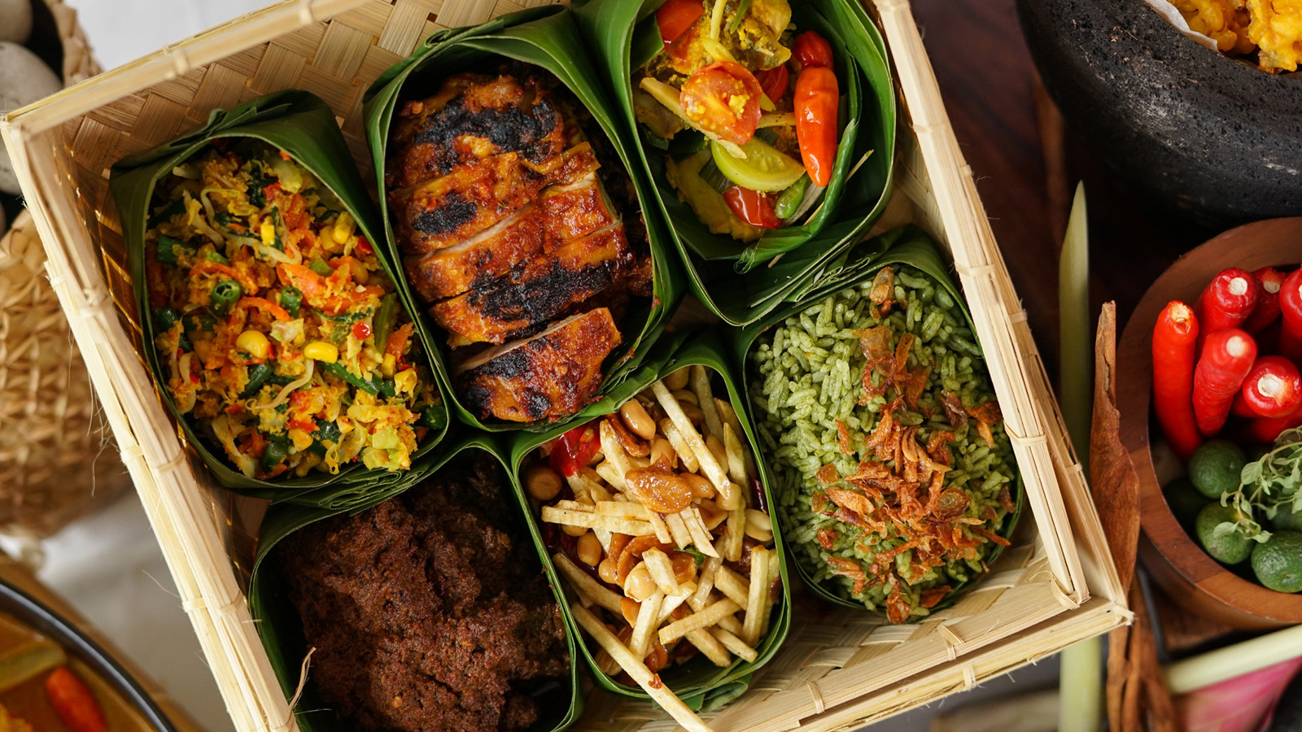 | 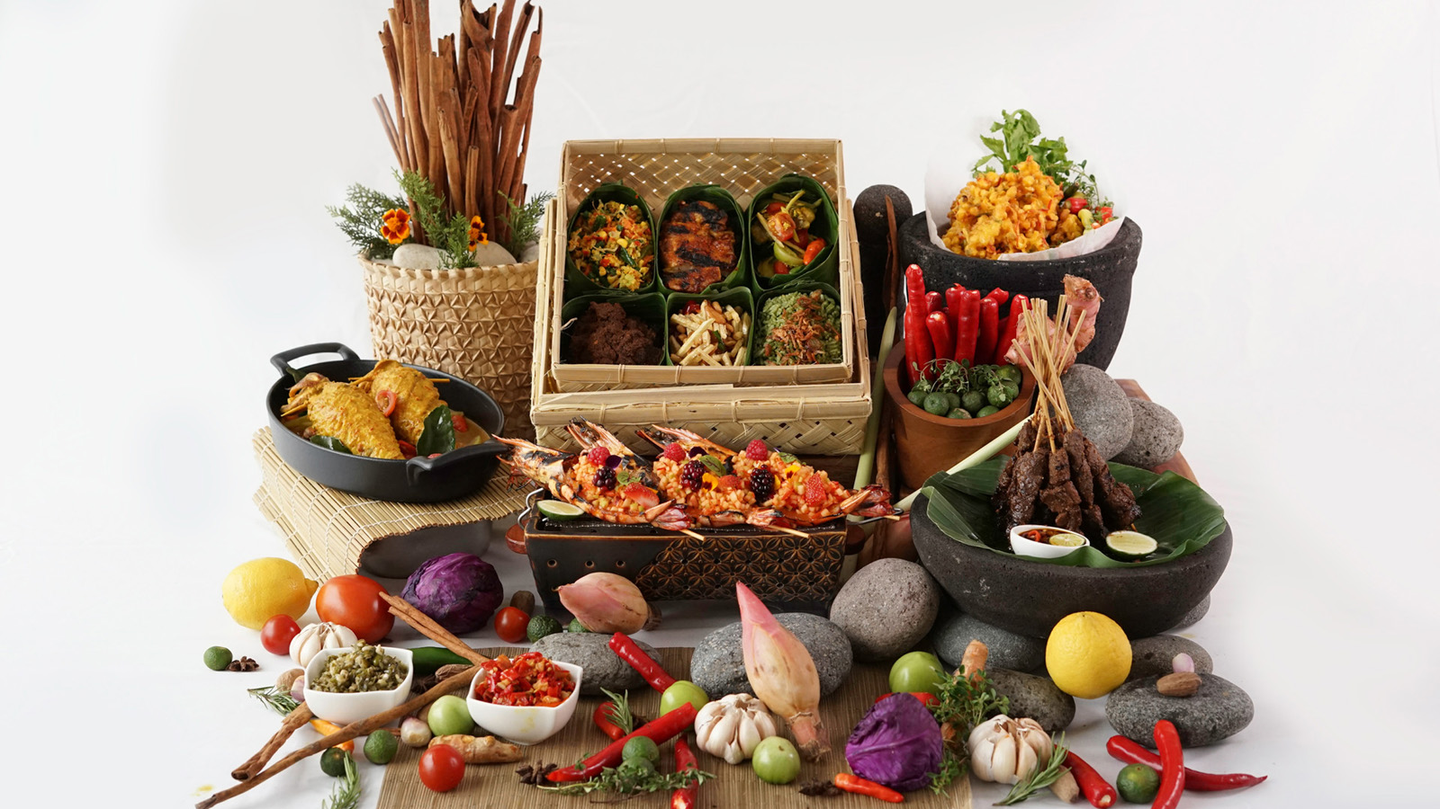 | 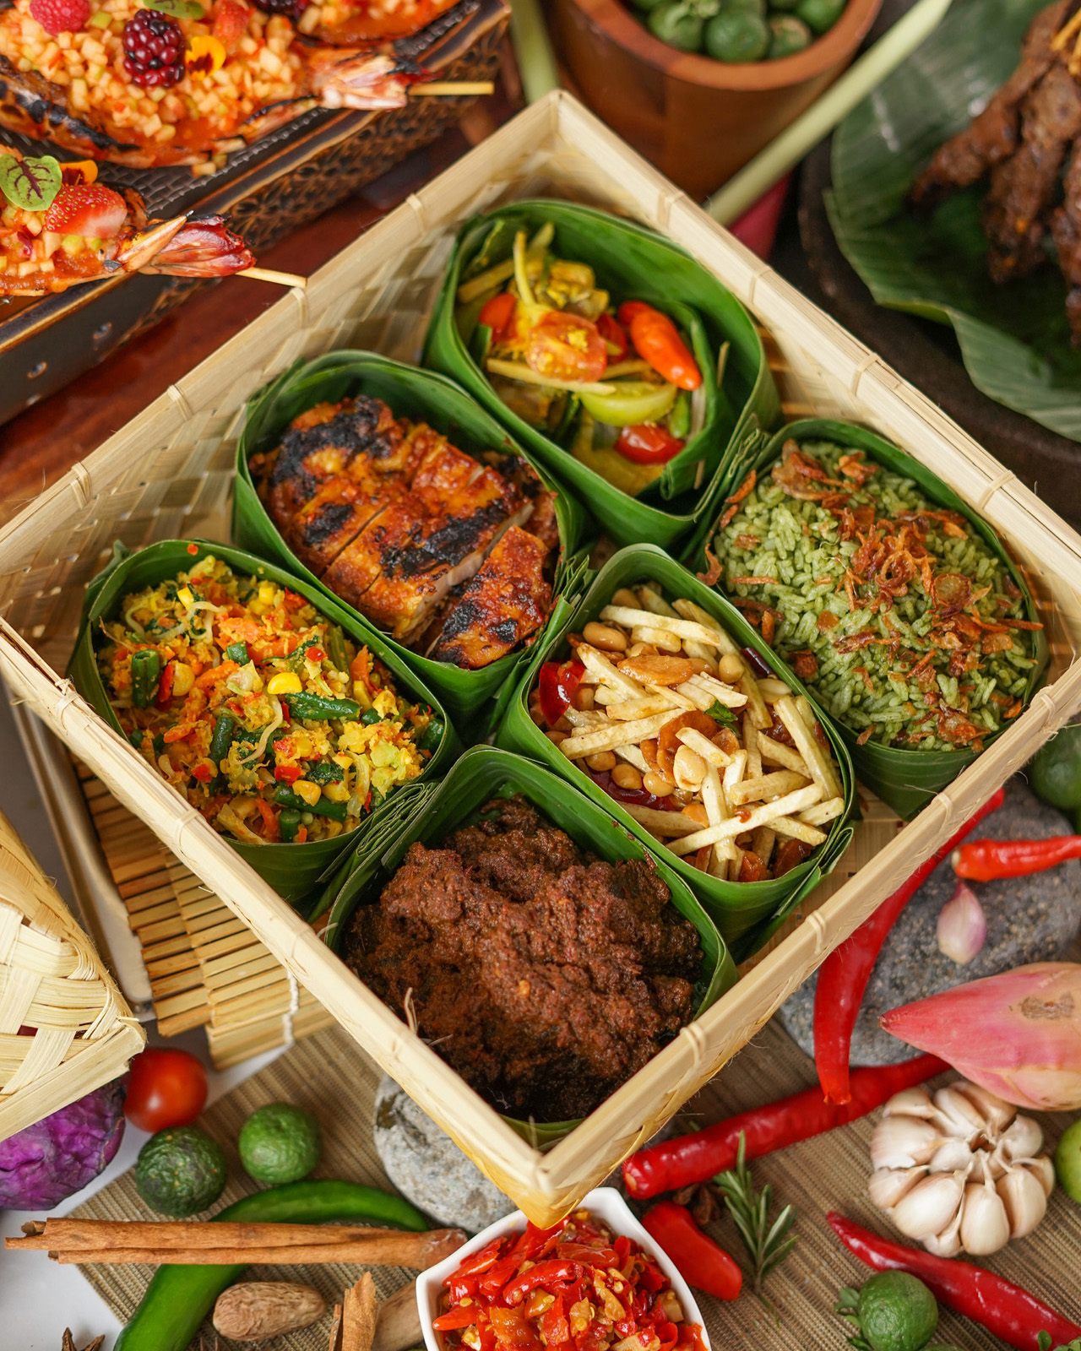
Iftar2Go
Enjoy breakfasting in the comfort of home with delectable Iftar delights prepared by the Hotel’s talented chefs using treasured family recipes. There are four packages to select from, and each package includes kurma, signature Indonesian menu choice of beef rendang curry, baked prawn gili trawangan, ayam bumbu kalasan or ayam bakar madu. Also included in the package is the Chef’s signature sambal and dessert.
Iftar2Go package priced at IDR 328,000 ++, available from 10:00 am to 9:00 pm during the Holy Month of Ramadan with free delivery within Jakarta area for minimum order of IDR 600,000++.
Four Seasons Ramadan Delights
Ramadan is a season of love, devotion and forgiveness. To welcome the Holy Month, Four Seasons Hotel Jakarta offers delectable festive treats and hampers with its finest products, to be shared during the Eid Mubarak blessings. The talented pastry team led by Executive Pastry Chef Lorenzo Sollecito has put together all-time favourite delicacies including premium nastar, sulawesi vanilla sugar, and delightful festive cookies.
A Lavish Iftar at Palm Court
Indulge in a lavish breakfasting at the Hotel’s signature restaurant Palm Court, ideal for celebrating with families and loved ones. The breakfasting feast is curated by the Hotel’s Indonesian talented chefs, Tri Priyanto, Darius Tjahja and Asep Hamdani, who will take you on an Iftar culinary journey featuring Indonesian traditional kampong specialties. Enjoy an array of classic dishes including ayam bakar sereh limo, wok-fried Javanese corn black pepper crusted sauce, wok-fried prawn cereal and curry leaf, and pan-seared Atlantic salmon bail and also various live stations of satay, signature mie ayam and meat ball and es dawet ayu solo. Not to be missed are the tajil and an array of desserts prepared by Executive Pastry Chef Lorenzo Sollecito and team.
Terms and conditions apply. For more information or to make an order, contact +6221 2277 1888 through WhatsApp, or download the Four Seasons App on iTunes or Google Play Store and use the #FSChat.

RELATED

November 24, 2020, Jakarta, Indonesia
Celebrate the Warmth of Festive Season with Four Seasons Hotel Jakarta
https://publish.url/jakarta/hotel-news/2020/festive-season.html

October 8, 2020, Jakarta, Indonesia
Four Seasons Hotel Jakarta Awarded Highest Rank in Indonesia by Condé Nast Traveler’s 2020 Global Readers’ Choice Awards
https://publish.url/jakarta/hotel-news/2020/top-hotel-in-indonesia.html

PRESS CONTACTS

Cindy Yuwono
Public Relations and Communications Executive
Jalan Jenderal Gatot Subroto Kav. 18
Jakarta
Indonesia
cindy.yuwono@fourseasons.com

+62 812 80940637

