Four Seasons Hotel San Francisco at Embarcadero Names Gunnar Planter Executive Chef of its Soon-to-Open Restaurant, Orafo

Seasoned California chef to open Italian-inspired dining concept at the newly renovated, sky-high urban luxury retreat later this month
February 10, 2023, San Francisco, U.S.A.

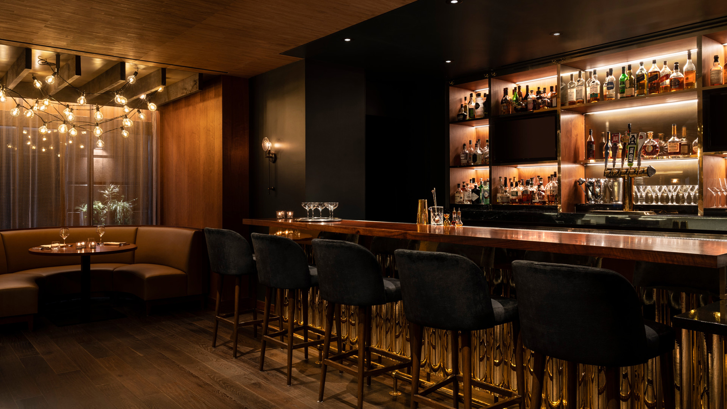
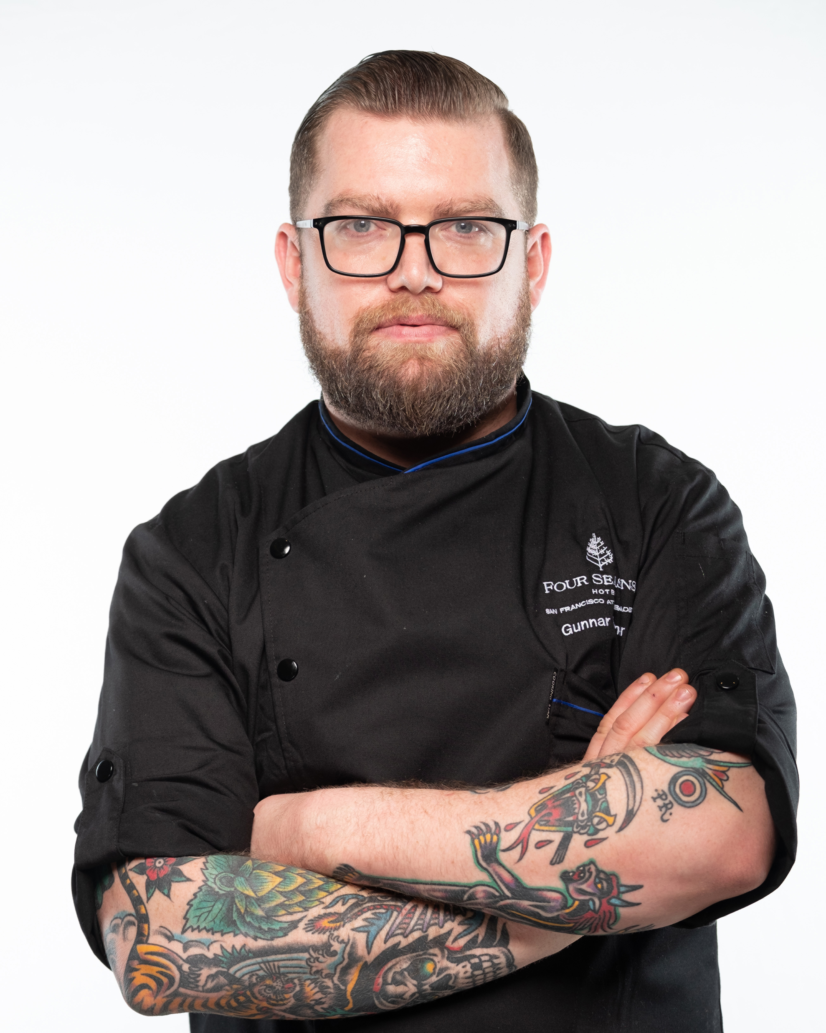
Following the completion of the newly renovated 155-room, boutique lifestyle-driven property, Four Seasons Hotel San Francisco At Embarcadero announces the appointment of acclaimed Chef Gunnar Planter as the Executive Chef of Orafo, the highly anticipated California-Italian inspired restaurant, later this month. Located on the ground floor lobby, Orafo will mark Chef Planter’s Bay Area debut, bringing with him more than 16 years of culinary experience and a passion for sourcing fresh, top-quality ingredients that bring authentic dishes to life.
The name Orafo, Italian for goldsmith, plays on the skilled artistry focused on mastery and method while giving a nod to San Francisco’s legendary gold rush heritage. At Orafo, Chef Planter looks forward to presenting diners with dishes that pay homage to regional Italian specialties – drawing inspiration from Tuscany and Calabria, offering tableside finishes, and working with authentic ingredients overnighted from Italy that accentuate the bountiful local produce. Guests will indulge in a menu of sharable appetizers such as Culatello and Buffalo Mozzarella and Tuna Bresaola Carpaccio and a la carte entrees starring handmade pastas from Pappardelle to Orecchiette to Campanelle, as well as large format main dishes like Porchetta and Branzino.
“I have worked my way up the California coast and am thrilled to join the iconic Four Seasons Embarcadero team,” says Chef Planter. “Orafo presents the opportunity for me to work with the finest imported Italian products from guanciale to culatello to olive oils and in-house freshly made pastas. I’m excited to cook in San Francisco’s world-class culinary community for the first time and can’t wait to welcome our guests with memorable dishes that will leave them looking forward to their next visit.”
Originally from San Diego, California, Chef Planter began his culinary career in his hometown of Rancho Santa Fe at French restaurant Mille Fleurs, learning the basics of fine dining cuisine under the mentorship of James Beard Award-winning Chef Martin Woesle. Over the next six years, he worked his way up to sous chef at Mille Fleurs while obtaining his Bachelor of Culinary Science from The Art Institutes. Next, Chef Planter grew his experience training at private social clubs, hotels, and restaurants where he began to develop an understanding for fine dining and banquets, and subsequently as the executive sous chef at the Inn at Rancho Santa Fe. In the following years, he took on the role of executive chef opening Viewpoint, a dining destination focused on coastal California cuisine located in Del Mar, California, and later at Ebullition Gastronomy, a fine dining gastropub in Carlsbad, California, where he specialized in both dry aged meats and charcuterie. Most recently, Chef Planter served as executive chef at boutique luxury hotel Mar Monte’s costa Kitchen & Bar and Café Lido, in Santa Barbara, California, where he focused on sustainably-sourced ingredients inspired by the local fresh seafood and farmer’s markets.
“Since the completion of our 2022 renovation, we have eagerly awaited the perfect match for our restaurant and are grateful to have found Chef Gunnar Planter to bring to life our new dining experience at Orafo,” comments General Manager Gigi Vega. “We’re confident that Chef Planter’s world-class culinary training, tremendous talent, and dedication to sourcing the highest quality ingredients will provide guests with an unforgettable meal at Orafo.”
Orafo is located at Four Seasons Embarcadero at 222 Sansome Street and will be open daily for breakfast, lunch, and dinner. Chef Planter and the Four Seasons Embarcadero team look forward to sharing more details on Orafo’s opening in the coming weeks including opening timeline and menus.

RELATED

December 21, 2022, San Francisco, U.S.A.
Get into the Holiday Spirit with Festive Happenings, Holiday Package and Special Menu Offerings at Four Seasons Hotel San Francisco at Embarcadero
https://publish.url/embarcadero/hotel-news/2022/festive-season.html

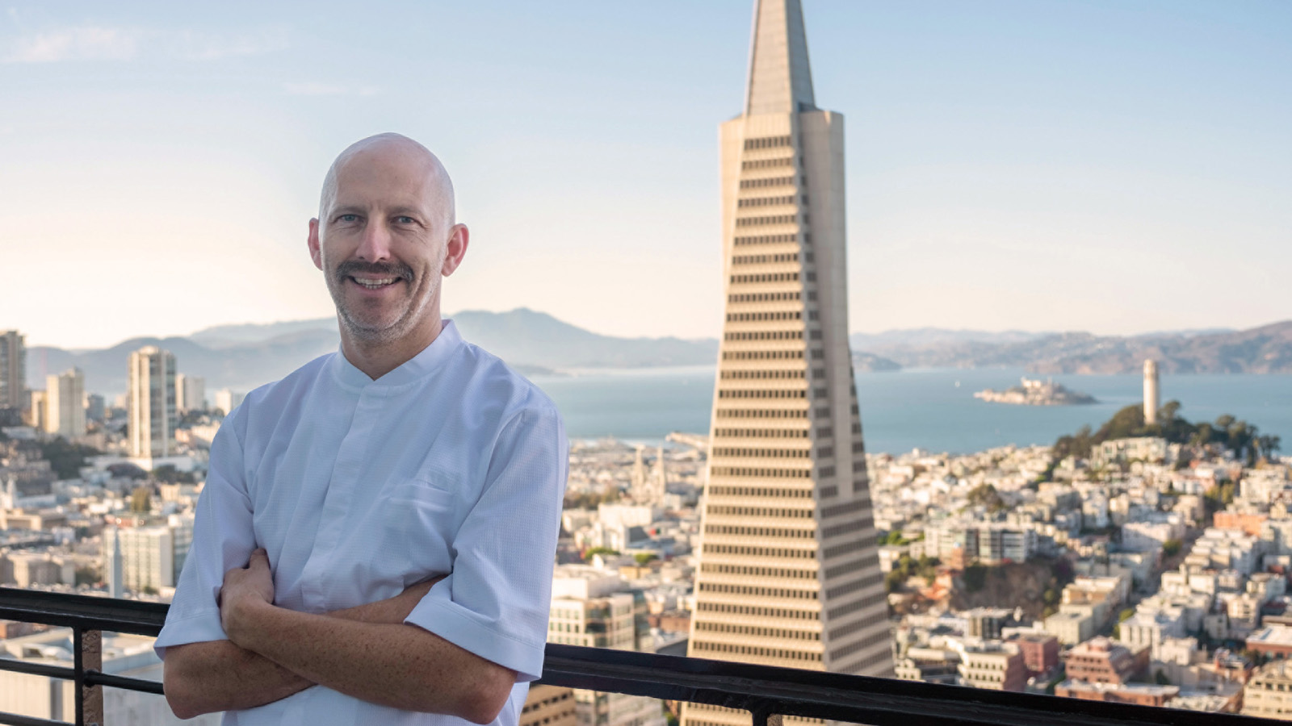 | November 1, 2022, San Francisco, U.S.A.  Four Seasons Hotel San Francisco at Embarcadero Welcomes Renowned Local Chef Rupert Blease as Chef-in-Residence  https://publish.url/embarcadero/hotel-news/2022/turntable-at-four-seasons-pop-up-restaurant.html

PRESS CONTACTS

Blake Willahan
J. Wade Public Relations
550 15th Street, Suite 25
San Francisco
USA
fsembarcaderopr@jwadepr.com

+1 949 395 1751

