10 Boston Attractions Within 10 Minutes of Four Seasons Hotel Boston

February 14, 2020, Boston, U.S.A.

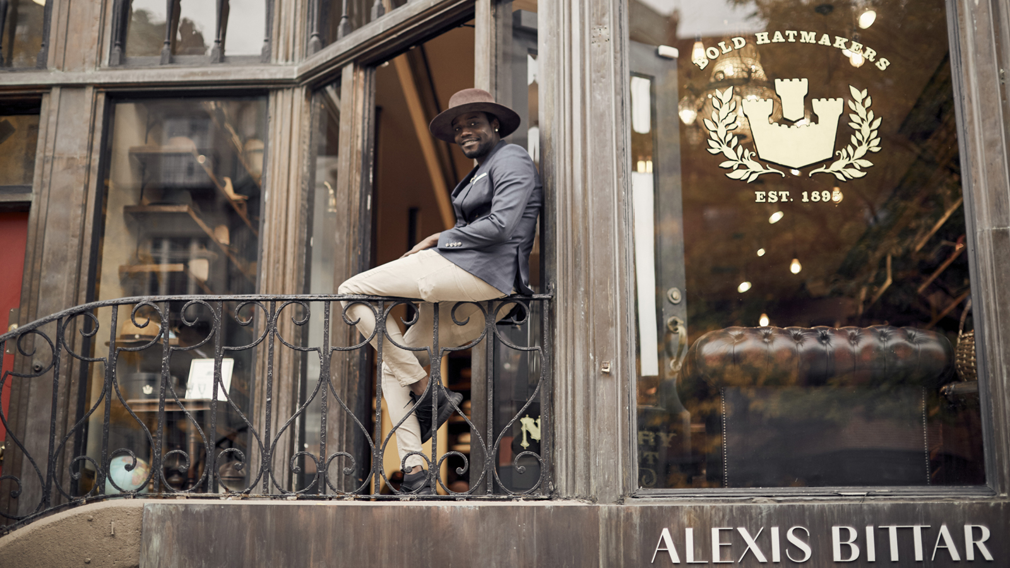
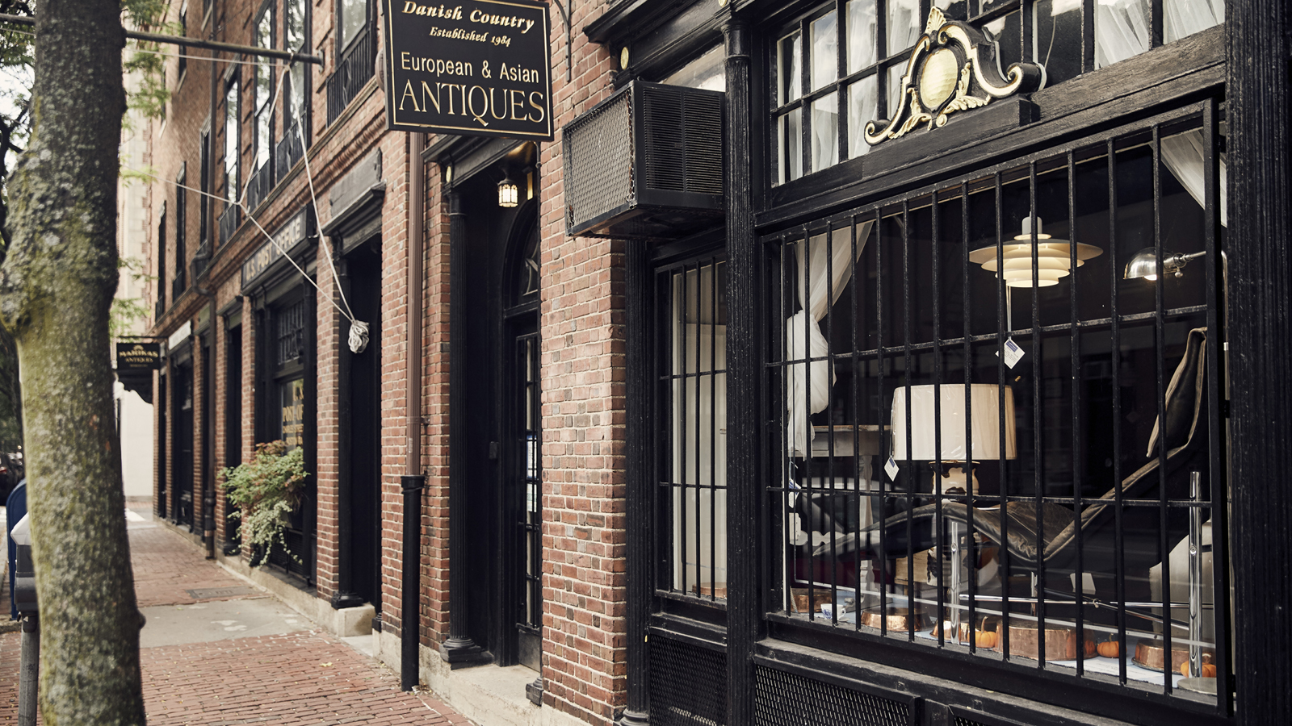 | 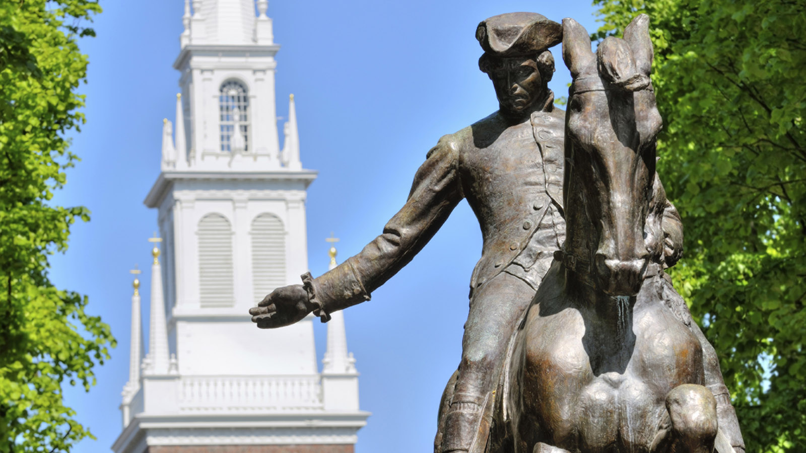 | 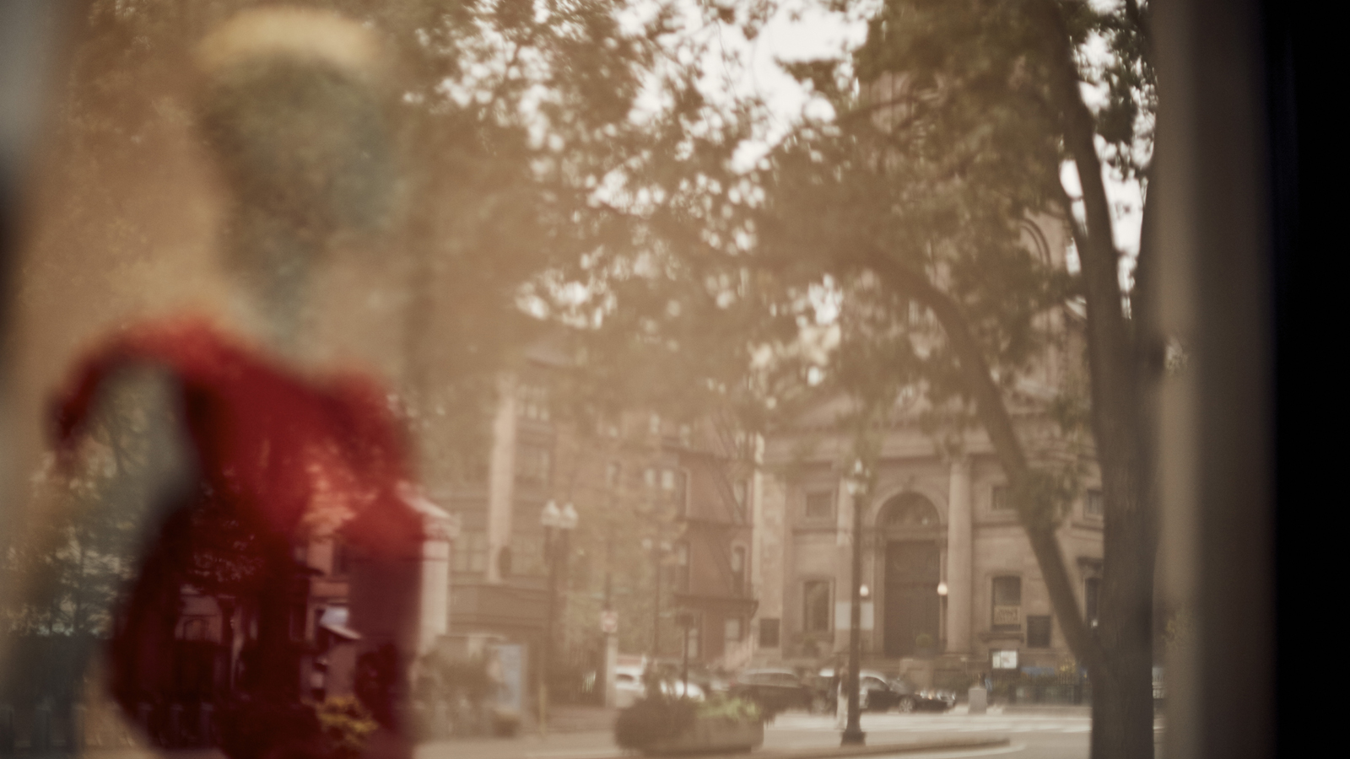
If proximity to the best that Boston has to offer is a priority, then look no further than Four Seasons Hotel Boston. Located in the heart of the Back Bay neighbourhood, the central location puts the “must-see” sites and landmarks at guests’ fingertips, offering a truly quintessential Boston experience.
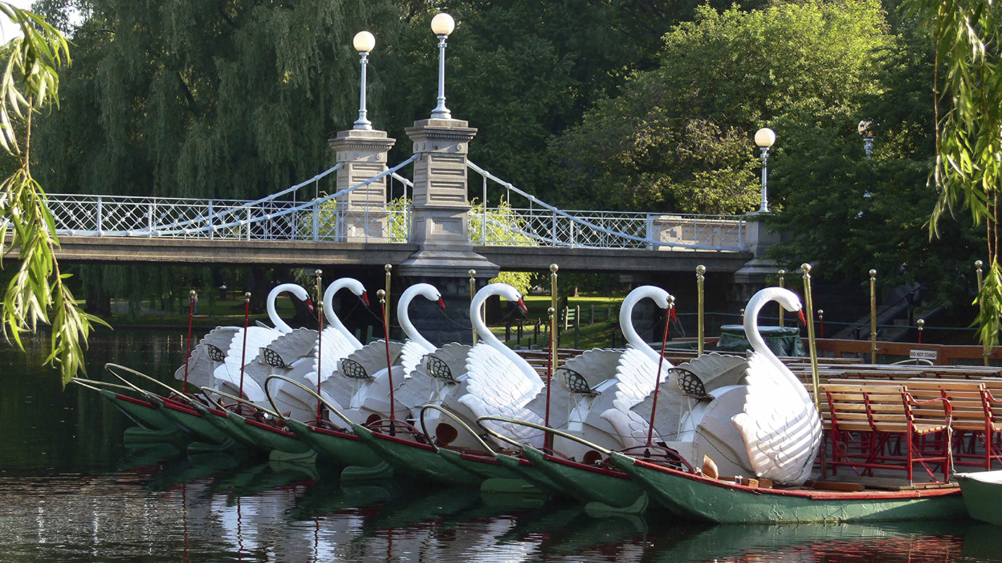
The Freedom Trail
Just steps from the Hotel is the start of the famed Freedom Trail, a collection of museums, meeting points, and historic markers that take explorers on a journey through the extraordinary history of the American revolution.
Boston Common
Established in 1634, the Boston Common significantly pre-dates even the formal founding of the United States of America and is, not surprisingly, the oldest park in the country. The Common - as it’s known by locals - is the anchor for the Emerald Necklace, a system of connected parks that winds through many of Boston's neighbourhoods.
Boston Public Garden
The “front yard” of Four Seasons Hotel Boston is the oasis that is the Boston Public Garden. Founded in 1837, the Public Garden is America’s first public botanical garden. The spectacularly manicured space boasts Victorian flowerbeds, verdant grass, and weeping willow trees shading a tranquil pond that famously hosts seasonal Swan Boat tours. Many of the rooms and suites at Four Seasons Hotel Boston overlook this iconic Boston landmark.
Beacon Hill
A short stroll through the Boston Public Garden and guests will arrive at the famous Boston Brahmin neighbourhood of red brick sidewalks, cobblestoned streets, elegant townhouses and gas street lamps in Beacon Hill.
Newbury Street
Guests can walk less than 5 minutes to arrive on the “luxury end” of Newbury Street, a renowned destination that boasts more than 5,000 feet (1,500 metres) of shopping and dining.
The Commonwealth Avenue Mall
Commonwealth Avenue is one of the most famous streets in Boston, and The Mall is considered the spine of the elegant Back Bay neighbourhood. The 32-acre (13 hectare) narrow promenade in the centre of the avenue was designed in the French boulevard style by Arthur Gilman in 1856, and offers beautiful landscaping and historic monuments. Today, the expansive, tree-lined walk-way is enjoyed by locals and visitors alike.
The Charles River Esplanade
Jump in our house car to arrive at the Esplanade in less than 5 minutes, or take a walk through Beacon Hill and enjoy the roughly half-mile (3/4 of a kilometre) journey. The Esplanade is a popular path for walkers, joggers and bicyclists, and is also home to the Hatch Shell, where the Boston Pops holds its annual summer concerts. Set on the Charles River, the sunset views are spectacular!
Boston Public Library
Founded in 1848, the Boston Public Library is a breath-taking Renaissance Revival building with grand architectural details. The landmark has a magnificent Reading Room and an array of art treasures, including works by Daniel Chester French and John Singer Sargent.
Skywalk Observatory at Prudential Tower
For guests looking for a birds’ eye view of Boston, ask one of our friendly doormen to hail the house car, or take the walk (it’s less than a mile) to the Prudential Tower. There you’ll find the Skywalk Observatory, offering sweeping 360-degree views of greater Boston, and an exclusive state-of-the-art Acoustiguide audio tour detailing the city's many points of historic and cultural interest.

RELATED

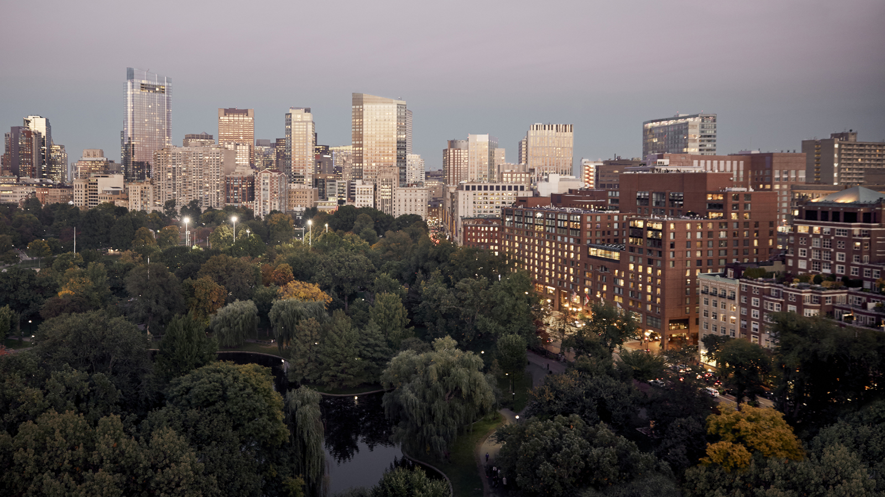 | February 15, 2023, Boston, U.S.A.  Four Seasons Hotel Boston Maintains Prestigious Five Star Distinction in Forbes Travel Guide 2023 Star Awards  https://publish.url/boston/hotel-news/2023/forbes-five-star-hotel.html
December 7, 2022, Boston, U.S.A.
Four Seasons Hotel Boston Unlocks “Vaults” of Complimentary Snacks and Beverages
https://publish.url/boston/hotel-news/2022/complimentary-snacks-and-beverages.html

PRESS CONTACTS

Crissa Hiranaga
Senior Director of Public Relations and Communications
200 Boylston Street
Boston
USA
crissa.hiranaga@fourseasons.com

+1 808 268 9644

Brianna Roberts
Digital Marketing Manager
200 Boylston Street
Boston
USA
brianna.roberts@fourseasons.com

+1 617 351 2141

