2017-2018 Winter Season Brings New Indulgences, Experiences and Relaxation at Four Seasons Resort and Residences Jackson Hole

September 11, 2017, Jackson Hole, U.S.A.

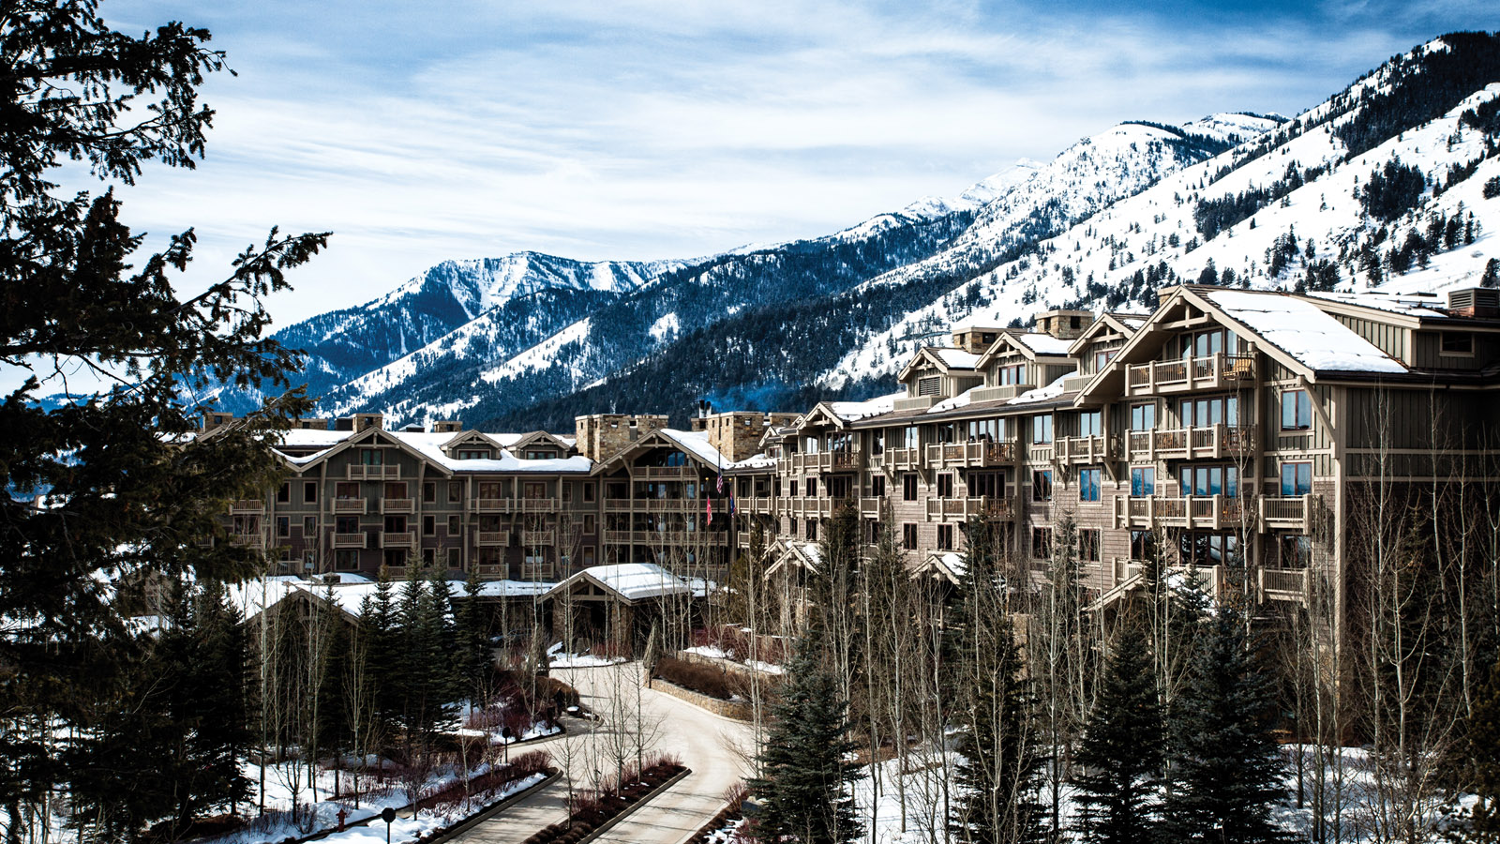
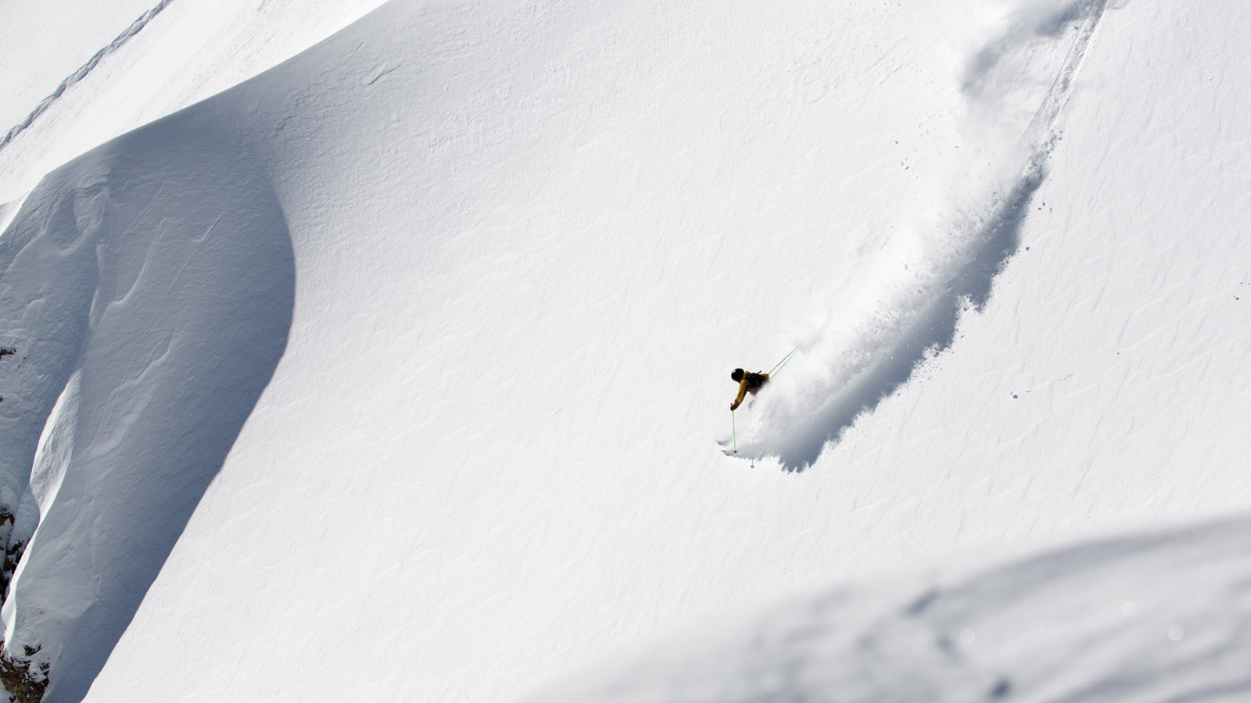 | 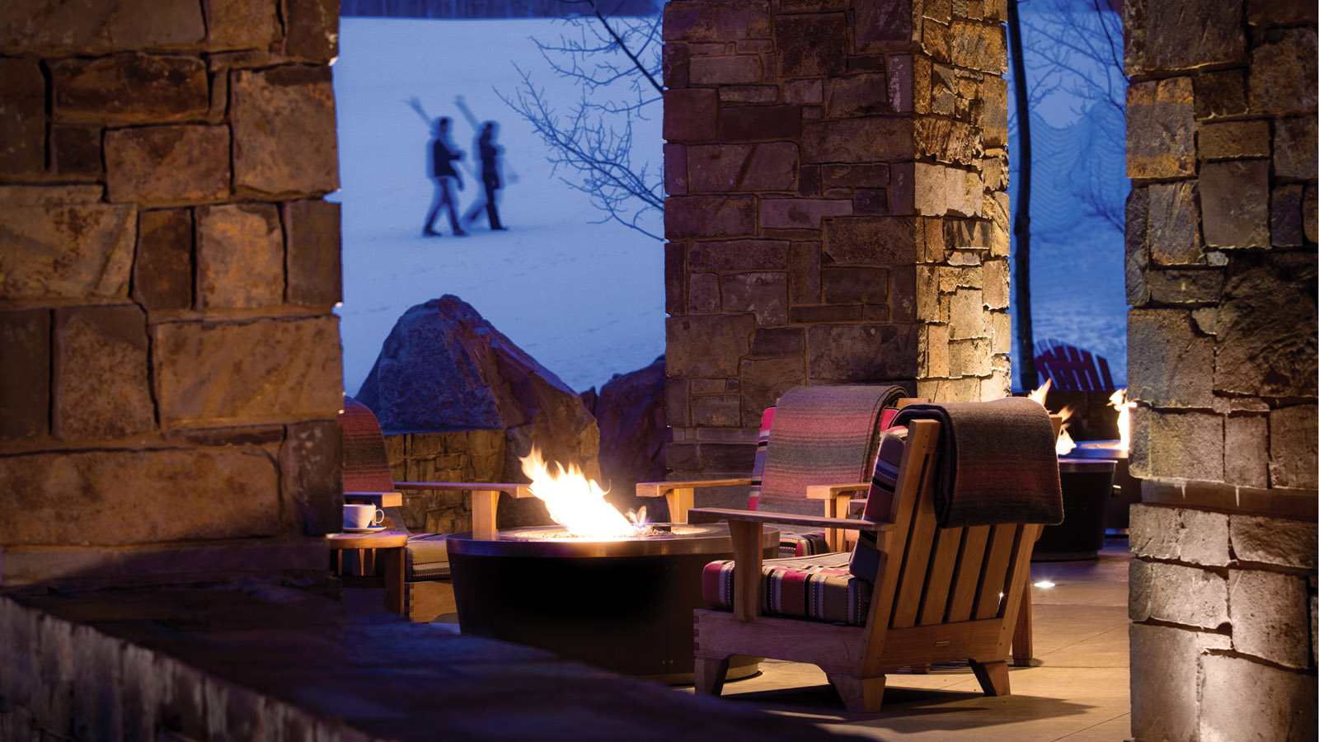 | 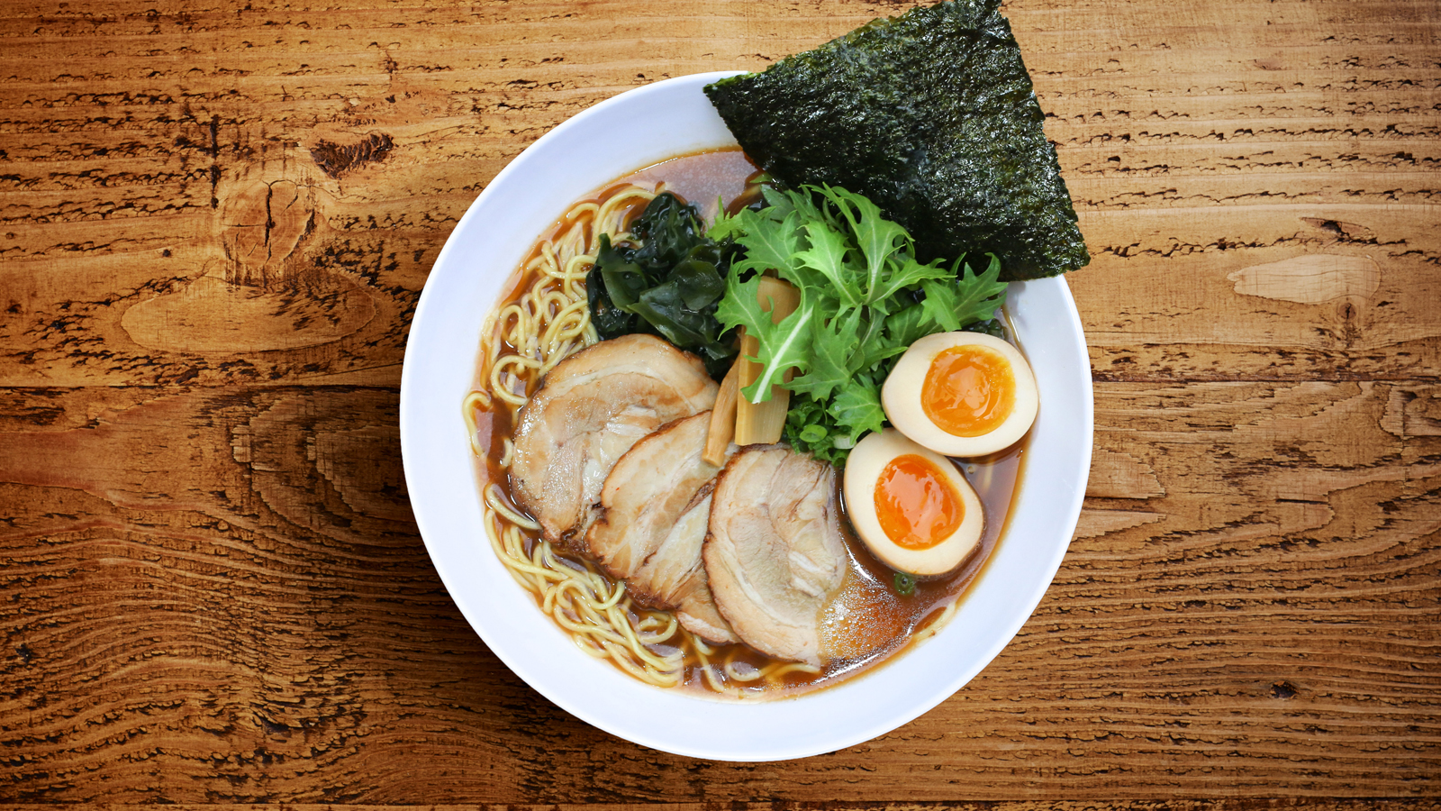
Four Seasons
Resort and Residences Jackson Hole welcomes winter with a few new indulgences, experiences and relaxation options. Located slope side to Jackson Hole Mountain Resort, this Forbes Five star and AAA Five Diamond rated property offers the best in mountain luxury after a day of rustic adventure.
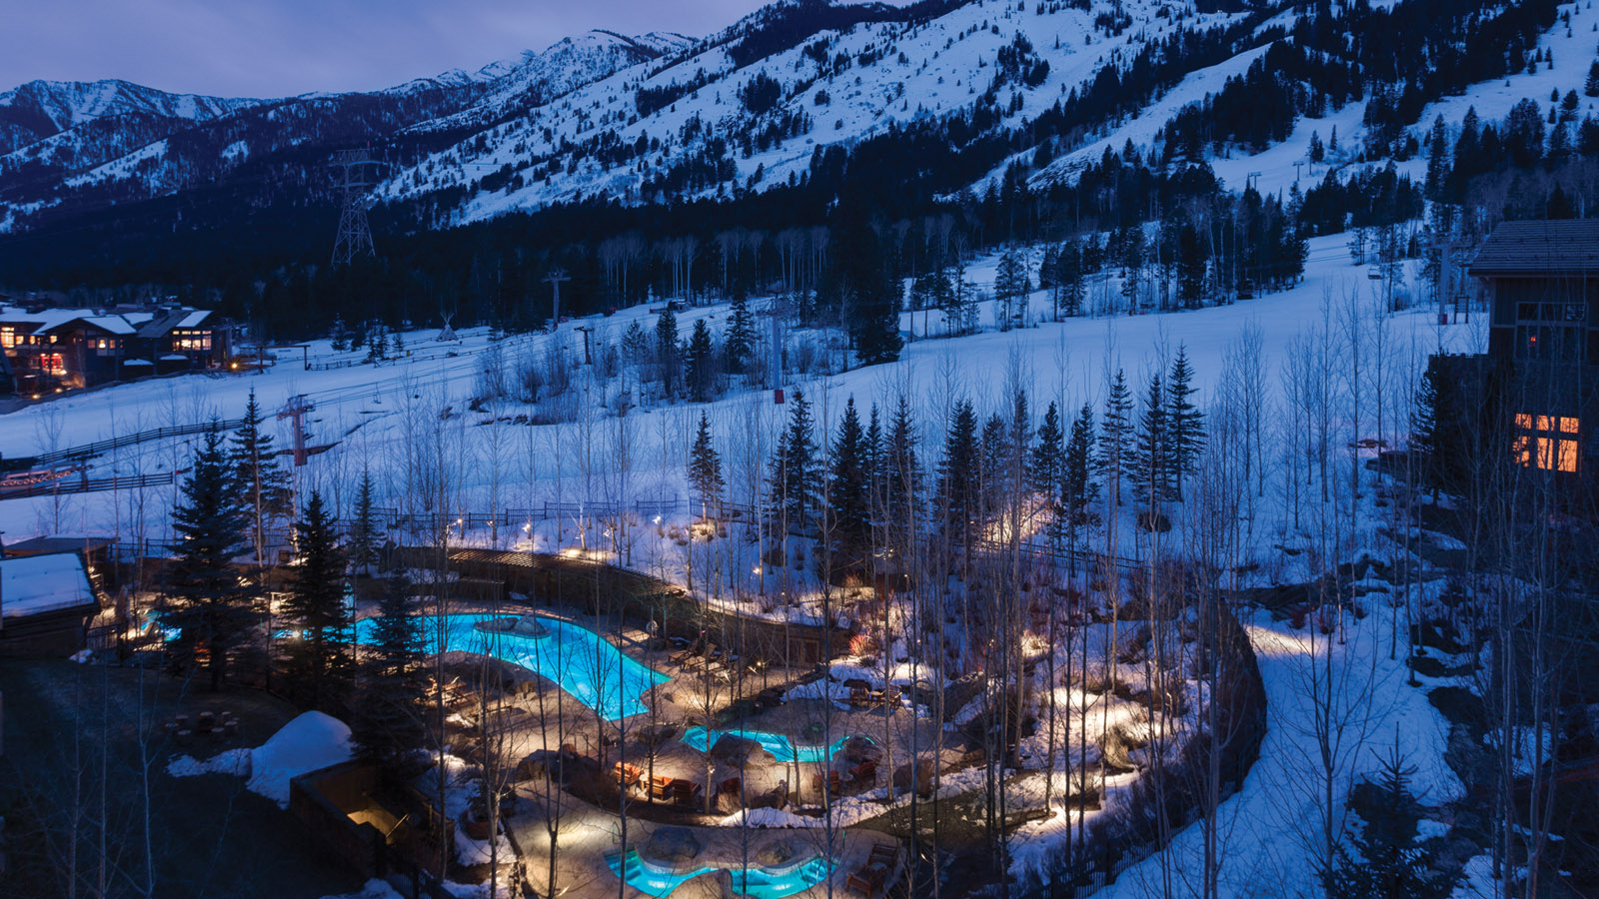 | 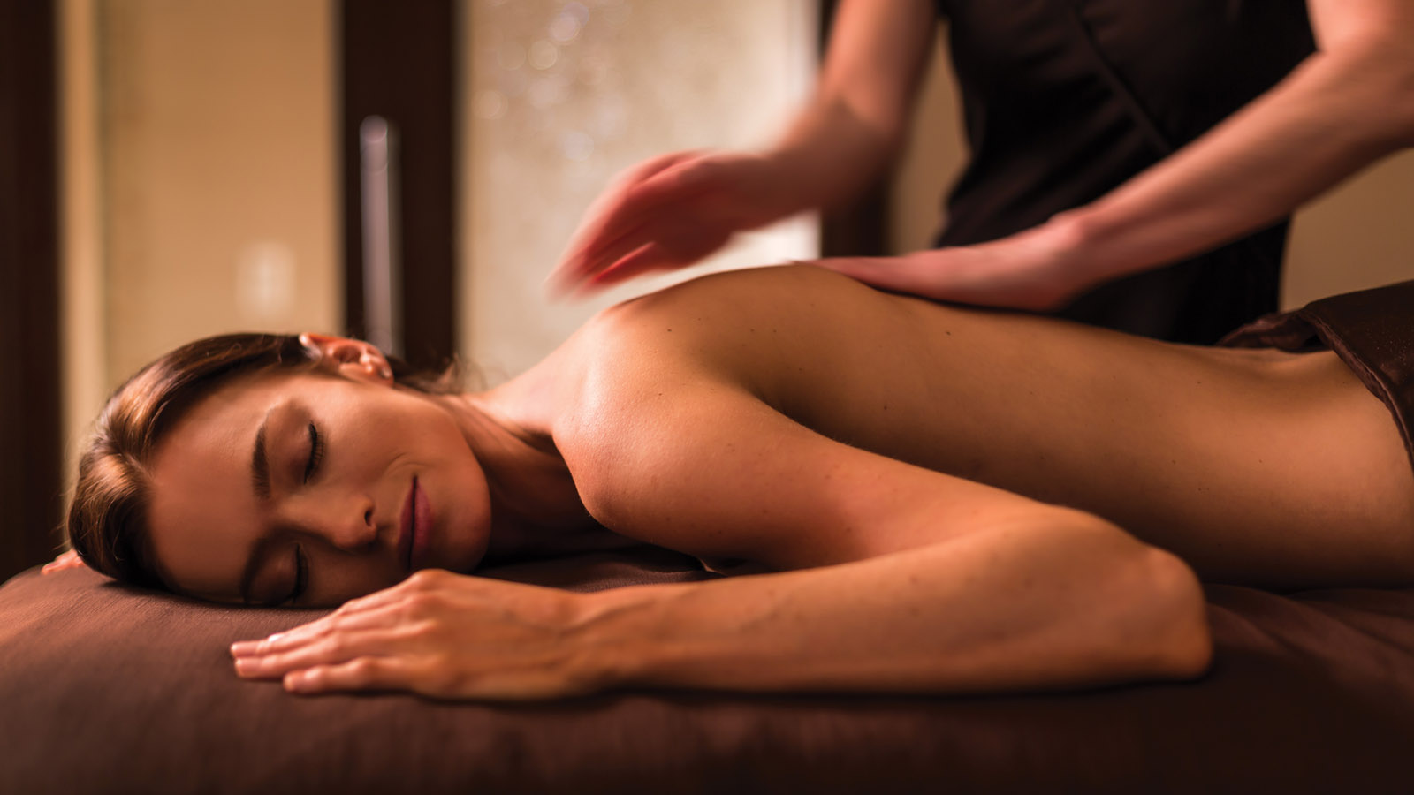
Indulgences
- Veuve Clicquot Bar – Westbank Grill will be offering bubbles all winter long with its outdoor pop-up Veuve Clicquot Bar. The orange slopeside bar will be available on the weekends, complete with lounge chairs, retro sunglasses, and most importantly - bubbles!
- Raclette - Raclette is a staple of wintertime in Switzerland and will now be served in the Ascent Lounge. This dish of melted cheese, local charcuterie, meats, potatoes and warm bread, accompanied by a refreshing glass of wine, is sure to meet any après skier's craving.
- Mountain Whiskey Ceremony –This whiskey ceremony is performed tableside. Guests choose from a list of whiskeys and their recommended aromatic pairings. Each garnish is heated with a handheld torch until smoldering, and then covered with a tumbler so the glass can absorb the aromatics without overwhelming the natural flavour of the spirit. The whiskey is poured into the glass and it’s ready to “rock.”
- Hotshots - Ascent Lounge will continue to be the “it” spot for a quick pick me up with its infamous hotshots. Back by popular demand, these mini-shots all have a hot cocoa base with flavours that change daily, such as Crater Lake hazelnut vodka, Aztec tequila, Jameson whiskey, Baileys and Rumple Minze mint liqueur. It's safe to say, one's chocolate fix will be met with these tasty treats.
- Ramen Night - A collaboration between The Handle Bar's Executive Chef Michael Lishchynsky and celebrity chef Michael Mina, The Ramen Bar takeover happens every Wednesday night in The Handle Bar from 6:00 to 9:00 pm. The concept is Japanese technique and ingredients to create a new variation on Japanese ramen with West Coast style, as well as a selection of Japanese beers, togarashi edamame, gochujang fried chicken and fried banana lumpia.
Exploration
- Winter Bowls - This winter, skiers and snowboarders will have the chance to experience Jackson Hole Mountain Resort's eight legendary bowls with a Jackson Hole Mountain Resort athlete as the guide. From dawn to dusk, skiers will get to span the 2,500 acres (1,000 hectares) of skiable terrain while taking in sweeping views of the valley below. JHMR athletes will share their favourite lines, best powder stashes and expert tips. A suggested lunch in The Handle Bar might offer the perfect mid-day pause but bagged lunches to go are also available. Note that skiing and riding JHMR’s legendary bowls will be subject to snow conditions. Terrain will be chosen at the discretion of the athlete and guide for safety and enjoyable skiing and riding purposes.
- Snow Yoga - The Spa announces Snow Yoga this winter. Guests will get the chance to surround themselves with a tranquil landscape of white snow and the rendezvous peaks as their backdrop. The class was inspired to remind people to get outside and play in the snow. Snowga is also a great practice for the mind, in helping to maintain focus despite the weather and scenery. #FSJHsnowga
Relaxation
- Après Ski Spa Ritual – New this winter and tailored to the tired skier or snowboarder is The Spa’s Après Ski Ritual. The ritual will feature different components of heat to help alleviate sore muscles. The ritual starts with a Himalayan salt body soak which will draw out toxins and helps cleanse the body energetically. A native hot stone massage follows, incorporating local arnica. The Wind River Arnica is one of the few producers who still hand pick the arnica flower creating much more potent oil, for optimal results. The treatment concludes with a willow bark wrap. Willow bark is a natural anti-inflammatory, and is excellent for people who have been very active, as the benefits are similar to taking an aspirin. The end result, pure relaxation and rehabilitation.
Ready to pack the ski bags and head to Jackson Hole? Book a snow vacation today with one of the Resort’s offers.

RELATED

August 8, 2017, Jackson Hole, U.S.A.
The Spa at Four Seasons Resort and Residences Jackson Hole Announces Solar Eclipse Treatments with Luna Mystica Exquisite Oil Charged by the Moon
http://publish.url/jacksonhole/hotel-news/2017/solar-eclipse-spa-treatments.html

June 15, 2017, Toronto, Canada
Four Seasons Mountain Collection Resorts Unveil Summer Experiences
http://publish.url/news-releases/2017/summer-mountain-experiences.html

PRESS CONTACTS

Nina Braga
Public Relations Director
7680 Granite Loop Road, P.O. Box 544
Teton Village
U.S.A.
nina.braga@fourseasons.com

+1 (307) 732-5062

