Four Seasons Hotel Atlanta and Bar Margot Launch Supper Club Pop-Up Series

June 7, 2016, Atlanta, U.S.A

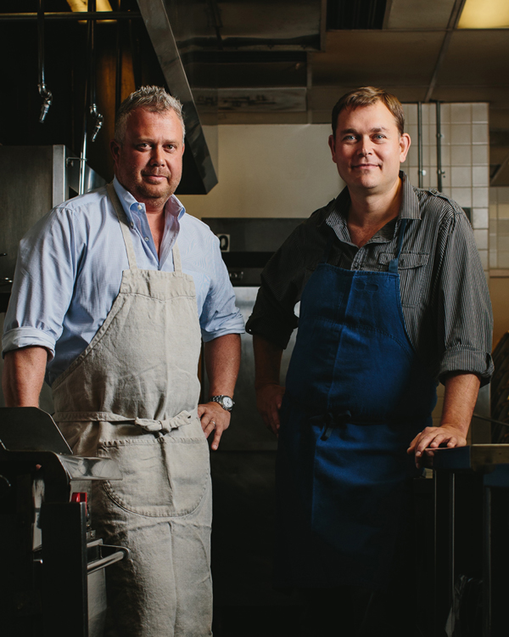
Earlier this year, Executive Chef Robert Gerstenecker of Bar Margot and
Four Seasons
Hotel Atlanta decided to open up his kitchen and dining room to share the culinary stage with visiting chefs without a traditional restaurant or the chef on a rise looking for some stage time. The first supper club kicked off in March 2016 with guest chef Hector Santiago of El Super Pan, the Latin sandwich shop at Atlanta’s popular Ponce City Market.
The impromptu dinner menu and guest chef proved to be such a hit with diners that Chef Gerstenecker has since launched an ongoing series of pop-up supper club events that will continue throughout the year.
“Our Supper Club gathering will be an excellent way for the culinary team at Bar Margot and Four Seasons to engage with the dining community - get to know more about their trending tastes while igniting our culinary creativity,” says Chef Gerstenecker.
The series takes off with the next pop-up supper club scheduled for Thursday, June 16, 2016 at Bar Margot from 7:00 to 10:00 pm, with Bar Margot co-owner and James Beard nominee Chef Ford Fry as co-host. As is tradition for pop-up supper club events, the menu is yet to be determined.
“I really like to think about vegetables and dishes that would be very unexpected but also 100 percent local when creating a menu,” says Chef Gerstenecker. “We’re just going to take some time to find those special ingredients and decide on the final menu for the evening.”
Even though the menu remains a mystery, the evening is expected to be an unmatched experience for guests who will be treated to a family style meal, which will include a rich dessert course prepared by Four Seasons Pastry Chef Charles Barrett.
On the evening of June 16, guests are expected to trickle in as the clock strikes seven and gather at Bar Margot to sip on the bar’s popular cocktails and socialise with their dining mates. As the night continues, guests will be escorted into the dining area, where they will be seated among fellow guests in an effort to invoke an intimate, family-style dining experience.
"It's going to be a night of surprises and new experiences," says Gerstenecker. "This whole series is definitely something for the Atlanta community to get excited about."
Ticket prices for the next pop-up supper club on Thursday, June 16, 2016 are set at USD 110, which is includes the cost of taxes and gratuity. Free valet parking will also be available to guests.
Seats can be reserved through the Hotel’s reservation desk or online.

RELATED

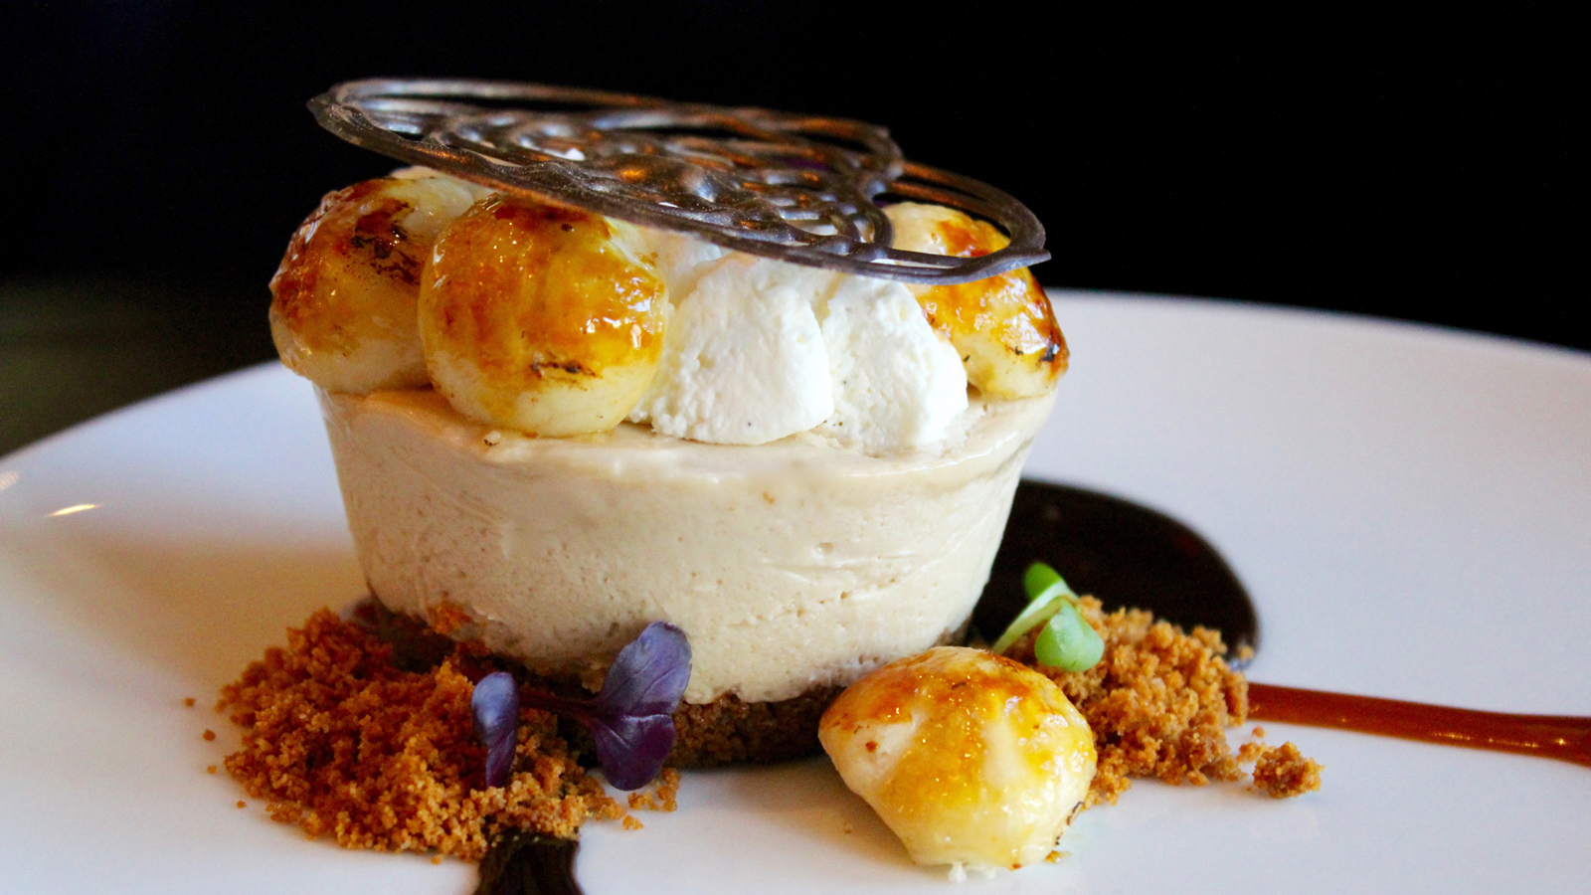 | March 1, 2017, Atlanta, U.S.A  Bar Margot's Newest Dessert is "Pie in the Sky" Idea for Chef Lasheeda Perry at Four Seasons Hotel Atlanta  http://publish.url/atlanta/hotel-news/2017/biscoff-cream-pie.html
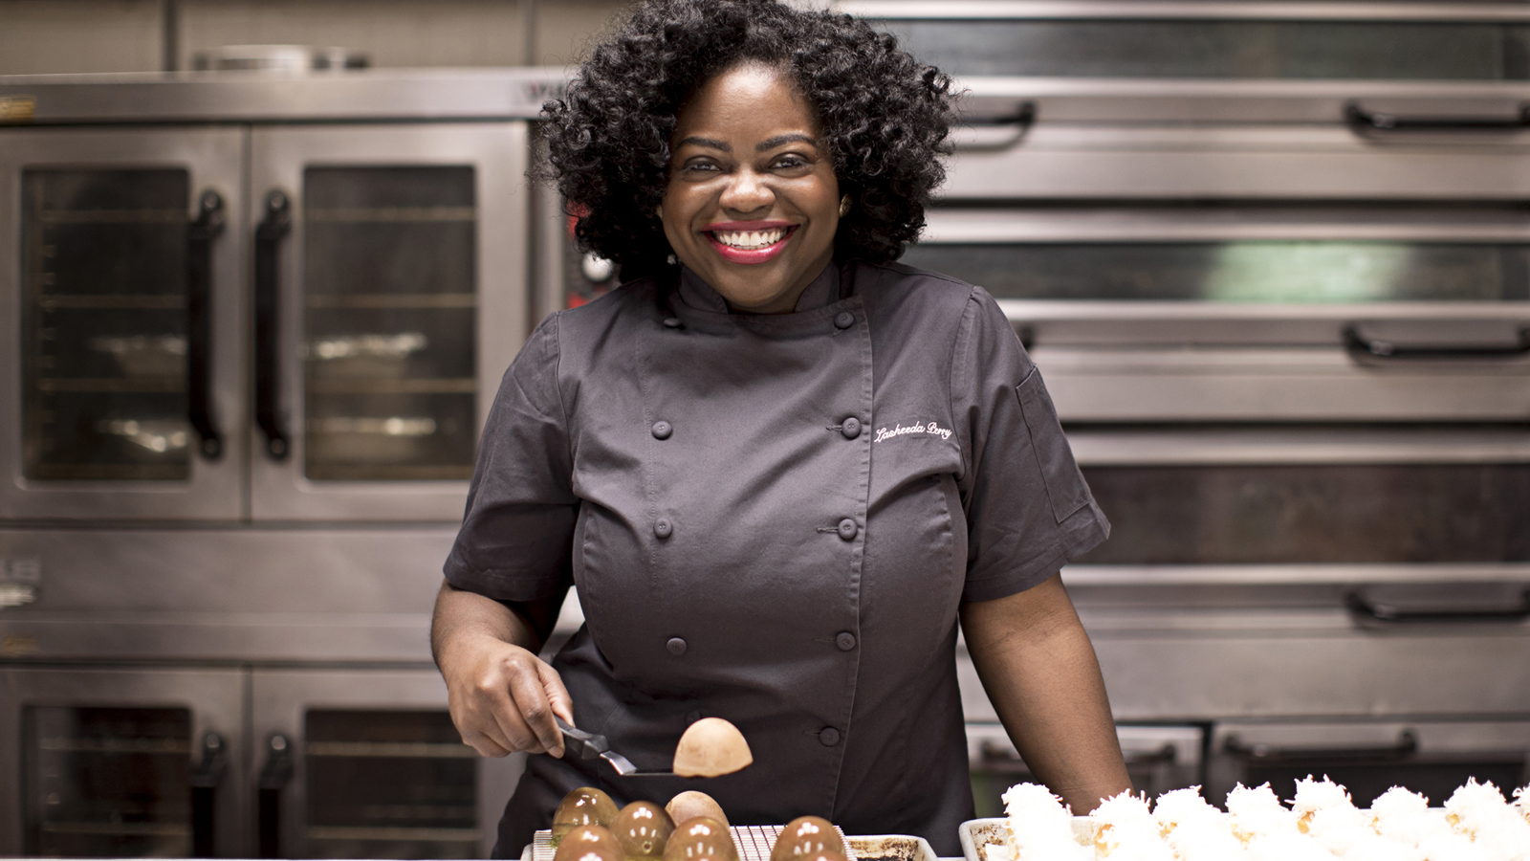 | January 9, 2017, Atlanta, U.S.A  New Pastry Chef Lasheeda Perry Appointed at Four Seasons Hotel Atlanta  http://publish.url/atlanta/hotel-news/2017/new-pastry-chef-lasheeda-perry.html

PRESS CONTACTS

Marsha Middleton
Consulting Director of Public Relations, M-Squared Public Relations
241 W. Wieuca Rd., Suite 260
Atlanta
U.S.A.
marsha@msquaredpr.com

1 (404) 303-7797

