Four Seasons Hotel New York Downtown Celebrates WorldPride 2019 with the Launch of Be Loud, Be Proud Package

Enjoy the ultimate Pride package including VIP tickets to the Opening Ceremony
April 25, 2019, New York, U.S.A.

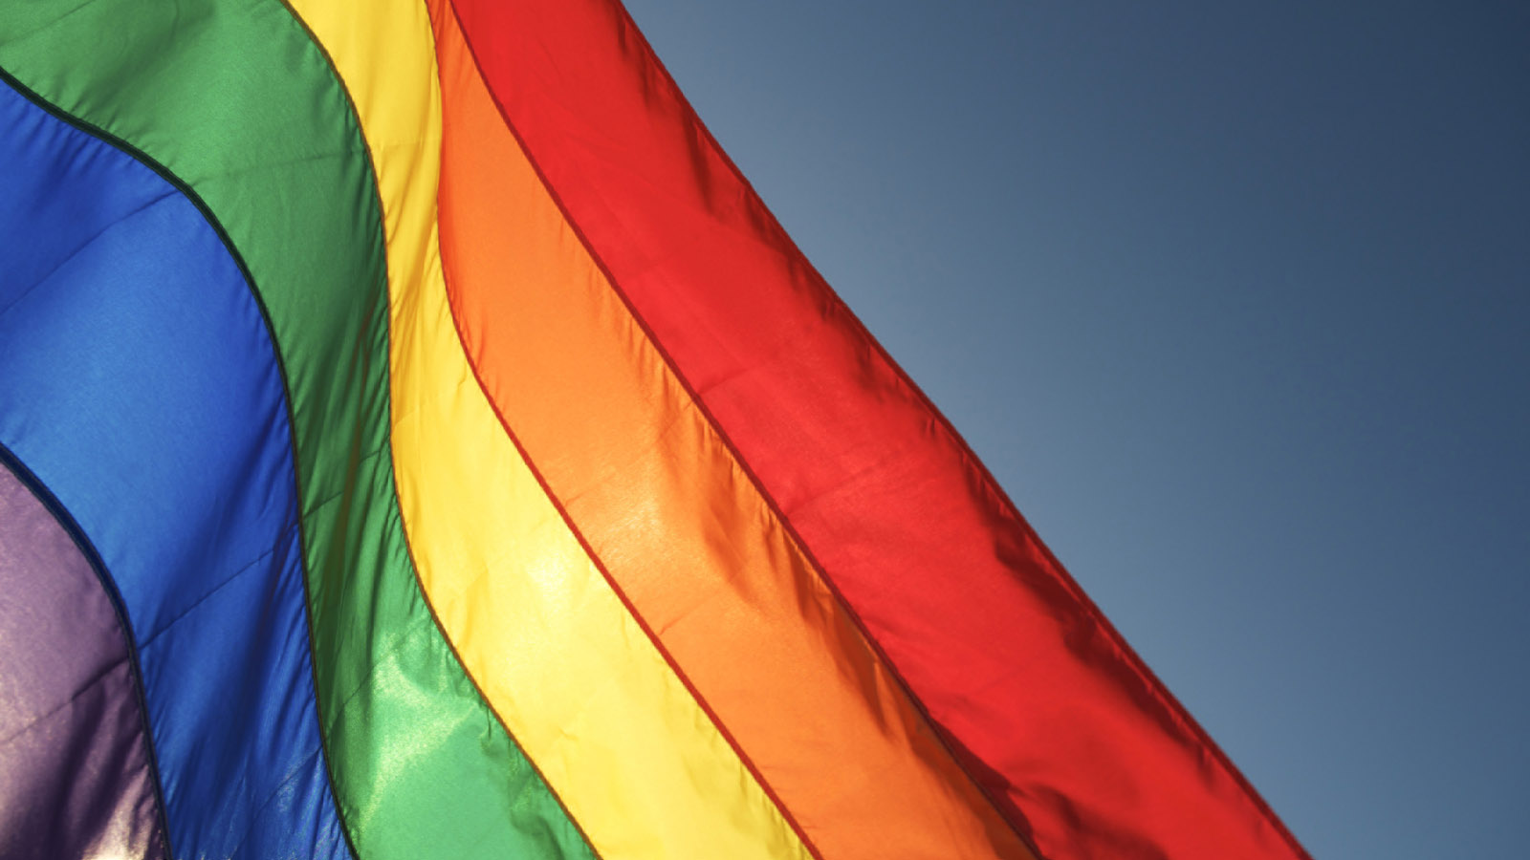
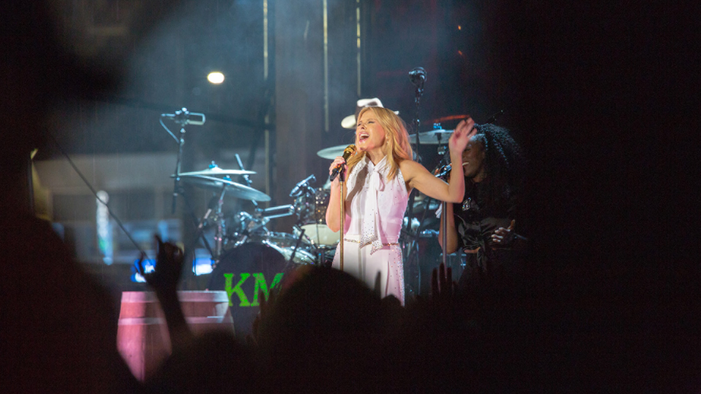 | 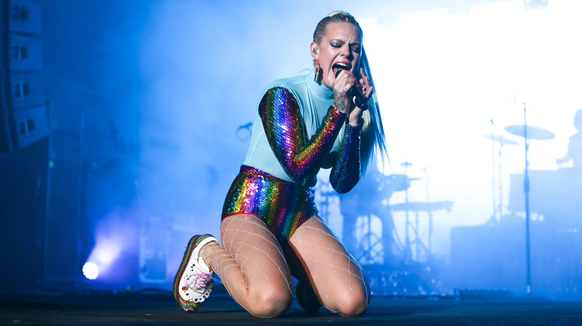 | 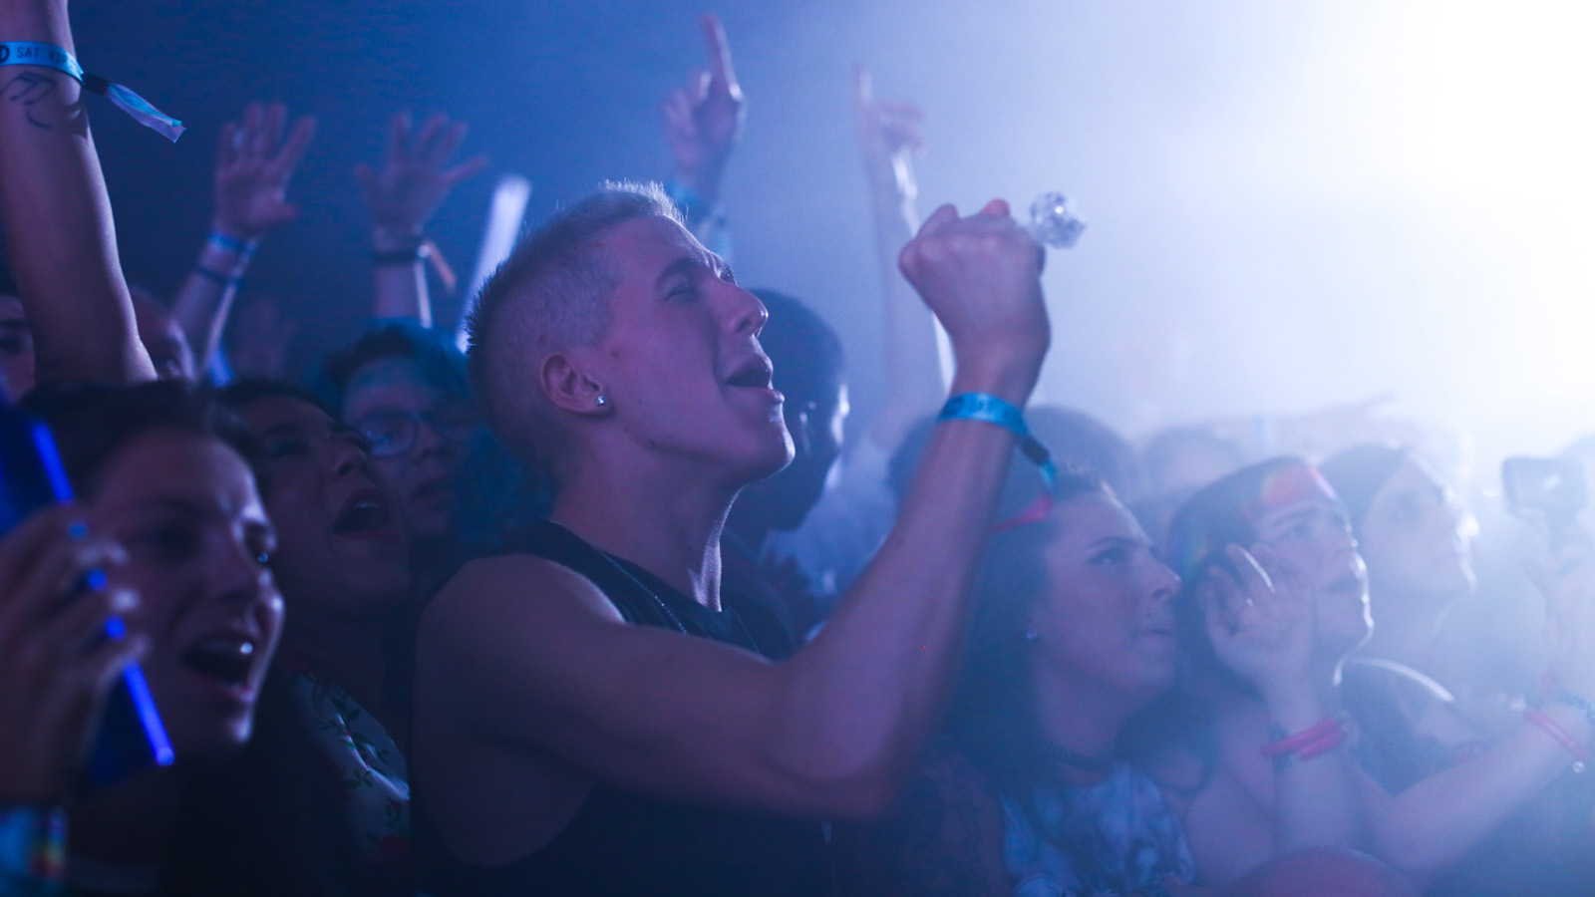
In celebration of WorldPride 2019, Four Seasons Hotel New York Downtown has launched the Be Loud, Be Proud package.
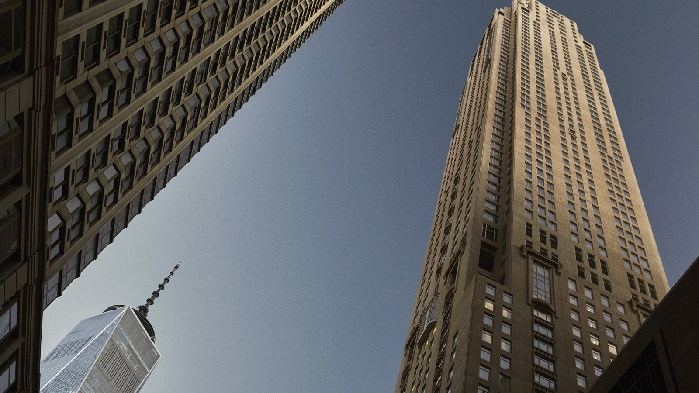 | 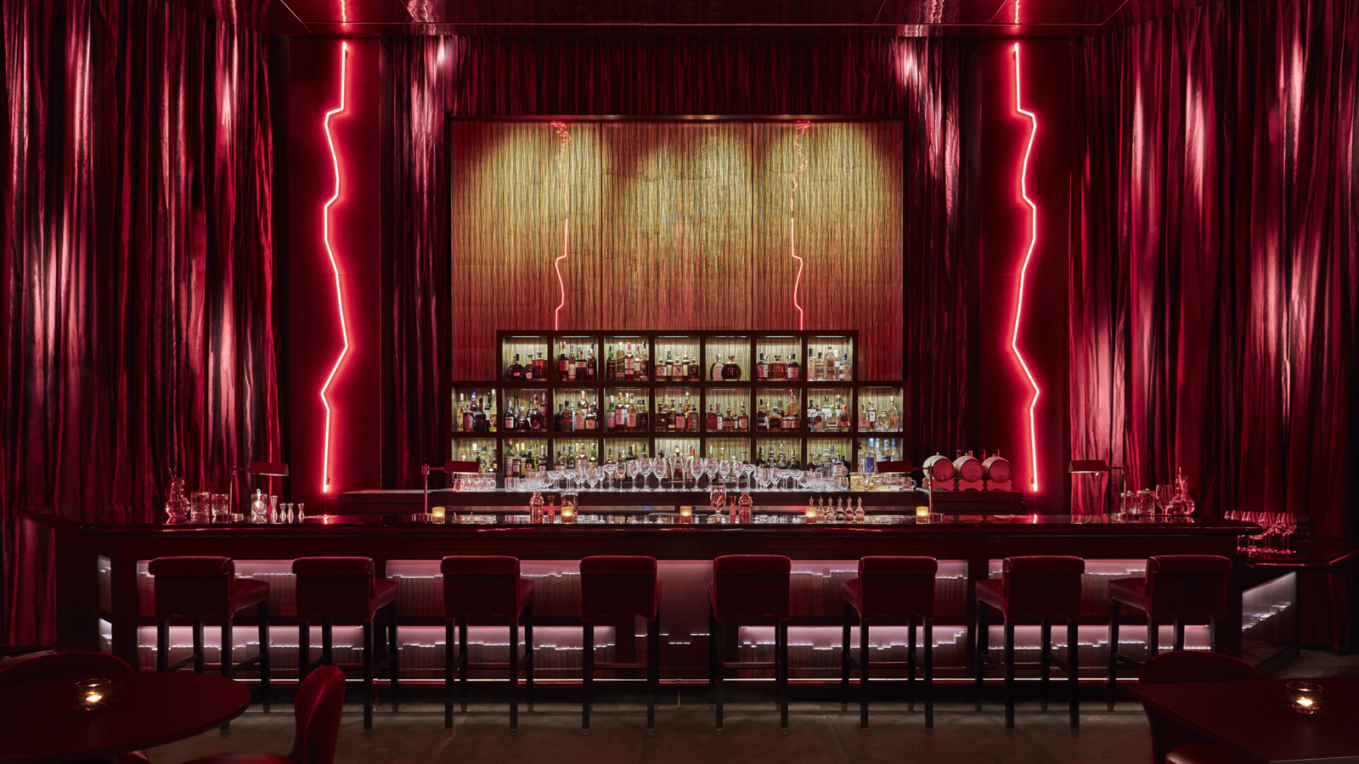 | 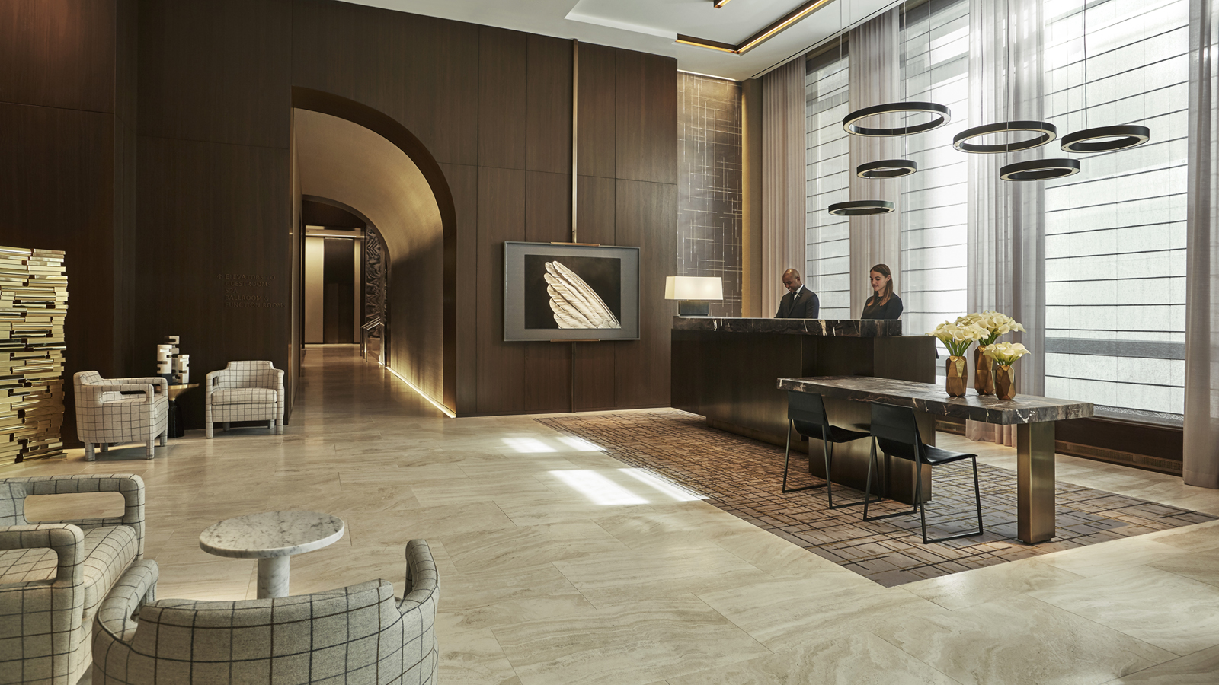
In 2019, NYC Pride welcomes WorldPride along with the 50th anniversary of the Stonewall Uprising and a half-century of LGBTQIA+ liberation. The concept of WorldPride was first introduced by the member-based organisation, InterPride. Since its inception in 2000, five WorldPride celebrations have taken place around the world, in Rome, Jerusalem, London, Toronto and Madrid. This will be the first time that WorldPride has ever been hosted in the United States.
Four Seasons Hotel New York Downtown is proud to be an official hotel partner and supporter of WorldPride 2019. In celebration of this momentous milestone, the Be Loud, Be Proud package offers exclusive access to the WorldPride Opening Ceremony at Barclays Center on June 26, 2019. Prolific entertainer and internationally-recognised humanitarian Whoopi Goldberg will host the Opening Ceremony. The evening will also feature a performance by the iconic Cyndi Lauper. Cyndi's unmistakable voice, influential style and infectious performances have catapulted her to stardom. There will also be a performance by Ciara, a Grammy Award-winning singer/songwriter, producer, model and actress who has sold more than 23 million records and 16 million singles worldwide over her thirteen-year career. Chaka Khan and Todrick Hall are also confirmed to perform, with additional acts still to be announced.
The full Be Loud, Be Proud package includes:
- Two VIP tickets to the Opening Ceremony at Barclays Center on June 26, 2019
- Two welcome cocktails in CUT by Wolfgang Puck
- 4:00 pm late checkout
- Overnight accommodation in a chosen room category
Due to the exclusive nature of this package, reservations for the Be Loud, Be Proud package must be made directly through Megan Laws via email at megan.laws@fourseasons.com or via phone on +1 646 880 1924.
Rates start at USD 995 per night for the Be Loud, Be Proud package and are only valid on the night of Wednesday, June 26, 2019.

RELATED

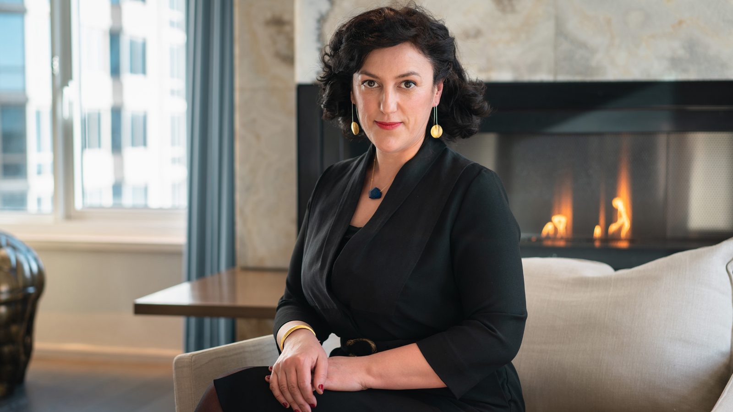 | March 29, 2019, New York, U.S.A.  The Spa at Four Seasons Hotel New York Downtown Launches Aromatherapy Blend Bar and Bespoke Aromatherapy Experience with Essential Oils by SOVERAL  https://publish.url/newyorkdowntown/hotel-news/2019/aromatherapy-at-the-spa.html
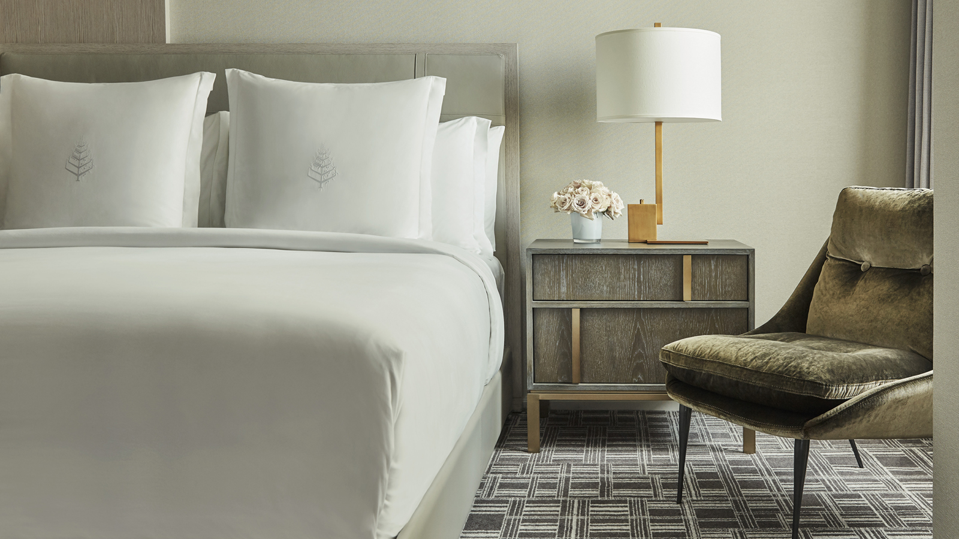 | March 15, 2019, New York, U.S.A.  Four Seasons Hotel New York Downtown Launches Sleep Well, Live Well Experience  https://publish.url/newyorkdowntown/hotel-news/2019/sleep-well-live-well-package.html

PRESS CONTACTS

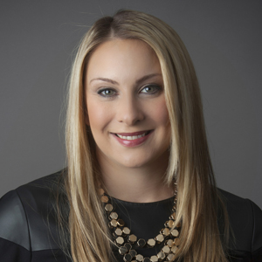 | Kristi Blake  Director of Public Relations and Communications  27 Barclay Street  New York  U.S.A.  kristi.blake@fourseasons.com  +1 (646) 880-1917

