Time to Shine for Vivid Sydney at Four Seasons Hotel Sydney

May 24, 2023, Sydney, Australia

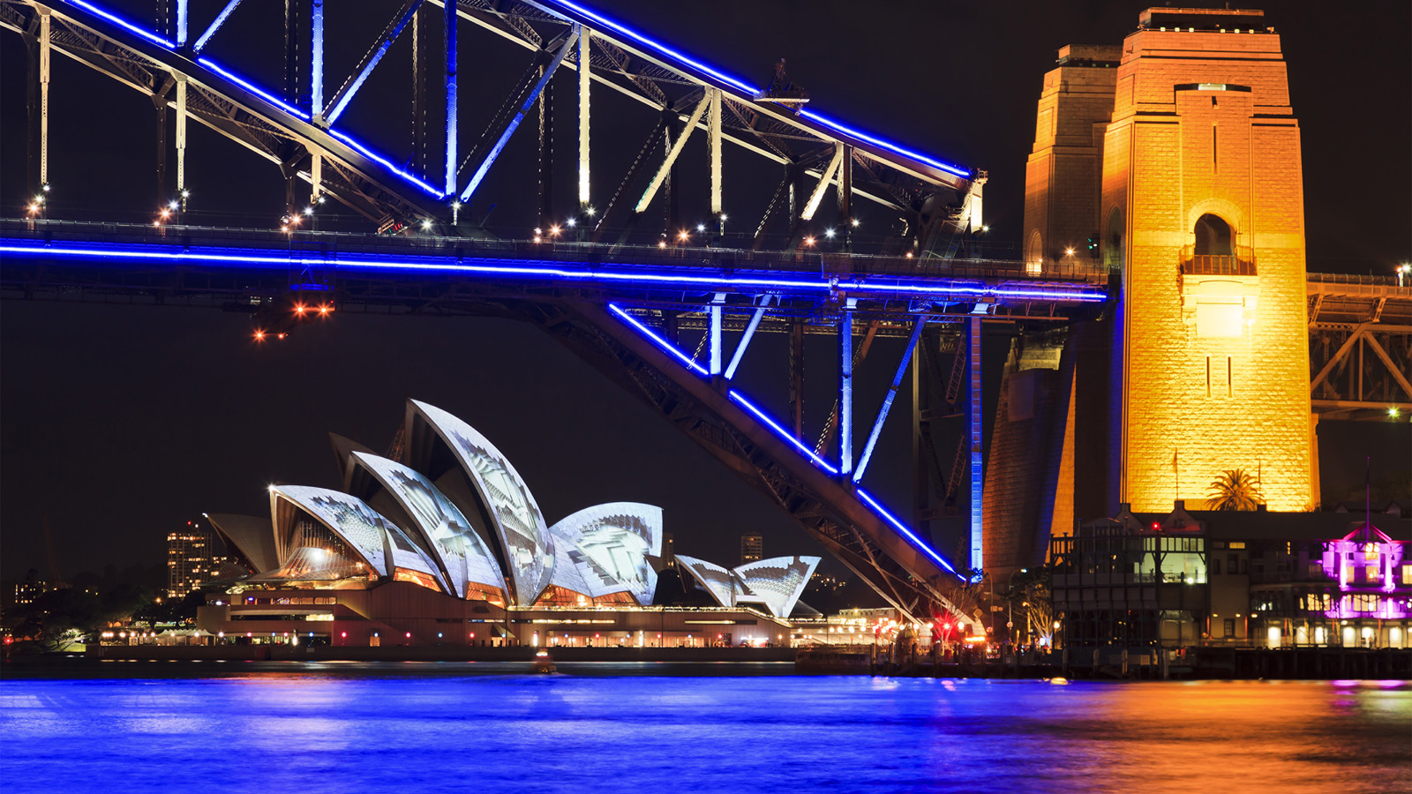
Secure the best seats in town to experience this year's world-famous Vivid Sydney, May 26 to June 17, 2023, at the city's best located five-star hotel, Four Seasons Hotel Sydney. From pop-up Bubble Dog stand to glowing parties at Grain, it is the perfect place to start or end the evening during Vivid Sydney.
"Vivid Sydney is an extraordinary celebration of creativity and innovation, and we are thrilled to be a part of it,” says Uday Rao, General Manager. “Our team at Four Seasons Hotel Sydney is committed to creating an unforgettable experience for all of our guests during this vibrant festival of light, music, and ideas."
Glow Party at Grain: On the weekends, the bar will shine bright, inviting guests to have glowing face paint, enjoy beats from a neon DJ, and sip delicious cocktails and luminating bottles of Champagne from Moët Hennessy and Dom Pérignon - it is worth a stop before or after walking through Vivid Sydney. Follow @GrainBarSyd for more details.
Mode Kitchen & Bar: Executive Chef Francesco Mannelli and his team have crafted a vibrant Vivid menu on offer each night, with three courses for AUD 90 per person. The menu highlights seasonal ingredients such as Beetroot cure Hiramasa kingfish, Black Murray Cod with Brussels sprouts, and a colourful Vivid Pavlova. For reservations, visit click here.
Bubble Dogs: Four Seasons Sydney is firing up the wood-fired grill for a gourmet selection of hot dogs to-go. Surrounded by lights, bubbles, and fun the team will be grilling every weekend Friday–Sunday from 6:00 pm on the Hotel’s front drive. Follow #BubbleDogSydney
Enjoy all the above throughout the Vivid Sydney festival and stay the night for the best view of Sydney from the comfort of a luxurious suite. The Vivid Sydney Package, included overnight accommodation, buffet breakfast and a complimentary Opera House Pavlova amenity starting from AUD 490 per night. For reservations click here.
Four Seasons Hotel Sydney's façade will also feature as a backdrop to a major Vivid Sydney light projection across the cityscape, illuminating the building each evening from 6:00 to 11:00 pm along with special fireworks.

RELATED

April 18, 2023, Sydney, Australia
Spoil Mum This Mother's Day with a Memorable Weekend at Four Seasons Hotel Sydney and a Champagne Lunch at Mode Kitchen & Bar
https://publish.url/sydney/hotel-news/2023/mothers-day.html

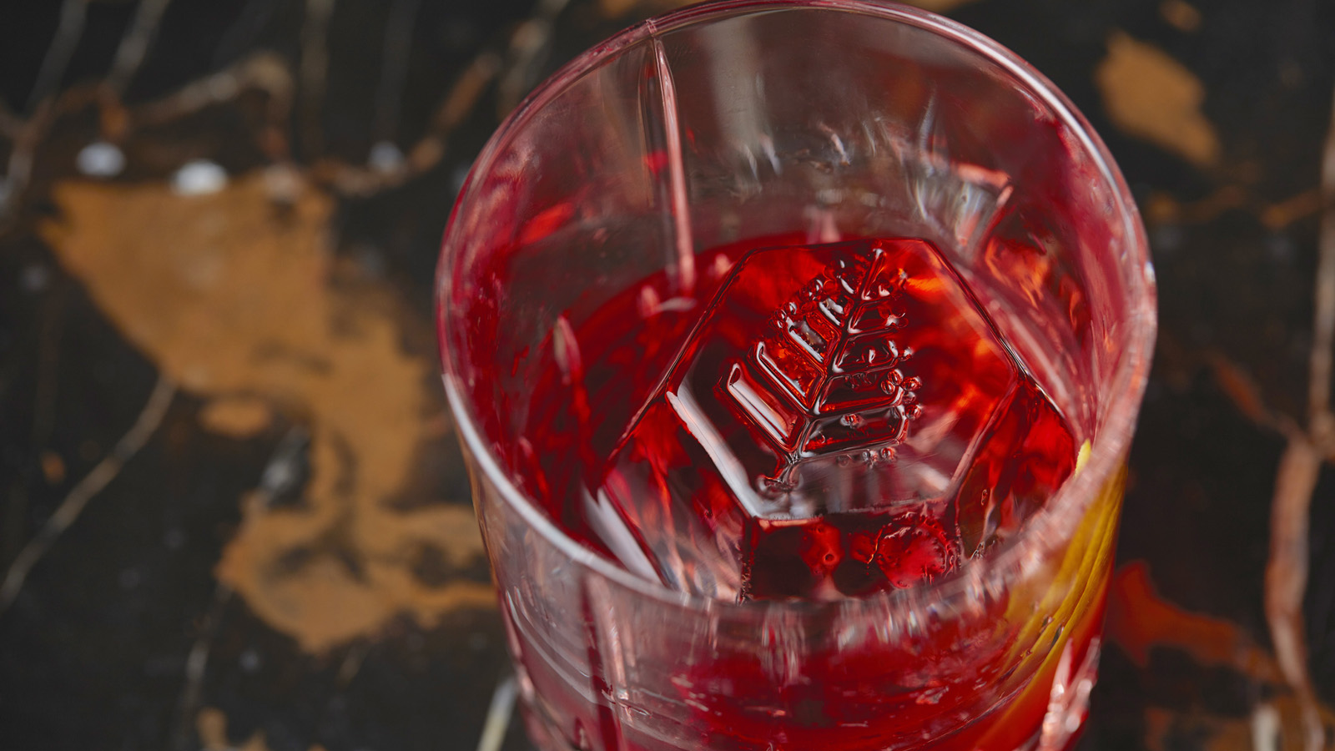 | April 12, 2023, Sydney, Australia  A New After-Work Aperitivo Has Arrived at Mode Kitchen & Bar at Four Seasons Hotel Sydney  https://publish.url/sydney/hotel-news/2023/aperitivo-at-mode-kitchen-and-bar.html

PRESS CONTACTS

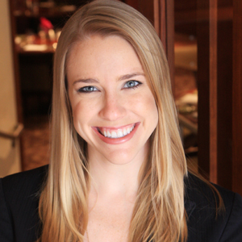 | Elysia McEwen  Director of PR and Communications  199 George Street  Sydney  Australia  elysia.mcewen@fourseasons.com  +61 2 9250 3315

