Proper Rideshop x Four Seasons Resort Oahu at Ko Olina Skateboarding Camp Dropping in This Spring Break

Hawaii’s first and only resort-style skateboarding camp returns to Four Seasons Resort Oahu for exclusive two-day skateboarding camp package
February 7, 2019, Hawaii, Oahu, U.S.A.

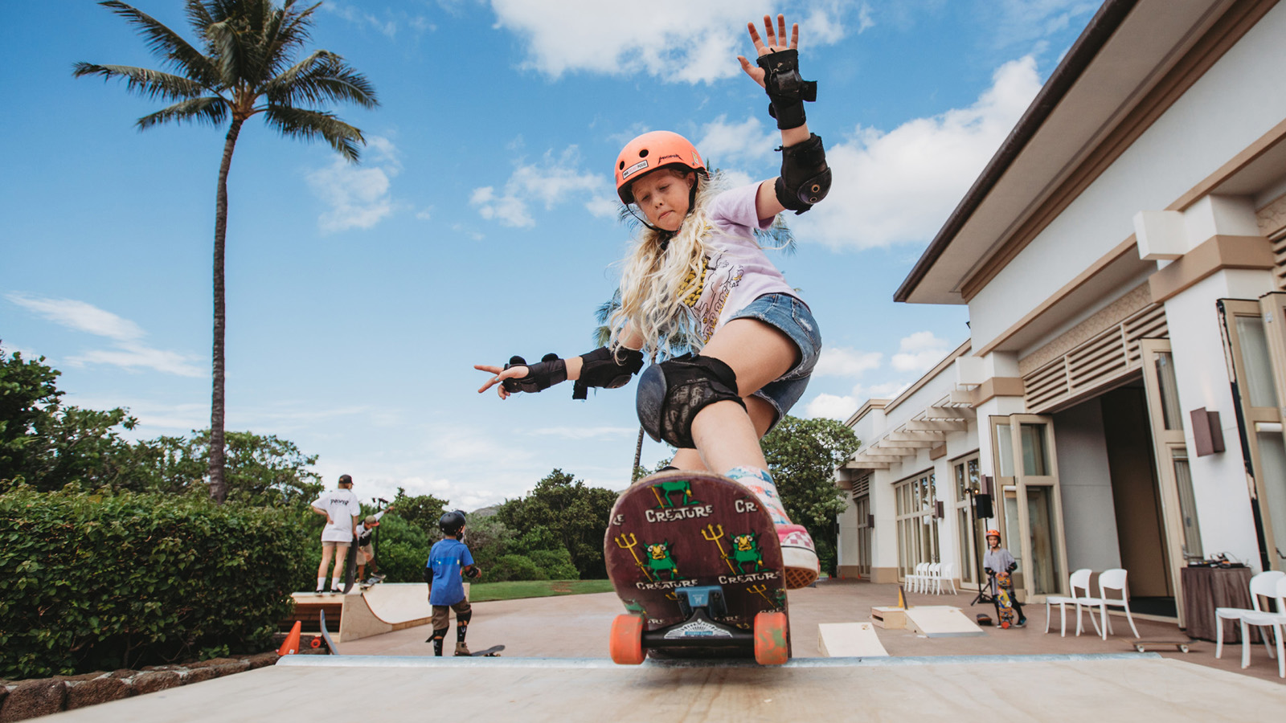
Shred, skate and get stoked at Four Seasons Resort Oahu at Ko Olina with the Resort’s kid-centric skateboarding camp offered exclusively by Camp Kohola, the supervised daily activity program for keiki and teens at Four Seasons. In partnership with Proper Rideshop – Hawaii’s premiere youth development skateboarding training facility - Four Seasons Resort Oahu x Proper Rideshop Skate Camp returns to the Resort over Spring Break, March 23-24, 2019.
“Whether skateboarding for the very first time, or as an intermediate skater, Proper Rideshop Skate Camp is a safe and cutting-edge program ideal for skaters of all levels,” says Graham Williamson, Resort Manager at Four Seasons Resort Oahu at Ko Olina. “Skateboarding has become an iconic sport for Hawaii’s youth culture, and it seamlessly merges surfing and snowboarding, making it an ideal sport to enjoy anywhere – no waves or snow required, just proper and safe riding technique – and loads of fun.”
As the first resort-style skateboarding facility in Hawaii, Four Seasons Resort Oahu x Proper Rideshop Skate Camp is designed to empower, encourage and build confidence for the youth through skateboarding in a safe environment. The Skate Camp package will feature two sessions March 23-24, 2019, offered to children ages 7 to 17 years of age, with private lessons available upon request. The camp is available to skateboarders of all skill levels, with no previous skateboarding experience required. Mini-shredders will learn the fundamentals of skateboarding and safety skills, while also building social, mental and physical skills.
The fun and engaging camp will feature expert instruction by Proper Rideshop’s professional staff of experienced board riders and trained instructors to give each rider a positive experience. Private one-on-one hour skateboarding lessons are also available upon request and availability. The pop-up camp includes equipment rental (helmet, pads, skateboard), and a top of the line pop-up skate park made exclusively for Four Seasons.
The two-day Skate Camp package is USD 495 and includes:
- Camp Session 1: Saturday, March 23, 2019, 9:00 am to 2:00 pm, includes skate lessons, snack, and lunch
- Shred Session: Saturday, March 23, 2019, 5:00 to 8:00 pm, includes keiki dinner buffet
- Camp Session 2: Sunday, March 24, 2019, 9:00 am to 2:00 pm, includes lessons, snack, and lunch
- Proper Rideshop amenity gift and skateboard deck
Shred, skate and get stoked at Four Seasons-style with Proper Rideshop. To book an unforgettable family stay in paradise combined with an exclusive Proper Rideshop Skate Camp Package, visit Four Seasons Resort Oahu at Ko Olina online or call 1 800 819 5053.

RELATED

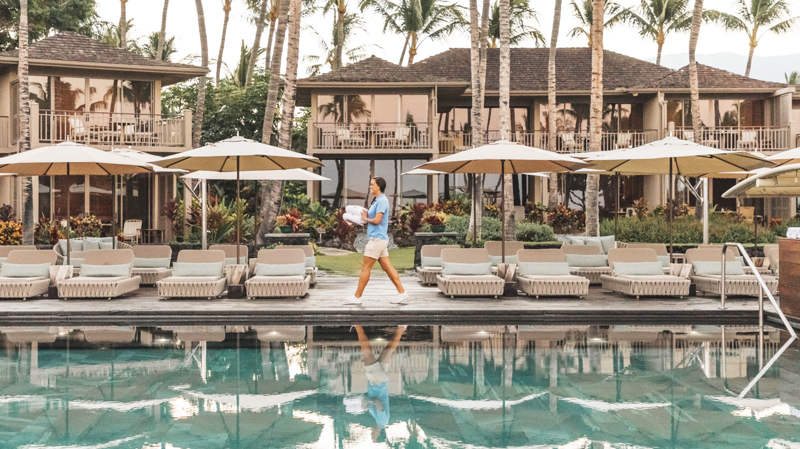 | February 6, 2019, Hawaii, Hualalai, U.S.A.  U.S. News & World Resport Names Four Seasons Resort Hualalai #1 Hotel in the United States and Hawaii  https://publish.url/hualalai/hotel-news/2019/best-hotel-in-the-united-states-and-hawaii.html
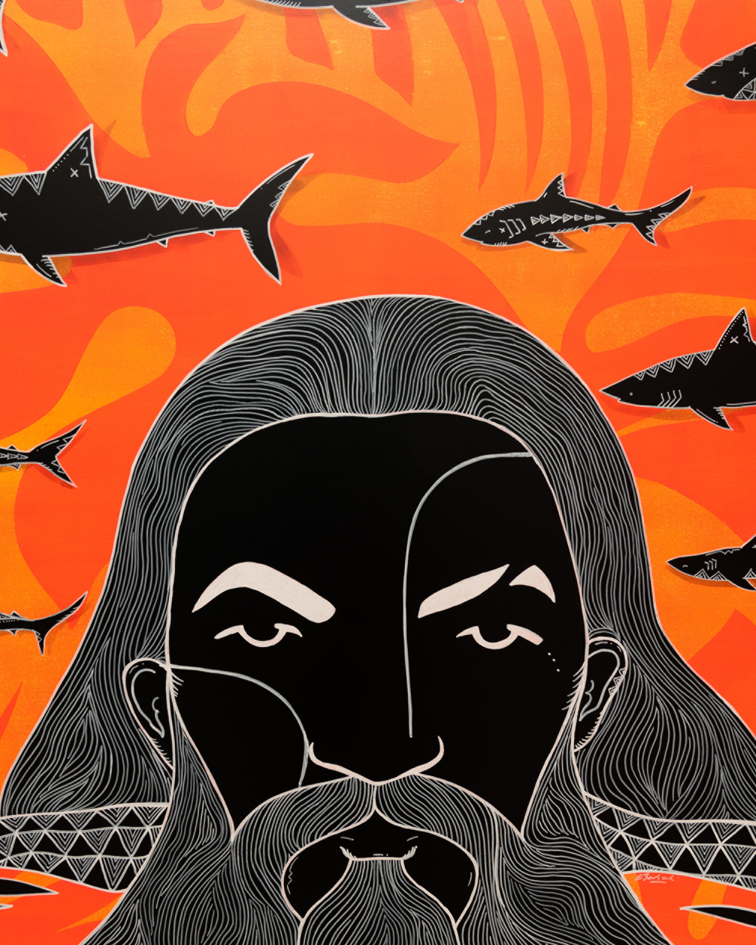 | February 4, 2019, Hawaii, Oahu, U.S.A.  Legendary Watermen from Buffalo Keaulana to Jason Momoa Feature in Eduardo Bolioli’s West Side Stories at Four Seasons Resort Oahu at Ko Olina  https://publish.url/oahu/hotel-news/2019/west-side-stories-bolioli-exhibit.html

PRESS CONTACTS

Yvonne Hunter
Director of Public Relations
92-1001 Olani Street
Kapolei
U.S.A.
yvonne.hunter@fourseasons.com

+1 (808) 377-0746

Laura Fairweather
Director of Public Relations, Americas
1165 Leslie Street
Toronto
Canada
laura.fairweather@fourseasons.com
@FourSeasonsPR
+1 416 441 4233

