Four Seasons Hotel Washington, DC Offers "Easter Brunch at Home" to Benefit MedStar Washington Hospital Centre

April 3, 2020, Washington, DC, U.S.A.

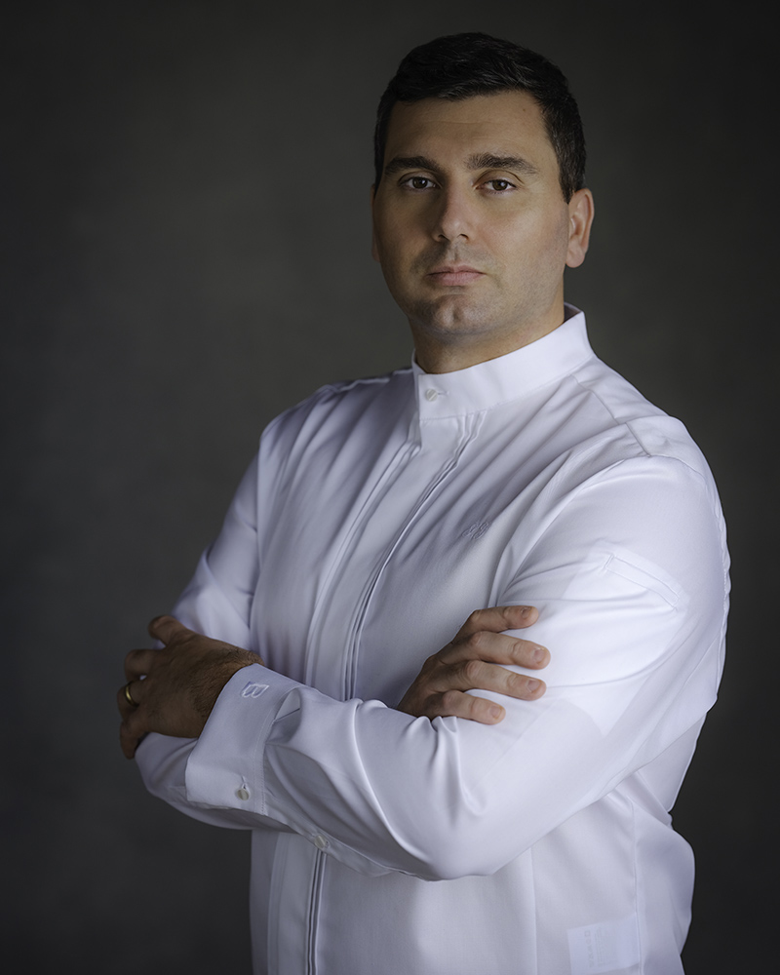
Four Seasons Hotel Washington, DC announces a special take-away Easter Menu created by Executive Chef Sebastien Giannini to enjoy at home. A portion of the proceeds to benefit MedStar Washington Hospital Centre.
The team at Four Seasons Hotel Washington, DC has loved being a part of Easter family memories for the past 40 years with its iconic Easter Brunch at Seasons or at BOURBON STEAK, and annual Easter egg hunt. While this year will certainly be different than the past 40, Executive Chef Sebastien Giannini and his team want to bring the legendary luxury of a Four Seasons Easter celebration to one's own home.
“Easter is such an important family holiday for so many people. While we cannot serve the traditional brunch at the Hotel, we are happy to help spread joy this Easter and share our Brunch with you at home,” says Giannini.
Four Seasons Easter Brunch at Home is available for pick up in portions from one to twelve people for USD 65 per person. A portion of the proceeds from every menu sold will go to MedStar Washington Hospital Centre. Chef Giannini’s menu includes favourites from Seasons and BOURBON STEAK to enjoy in the comfort of one's own home. Whet the appetite with an amuse bouche of smoked duck tartlet accompanied by a savoury mango chutney. Delight in Scottish-style smoked salmon, lemon cream, pickled cucumber and grilled lemon as an appetiser. Dig in to a BOURBON STEAK 7x ribeye accompanied by a truffle potato mousseline. Satisfy a sweet tooth with a white chocolate and seasonal fruit tartelette.
A selection of Champagne or wine bottles are also available to take home to accompany the meal.
Reservations for Four Seasons Brunch at Home must be made before 5:00 pm on Friday, April 10, 2020 by calling Four Seasons Hotel Washington, DC at +1 202 342 0444.
Pick up is available on the front drive of the Hotel from 10:00 am on Sunday, April 12, 2020.
Four Seasons Hotel Washington, DC remains open, with limited services and in respect of the latest government guidelines, to accommodate guests who need to come to DC.

RELATED

March 27, 2020, Washington, DC, U.S.A.
From Our Four Seasons Family to Yours: Four Seasons Hotel Washington, DC Shares Love of Hospitality with Tips to Recreate the Experience at Home
https://publish.url/washington/hotel-news/2020/from-our-four-seasons-family-to-yours.html

February 7, 2020, Washington, DC, U.S.A.
Four Seasons Hotel Washington, DC Appoints Sebastien Giannini as Executive Chef
https://publish.url/washington/hotel-news/2020/new-executive-chef-sebastien-giannini.html

PRESS CONTACTS

Anina Belle Giannini
Director of Public Relations
2800 Pennsylvania Avenue N.W.
Washington
U.S.A.
aninabelle.giannini@fourseasons.com

+1 202 944 2074

