Enjoy a Delicious New Dessert at Four Seasons Resort Scottsdale and Support a Great Cause

Proof, An American Canteen to compete in annual Girl Scout Cookie Challenge
January 23, 2019, Scottsdale, U.S.A.

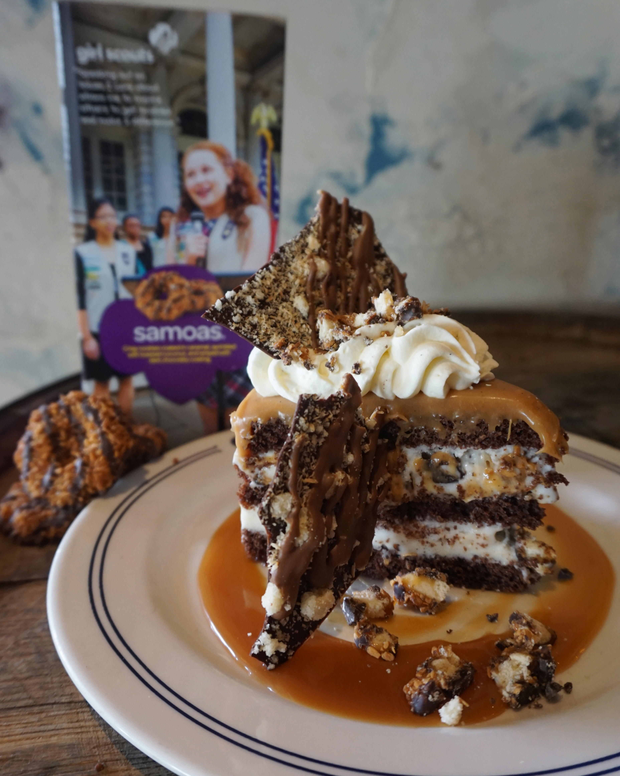
If there is ever a good time to splurge on calories, it’s during Girl Scout cookie season. What could be better than enjoying a delicious cookie to support a great cause?
Chef Lance Whipple, Executive Pastry Chef at Four Seasons Resort Scottsdale at Troon North, is taking Girl Scout cookie cravings to the next level with a scrumptious dessert that not only satisfies the sweet tooth but also raises awareness and funds for Arizona’s Girl Scouts.
During the month of February 2019, Chef Whipple and Proof, an American Canteen will participate in the 6th Annual Girl Scout Cookie Challenge, a competition in which Arizona chefs use their culinary prowess to create a custom dessert item using one of the beloved flavours of Girl Scout cookies. A portion of the dessert sales directly benefits local girls through the Girl Scouts – Arizona Cactus-Pine Council.
This year, Chef Whipple chose samoas as his cookie of choice and has crafted the coconut chocolate samoas ice cream cake with gooey caramel sauce as his entry. It is a delectable coconut samoas ice cream cake that is layered with rich chocolate cake and smothered in gooey caramel sauce.
In addition to creating the coconut samoas ice cream cake for the restaurant’s dessert menu, Chef Whipple also has invited Girl Scouts to join him and his pastry team in the kitchen.
“Last year, we got the idea to have a few girls join us in the kitchen to see all the moving parts of running a restaurant and delivering food to the table,” he says. “It was such a hit that we are hosting Girl Scout field trips with some local troops this year to really get them excited about the art, math and science behind what we do. Maybe there are even a few future chefs in our mix!”
In past years, the winning entry was decided by dessert sales. This year, the Girls Scouts Council is hosting a online poll.
“No matter who wins the dessert challenge, the Girl Scouts win,” says Chef Whipple. “We are proud to support this great organisation and invite our guests to join us simply by enjoying a delicious dessert that they won’t find anywhere else.”
The coconut samoas ice cream cake, priced at USD 12, will be available for purchase at Proof, An American Canteen from February 1 to 28, 2019.
For dining reservations, call 480 513 5085.

RELATED

January 14, 2019, Scottsdale, U.S.A.
Four Seasons Resort Scottsdale at Troon North Offers Romantic Dining and the Gift of Pampering
https://publish.url/scottsdale/hotel-news/2019/valentines-day.html

December 19, 2018, Scottsdale, U.S.A.
Ring in the New Year at Four Seasons Resort Scottsdale at Troon North
https://publish.url/scottsdale/hotel-news/2018/new-years-eve.html

PRESS CONTACTS

Jennifer Franklin
Director of Public Relations and Communications
10600 East Crescent Moon Drive
Scottsdale
U.S.A.
jennifer.franklin@fourseasons.com

+1 (480) 513-5049

