Four Seasons Hotel des Bergues Geneva Launches New Spa Treatments for Adults and Children

The Spa continues to innovate its beauty offering with the launch of new treatments that use state-of-the-art technology
May 15, 2023, Geneva, Switzerland

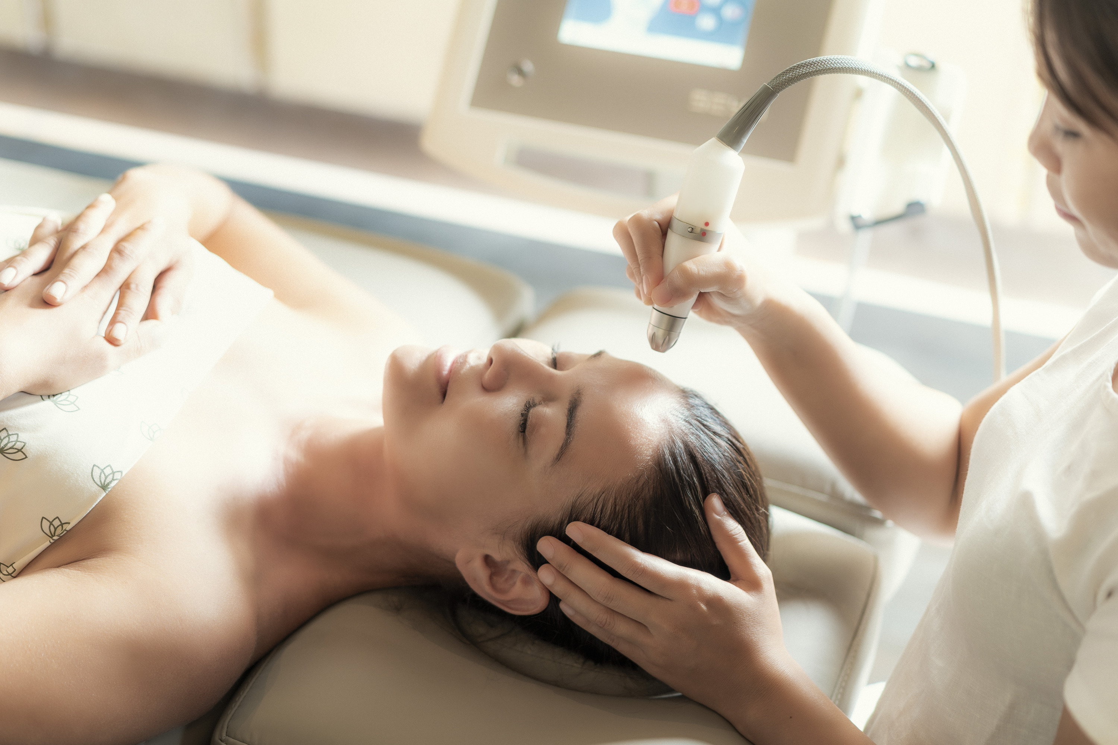
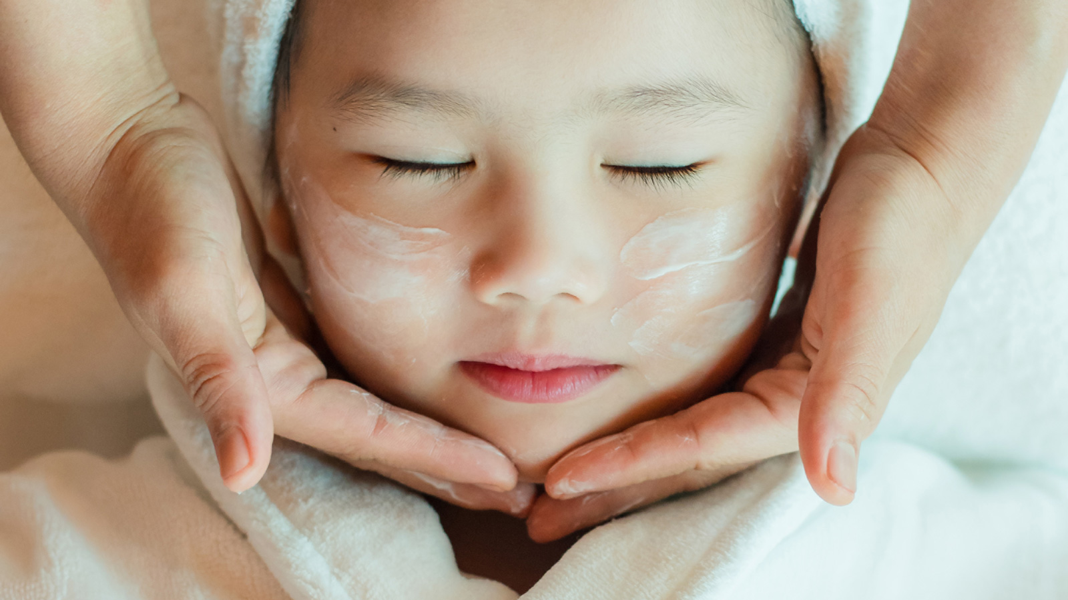
The Spa at Four Seasons Hotel des Bergues Geneva is a restorative haven renowned for offering cutting-edge beauty treatments that reflect outstanding Swiss craftsmanship. Spread over the top two floors of the Hotel, Spa Mont Blanc is a sanctuary of peace, with large windows offering panoramic views of Geneva and the surrounding snow-capped mountains. The Spa prides itself on its in-depth personalised approach to beauty and anti-ageing, with a selection of brands and treatments carefully chosen for their exceptional, immediately visible results. This year, the Spa has launched several new hair and beauty treatments for adults and young guests.
Face and Hair Treatments by Biologique Recherche
Parisian brand Biologique Recherche is renowned for its highly effective skincare products offering immediate, exceptional results. With high concentrations of botanical, marine and biological extracts, the formulas are highly innovative and powerful. Facial and hair treatments combine avant-garde skincare products with cutting edge technology, using manual techniques that invite relaxation and revive overall wellbeing.
- Micro-Puncture Mesotherapy Facial (50 minutes) - This treatment uses Micro-Puncture Lab, a machine consisting of a single use multi-needle head that gently punctures the surface of the skin to stimulate the epidermis to rejuvenate and repair. This painless technique is known to boost intra-dermal collagen production and increase the skin’s absorption of 56 regenerative active ingredients, including polypeptides, oligopeptides, tripeptides, amino acids, minerals and vitamins, offering immediate results. Prices start from CHF 300.
- Hair Loss Mesotherapy Treatment (30 minutes) - This unique, painless procedure uses a Micro-Puncture Lab machine to slow hair loss. The machine uses multi-needle heads to microinject active ingredients into the middle layer of the skin to stimulate intra-dermal collagen production and increase skin absorption to encourage hair growth. Among the 56 active ingredients used are polypeptides, oligopeptides, tripeptides, amino acids, minerals and vitamins. Prices start from CHF 300.
Treatments for Kids and Teens by Bonpoint
In collaboration with children’s designer brand Bonpoint, Spa Mont Blanc has created three signature Spa treatments for kids and teens. The brand prides itself on its eco-responsible approach to skincare, creating natural products that are soft, gentle and safe to use on children’s sensitive skin. At the Spa boutique, guests can purchase Bonpoint beauty products specially formulated for different life stages.
- Bonpoint Dreamy Massage (30 or 60 minutes) - Created for children aged between 10 and 16, this cocooning treatment is designed to help young guests switch off and unwind. This deeply relaxing treatment soothes the mind and body, easing stress and restoring energy levels. The massage ends with a revitalising fruit smoothie to replenish the body with vitamins and boost energy levels. Children are gifted with a Bonpoint Beauty Essentials Kit to maximise results.
- Bonpoint Fairy Facial (30 minutes) - Suitable for children as young as four, this relaxing facial is a fun and playful introduction to facial care. Children are softly lulled by the soothing sound of background music or an audio book as therapists apply beauty products with fun textures using gentle manual gestures. The treatment ends with a fruit smoothie to boost and re-energise, and children are gifted with a Bonpoint Beauty Essentials Kit to maximise results and continue their beauty routine at home.
- Bonpoint Tenderness Awakening Facial (30 minutes) - This gentle treatment designed for children aged between 6 and 12 provides the perfect introduction to a facial, with beauticians talking young guests through each step of the ritual. The aim is to transmit the importance of a good, regular skincare routine so that children learn how to take care of their skin from a young age to help prevent skin issues down the line. The treatment ends with a fresh fruit smoothie packed full of nutrients. The skin is left feeling fresh, nourished and hydrated, and children are gifted with a Bonpoint Beauty Essentials Kit to continue their beauty routine at home.
About Spa Mont Blanc
Spa Mont Blanc is a leading health and beauty centre delivering results-driven treatments that are at the forefront of advanced beauty. The Spa has a steam room, heated indoor swimming pool and vitality pool with water jets to help relieve tired and aching muscles while improving circulation and detoxifying the skin. The state-of-the-art fitness centre is equipped with the latest Technogym and Matrix equipment for cardiovascular and strength training.

RELATED

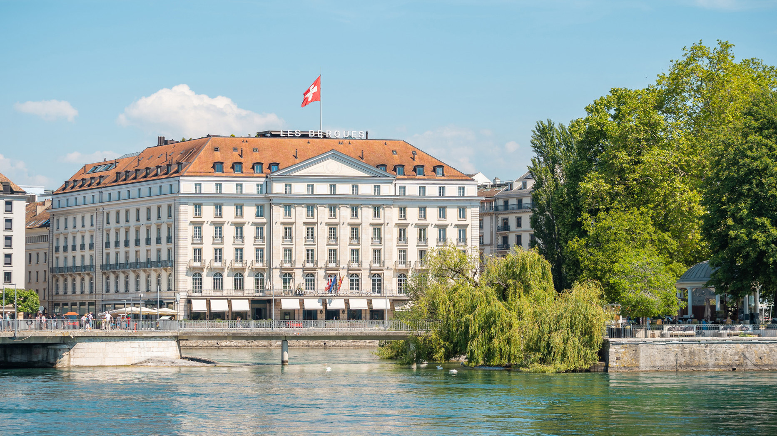 | March 10, 2023, Geneva, Switzerland  Four Seasons Hotel des Bergues Geneva Offers Cracking Easter Activities for All to Enjoy  https://publish.url/geneva/hotel-news/2023/easter.html
March 10, 2023, Geneva, Switzerland
Pâques en famille au Four Seasons Hotel des Bergues Geneva
https://publish.url/fr/geneva/hotel-news/2023/easter-2.html

PRESS CONTACTS

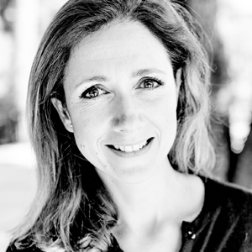 | Caroline Mennetrier  Director of PR and Marketing Communication  33, Quai des Bergues  Geneva  Switzerland  caroline.mennetrier@fourseasons.com  00 33 6 26 39 96 76

