10 Reasons to Fall in Love with Athens

January 15, 2019, Athens, Greece

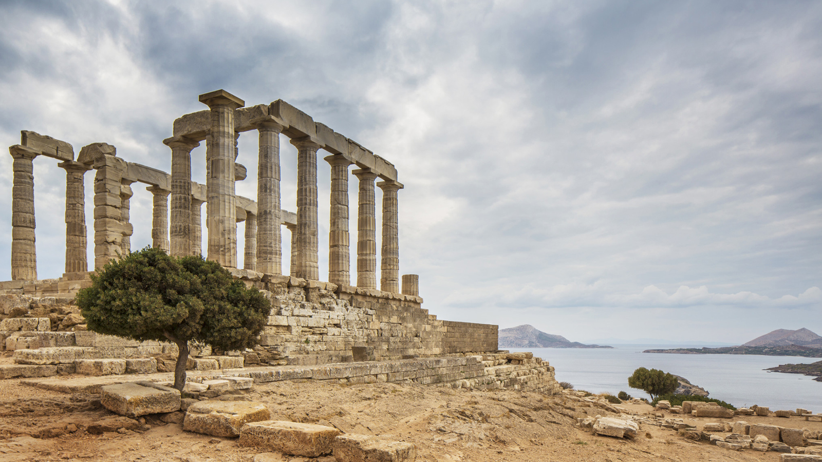
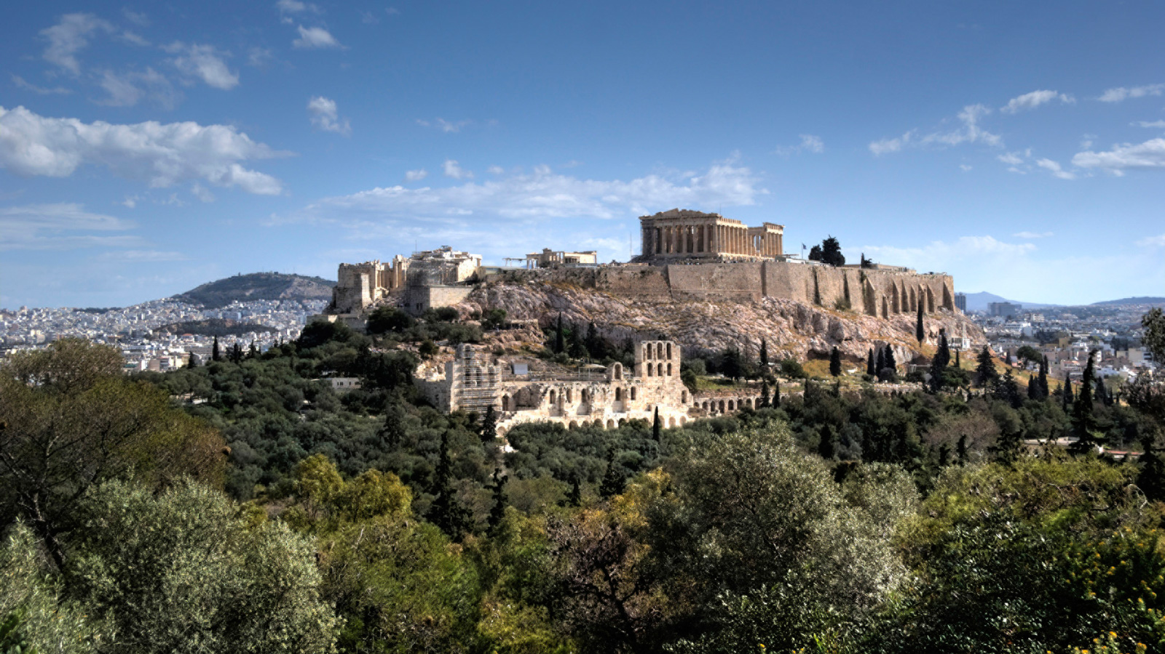 | 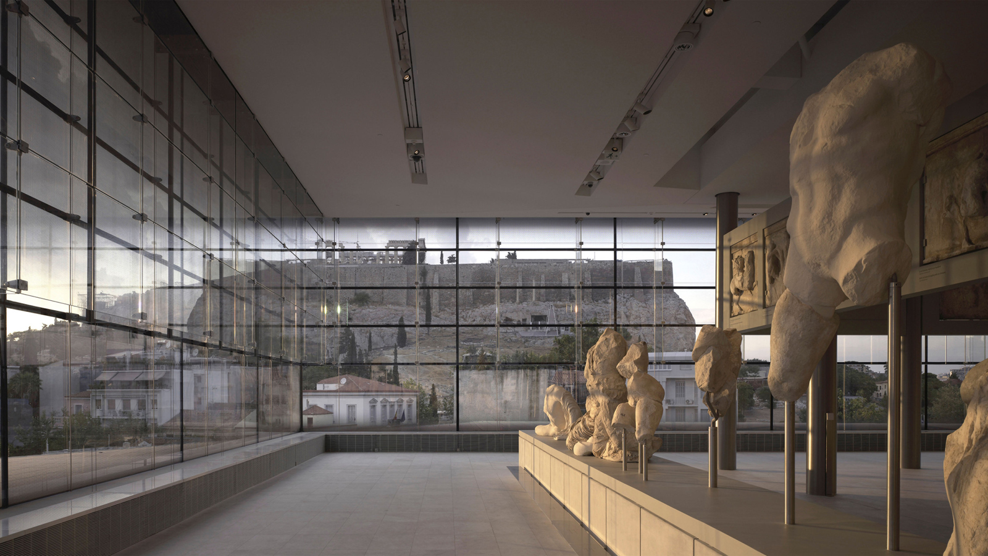
Athens has hit a new stride thanks to a glorious revival in art, food and architecture that has been underway for the last decade. Here, the concierge team at Four Seasons Astir Palace Hotel Athens offers ten reasons to fall in love with this flourishing metropolis.
1. An Epic Heritage: The Parthenon is visible from almost every street corner in central Athens and must be seen up close to appreciate just how imposing these famous and majestic columns are. Fast forward a few millennia and you will find yourself at the Panathenaic Stadium, also made entirely of marble and the site of the first modern Olympic Games in 1896.
2. A City by the Sea: Bon vivants know that you can experience almost everything the Greek islands have to offer in Athens. With some of the most beautiful beaches found along a 31 mile (50 kilometre) coastline, you can enjoy life just as the ancients did, with fresh seafood all year round, while swimming in the crystal blue waters of the Aegean Sea for the majority of the year.
3. Music and Theatre Beneath the Acropolis: From majestic ballets and arias to ancient Greek tragedies, witnessing a performance at the Odeon of Herodes Atticus (June–October) is something you’ll unlikely forget. Despite being nearly 2,000 years old, the theatre is heralded for its exemplary acoustics.
4. Temple of Poseidon: Erected in the middle of the 5th century BC and located at the end of the Sounion peninsula, this ancient temple was built to honour Poseidon, god of the sea. A sunset here is one of the most magical in Greece, blanketed by vivid reds and oranges.
5. Evzones: Rain, hail or shine, the Greek Presidential Guards or Evzones march towards Hellenic Parliament every Sunday morning in a spectacular ceremonial parade that has become synonymous with Athens.
6. Wines of Athens: As a city surrounded by small historical vineyards, Attica is the largest wine region in Greece, touting talented winemakers who are producing award-winning wines using the indigenous savatiano grape.
7. An Athenian Way of Life: The weekly farmers markets or laiki agora are an inherent part of Athenian society. Setting up in neighbourhoods all around the city, these food markets allow locals to stock up on fresh produce while socialising within their community. The largest, known as the Varvakeios Markets in downtown Athens, operates daily and offers seasonal harvests and local delicacies.
8. Byzantine Churches: For anyone that appreciates beauty, the churches in Athens are among the most special in Greece, hailing from the Byzantine era and defined by their tall domes with arched windows. The Church of Panagia Kapnikarea is one of the oldest in Athens, built around 1050 AD. All are welcome to enter and appreciate the rare frescos and beautiful iconography inside.
9. Art and Culture go hand in hand in Athens beginning with the Acropolis Museum. With floor to ceiling windows overlooking the ancient city, thousands of sculptures and artefacts found around the Acropolis are displayed and bathed in natural light. At the Museum of Cycladic Art, a stunning collection of Cycladic figurines and ceramics from the 3rd millennium BC can be seen. Over at the National Archaeological Museum, a treasure trove of antiquities await including the gold mask of Agamemnon and the Antikythera Mechanism.
10. Athens’ New Agora: Athenians received a contemporary agora at the newly opened Stavros Niarchos Foundation Cultural Center. The Agora, emblematic of the central gathering spaces in ancient Greece, upholds this tradition with regular events held throughout the year. The entire building is a significant addition to modern day Athens and an architectural feat by architect Renzo Piano.

RELATED

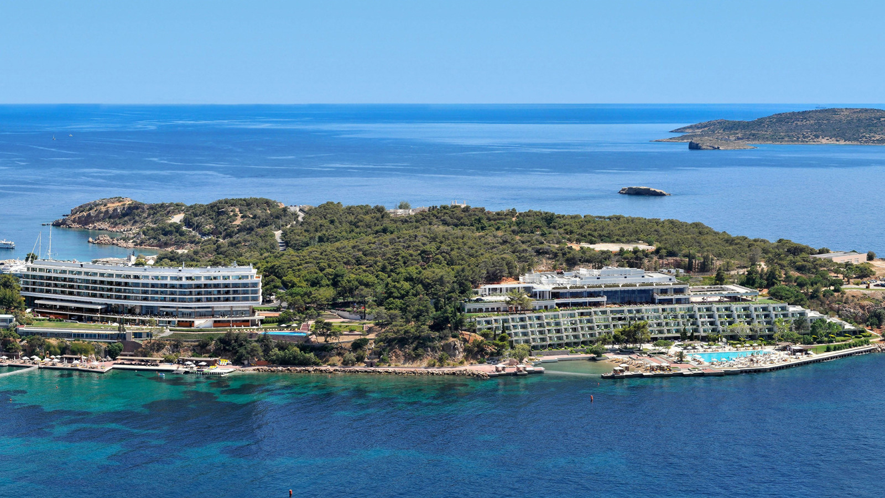 | December 5, 2018, Athens, Greece  Renaissance d’une icône glamour en bord de mer : le Four Seasons Astir Palace Hotel Athens ouvrira au printemps prochain et accepte désormais les réservations  https://publish.url/fr/athens/hotel-news/2018/reservations-live-3.html
December 5, 2018, Athens, Greece
Reservas abertas para 2019: novo Four Seasons Astir Palace Hotel Athens traz glamour para a Riviera ateniense
https://publish.url/br/athens/hotel-news/2018/reservations-live-4.html

PRESS CONTACTS

Elia Kentrota
Director of Public Relations
40 Apollonos Street
Vouliagmeni, Athens
Greece
elia.kentrota@fourseasons.com

+30 210 8901077

