Valentine’s Day Delights, with Love from Four Seasons Hotel Kuala Lumpur

Magical experiences to fall in love all over again
January 28, 2022, Kuala Lumpur, Malaysia

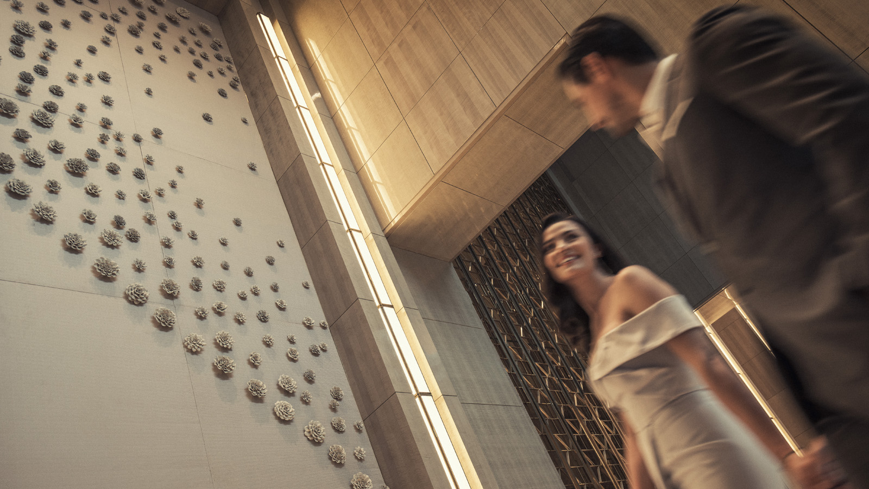
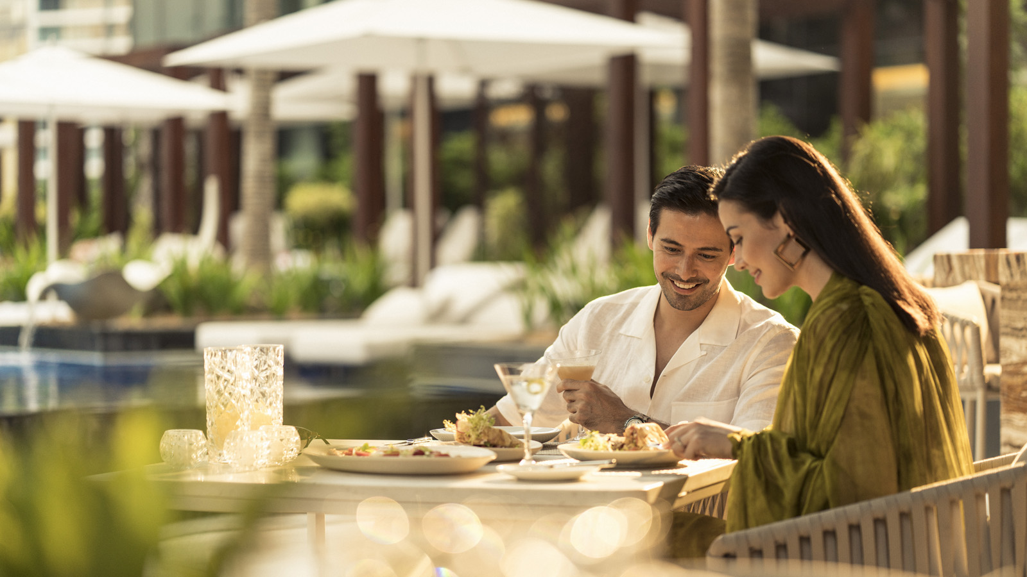 | 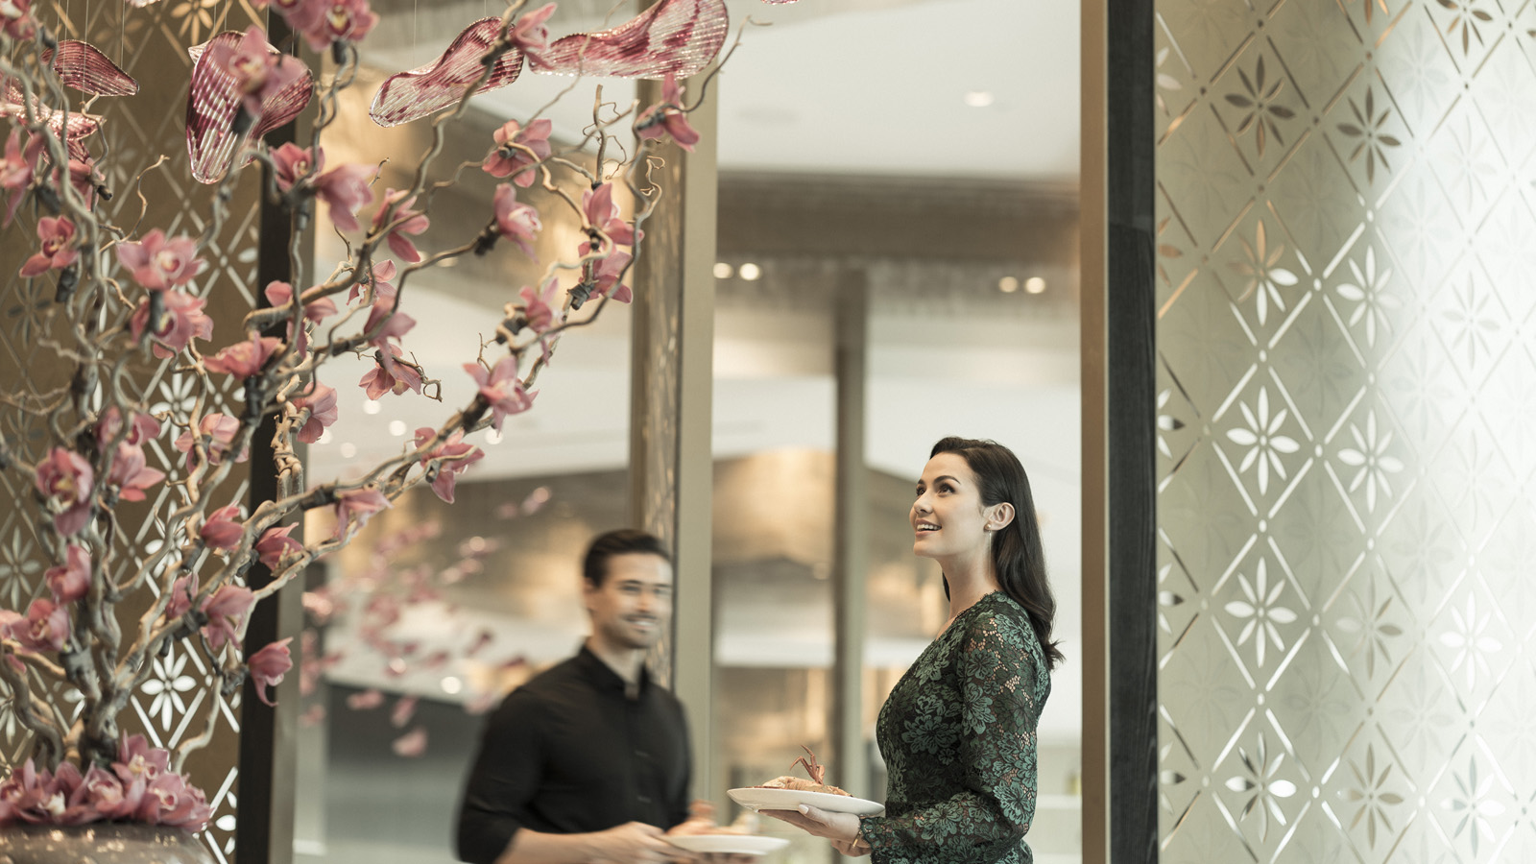
Love is in the air at Four Seasons Hotel Kuala Lumpur. This Valentine’s Day, the stylish urban retreat is set to transform into a wonderland of romance and indulgence.
Lovebirds can look forward to exquisite dining and drinking experiences, cocooned in enchanting settings and framed by incredible views. With warm yet discreet service from the Four Seasons team, each moment feels glamorous, intimate and utterly memorable.
“Whether you’re just starting to woo that special someone or celebrating a romance that has lasted decades, we’re here to add a sprinkle of fairy dust to your love story,” says Executive Chef Junious Dickerson with a smile.
Love at First Bite, Curate. Embark on an irresistible epicurean journey, serenaded by violinists and canopied by floating hibiscus petals. This love feast features fabled ingredients from around the world, believed to deepen intimacy and ignite passion – from freshly shucked oysters and slipper lobster, to dark chocolate and mango. Even the names of dishes exude pure romance: Affection, Deep Affair, Reverence and Sweet Nothings.
The highlight of the night? Live nitrogen ice cream, served with raspberry kombucha. The sparkling flavours explode in the mouth, leaving one wanting more. Thoughtful touches by Four Seasons elevate the entire experience, from welcome drinks to surprise gifts for the couple, including a savings voucher for The Spa.
- February 14, 2022, 6:00 to 10:30 pm
- MYR 500 per couple
- MYR 378 per person for add-on beverage package (selection of prosecco, red wine, white wine, Tiger beer)
- Special price for Champagne bottles (a la carte)
Endless Love, Pool Bar & Grill. A magical evening awaits at the poolside restaurant, caressed by cool breezes and framed by shimmering waters. Lovers are invited to linger over an extravagant menu by Chef Junious, designed to rekindle romance and nurture connection.
Savour a collection of uniquely named dishes, such as Boyish Infatuation (wagyu beef pave with smoked chestnut puree and sea urchin) and Fountain of Love (seared Atlantic cod with flashed baby squids and preserved lemon caponata). A heavenly sweet ending arrives in the form of Forbidden Pleasure, a medley of fudge and berries topped with strawberry sable and dark chocolate foam.
- February 13-14, 2022, 6:00 to 10:00 pm
- 5 courses: MYR 588 per couple
- 6 courses: MYR 638 per couple
Food for the Heart & Soul, The Lounge at Four Seasons. Share a night of aphrodisiacal flavours with that special someone. Inspired by Aphrodite, the Greek goddess of love, Chef Junious’ four-course menu features premium ingredients such as Boston lobster, chestnut, rose and strawberry. A glass of Italian prosecco sets the stage for this passionate yet playful feast.
- February 13-14, 2022, 6:00 to 10:00 pm
- MYR 588 per couple
To reserve a Valentine’s Day experience, chat via Four Seasons App or call +603-23828888.

RELATED

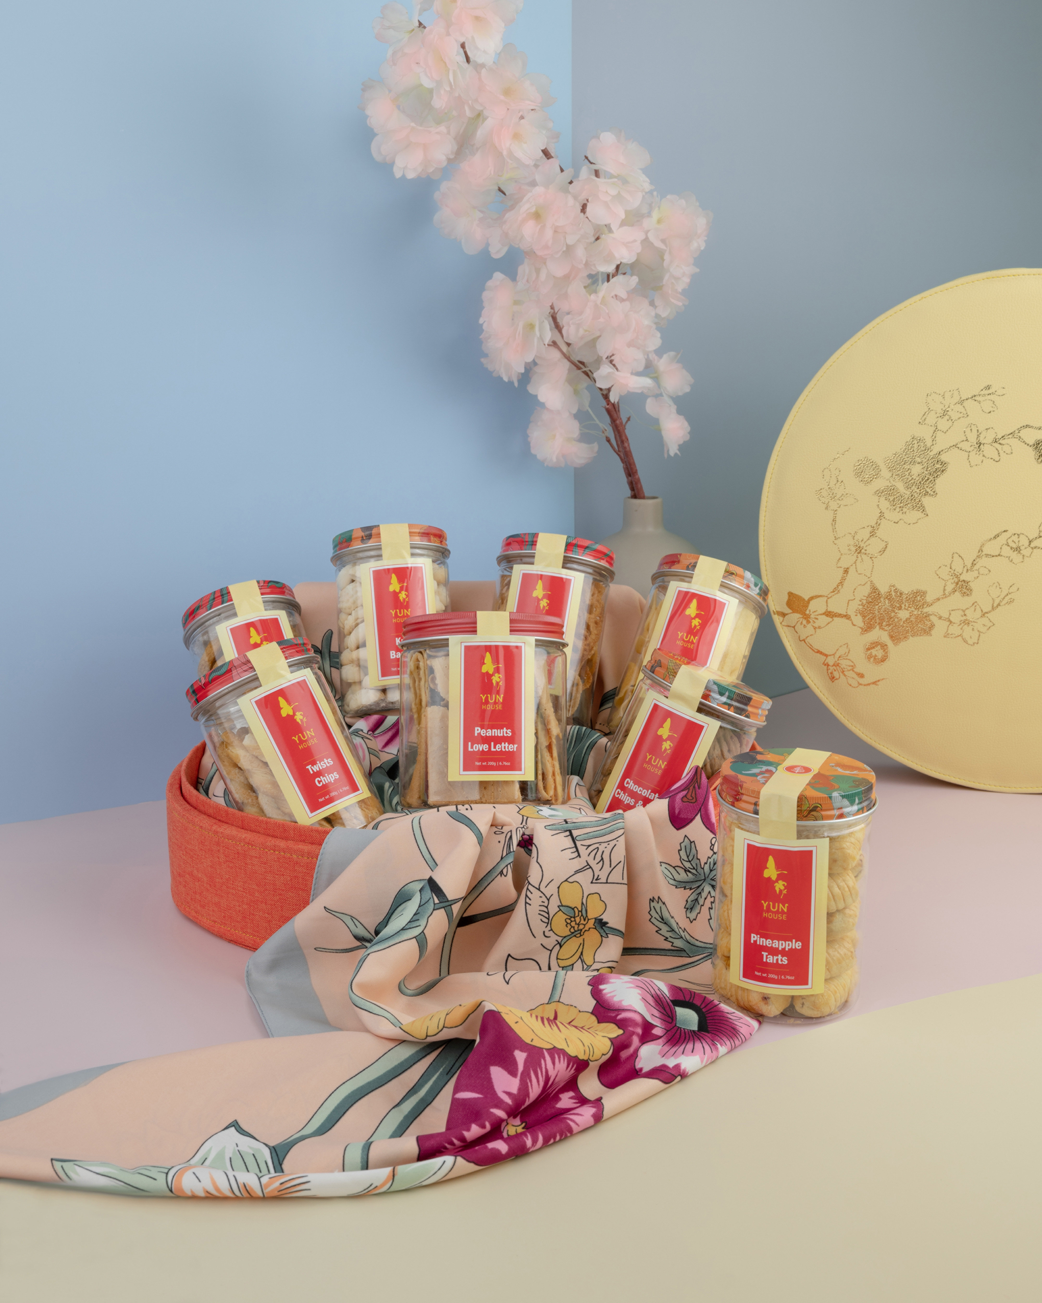 | January 19, 2022, Kuala Lumpur, Malaysia  Celebrate Chinese New Year in Delectable Style at Four Seasons Hotel Kuala Lumpur  https://publish.url/kualalumpur/hotel-news/2022/lunar-new-year.html
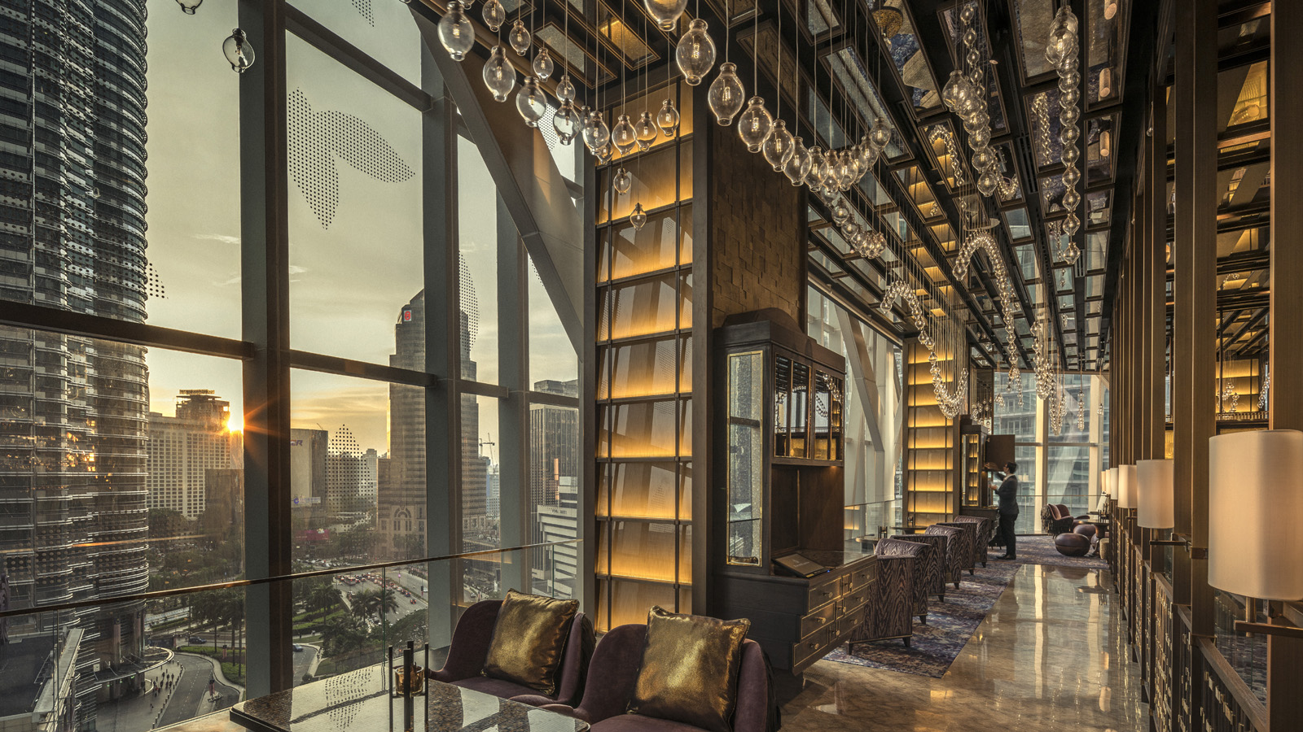 | December 8, 2021, Kuala Lumpur, Malaysia  Bar Trigona at Four Seasons Hotel Kuala Lumpur Ranks in Top 5 for Best Cocktail Menu Award  https://publish.url/kualalumpur/hotel-news/2021/cocktail-menu-award.html

PRESS CONTACTS

Kanchana Ganglani
Director of Public Relations
145 Jalan Ampang
Kuala Lumpur
Malaysia
kanchana.ganglani@fourseasons.com

+6(03) 2382 8740

