Four Seasons Resort Maui at Wailea Launches 31st Annual Virtual Day of Hope Run/Walk

Resort invites participants from around the globe to support cancer patients in Hawaii
November 4, 2021, Hawaii, Maui, U.S.A.

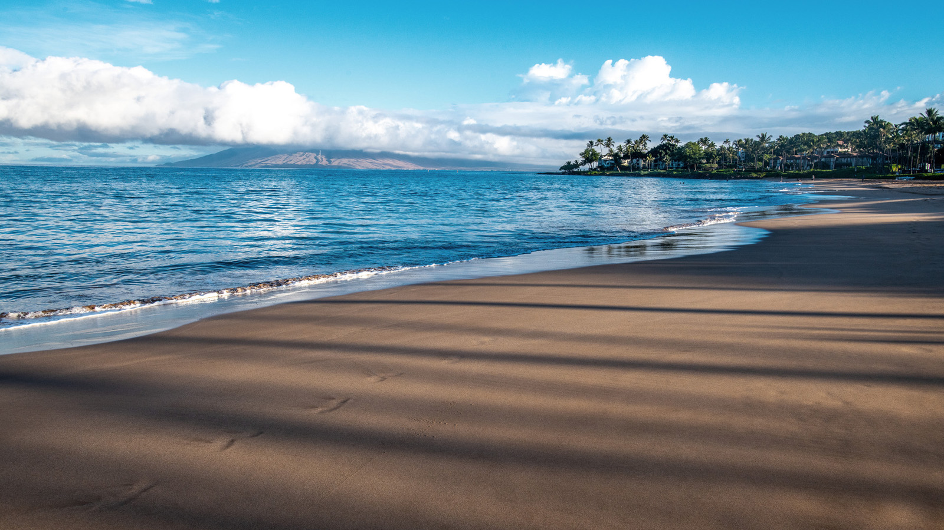 | 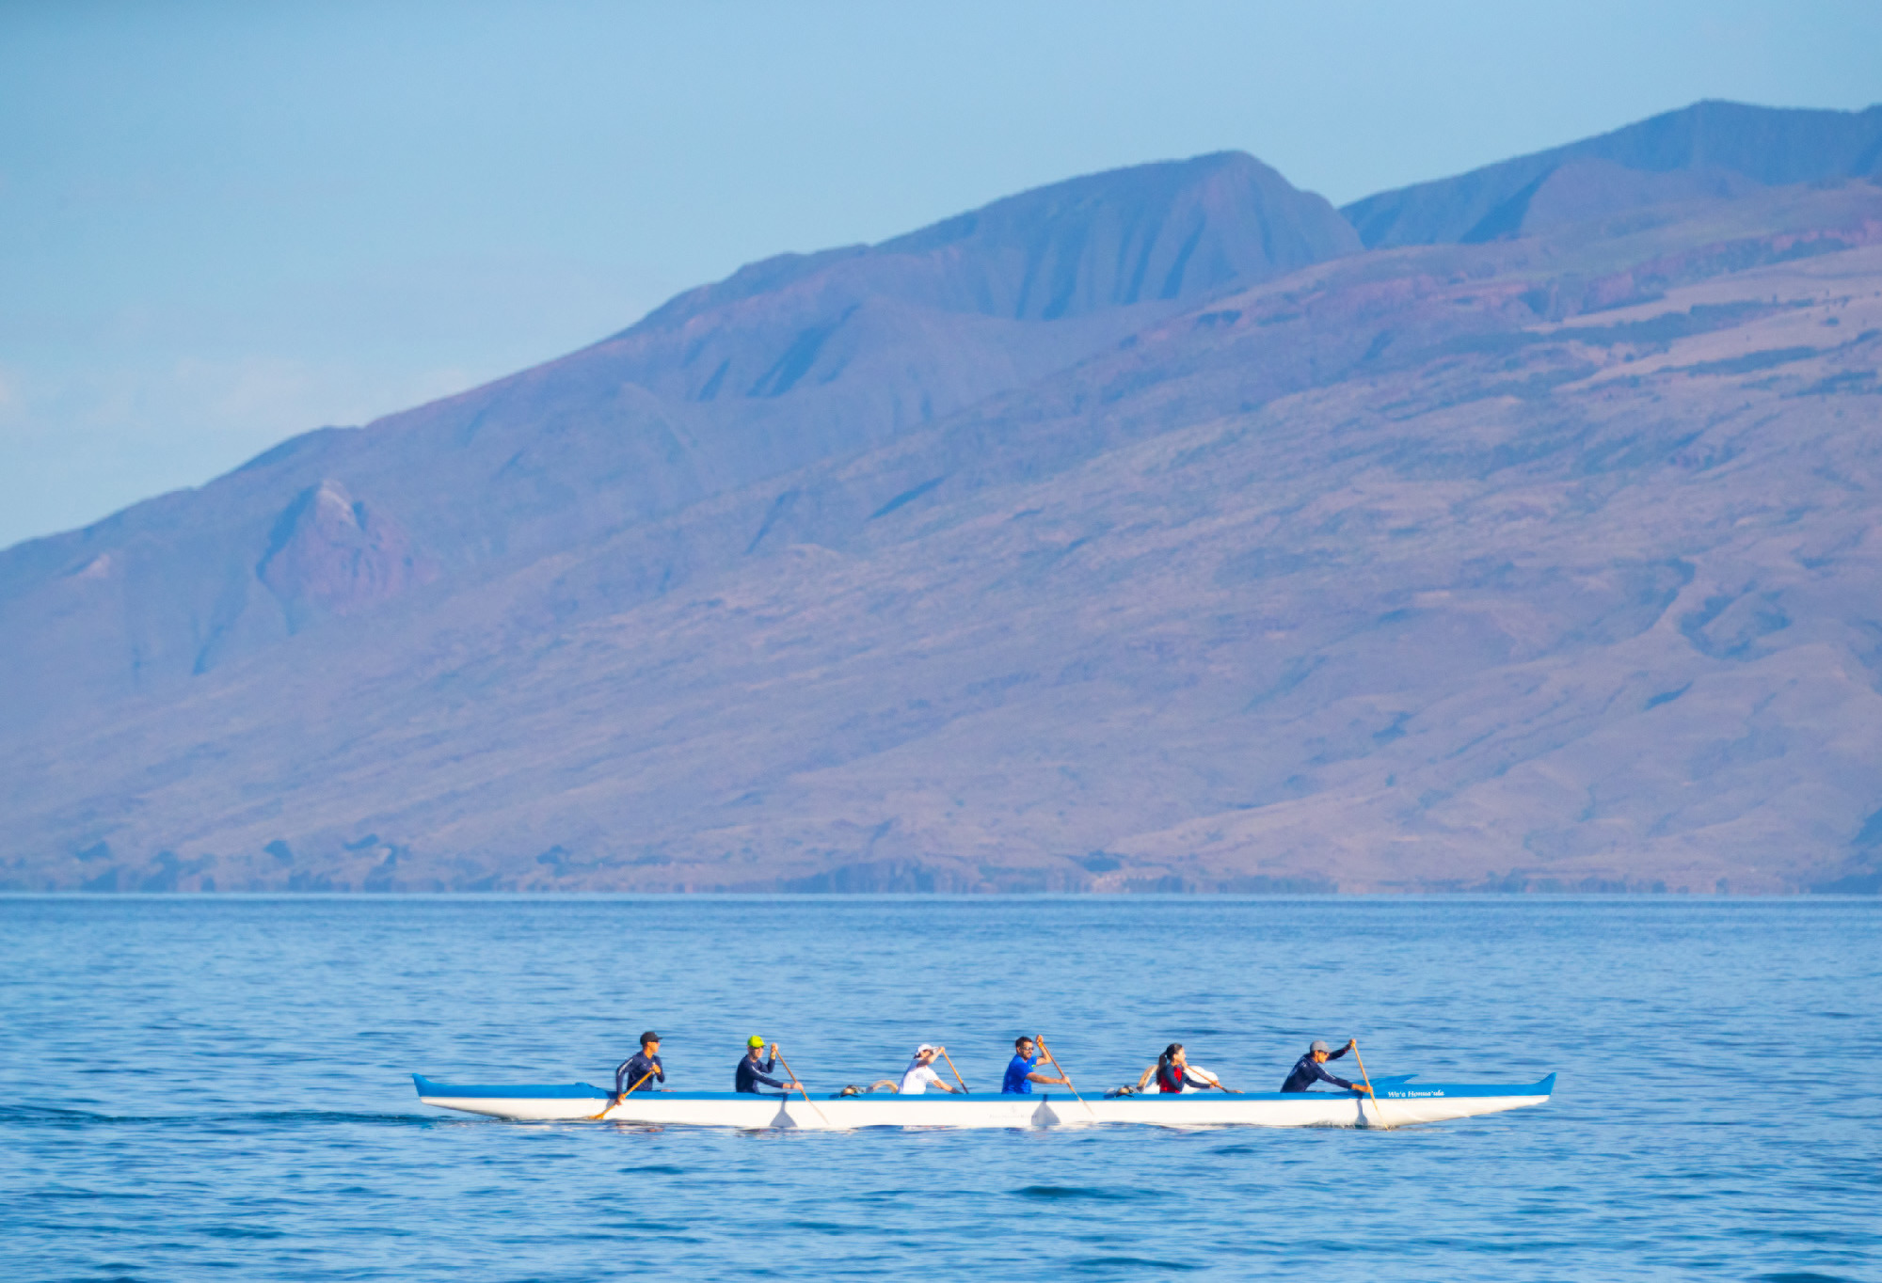 | 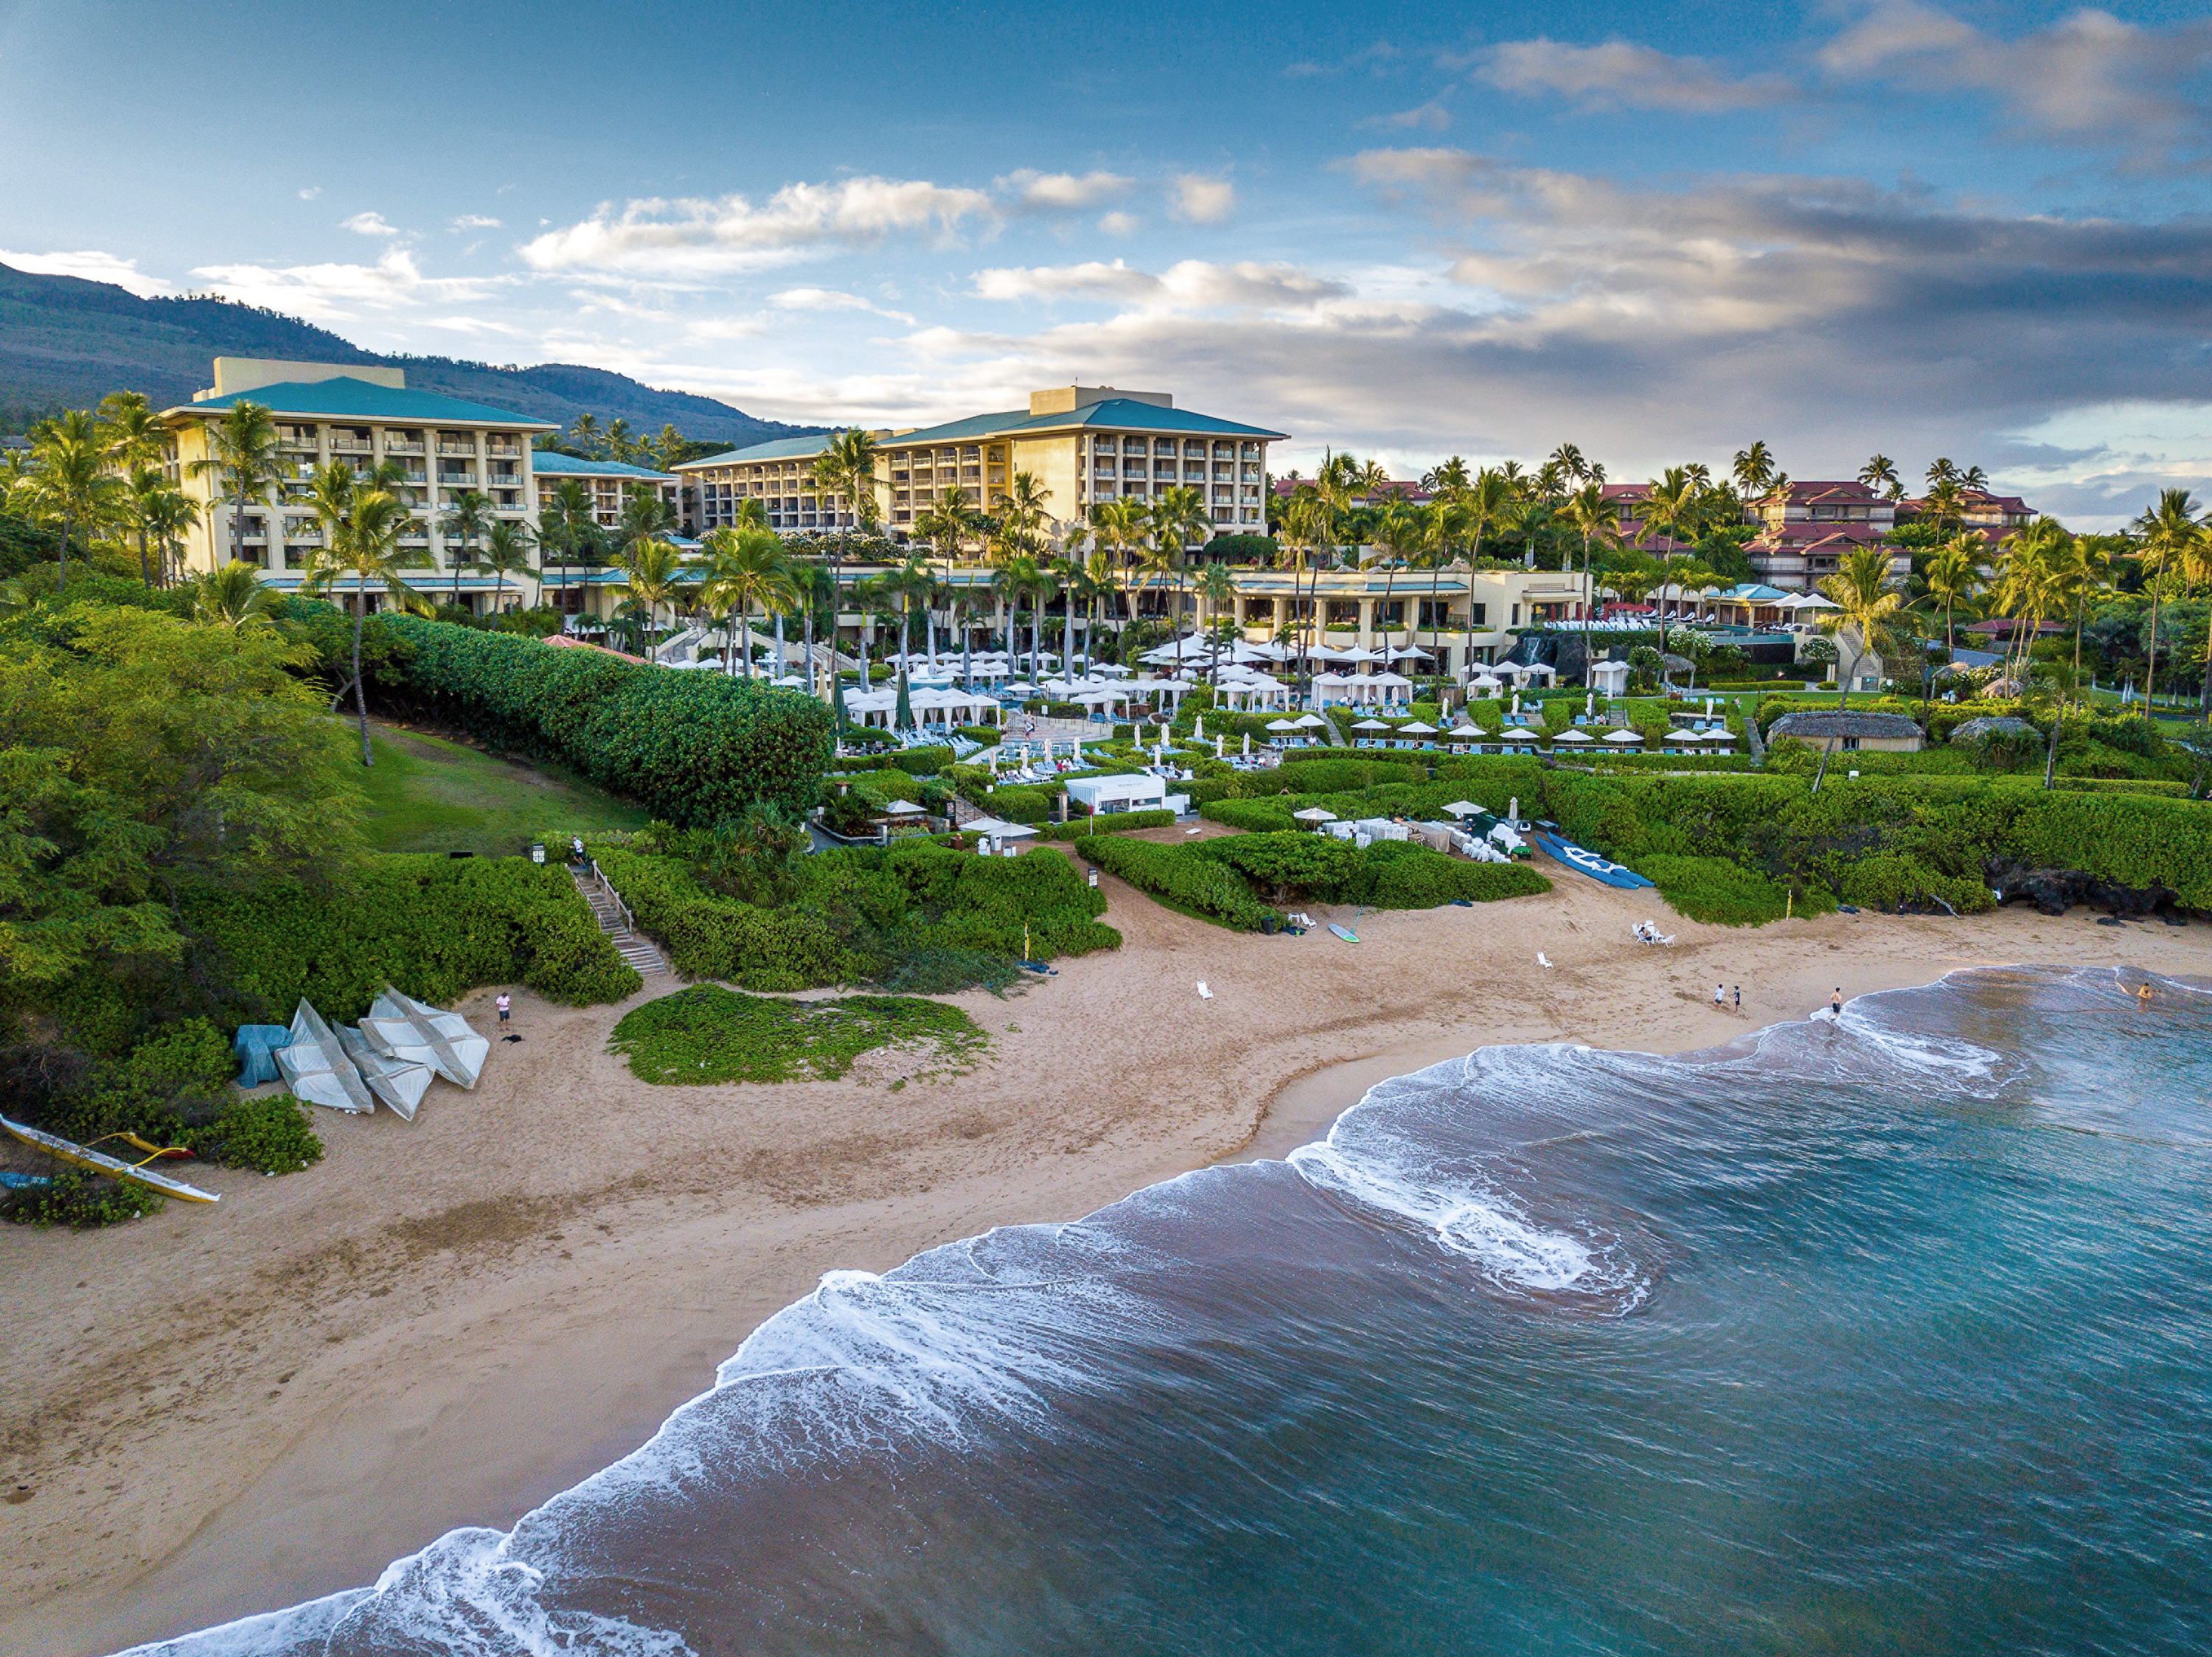
Four Seasons Resort Maui at Wailea announces the 31st Annual Day of Hope Run/Walk, with proceeds benefitting Pacific Cancer Foundation, Kapi‘olani Medical Center for Women & Children, and American Cancer Society’s Hope Lodge. Following a hiatus in 2020 due to the COVID-19 pandemic, the Resort has reimagined the fundraiser, with safety top of mind. This year, a virtual 5K and 10K run/walk and streamed ceremonies will allow participants worldwide to be a part of the Resort’s tradition.
“We’re excited to invite people from all corners of the globe to take part in the Resort’s Day of Hope this year,” says Four Seasons Resort General Manager Ben Shank. “The virtual format gives our extended Four Seasons Maui ‘ohana (family) - regardless of where they are physically - an opportunity to join our community as we raise funds for those affected by cancer in Hawaii.”
Runners and walkers who wish to participate in the virtual 5K and 10K run/walk, can register starting today by visiting the Day of Hope website. Participants can sign up for either distance and will have until 11:59 pm HST on Saturday, December 4, 2021, to complete the race and record their times on the site.
On Sunday, December 5, 2021, at 9:00 am HST, tune into the Four Seasons Resort Maui Facebook page or @fsmaui on Instagram, as the Resort will live broadcast closing ceremonies, including an oli (Hawaiian chant) by Hawaiian Cultural Ambassador Wendy Tuivaioge and an outrigger canoe paddle to scatter orchids in honour of those affected by cancer. Additionally, during the ceremonies, participation prizes will be awarded.
Participation prizes will be drawn randomly and include:
- (1) 3-night stay at Four Seasons Resort Maui at Wailea including breakfast for two daily, parking, and premium internet
- (2) USD 250 Four Seasons Hotels and Resorts Gift Card
The registration for the 5K or 10K run/walk is USD 50 or USD 30 for kama’aina. Dedication orchids for the canoe ceremony can be purchased for USD 5 each. Those who wish to donate directly to support Day of Hope can also do so on the registration website.
Participants are encouraged to tag the Resort’s social media accounts at Four Seasons Resort Maui on Facebook and @fsmaui on Instagram, using the hashtag #fsdayofhope, for a chance to be highlighted on the Resort’s pages.

RELATED

November 3, 2021, Hawaii, Oahu, U.S.A.
Four Seasons Resort Oahu at Ko Olina Welcomes Jason de Vries as New Resort Manager
https://publish.url/oahu/hotel-news/2021/new-resort-manager-jason-de-vries.html

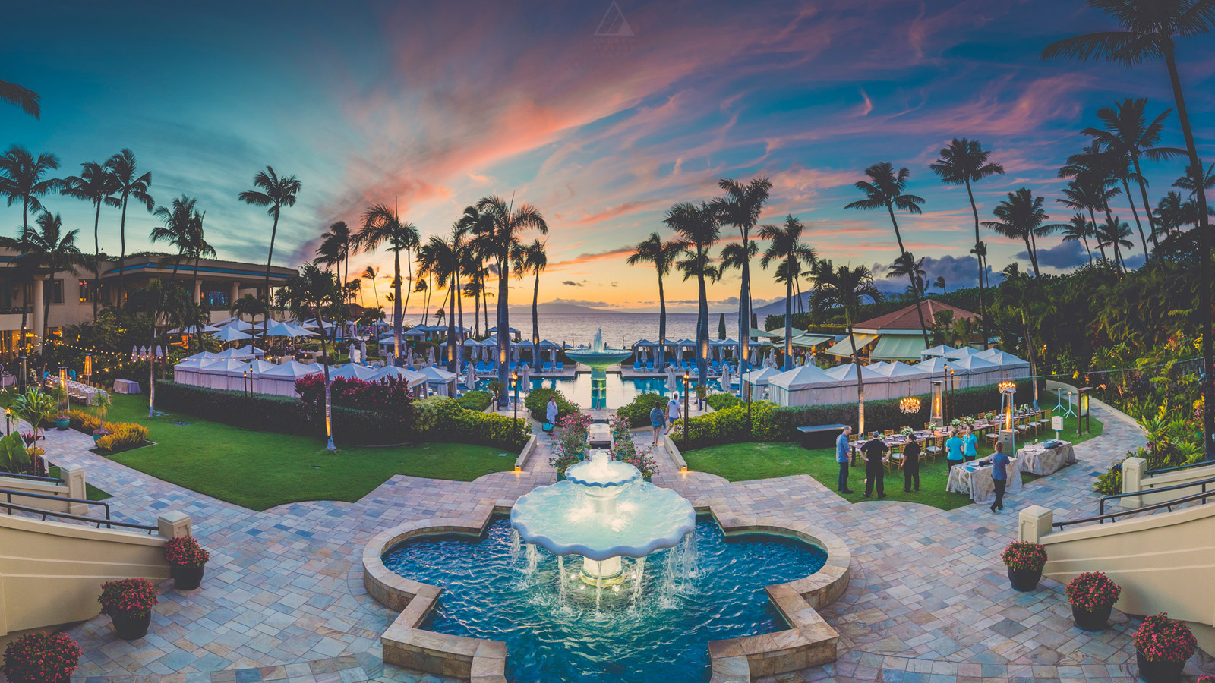 | October 27, 2021, Hawaii, Maui, U.S.A.  Wally’s Wine & Spirits “Pops Up” at Four Seasons Resort Maui for Thanksgiving Weekend, November 26-28, 2021  https://publish.url/maui/hotel-news/2021/wallys-pop-up.html

PRESS CONTACTS

Crissa Hiranaga
Director of Public Relations
3900 Wailea Alanui Drive
Wailea, Maui
U.S.A.
crissa.hiranaga@fourseasons.com

+1 (808) 891-4115

