The New Four Seasons Hotel New Orleans Sweeps Couples Off Their Feet with Elegant Venues and Attentive Service

The newly opened Hotel invites couples to say “I Do" in true New Orleans fashion
June 16, 2022, New Orleans, U.S.A.

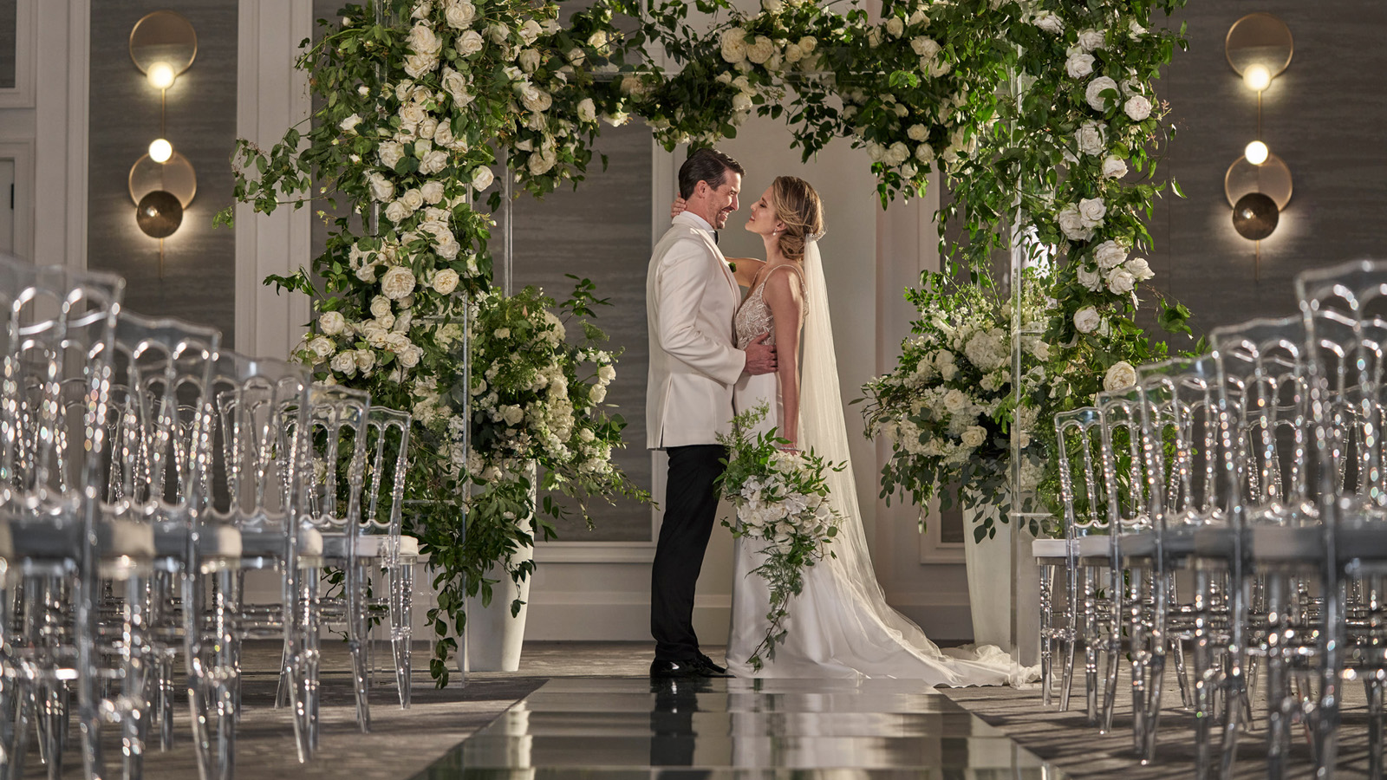
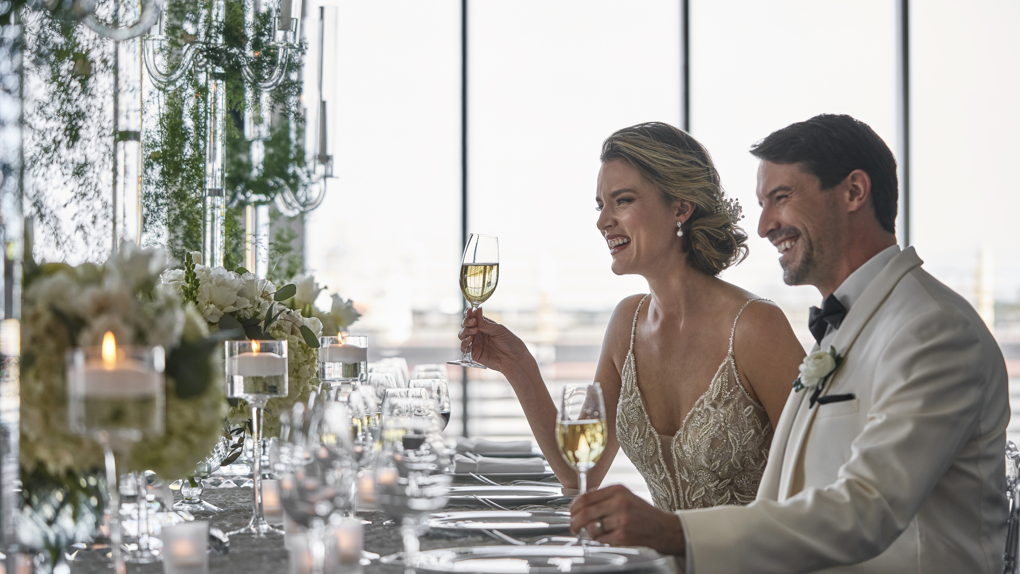 | 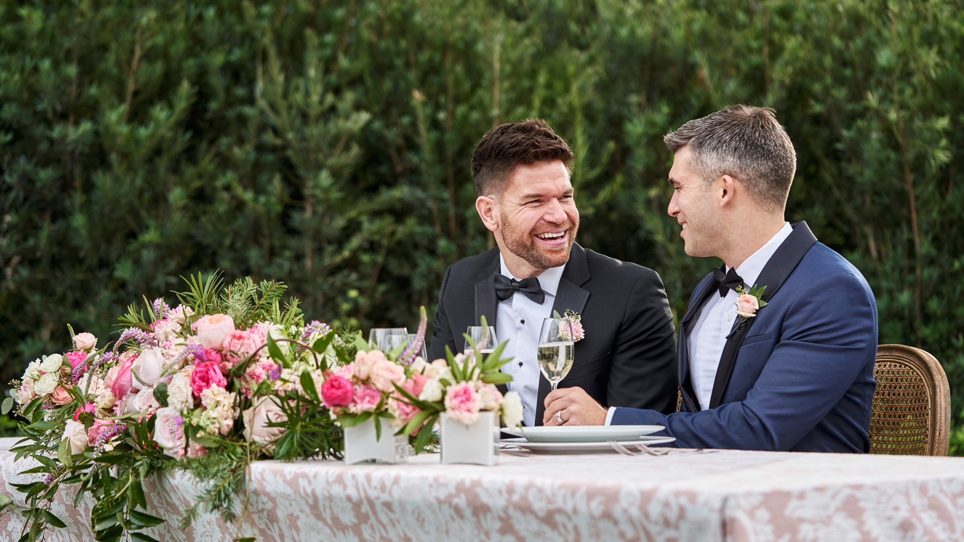 | 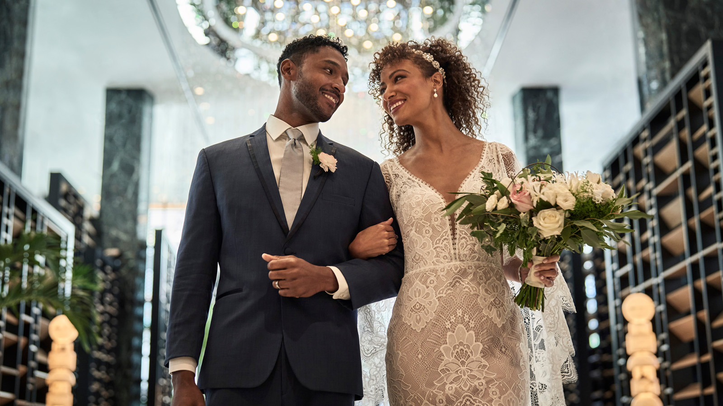
With modern design and a spirit of celebration, Four Seasons Hotel New Orleans helps guests plan the New Orleans nuptials of their dreams, elevating Southern wedding traditions such as a classic second line parade complete with a jazz band and custom parasols. Couples will discover a level of service never before seen in New Orleans with an attitude that is warm and gracious, but also lively and fun. Allow the Hotel’s talented team of wedding experts to deliver an unforgettable, personalized celebration.
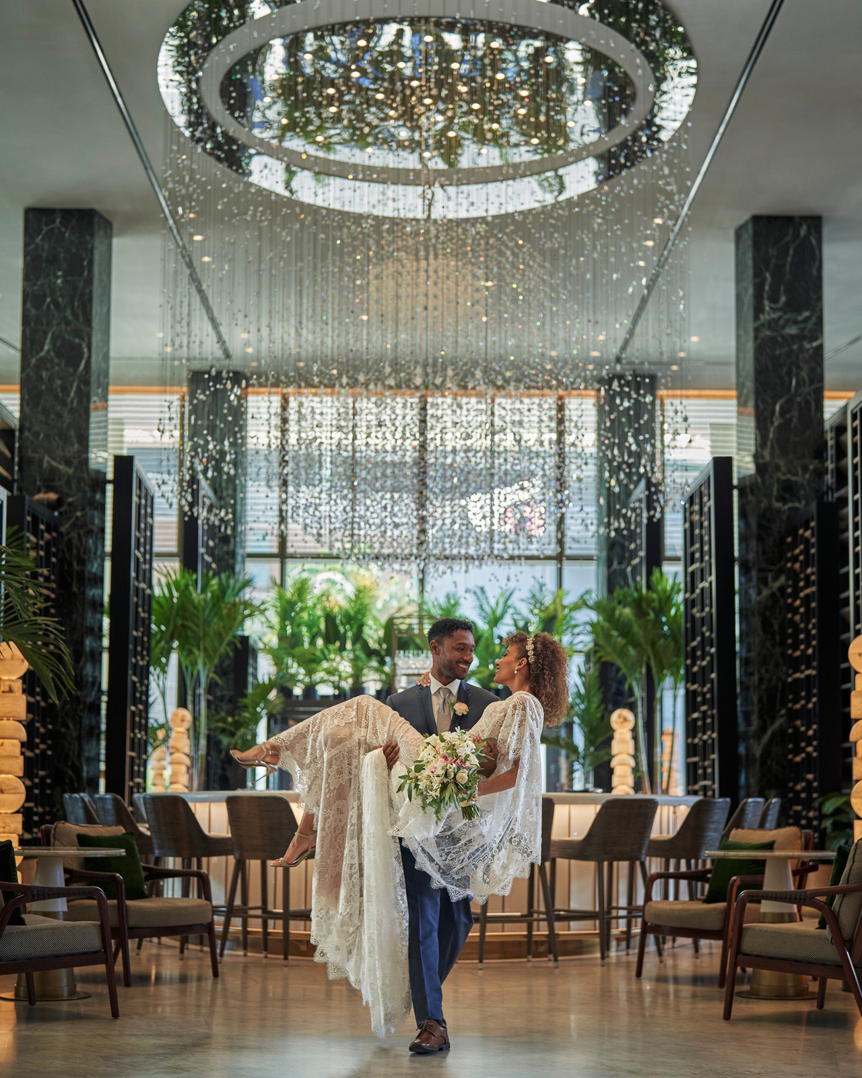 | 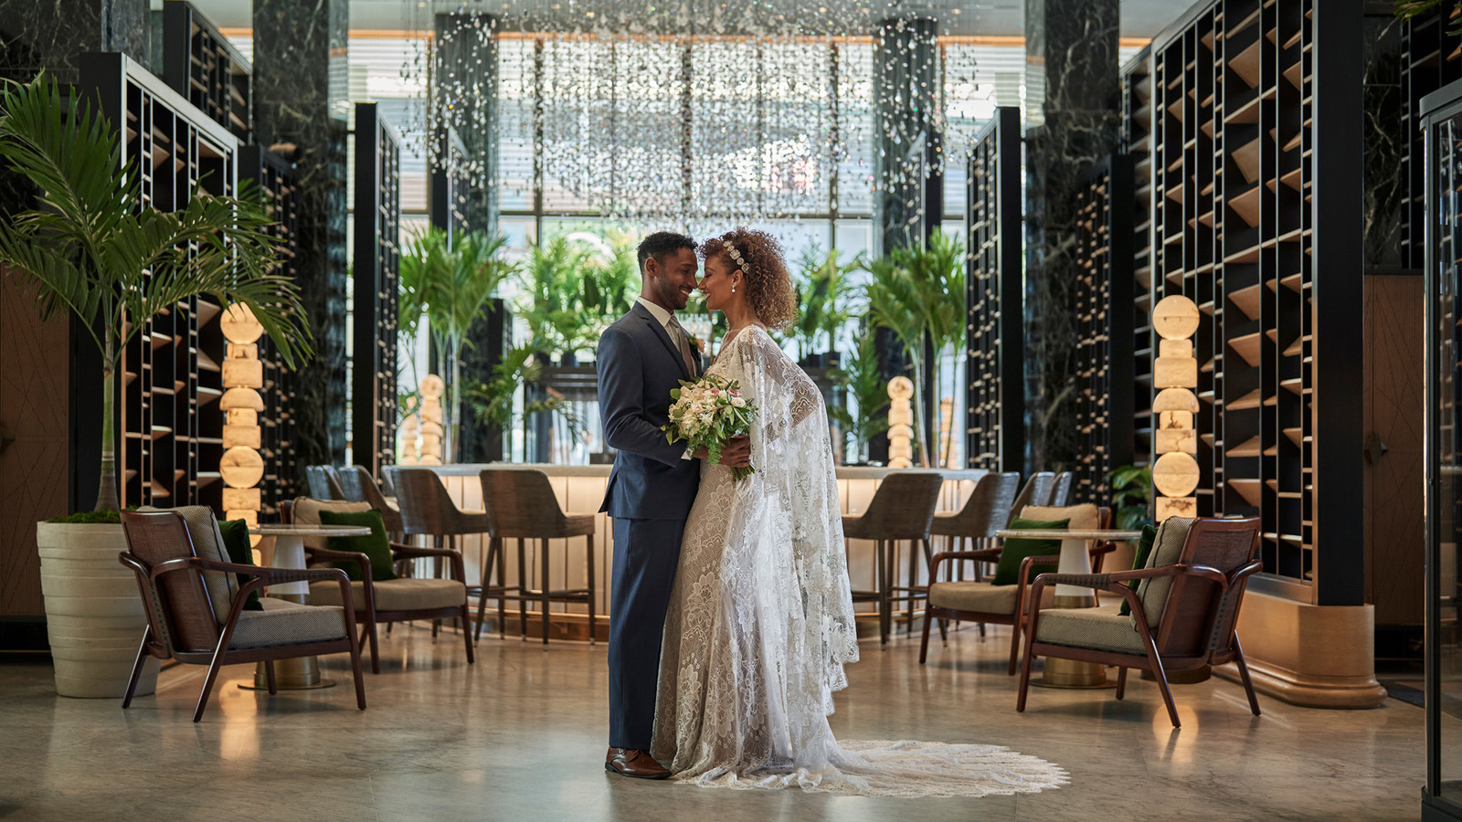 | 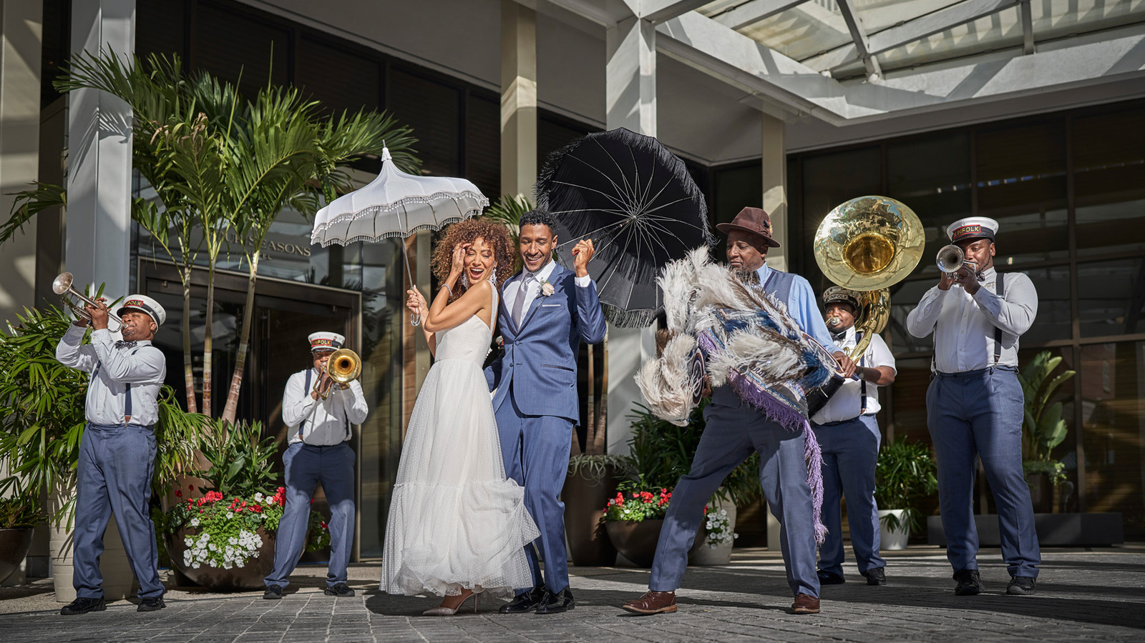
Four Seasons Hotel New Orleans offers unmatched venues for the special day: indoors and outdoors, street-level and high above the skyline. From two modern ballrooms overlooking the Mississippi River, to a lush garden ceremony, to an observation deck with panoramic views, the Hotel offers a vibrant backdrop and best-in-class service to bring any dream celebration to life.
“New Orleans is a city known for celebrations, and that certainly rings true at Four Seasons Hotel New Orleans,” says Mali Carow, General Manager of Four Seasons Hotel New Orleans. “We are delighted to welcome couples from near and far to host their wedding celebrations in our new Hotel. Whether for welcome cocktails at our Garden, second lines on the front drive, or any of the special moments in between, we specialize in delivering exceptionally memorable events.”
Grand Designs
Couples can choose from an array of dynamic indoor and outdoor wedding venues at Four Seasons Hotel New Orleans to perfectly match their vision. At Vue Orleans’ 34th floor observation deck, guests have access to the city’s only panoramic views of downtown and the Mississippi River, perfect for a high in the sky welcome reception to kick-off the wedding weekend. On the ground level, the Hotel’s Garden provides a lush, green space nestled against the vibrant French Quarter and is the ideal setting for a ceremony for up to 200 guests or a post-wedding al fresco brunch.
The true showstoppers are the Hotel’s ballrooms with chic, modern designs that can be transformed to suit the couple’s wedding dreams. Both River Ballroom and Plimsoll Ballroom feature unobstructed views, sleek lines, and neutral tones, allowing for an elegant canvas to design a variety of reception styles. River Ballroom, true to its name, features floor-to-ceiling windows with sweeping views of the Mississippi River. Celebrations in Plimsoll Ballroom also have access to a pre-function space with beautiful built-in marble bars, overhead star-lighting, and wrap-around access to a historic, open-air terrace. Four Seasons Hotel New Orleans can accommodate receptions up to 500 guests to fit any event style.
Food for the Soul
Wedding guests will not have to venture far for a taste of the local cuisine. Executive Banquet Chef David Harrower expertly melds the flavours of Louisiana with elegant catering service from his years of experience at the city’s most sought-after private dining venues. From plated dinners to passed receptions with creative and elaborate displays, Chef Harrower and his team will personalize each menu to suit the tastes and style of the event.
“In the South, food is a central part of celebrations and never an afterthought. Around the table is where friends and family come together,” says Executive Banquet Chef David Harrower. “It is an honour to develop and execute wedding menus that play up the flavours of the destination on a grand scale, while helping guests from near and far connect over delicious cuisine.”
In addition to an all-star catering and events team, Four Seasons Hotel New Orleans is home to the city’s hottest new restaurants led by James Beard Award-winning chefs Alon Shaya and Donald Link. Miss River, located on the lobby-level of the Hotel, pays tribute to New Orleans grand dining, showcasing Chef Shaya’s spirited take on beloved local dishes. With one-of-a-kind views of the Mississippi River, Chemin à la Mer offers a curated menu of Louisiana fare expertly executed with French technique including classic and specialty steaks and a grand oyster bar. Chemin à la Mer’s private dining room can accommodate up to 12 guests for a pre-wedding family meal or intimate dinner.
Bridal Bliss
Inspired by the allure of the bon vivant lifestyle, The Spa is dedicated to the joy of looking and feeling good. Bridal parties can visit for pre-wedding pampering to ensure everyone is glowing before the big day. Sip champagne on the Spa Deck or relax after the celebrations with a side-by-side massage in the deluxe couple’s treatment room. The Spa features coveted skincare line Biologique Recherche, and combines French beauty techniques with state-of-the-art technology for immediate results. The thoughtful menu includes a variety of massage and body treatments as well as customized facials to leave guests feeling rejuvenated for the next event.
For couples looking for a resort-style experience with various spaces for out of town guests to connect and celebrate, they will enjoy the Hotel’s vibrant outdoor pool deck with five private cabanas and lively pool bar. At 70 feet (21 metres) long, the crescent-shaped pool is the largest hotel pool in the city, truly offering a relaxed vacation vibe in the heart of the city.
Unlocking the Destination
The Hotel’s concierge team has the local knowledge and contacts to help wedding guests unlock the authenticity of the city from curated dining itineraries to private streetcar tours through the Garden District. Guests can work with the Hotel’s local experts for exclusive access to the best music venues, fun-filled family itineraries, and cultural experiences for an unforgettable destination wedding experience.
At Four Seasons Hotel New Orleans, there are endless possibilities when it comes to celebration styles and refined service. To begin planning a celebration, click here.

RELATED

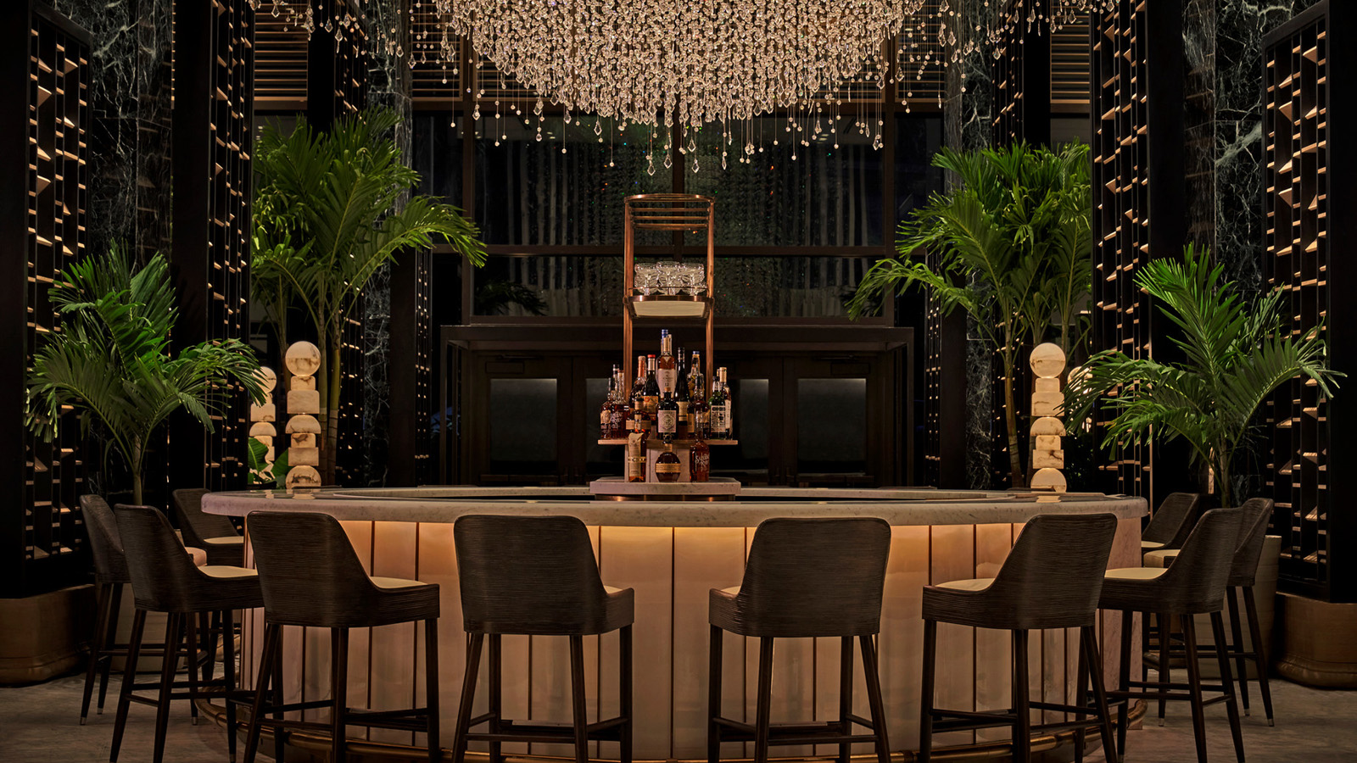 | April 13, 2022, New Orleans, U.S.A.  Four Seasons Hotel New Orleans Named One of the Best New Hotels in the World by Travel + Leisure  https://publish.url/neworleans/hotel-news/2022/travel-and-leisure-it-list.html
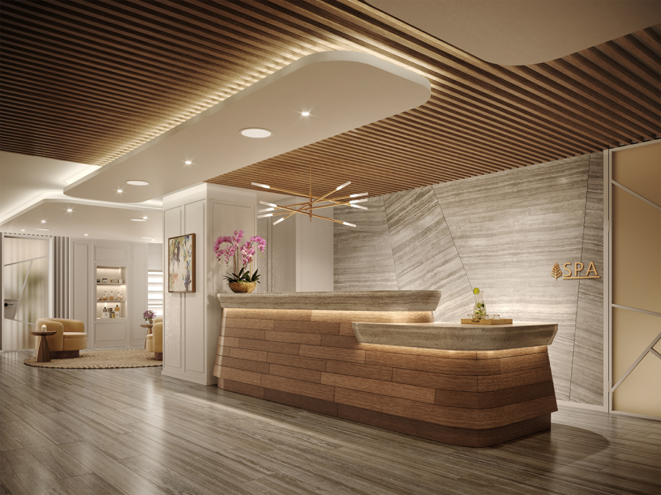 | April 7, 2022, New Orleans, U.S.A.  The Spa at Four Seasons Hotel New Orleans Announces Opening Date and Partnership with Biologique Recherche  https://publish.url/neworleans/hotel-news/2022/introducing-the-spa.html

PRESS CONTACTS

Vicki Bristol
Director of Public Relations and Communications
2 Canal Street
New Orleans
USA
vicki.bristol@fourseasons.com

+1 504 434 7012

