Immerse in Roses with the New KYPRIS 1,000 Roses Facial at the Spa at Four Seasons Hotel Los Angeles at Beverly Hills

The KYPRIS 1,000 Roses Facial invokes the tenderness and sensuality of heart-centred, biodynamic Bulgarian roses to transform even the most tired, imbalanced complexions to glowing, rose petal-softness
January 28, 2019, Los Angeles at Beverly Hills, U.S.A.

The Spa at Four Seasons Hotel Los Angeles at Beverly Hills has introduced a new facial, The KYPRIS 1,000 Roses Facial, to its esteemed list of available services. The treatment, developed in conjunction with the award-winning holistic, high-performance skincare line incorporating the best of green bio-technology with organic, wild-crafted and sustainably-sourced botanicals for gorgeous results and an ecstatic experience of beauty and being, transforms dull, fatigued skin into glowing, rose petal freshness and boasts an impressive lineup of both transformative and luxurious products.
The KYPRIS facial begins with aromatherapy grounding and a two-step rose quartz cleanse to prepare the skin and senses for rest and renewal. The ritual continues with a gentle, multi-dimensional exfoliation process that drenches skin with water-binding silver eared mushroom and saccharide-wealthy sea algae. Powered by biodynamic Bulgarian rose actives, a massage inspired by nature’s animating energies further soothes the skin and senses alike. Finally, skin is cocooned in a cooling rose petal hydration mask infused with tetra-peptides and quieting nervine botanicals such as tulsi and chamomile to enhance the appearance of a glowing, hydrated complexion. The ritual completes with a customised, skin-specific application of KYPRIS serums and golden beauty elixirs, which sends guests into the world, transformed and glowing with the sensuality of the rose. The 80-minute facial is priced at USD 350.
“We are excited to offer a transformative new facial treatment that encourages overall harmony between the mind, body, and spirit. Guests will not only look as refreshed and renewed as a rose, they will feel like it too,” says Magdaleena Nikolov, Spa Director.
“KYPRIS is thrilled to partner with The Spa at Four Seasons Hotel Los Angeles at Beverly Hills,” says Chase Polan, founder of KYPRIS. “We are excited to introduce uniquely beautiful experiences of delight, rest and renewal for their Four Seasons community.”
The Spa at Four Seasons Hotel Los Angeles at Beverly Hills features eight treatment rooms, a beautiful Nail Suite, steam and sauna rooms. Treatments may be booked online or by calling 310 273 2222.

RELATED

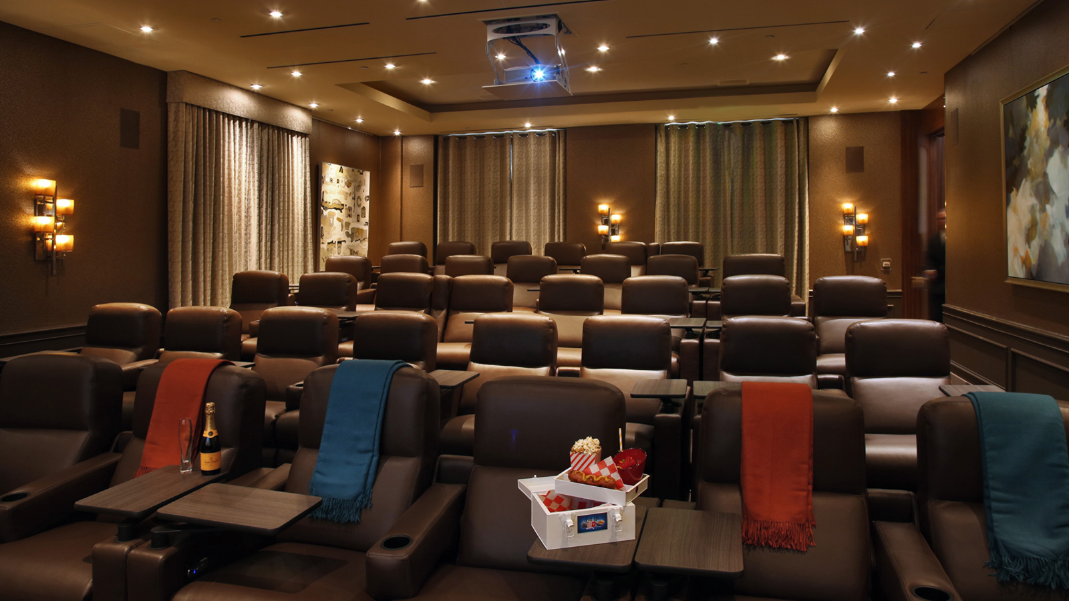 | February 14, 2019, Los Angeles at Beverly Hills, U.S.A.  Culina at Four Seasons Hotel Los Angeles at Beverly Hills Launches Dinner and a Movie or Pronto Market Lunch and Matinee  https://publish.url/losangeles/hotel-news/2019/oscar-week-film-festival.html
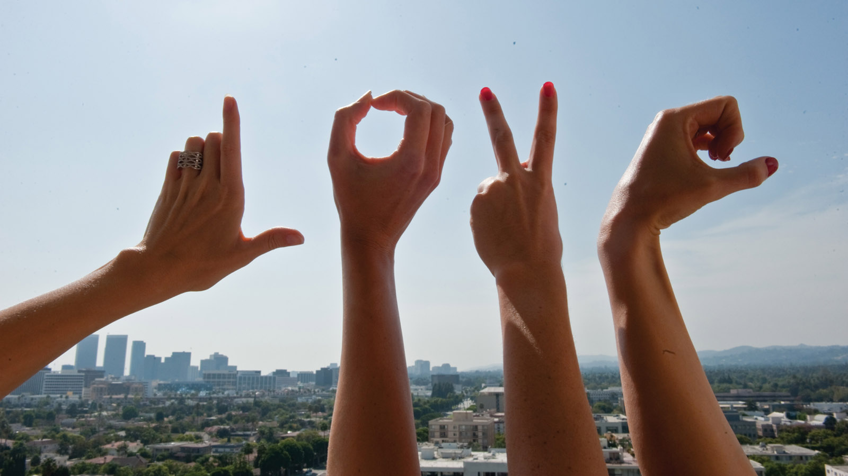 | February 2, 2019, Los Angeles at Beverly Hills, U.S.A.  Open Up to Deeper Love This Valentine’s Day with The Love Awakening Event at the Spa at Four Seasons Hotel Los Angeles at Beverly Hills  https://publish.url/losangeles/hotel-news/2019/love-awakening-event.html

PRESS CONTACTS

Melanee Shale
Digital Marketing Manager
300 South Doheny Drive
Los Angeles
U.S.A.
melanee.shale@fourseasons.com

+1 (310) 786-2217

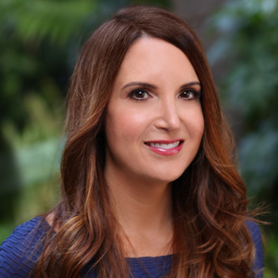 | Kim Kessler  Director of Public Relations  300 South Doheny Drive  Los Angeles  U.S.A  kim.kessler@fourseasons.com  1 (310) 786 2212

