Mode Kitchen & Bar Takes High Tea to the Next Level at Four Seasons Hotel Sydney

100% handcrafted by Alain Ducasse-trained pastry chefs
March 15, 2021, Sydney, Australia

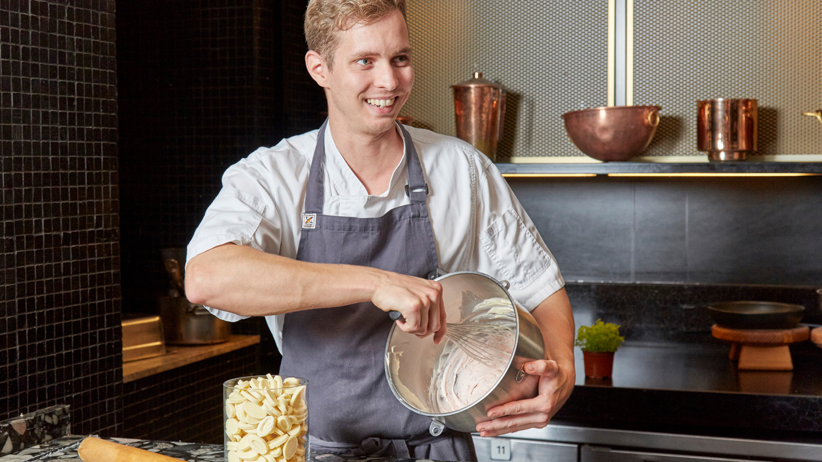
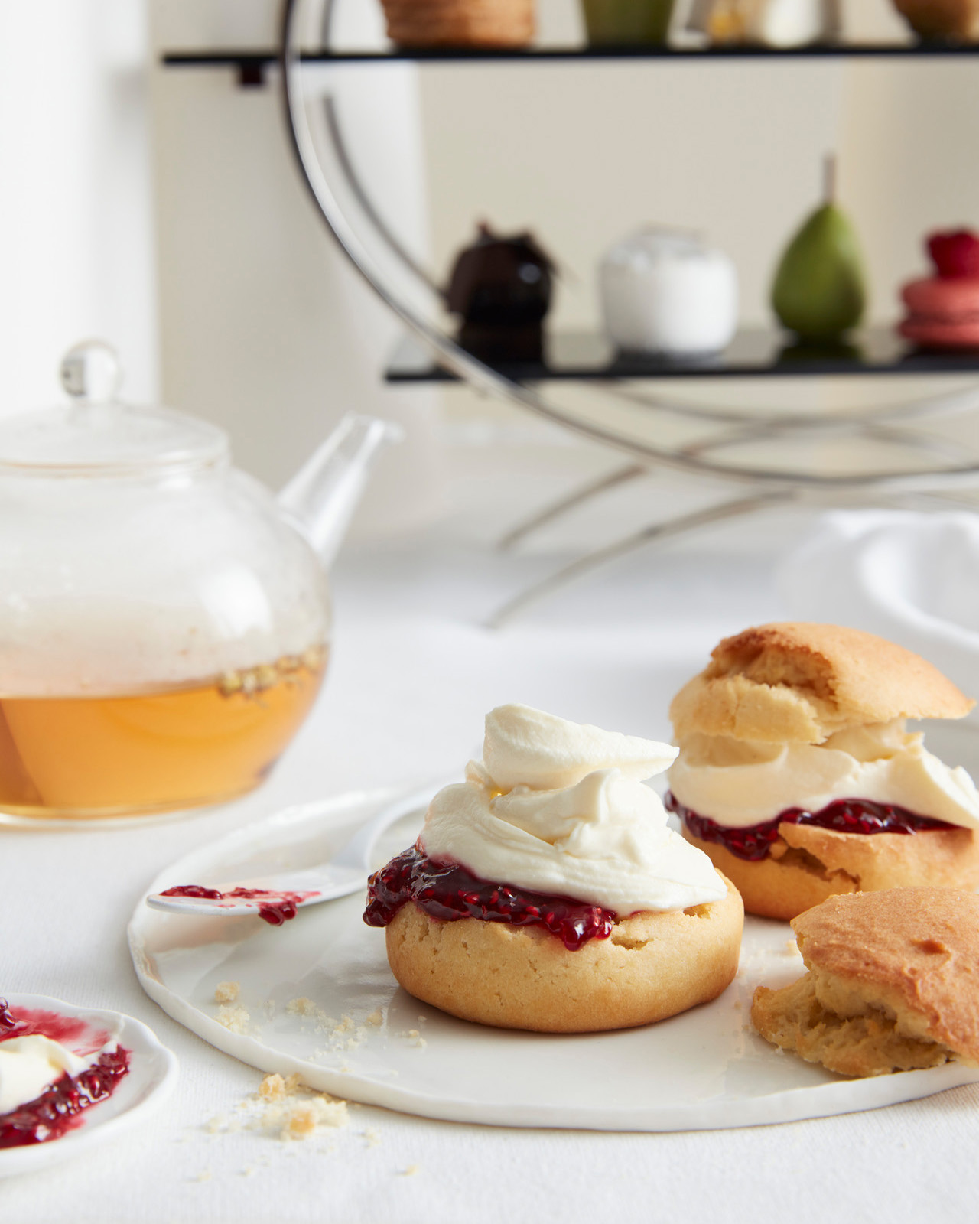 |  | 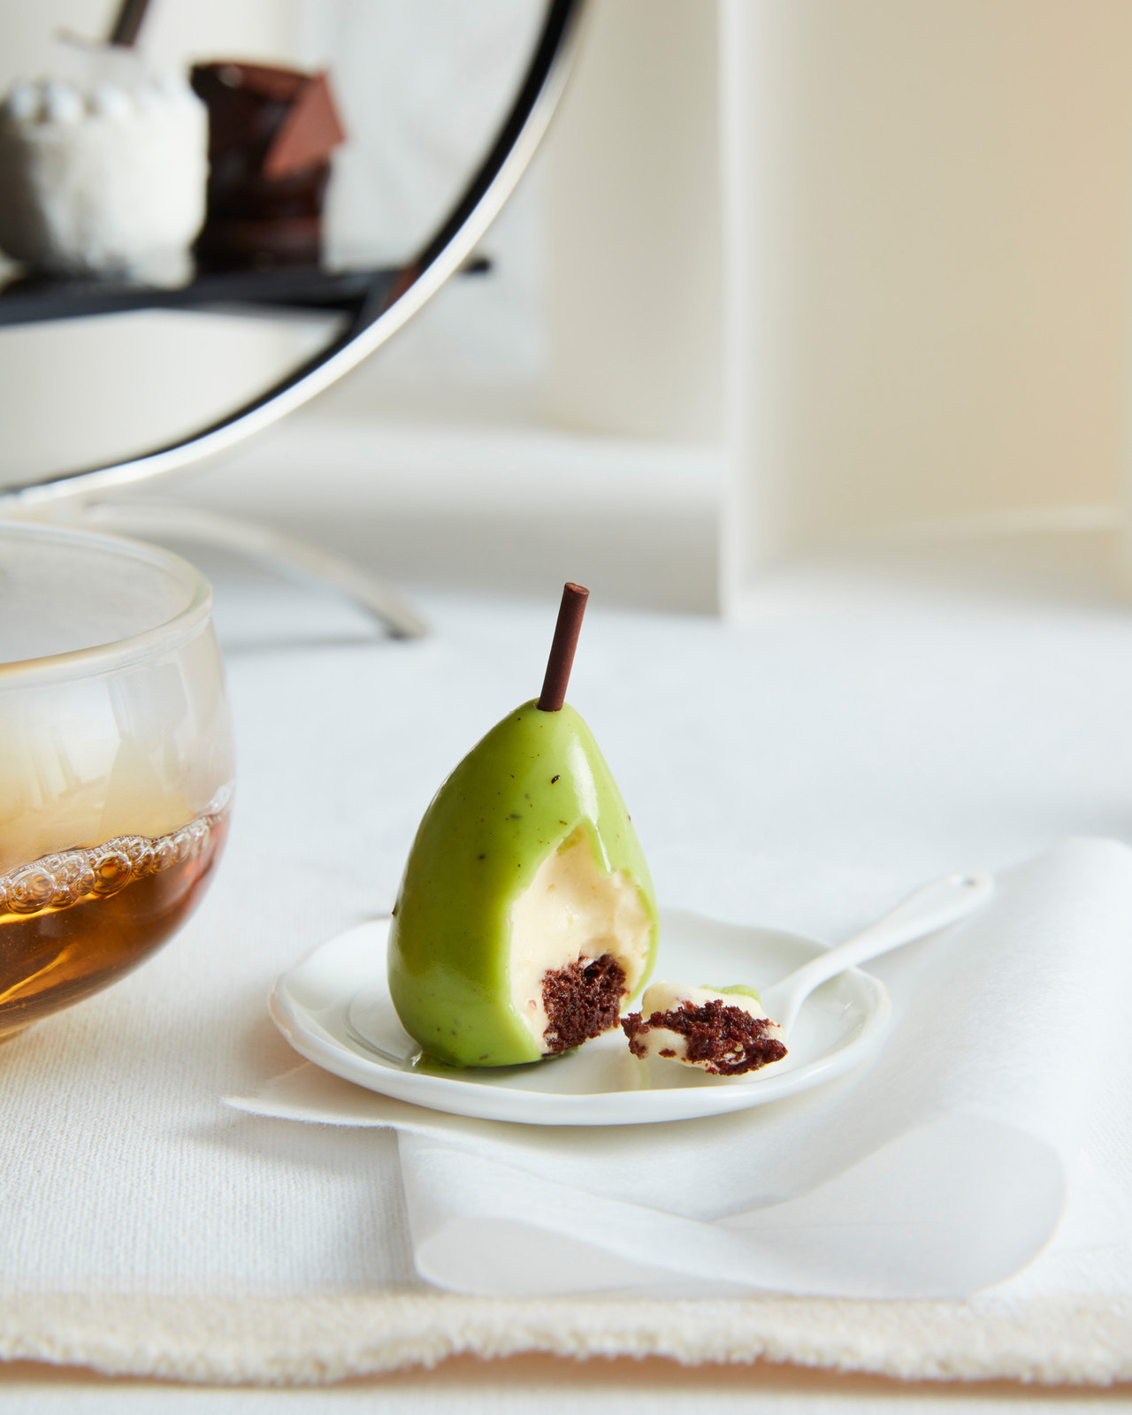
Mode Kitchen & Bar has carved its name into The Rocks as the destination lobby restaurant at Four Seasons Hotel Sydney, and now it’s raised the bar with an exquisite High Tea.
The three tiers of handcrafted sweets, savouries and scones on the new High Tea menu are made 100 percent in-house by the Hotel’s Alain Ducasse-trained pastry chef Quentin Zerr, combining classic French technique with Australia’s best available seasonal produce.
Quentin’s version of the iconic Australian pavlova is a Four Seasons Masterdish: perfectly crisp coconut meringue is dressed with passionfruit, mango and coconut sorbet. While his vol au vent is based on a recipe he learned to perfection while training under one of the world’s top pastry chefs at the renowned Le Meurice restaurant in Paris; the light and crispy puff pastry takes four days to make.
“I am so lucky to have Quentin leading an extraordinary pastry team at Mode,” said head chef Francesco Mannelli. “He is so passionate about his craft, I’ve never before seen some of the things he can do, and this High Tea is a fantastic collaboration of French training and Australian produce.”
Matching French technique with Australian flavours, the current seasonal selection also features a decadent egg and truffle finger sandwich; leek, gruyere and salt bush tart; ocean trout with cucumber and burnt onion; and Mode’s signature coconut and passion fruit pavlova. Gluten-free, dairy-free and other dietary preferences are also catered for, as well as a Kids High Tea for mini socialites.

RELATED

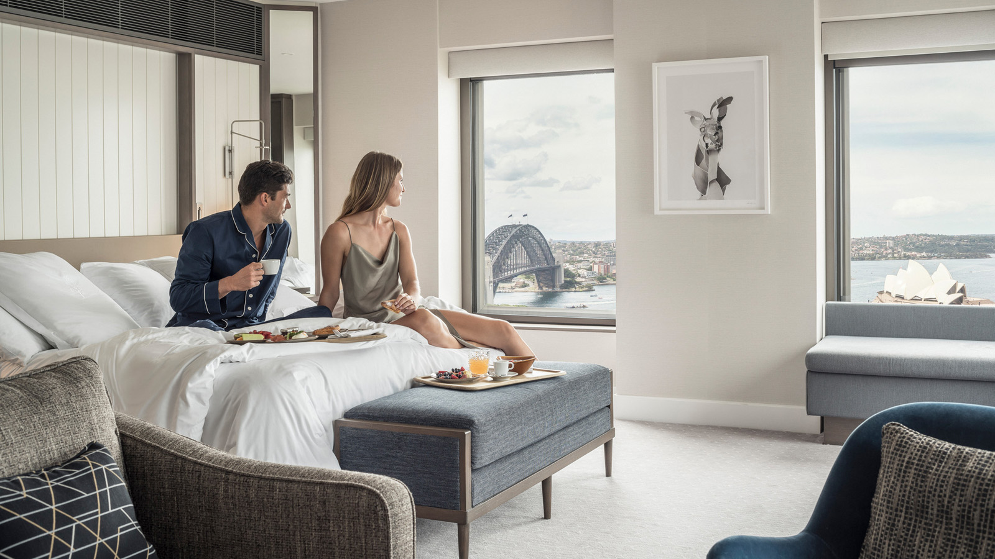 | June 23, 2021, Sydney, Australia  Four Seasons Hotel Sydney Elevates Guest Experience Following Multi-Million Dollar Room Renovation  https://publish.url/sydney/hotel-news/2021/room-renovation-and-new-experiences.html
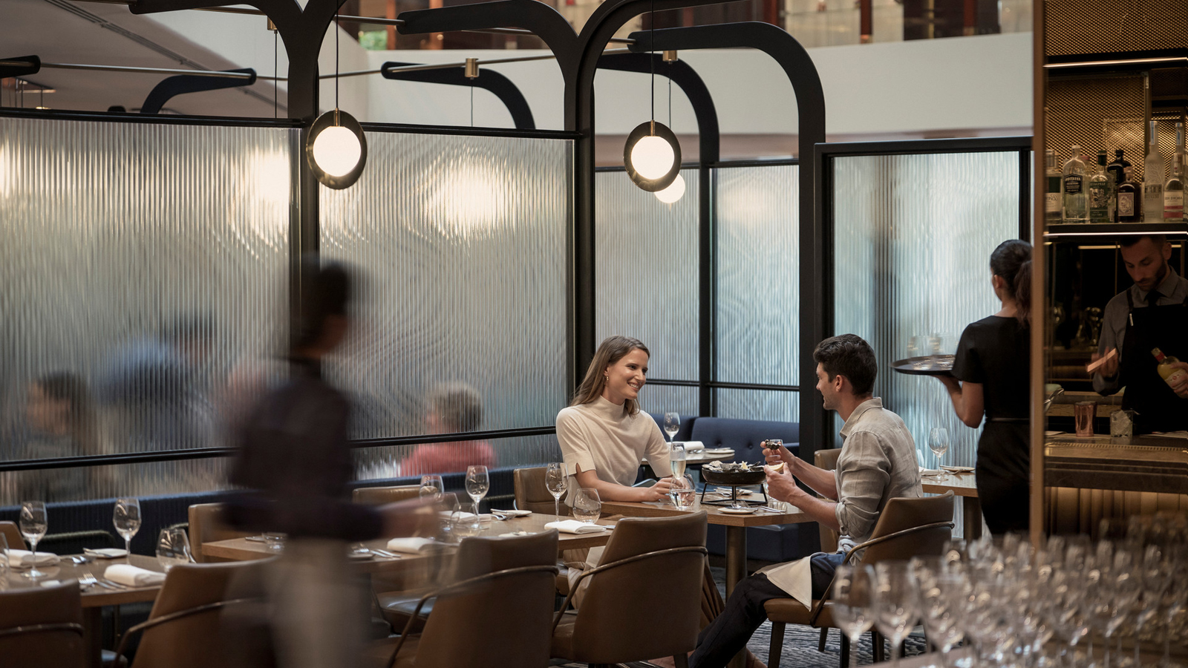 | April 6, 2021, Sydney, Australia  Get #InTheMode for the Flavours of Autumn at Mode Kitchen & Bar at Four Seasons Hotel Sydney  https://publish.url/sydney/hotel-news/2021/mode-kitchen-and-bar-fall-menu.html

PRESS CONTACTS

Elysia McEwen
Director of PR and Communications
199 George Street
Sydney
Australia
elysia.mcewen@fourseasons.com

+61 2 9250 3315

